Amcrest Car DVR ACD-830B Camera

User Manual

Version 1.1
Revised July 8, 2016
Table of Contents
Welcome
Important Safeguards and Warnings
1. Quick Start Guide
1.1. Micro SD Card Installation
1.2. How to Record Video
1.3. How to Take Photos
1.4. How to View Saved Video and Images
1.5. Know What Mode You Are In
1.6. Camera Installation
1.7. FAQ
2. Device Introduction
2.1. Device Description
2.2. Features
2.3. Specification Chart
2.4. Package Contents
3. Device Overview
3.1. Device Structure
3.2. Charging Camera
3.3. Syncing Camera Data
3.4. MicroSD Card
3.5. Camera Modes
3.6. Using Video Mode
3.7. Using Still Mode
3.8. Using Playback Mode
3.9. General Settings
3.10. Camera Installation
3.11. HDMI Output
3.12. Activity LED Indicators
3.13. GPS Operation (Add-On Feature)
4. Amcrest Car DVR Media Player (Software)
5. Firmware Upgrades
6. Troubleshooting Q&A
7. Glossary of Terms
8. Customer Support

Welcome
Thank you for purchasing our Amcrest ACD-830B Car DVR Camera!
This user manual is designed as a reference tool for the installation and operation of your Amcrest ACD-830B Car DVR Camera. Here you can find information about the camera’s features, functions, and information to aid in troubleshooting.

Important Safeguards and Warnings
The camera must be positioned where it would not obstruct the view of the driver.

Do NOT attempt to operate camera while driving! This device is NOT intended to be adjusted while driving. Please follow local laws and regulations on the use of installed in-vehicle equipment. Always give full attention to driving at all times.

Electrical Safety and Battery Information
All installation and operation should conform to your local electrical safety codes. Amcrest assumes no liability or responsibility for fires or electrical shock caused by improper handling or installation.

This product uses a low capacity Lithium-Polymer battery. Do not expose the device to extreme temperatures above +70°C (+158°F). Do not use in humid, wet, and/or corrosive environment. Do not store or leave product in or near a heat source, a high temperature location, strong direct sunlight, microwave oven or pressurized container.

For safety reasons the battery was engineered to a very low capacity. This low capacity battery allows temporary power for up to 30 seconds and from overheating dangers caused by sunlight exertion.

Installation and Transportation Security
Heavy stress, violent vibrations, and excess moisture should not occur during transportation, storage, and installation of device. Handle device with care during installation. Follow installation instructions listed in this user manual.

Repair Professionals
All the examination and repair work should be done by qualified service technicians. We are not liable for any problems caused by unauthorized modifications or user-attempted repair.

Environment
The camera should be kept in a cool, dry place away from flammable materials, explosive substances, etc. Do not aim the camera at a strong light source, as it may cause overexposure of the picture, and may affect the longevity of the camera’s sensors. Ensure that the camera is in a well ventilated area to prevent overheating.

Operation and Maintenance
Do not touch the camera sensor or lens directly. To clean dust or dirt off lens, use an air blower or a microfiber cloth.

Quick Start Guide
This section will provide the user with quick instructions on the basic operation of the camera.

Micro SD Card Installation
The minimum MicroSD card size requirement is 4 GB Class 6. The maximum MicroSD card size that can be used is 64GB class 10. The MicroSD card must the formatted using the camera before initial use.

- Make sure the camera is off. Insert the MicroSD card into the slot on the left side of the camera.
- Turn the camera on using the power button or connect an external power source.
- Press OK to disable recording.
- Press the “MENU” Button twice to enter the “General Settings” menu.
- Use the down arrow to scroll down to the “Format” option and press the “OK” button to select.
- When prompted “All data will be deleted,” select “OK” in the options and press the “OK” button to format the MicroSD card.

How to Record Video
There is an automatic and manual way to initiate recording.

How to Record Automatically
- Press the power button momentarily.
- After complete boot up, the camera will automatically initiate video recording in the Video Mode [].

How to Record Manually
- Press the power button momentarily.
Note: After complete boot up, the camera will initiate video recording.
- Press the OK button to stop recording and a second time to start recording again.
TIP: While recording videos, you can use the quick lock button to lock video files. This will protect the video file from being overwritten with loop record. The quick lock button is located on the right side of the camera indicated with the lock symbol.

How to Take Photos
- Press the power button momentarily.
Note: After complete boot up, the camera will initiate video recording.
- Press the OK button to stop recording.
- Press the M button once to switch to the Still Mode and notice the Mode Icon
- Press the OK button to capture images.

How to View Saved Video and Images
- Press the power button momentarily.
Note: After complete boot up, the camera will initiate video recording.
- Press the OK button to stop recording.
- Press the M button twice to switch to the Playback Mode.
- Mode Icon indicates you are viewing an image and Mode Icon indicates you are viewing a video.
- Press the UP and DOWN buttons to browse through the saved videos and images.
- Press the OK button to play/pause videos, the UP button to fast forward, and DOWN button to rewind.

Know What Mode You Are In
The Mode Icon that is in the top left of the camera screen will show what mode you are in.

- Press the power button momentarily. Note: After complete boot up, the camera will initiate video recording.
- Press the OK button to stop recording.
- Look for the mode icon on the top left of the screen and notice the Video Mode icon
- Press the M button once to switch to the Still Mode [].
- Press the M button once again to switch to the Playback Mode icon OR
- Easily cycle through the modes with the M button on the right side of the camera.

Camera Installation
The following steps will guide you through the installation process:
- Locate the mounting screw hole on the top of the camera. See figure 1.
- Before attaching the mount to the camera, spin the lock nut so that it is positioned at the base of the threaded shaft.
- The threaded shaft of the mount should now be screwed into the top of the camera at the mounting screw hole.
- Spin the lock nut so that it goes down and locks the camera to the mount.
- Push the suction cup up and against the vehicle’s glass windshield.
- Pull and push the locking lever up so that the suction cup can lock against the glass.
- Loosen the grip nut and position the camera to the desired direction. Tighten the grip nut to lock the cameras direction in place.
Note: Always loosen the grip nut before pivoting the camera in any direction. Failure to do so before pivoting the camera may cause mount failure.
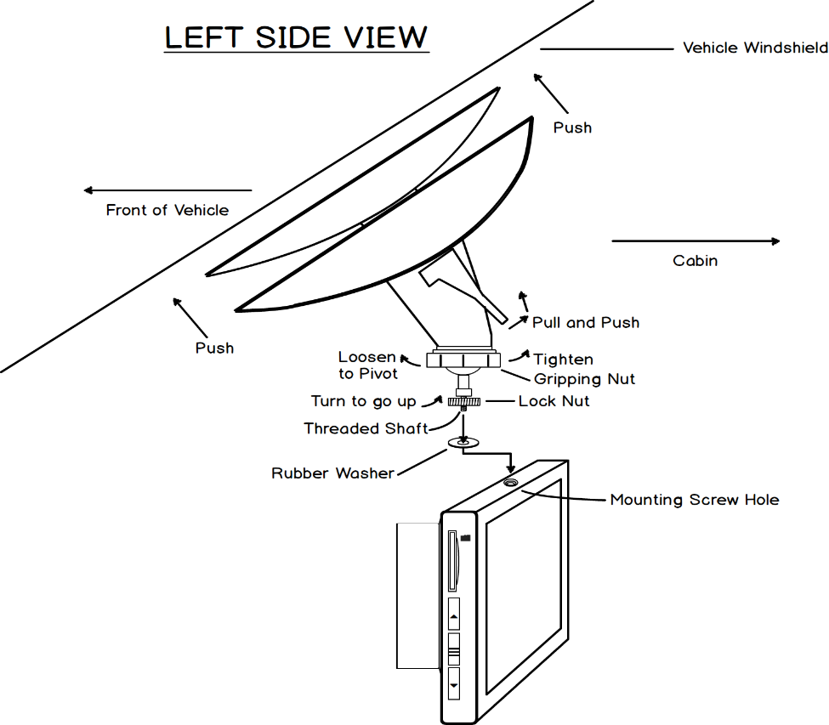
Figure 1: Camera mounting structure.

FAQ
- Question: Why does the battery last only 20 - 30 seconds?
Answer: This is normal. The built in battery has a very limited capacity which is specifically designed to prevent overheating dangers. It also allows the camera to record for a short duration when external power is not available. The external power should always be connected. Ensure whether or not the camera is powering off with the Auto Power Off feature.
- Question: Why is the device not turning off?
Answer: Ensure that the 12V cigarette lighter socket turns off when the ignition is turned off. Some 12v sockets may still be powered on depending on the vehicles wiring structure. When the external power is disconnected for any reason, the auto power off feature will turn the camera off. Ensure that you turn it back on to record more footage when you are not using external power sources.
- Question: How can I adjust the time and date?
Answer: Set the date and time in the settings menu. If the battery runs completely dry by sitting unused for several days, then the time and date may need to be reset. This may also happen if the camera was reset using the reset feature in the general settings menu.
- Question: Why can't I find recorded footage of an incident?
Answer: It is best to always lock the files you want to keep as soon as possible. Periodically check to make sure the Collision Sensor feature is set to ON. Keep an extra SD card handy in your car so that you can safely keep recording in case you feel that you may accidentally overwrite footage you want to save.

Device Introduction
The purpose of this section is to introduce the user to the camera.

Device Description
The Amcrest ACD-830B is a professional in-vehicle dash camera that is mounted on the inner side of the car windshield, and is frequently used to prove liability in traffic incidents. This camera has the flexibility needed to capture everything in your vehicle’s view.

Although the camera comes with a built-in rechargeable battery, for safety reasons, the battery is engineered to a very low capacity. See battery section for more information.

Features include loop record, file auto-lock on accident, parking impact sensor, motion detection, wide dynamic range recording, time-lapse recording, anti-shake, burst shot, and much more.

Features
The Amcrest ACD-830B has the following video, still image and playback features:

Video Features
MicroSD Card: Supports up to 64GB.
Quick Lock: Quickly lock a video while it is still recording.
GPS: Global Positioning System for location and speed monitoring (GPS antenna sold separately).
Mini HDMI: Display video from the camera straight to an external display via Mini HDMI.
Video Recording Resolutions: 1080P, 720P, WVGA, and VGA.
Audio: Enable or disable audio for video recording.
Loop Record: Automatically loop recordings and segment them in 3, 5, or 10 minute durations.
Time Lapse Record: Record in time lapse to review footage in time lapse format.
WDR: Record in Wide Dynamic Range to capture the best light exposure between different objects.
Motion Detection: Records when camera detects motion.
Date Stamp: Allow the date and time to be captured with recorded footage.
Plate Number: Allows your license plate number to be displayed in video playback.
Motion Impact Sensor: Allows camera to lock the video being recorded during a vehicle collision.
Parking Impact Sensor: Allows camera to power on, and record and lock video.

Still Image Features
Still Image Resolutions: 3MP, 2MP, VGA, and 1.3MP.
Capture Timer: Enable capture timer to time image capturing.
Burst Shot: Take three consecutive photos in one instance.
Anti-Shake: Take photos with image stabilization.
Quick Review: Temporarily display the picture after it has been taken.
Date Stamp: Allow the date and time to be captured with still images.

Playback Features
Delete: Delete content from MicroSD card using the camera interface.
Protect: Protect files that are written to the MicroSD Card.
Slide Show: View a slide show with 2, 5, or 10 seconds in between images and videos.

Specification Chart
Feature | Description
CPU | NT96655
SDRAM | Built-in
Loud Speaker | Built-in
Microphone | Built-in
Micro SD | Max 64GB Class 10, Min 2GB Class 6
GPS | GPS compatibility using Mini HDMI port (GPS antenna sold separately)
Battery | Built-in Rechargeable 3.7V Lithium Ion
Power Supply | Output: Mini USB 5V 1.5A; Input: Car Adaptor Socket 12-24V
Image Sensor | WDR Sony IMX322
Lens Size | 160-degree wide viewing angle
Screen | 3.0 inch TFT non-touch screen
Video Resolution | 1080 FHD 1920*1080 / 720P 1280*720 / WVGA 848*480 / VGA 640*480
Loop Recording | 3 min, 5 min, and 10 min
Motion Impact Sensor | Built-in
Motion Detection | Built-in
Auto Power Off | Delay shut off for 3, 5, or 10 Minutes
Video Format | MOV H.264
Image Format | JPG
Image Resolution | 3MP, 2MP, 1.3MP, or VGA
Display Output | Mini HDMI
Reset Button | Built-in
Working Temperature | -20℃ ~ +65℃

Package Contents
Be sure to use only the accessories recommended by Amcrest. Before installation, please open package and ensure all components are present. Contact Amcrest directly if anything is broken or missing in the package.

The following items come in the package:
- Amcrest Car DVR ACD-830B Camera
- Windshield Mounting Suction Cup
- Universal Car Adapter
- Software CD with included Amcrest Car DVR Player
- User Manual
- Mini USB Cable 3 feet

Device Overview
This section will give you an overview of the camera and the user interface.

Device Structure
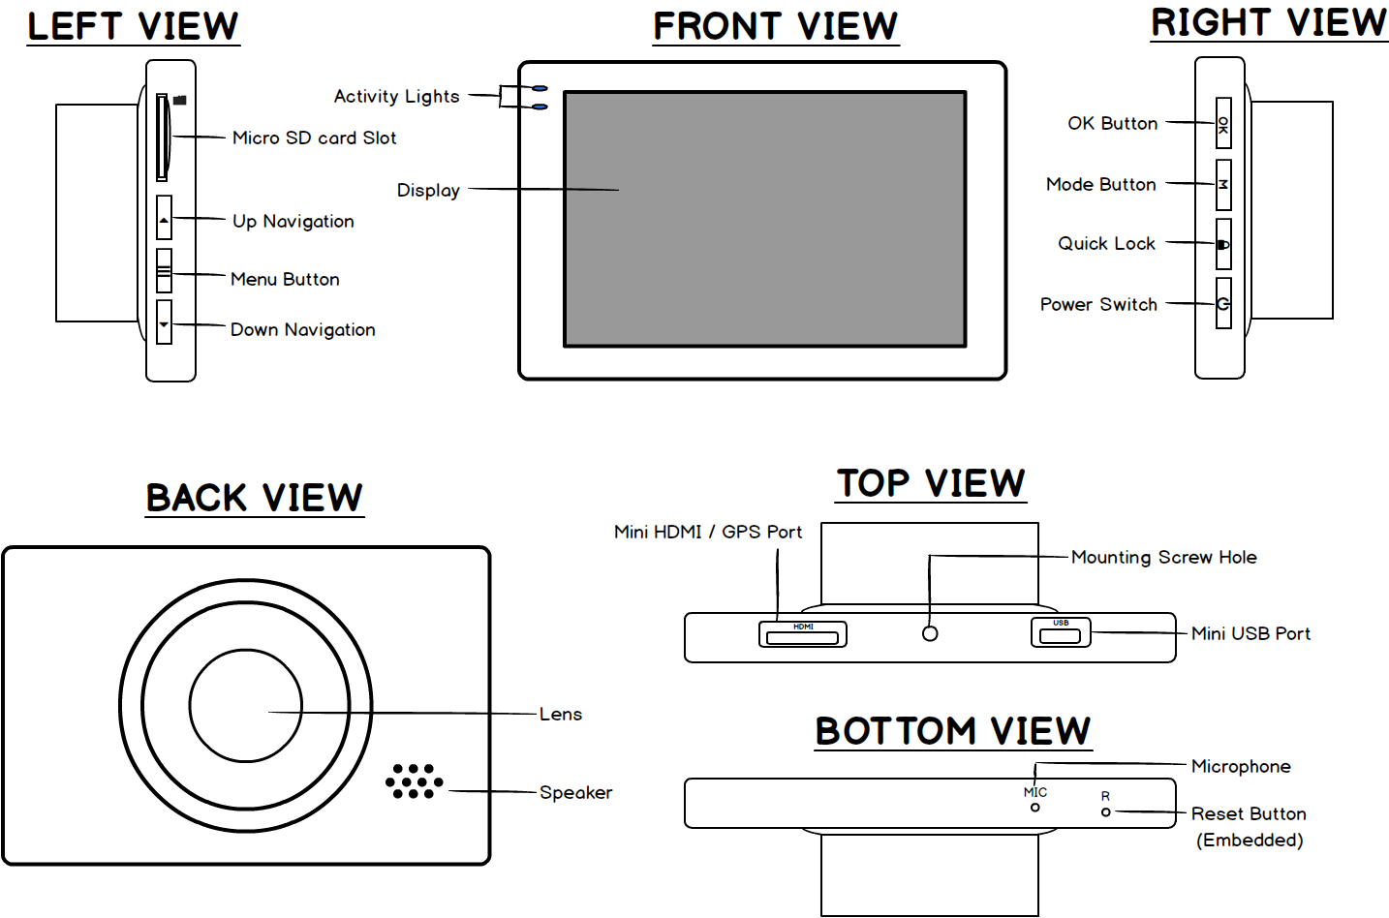

Charging Camera
The camera comes with an internal rechargeable battery that charges with the provided Mini USB cable and car adapter. Charge the battery to full capacity for at least 4 hours before initial use.
Note: In any instance when the camera is powered on (with the power button or an external source), the camera will boot up to Video Mode and initiate recording.

Charging the Camera with Car Adapter
Your camera will charge via the car adapter when it is plugged in and running. This will also initiate recording. To stop recording, press the “OK” button.

Charging the Camera Using a Computer
When the camera is connected via the mini USB to a computer, the camera will automatically start charging. To charge the camera using without syncing data to the computer, allow the camera to sit for more than 10 seconds to disable the prompt message.

Syncing Camera Data
To sync the camera to your computer, connect the included Mini USB cable to the computer’s USB port and the camera. You will be prompted to use the camera as a “Mass Storage Device”. Select “Mass Storage Device” by pressing the “OK” button. Once connected to the computer, the files can safely be transferred.
Note: We recommend transferring all data to your computer before browsing any files.

MicroSD Card
The Amcrest ACD-830B Camera uses a MicroSD card. The MicroSD card must be class 6 or above. The maximum MicroSD card size that can be used is 64 GB. Format the MicroSD card using the camera before initial use (see Section 2.9). Format the MicroSD card after removing all data as well.

Camera Modes
Cycle through all three modes by using the “M” (mode) button. The modes will cycle in the order of Video, Still, Playback then back to the Video mode again.

Default Camera Mode Settings
The following table shows the default settings for each mode:

Setting | Video Mode | Still Mode | Playback Mode
Resolution | 1080P | 5M 2592x1944 | N/A
Loop Recording | 3 Minutes | N/A | N/A
Time Lapse Recording | OFF | N/A | N/A
HDR | ON | N/A | N/A
Exposure | 0.00 | 0.00 | N/A
Motion Detection | OFF | N/A | N/A
Audio | ON | N/A | N/A
Date Stamp | ON | Date/Time | N/A
Plate Number | OFF | N/A | N/A
Motion Impact Sensor | OFF | N/A | N/A
Parking Impact Sensor | OFF | N/A | N/A
Timer | N/A | OFF | N/A
Burst Shot | N/A | OFF | N/A
Quality | N/A | Normal | N/A
Sharpness | N/A | Normal | N/A
White Balance | N/A | Auto | N/A
Color | N/A | Normal | N/A
ISO | N/A | Auto | N/A
Anti-Shake | N/A | OFF | N/A
Quick Review | N/A | OFF | N/A
Slide Show | N/A | N/A | 2 Seconds
Date/Time | MM/DD/YY
Auto Power Off | Off
Beep Sound | On
Language | English
Power Frequency | 50 Hz
Screen Saver | Off
Delayed Shutdown | - seconds

Using Video Mode
The camera will automatically start recording once the power button is pressed and the camera is on. The camera always starts from the video mode and initiates recording every time it is powered on. If the camera is already on and in another mode, switch to the Video Mode using the “M” (mode) button and press “OK” button to record.

TIP: While recording videos, use the Quick Lock button to lock video files. This will protect the video file from being overwritten with loop record. The Quick Lock button is located on the right side of the camera labeled with a lock symbol.

Video Mode Menu
Below is a description for each setting in the Video Mode Menu:

Resolution (): 1080P FHD 1920 x 1080, 720P 1280 x 720, WVGA 848 x 480, VGA 640 x 480.

Loop Recording (): Off, 3 Minutes (), 5 Minutes (), and 10 Minutes ().
Keep loop record on for continuous and seamless recording without stopping. The videos will be segmented into 3, 5, or 10 minutes. When this feature is on, it will delete the oldest recording for the amount set at either 3, 5, or 10 minutes. This feature will turn off when the MicroSD card is full and recording will stop. It will save the recording as one file.

Motion Detection (): Off () and On ().
The camera will initiate recording when it detects motion. Recordings will stop when no motion is detected.

Audio (): Off () and On ().
This option allows control to record video with or without audio. To record sound with video, ensure that audio is enabled.

Motion Impact Sensor ():
Off, low sensitivity (), medium sensitivity (), and high sensitivity ().
If a vehicle is equipped with this Car DVR and the motion impact sensor is enabled, the device will lock a recording once a collision is detected. Note: Camera must be previously recording in order for a video to be locked and saved for future playback.

Parking Impact Sensor (): Off and On ().
If this feature is enabled and the parked vehicle is hit, the camera will turn on, start recording, and lock the video. The video will record for 20 seconds and turn back off.

Time Lapse Recording (): Off, 100Ms, 200Ms and 500Ms ().
The higher frame rate in milliseconds, the faster recorded scenes will replay.

Exposure (): +2.0, +5/3, +4/3, +1.0, +2/3, +1/3, 0.0, -1/3, -2/3, -1.0, -4/3, -5/3, -2.0
Adjust the white balance to acquire different image brightness

Date Stamp (): Off, Date, Time, and Date & Time.
Enables specified option of the date and/or time to be captured with the video.

WDR (Wide Dynamic Range ): Off and On ().
Record footage by auto matching the light exposure between objects and background.

Plate Number (): Off and On.
Enable this feature to display your license plate in video playback. The license plate number will display in the video file.
To enter your license plate:
- Select “ON” by pressing the “OK” button.
- Use the UP and DOWN arrow keys to choose the first character, then press the MENU button to move to the next character.
Repeating these steps will allow programming of your entire license plate into the dash camera. Pressing OK will exit the license plate setup.
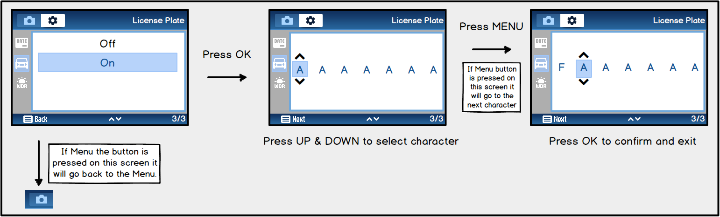

Using Still Mode
To capture images, enter the Still Mode by pressing the “M” (mode) button.

Still Mode Menu
Below is a description for each setting in the Still Mode Menu.

Capture Timer (): Off, 2 Second, 5 second, and 10 seconds.
Use this feature to take a still image with a delay.

Resolution (): 3M HD 2048x1536, 2MP HD 1920x1080, VGA 640x480, 1.3MP 1280x960.

Burst Shot (): Off, On.
This feature takes three consecutive photos in one instance.

Quality (): Fine (), Normal (), Economy ().
Choose a quality setting to set the overall quality of the photo.

Anti-Shake (): Off (), On ().
When Anti-Shake is enabled, feature will allow images to be taken without motion blur. There is a short delay when the image is being taken, which is normal when Anti-Shake is enabled.

Quick Review (): Off, 2 Seconds, and 5 Seconds.
After taking an image, the camera will preview the image captured for the set time. If the feature is off, it will preview the image for a very short duration.

Sharpness (): Strong (), Standard (), Soft ().
This feature allows the amount of detail in a picture or video to be adjusted. The Strong feature will capture more detail between different objects making the image sharper. Soft will capture less detail. The standard setting is the median of soft and strong.

ISO (): Auto (), 100 (), 200 () and 400 ().
ISO measures the sensitivity of the image sensor. A lower value means the camera lens is less sensitive to light. A higher value means the camera lens is more sensitive to light. Use the “Auto” option to adjust the ISO sensitivity automatically.

Color (): Normal, Black & White and Sepia.
Adjust to the desired color effect. Effects will take place for images captured after option has been selected.
White Balance ():
Auto (), Daylight (), Cloudy (), Tungsten (), Fluorescent ().
Adjust the white balance to acquire different color temperatures. Auto adjust to the most natural white colors.

Exposure (): +2.0, +5/3, +4/3, +1.0, +2/3, +1/3, 0.0, -1/3, -2/3, -1.0, -4/3, -5/3, -2.0
Adjust the white balance to acquire different image brightness.

Date Stamp (): Off, Date, Time and Date & Time.
Enables specified option of the date and/or time to be captured with the video.

Using Playback Mode
To play recordings and view images, enter Playback Mode by pressing the “M” (mode) button.

Playback Menu
Below is a description for each setting in the Playback Mode Menu.

Delete (): Delete Current and Delete All.
Delete all footage at once or delete the currently viewed file. Locked files cannot be deleted. The file needs to be unlocked before deleting it.

Protect (): Lock Current, Unlock Current, Lock All, and Unlock All.
Lock/unlock one file at a time, or all files at once. Protected files will be erased when formatted. Ensure that files have been saved before formatting.

Slide Show (): 2 Seconds, 5 Seconds, and 8 Seconds.
Display a slide show and enable the images and videos to display for the desired time. Video files will display the initial captured frame as an image. Pressing OK will stop the slide show.

General Settings
Any settings adjusted in the General Settings Menu will apply to all modes of the camera. The General Settings Menu is also accessible from any mode. Press the “MENU” button twice in any mode. NOTE: General Setting cannot be accessed while camera is recording. Press “OK” button to stop recording.

General Settings Menu
Below is a description for all the options available in the Setup Menu:

Date & Time (): Day, Month, Year, Hour, Minute, and Second.
Set the date and time of the device. If the device is idle for long periods of time and the battery runs completely dry, time and date may need to be reset. Day, Month, and Year can be ordered in the following ways: MM/DD/YY, DD/MM/YY, and YY/MM/DD.

Auto Power Off (): Off, 3 Minutes, 5 Minutes, and 10 Minutes.
Adjust the time it takes for the camera to auto power off when it is in standby.

Beep Sound (): Off and On.
Control the beep sound the camera emits when buttons are pressed and the chime sound when powering the camera on or off.

Language (): English, French, Spanish, Portuguese, Deutsch, Italian, German, Chinese, and Vietnamese. Choose a language for the menu setting and camera user interface.

TV Mode: NTSC and PAL.
Select the TV encoding type for your TV/monitor set when connecting to the HDMI port. If the wrong selection has been made, the display may not show.

Frequency (): 50 Hz and 60 Hz.
50 Hz is used in regions that supply 110-120V AC, and 60 Hz is used in regions that supply 220-240V AC. Check the power standards for the country the car DVR is being used in.

Screen Saver (): Off, 30 Seconds, 1 Minutes, and 2 Minutes.
Adjust the time it takes for the screen to activate. Screen saver will allow the camera to keep recording. Pressing any button will wake the screen.

Format (): OK and Cancel.
Format the MicroSD card using the cameras built-in formatting feature. NOTE: Formatting the card will delete all files including locked files. Formatting will not reset the camera settings.

Delayed Shut Down (): Off, 10 Seconds, 20 Seconds and 30 Seconds.
When the cameras external power source is cut off (from turning car off), the video will keep recording until the desired time before shutting down.

Reset Settings (): OK and Cancel.
Restore to the cameras factory settings. This will not format the MicroSD card. TIP: Alternatively, the camera can be reset by pressing the embedded “R” (Reset) button located on the bottom of the camera. A paper clip is required.

Camera Installation
The following steps will guide you through the installation process:
- Locate the mounting screw hole on the top of the camera.
- Before attaching the mount to the camera, spin the lock nut so that it is positioned at the base of the threaded shaft.
- The threaded shaft of the mount should now be screwed into the top of the camera at the mounting screw hole.
- Spin the lock nut so that it goes down and locks the camera to the mount.
- Push the suction cup up and against the vehicle’s glass windshield.
- Pull and push the locking lever up so that the suction cup can lock against the glass.
- Loosen the grip nut and position the camera to the desired direction. Tighten the grip nut to lock the cameras direction in place.

Note: Always loosen the grip nut before pivoting the camera in any direction. Failure to do so before pivoting the camera may cause mount failure.

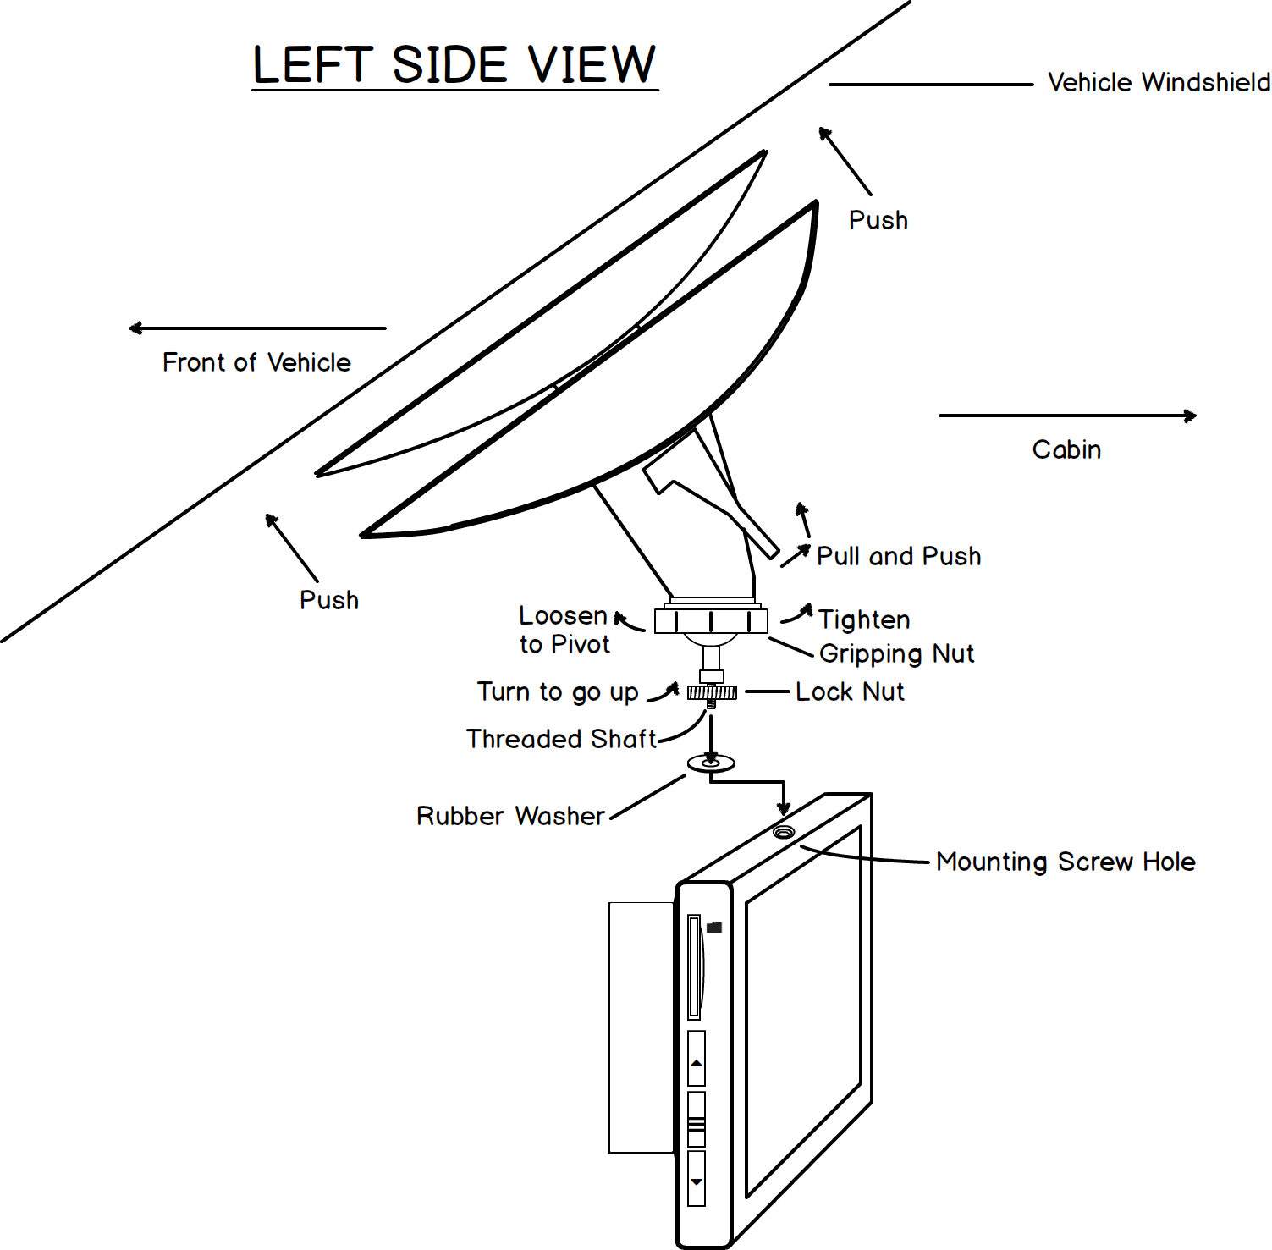

HDMI Output
A “mini HDMI” to “HDMI” cable is needed to connect the camera to an external monitor display. Set the monitor display to 1080P resolution to properly project the camera screen. The Mini HDMI port is located on the top of the camera (see Section 2.1).

Activity LED Indicators
The LED indicator lights on the top left of the camera screen signifies that the camera is active.
- No Activity: Standby
- Top LED when solid red: Charging
- Bottom LED when flashing blue: Recording in progress

GPS Operation (Add-On Feature)
Insert the Amcrest GPS Antenna cable into the camcorder using the Mini HDMI port (see Section 2.1). After GPS positioning, the GPS icon will display a green check mark. GPS telemetry is saved within the video files. Use the included software “Amcrest Car DVR Player” to play the recorded footage and show the GPS telemetry (see Section 3).
Note: GPS can only function within the Video Mode.

Amcrest Car DVR Media Player (Software)

Minimum System Requirements:
CPU: Intel Core 2 Duo 2.4 GHz
RAM: 1GB free of RAM
Monitor: 720P Resolution or above
OS: Windows 7 (32bit/64bit), Windows XP, Windows 8, Windows 10, MAC OS X 10, macOS 10.12.

Video Recorder Player User Interface
This section described the features and functions of the Amcrest Car DVR Player software:

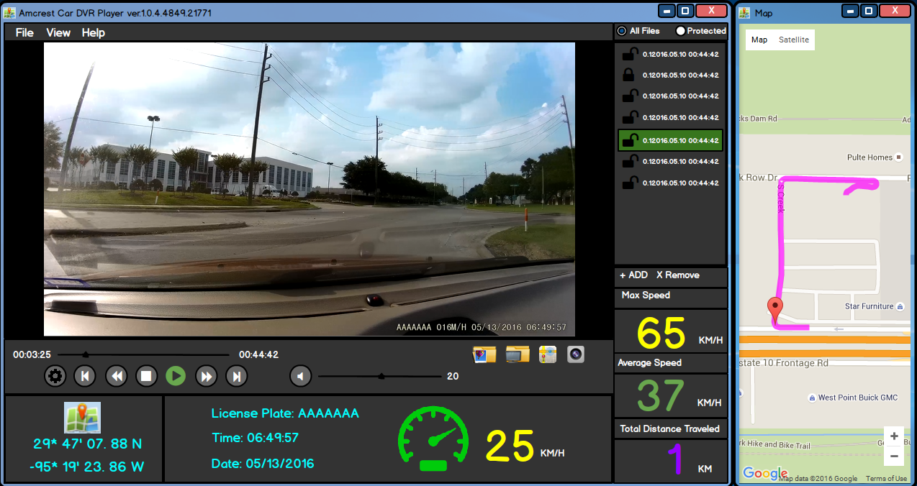
Media Player Controls
Item | Description
Play/Pause | Play or pause the current video.
Stop | Click stop icon to stop playing the video.
Fast Forward | Click forward icon to make video play faster.
Setting | Show setting window.
Slower | Click back icon to make video play slower.
Previous | Click previous icon to play previous video.
Next | Click next icon to play next video.
Audio | Sound on/off.
Screen Capture Folder | Open screen capture images folder.
File Explorer | Used to open file(s) or folder.
Maps | Used to view maps.
Screen Capture | Capture the current frame as an image.

Longitude and Latitude
Shows current longitude and latitude during video playback if applicable.

Speedometer
Shows speed of moving object in map.

License Plate, Time and Date
The License Plate, Time, and Date set by the camera settings will display here. Time and Date are not automatic and must be set within the camera. Please ensure the correct Time and Date are in the General Settings Menu within the camera user interface.

Playlist

Playlist | All Files | Show all files in the default folder.
 | Protected Files | Show locked files only.
 | + Add | Add file(s) to the playlist
 | x Remove | Remove file(s) from play list.

Max Speed, Average Speed and Total Distance Traveled
Shows the Max Speed, Average Speed, and Total Distance Traveled corresponding with the MOV file being played.

Map (GPS Add-On Feature)
Shows the route taken while the camera was recording and saving GPS telemetry.

Firmware Upgrades
This camera is equipped with an automatic firmware upgrade function. Upgrading is needed only when an improved firmware is available. The camera should always be operating on the latest firmware version available. A formatted MicroSD Card is required for this process.
Note: Camera must be plugged into an external power supply when upgrading the firmware, otherwise the firmware upgrade process can be interrupted and ruin the camera.

To upgrade the firmware, follow these steps:
- Download the most recent firmware from www.amcrest.com.
- Unzip the downloaded zip file from amcrest.com.
- Place the firmware file on the MicroSD card.
- Insert the MicroSD card into the camera and connect to an external power source.
- Notice the LED indicators flashing.
- When flashing the firmware, the camera’s screen will be off. Please wait while flashing.
- The camera will power on after the firmware flashing is complete.
- Immediately format the MicroSD card within the camera’s General Settings.
Note: If the firmware file is not deleted off the MicroSD card, the camera will attempt to flash the firmware again.
- Use camera as usual and enjoy!

Troubleshooting Q&A
Question: Why does my battery only last 20-30 seconds?
Answer: This is normal. The built in battery has a very limited capacity which was engineered to prevent overheating dangers. It also allows the camera to record for a short duration when external power is not available. The external power should always be connected. Ensure whether or not the camera is powering off with the Auto Power Off feature. When the external power is disconnected for any reason, the Auto Power Off feature will take effect.

Question: Why does the device not turn off in my car?
Answer: Ensure that the 12V cigarette lighter socket turns off when the ignition is also turned off. Some 12V sockets may still be powered on depending on the car wiring structure. In this case, you would either disconnect the car adapter or press the power button to turn the camera off manually.

Question: Why can’t I play the MOV video files?
Answer: Upgrade your Windows Media Player, or use an alternate media player, such as VLC media player or Quick Time media player. We recommend to use the Amcrest Car DVR Media Player, which is included in the CD software.

Question: Why were the Video/Pictures of an incident not saved?
Answer: We recommend to always lock the files you want to keep as soon as possible. Periodically ensure the Motion Impact Sensor feature is set to ON, which will activate automatic video locking during vehicles incidents. Also, Loop Recording can potentially overwrite any footage that is not locked. To avoid overwriting any recordings, lock the files you wish to save or keep an extra SD card in your vehicle.

Question: Why is the date and time incorrect and/or in the wrong format?
Answer: Reset the date and time in the General Settings Menu. If the battery runs completely dry by sitting unused for several days, then the date and time needs to be reset. This may also happen if the camera has been reset.

Question: Why does the suction cup keep coming off?
Answer: Ensure the interior of the windshield and surface area of the suction cup are clean. In very hot weather, the suction cup mount may need to be reapplied with the area slightly moistened. Apply the suction mount only to the vehicle windshield.

Question: Why can’t I see the device in my computer?
Answer: Check the USB cable connection to the device and the computer. Try a different cable and another USB port. Ensure that it is a data sync cable. If connected to a USB hub, reconnect directly to a USB port on the computer.

Question: Why can’t I turn on my device?
Answer: Charge the battery for 10 minutes and try again. The battery may be completely exhausted or the device may be frozen. Try resetting the camera using the Reset button (see Section 2.1). A paperclip is required.

Question: Why does my screen keep turning off?
Answer: Ensure the Screen Saver feature is disabled as it will turn the screen off (see Section 2.9).

Question: Why can’t I take any photos?
Answer: Your MicroSD might be full. Try deleting unwanted files or replace the storage card.

Question: Why does the recording seems to stop by itself?
Answer: Make sure you are using a class 6 or higher MicroSD card. Ensure that you are using the Loop Recording feature and is set to the desired option (see Section 2.9). Also, it is possible that the Motion Detection feature is enabled which can control recording duration.

Question: Why are videos and images blurry?
Answer: Make sure the lens is clean and free from debris. An unclean lens will cause the camera to be out of focus.

Glossary of Terms
Flash Memory: Type of memory that retains data without a power supply.

Still: An ordinary photograph.

Mass Storage Device: Portable storage media that provides a storage interface.

Video Frame: One of the many images that complete a moving picture.

Frame Rate: The frequency at which video frames in a motion picture are displayed.
JPG: A common file extension for images.

MOV: A common file extension for videos.

Image Tone: Lightness or darkness of colors in a picture.

Format: Prepares a memory card with its default settings and erases the memory card.

Standby: The state in which an electronic device is waiting for events to take place.

GPS Antenna: A device used to transmit or receive GPS radio signals.

GPS Telemetry: Recorded positions of a GPS device at regular intervals that are saved to memory.

LED: Stand for Light Emitting Diode. A type of diode used to emit light for signifying actions.

Lock Nut: A type of nut, usually a secondary nut, used to lock down fasteners.

Windshield: The window at the front of a vehicle.

Threaded Shaft: A relatively long rod that is threaded throughout.

Customer Support
Please feel free to contact us if you have further inquiries or issues with your Amcrest product:
Toll Free: 888.212.7538
International: +1-713-893-8956
USA: 888-212-7538
Canada: 437-888-0177
UK: 203-769-2757

Technical Support Inquiries - For questions regarding Amcrest Technical Support
- support@amcrest.com

Shipping inquiries - For questions related to shipping
- shipping@amcrest.com
- Or for tracking a package from Amcrest.com
- https://amcrest.com/trackshipping

RMA inquiries - For RMA questions or to request an RMA under warranty
- rma@amcrest.com

Marketing Inquiries - For questions regarding Amcrest Marketing
- marketing@amcrest.com

General Sales Inquiries - For questions related to making a purchase
- sales@amcrest.com

