

Amcrest HDCVI DVR User Manual

Version 2.0.9
Revised June 1, 2016
Contents
1. Overview and Features 11
1.1 Overview 11
1.2 Features 11
2. Overview and Controls 13
2.1 Front Panel 13
2.1.1 4-Channel & 8-Channel Front Panel 13
2.1.2 16-Channel Front Panel 14
2.2 Rear Panel 15
2.2.1 General 720p/1080p 4-Channel System 15
2.2.2 General 720p/1080p 8-Channel System 15
2.2.1 General 720p/1080p 16-Channel System 16
2.3 Device Connection Example 17
2.4 Remote Control 18
2.5 Mouse Control 19
3. Connection and Installation 21
3.1 Check Hardware 21
3.2 Hard Drive Installation 21
3.3 Connection Port Information 22
3.3.1 Power Supply Connection 22
3.3.2 Video Input/Output Connections 22
3.3.2.1 Video Input Connection Information 22
3.3.2.2 Video Output Connection Information 23
3.3.3 Audio Input/Output Connections 23
3.3.3.1 Audio Input Connection Information 23
3.3.3.2 Audio Output Connection Information 23
3.3.4 Alarm Input/Output Connections 24
3.3.4.1 Alarm Input Connection Information 24
3.3.4.2 Alarm Output Connection Information 24
3.3.4.3 Connecting a PTZ Decoder 24
3.3.4.4 Alarm Input/Output Details 25
3.3.4.5 Alarm Input Ports 25
3.3.4.6 Alarm Output Ports 26
3.3.5 RS485 Port 26
3.3.6 USB Port 27
3.4 DVR Assembly Guide 27
4. Overview of Navigation and Controls 32
4.1 Startup and Shutdown 32
4.1.1 Startup 32
4.1.2 Shutdown 32
4.1.3 Auto Resume Feature 32
4.1.4 Button Battery Replacement 33
4.2 Startup Wizard 33
4.2.1 Default Account Usernames and Passwords 33
4.3 Live View 37
4.4 Right-Click Menu 39
4.4.1 Video Viewing Options 39
4.4.2 Pan/Tilt/Zoom (PTZ) Control 39
4.4.2.1 Preset 42
4.4.2.2. Tour 42
4.4.2.3 Pattern 43
4.4.2.4 Border 43
4.4.2.5 Rotate 43
4.4.2.6 Flip 44
4.4.2.7 Reset 44
4.4.2.8 Aux On/Off 44
4.4.3 Color Settings 44
4.4.4 Search 46
4.4.5 Manual Recording 46
4.5 Navigation Bar 46
4.5.1 Main Menu 46
4.5.2 Video Viewing Options 46
4.5.3 Favorites 46
4.5.4 Color Settings 46
4.5.5 Search 47
4.5.6 Alarm Status 47
4.5.7 USB Manager 47
4.5.8 HDD Manager 47
4.5.9 Network 47
4.5.10 PTZ 47
4.5.11 Tour 47
4.5.12 Channel Info 48
4.6 USB Device Auto Popup 48
4.7 Main Menu 49
4.8 Main Menu: Operation 50
4.8.1 Search 50
4.8.1.1 Smart Search 53
4.8.1.2 Precise Playback by Time 54
4.8.1.3 Marked Playback 55
4.8.2 Backup 56
4.8.3 Shutdown 58
4.9 Main Menu: Information 59
4.9.1 System Information 59
4.9.1.1. HDD Information 59
4.9.1.2 Record Info 60
4.9.1.3 BPS 61
4.9.1.4 Version 61
4.9.2 Event 62
4.9.3. Network 62
4.9.3.1 Online Users 62
4.9.3.2 Network Load 63
4.9.3.3 Network Test 63
4.9.4 Log 65
4.10 Main Menu: Settings 66
4.10.1 Camera 66
4.10.1.1 Image Settings 66
4.10.1.2 Encode 67
4.10.1.3 Channel Name 69
4.10.1.4 Channel Type 70
4.10.2 Network 70
4.10.2.1 TCP/IP 70
4.10.2.2. Connection 72
4.10.2.3 PPPoE 73
4.10.2.4 DDNS 73
4.10.2.5 IP Filter 75
4.10.2.6 Email 76
4.10.2.7 FTP 77
4.10.2.8 UPnP 78
4.10.2.9 SNMP 80
4.10.2.10 Multicast 81
4.10.2.11 Register 82
4.10.2.12 Alarm Center 83
4.10.2.13 P2P 84
4.10.3 Event 85
4.10.3.1 Detect 85
4.10.3.2 Abnormality 95
4.10.4 System 97
4.10.4.1 General 97
4.10.4.2 Display 101
4.10.4.3 Pan/Tilt/Zoom 104
4.10.4.4 Text Overlay 105
4.10.4.5 Account 106
4.10.4.6 Auto Maintain 110
4.10.4.7 Config Backup 111
4.10.4.8 Default 112
4.10.4.9 Update 113
4.10.5 Storage 114
4.10.5.1 Schedule 114
4.10.5.2 HDD Manage 118
4.10.5.3 Record 119
4.10.5.4 HDD Detect 120
5 Web Operation 122
5.1 Local Web Access 122
5.2 Remote Web Access 123
5.2.1 UPnP/DDNS Remote Access Setup 123
5.2.2 Port Forwarding Remote Access Setup 124
5.3 Web Access Interface 126
5.3.1 LAN Live View Interface 126
5.3.2 WAN Live View Interface 127
5.3.3 Playback Interface 128
5.3.4 Alarm Interface 131
5.4 Web Access Settings Menu 132
5.4.1 Camera Settings 132
5.4.1.1 Image Settings 132
5.4.1.2 Encode Settings 133
5.4.1.3 Channel Name 136
5.4.2 Network 137
5.4.2.1 TCP/IP 137
5.4.2.2 Connection 139
5.4.2.3 PPPoE 139
5.4.2.4 DDNS 140
5.4.2.5 IP Filter 141
5.4.2.6 Email 142
5.4.2.7 FTP 143
5.4.2.8 UPnP 144
5.4.2.9 SNMP 145
5.4.2.10 Multicast 146
5.4.2.11 Register 147
5.4.2.12 Alarm Center 147
5.4.2.13 HTTPS 148
5.4.3 Event 149
5.4.3.1 Detect 149
5.4.3.2 Abnormality 155
5.4.4 Storage 157
5.4.4.1 Schedule 157
5.4.4.2 HDD Manage/Local Storage 162
5.4.4.3 Record 163
5.4.5 System 164
5.4.5.1 General 164
5.4.5.2 Display 167
5.4.5.3 Pan/Tilt/Zoom 170
5.4.5.4 Text Overlay 171
5.4.5.5 Account 172
5.4.5.7 Config Backup 175
5.4.5.8 Default 176
5.4.5.9 Upgrade 176
5.5 Web Access Information Menu 177
5.5.1 Version 177
5.5.2 Log 177
5.5.3 Online Users 178
5.6 Log Out 179
6. FAQs/Troubleshooting 180
Appendix A: Hard Disk Drive (HDD) Capacity Calculation 184
Appendix B: Compatible Backup Device List 185
Appendix C: Compatible CD/DVD Device List 190
Appendix D: Compatible Display List 191
Appendix E: Compatible Switch List 192
Appendix F: Compatible Wireless Mouse List 193
Appendix H: Toxic or Hazardous Materials or Elements 194

Welcome

Thank you for purchasing our Amcrest HDCVI DVR!

This user manual is designed to be a reference tool for the installation and operation of your HDCVI DVR system.

Here you can find information about the DVR’s features and functions, as well as information to aid in troubleshooting.


Many of the setup and installation sections below have corresponding videos on YouTube

To access the setup videos, please go to http://amcrest.com/videos

Important Security Warning

In order to keep your Amcrest camera secure and prevent unauthorized access, please make sure to follow the steps below:
- Always make sure that your camera has the latest firmware as listed on www.amcrest.com/firmware
- Never use the default password for your camera. Always ensure that your password is at least 8-10 characters long and contains a combination of lowercase characters, uppercase characters as well as numbers.

For access to the quick start guide and other support information, go to http://amcrest.com/support

To contact Amcrest support, please do one of the following:
- Visit http://amcrest.com/contacts and use the email form
- Call Amcrest Support using one of the following numbers
Toll Free: (888) 212-7538
International Callers (Outside of US): +1-713-893-8956
USA: 888-212-7538
Canada: 437-888-0177
UK: 203-769-2757
- Email Amcrest Customer Support support@amcrest.com

Important Safeguards and Warnings

1．Electrical Safety
All installation and operation should conform to your local electrical safety codes.
The product must be grounded to reduce the risk of electric shock.
We assume no liability or responsibility for any fires or electrical shock caused by improper handling or installation.

2．Transportation Security
Heavy stress, violent vibrations, and excess moisture should not occur during transportation, storage, and installation of the device.

3．Installation
Handle the device with care. Keep the device right side up.
Do not apply power to the DVR before completing installation.
Do not place objects on top of the DVR.

4．Repair Professionals
All the examination and repair work should be done by qualified service engineers.
We are not liable for any problems caused by unauthorized modifications or user-attempted repair.

5．Environment
The DVR should be installed and kept in a cool, dry place away from direct sunlight, flammable materials, explosive substances, etc.
This product should be transported, stored, and used only in the specified environments as stated above.

6. Accessories
Be sure to use only the accessories recommended by manufacturer.
Before installation, please open the package and check to ensure that all of the components are present.
Contact the retailer that you purchased from, or Amcrest directly if anything is broken or missing in the package.

Overview and Features

1.1 Overview

The Amcrest HDCVI is an excellent digital surveillance product designed for the security field. The DVR uses a Linux based OS in order to maintain reliable operation. It’s easy to use and can be set up in a relatively small amount of time. It has various functions such as recording, playback, and monitoring functionality and it synchronizes audio and video by default.

This HDCVI DVR adopts a high-quality design in order to achieve high levels of reliability and security. It can be configured to work locally, as well as on a network. With the provided professional surveillance software (PSS) tool, as well as many built-in tools on the DVR’s OS, this device can also help monitor and track network usage by the device itself.
By using industry standard cables and tribrid functionality, the DVR can be used with a variety of different cameras (Analog, HDCVI, or IP) and can work with most standard security system cable setups. This product can be used in a variety of locations such as banks, residential neighborhoods or homes, factories, warehouses, transportation (trucking), and more.

1.2 Features

The Amcrest HDCVI has the following features:
- Real-time Monitoring
The HDCVI has an analog output port, VGA port, and an HDMI port. You can use a variety of monitors to display the DVR’s interface, and the DVR can support VGA and HDMI output at the same time.
- Storage Functionality
The DVR is able to record multiple video and audio streams to the built-in hard drive to allow for playback of any recorded media.
- Compression Format
By utilizing advanced compression, the DVR is able to support multiple channels of audio and video, decoding audio and video from each channel in order to maintain video and audio synchronization.
- Backup Function
The DVR supports backup of recorded media and settings via the USB port. A variety of devices can be used for backup purposes, such as a flash drive, portable HDD, or even a CD/DVD burner.
- Advanced Playback Function
This device supports independent real-time recording for each channel and can support search, fast forwarded playback, recorded searches, and downloading of videos and screenshots. The DVR can also playback in slow motion, backwards, and frame by frame as needed. When recording, the DVR shows a date/time overlay to ensure accurate viewing of events when they occurred. Lastly, the DVR can support video enlargement of certain zones within a stream.
- Network Operation
The DVR has built-in tools to allow for remote network real-time monitoring, remote recording of searches, and remote PTZ control.
- Alarm Activation Function
On the back of the DVR there are ports for installation and connection of alarm outputs to enable alarm or light activation based on activity within the video stream. The alarm input and output circuits are protected to ensure device safety.
- Communication Port
By including an RS485 port, the device can support PTZ decoding, as well as various other decoding protocols in order to allow PTZ control of the attached cameras.
- Intelligent Operation
The DVR supports a variety of mouse and keyboard devices in order to enable easy use of the device. There is also a feature that allows for the saving of settings on the device.
- Advanced Network Protocol Support
The DVR is UPnP compatible, and also includes functionality for use with PPPoE, and DDNS protocols in order to allow remote and local connection with a large variety of network hardware.
Note: There may be slight differences in functionality due to the existence of different product series.

Overview and Controls

This section provides information about the physical design and controls for the HDCVI DVR. Please refer to the diagrams below to become acquainted with the DVR and its physical features.

2.1 Front Panel

2.1.1 4-Channel & 8-Channel Front Panel
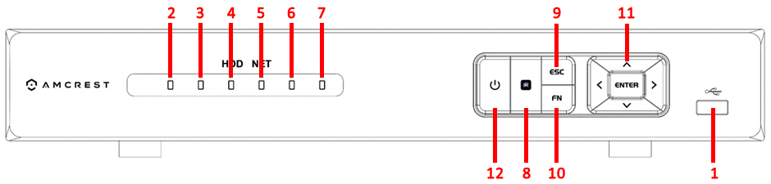
Please refer to the following table for front panel button information:

SN | Icon | Name | Function
1 |  | USB port | To connect USB storage device, USB mouse, etc.
2 | Alarm | Alarm indicator  light | When an alarm occurs, this light turns red.
3 | REC | Record indicator  light | When the DVR is recording, this light turns red.
4 | HDD | HDD abnormal indicator light | When an HDD error occurs or the HDD capacity is below the specified threshold value, this light turns red.
5 | NET | Network  abnormality  indicator light | When a network error occurs or there is no network connection, this light turns red.
6 | ACT | Remote control indicator light | When the DVR receives a signal from the remote, this light blinks.
7 | POWER | Power indicator | When DVR is on, this light remains on.
8 | IR | IR Receiver | This is used to receive the signal from the remote control.
9 | ESC | ESC | Go to the previous menu, or cancel current operation.
9 | ESC | ESC | When playback, click this to return to the real-time monitoring mode.
10 | FN | Assist | One-window monitor mode, click this button to display assistant functions such as PTZ control and image color settings.
10 | FN | Assist | Backspace function: While in numeral control or text control mode, press it for 1.5 seconds to delete the character to the left of the cursor.
10 | FN | Assist | In motion detection mode, FN and direction keys to assist in setup process.
10 | FN | Assist | In text mode, click this to switch between numeral, English character(small/capitalized) and etc.
10 | FN | Assist | Utilize other special functions.
11 | Enter | ENTER | Confirm current operation.
11 | Enter | ENTER | Go to default button.
11 | Enter | ENTER | Go to menu.
12 |  | Power button | Press this button for three seconds to boot up or shut down DVR.
 | , | Up  Down | Activate current control, modify setup, and then move up and down.
 | , | Up  Down | Increase/decrease a numeral value.
 | , | Up  Down | Activate assistant functions such as opening the PTZ menu.
 | , | Left  Right | Shift current activated controls.
 | , | Left  Right | During playback, click these buttons to control the playback bar.

2.1.2 16-Channel Front Panel
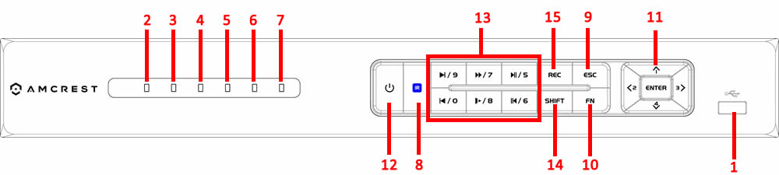
Please refer to the following table for front panel button information:
SN | Icon | Name | Function
1 |  | USB port | To connect USB storage device, USB mouse, etc.
2 | Alarm | Alarm indicator  light | When an alarm occurs, this light turns red.
3 | REC | Record indicator  light | When the DVR is recording, this light turns red.
4 | HDD | HDD abnormal indicator light | When an HDD error occurs or the HDD capacity is below the specified threshold value, this light turns red.
5 | NET | Network  abnormality  indicator light | When a network error occurs or there is no network connection, this light turns red.
6 | ACT | Remote control indicator light | When the DVR receives a signal from the remote, this light blinks.
7 | POWER | Power indicator | When DVR is on, this light remains on.
8 | IR | IR Receiver | This is used to receive the signal from the remote control.
9 | ESC | ESC | Go to the previous menu, or cancel current operation.
9 | ESC | ESC | When playback, click this to return to the real-time monitoring mode.
10 | FN | Assist | One-window monitor mode, click this button to display assistant functions such as PTZ control and image color settings.
10 | FN | Assist | Backspace function: While in numeral control or text control mode, press it for 1.5 seconds to delete the character to the left of the cursor.
10 | FN | Assist | In motion detection mode, FN and direction keys to assist in setup process.
10 | FN | Assist | In text mode, click this to switch between numeral, English character(small/capitalized) and etc.
10 | FN | Assist | Utilize other special functions.
11 | Enter | ENTER | Confirm current operation.
11 | Enter | ENTER | Go to default button.
11 | Enter | ENTER | Go to menu.
12 |  | Power button | Press this button for three seconds to boot up or shut down DVR.
 | , | Up  Down | Activate current control, modify setup, and then move up and down.
 | , | Up  Down | Increase/decrease a numeral value.
 | , | Up  Down | Activate assistant functions such as opening the PTZ menu.
 | , | Left  Right | Shift current activated controls.
 | , | Left  Right | During playback, click these buttons to control the playback bar.
13 | , , , , ,  | Playback Controls / Numbers | During playback, these buttons serve as playback controls.
13 |  | Playback Controls / Numbers | During numerical input, these buttons serve as number input.
14 | SHIFT | Shift | During text input, this button changes text into uppercase.
15 | REC | Manual Record | This button activates manual recording.

2.2 Rear Panel

2.2.1 General 720p/1080p 4-Channel System
The 4-channel system rear panel is as shown below.
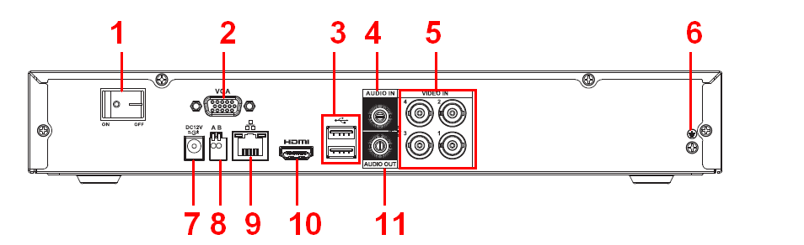

2.2.2 General 720p/1080p 8-Channel System
The 8-channel system rear panel is as shown below.
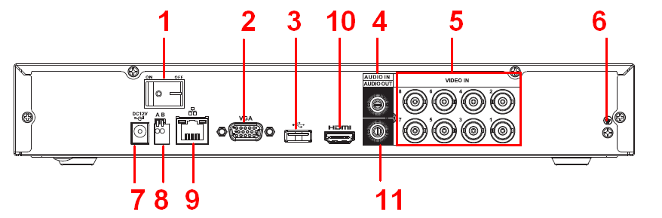

2.2.1 General 720p/1080p 16-Channel System
The 16-channel system rear panel is as shown below.
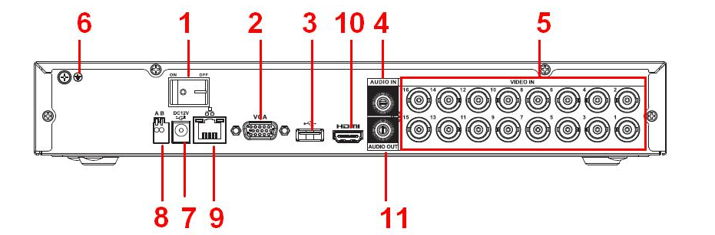

Please refer to the following table for detailed information:

SN | Icon | Name | Note
1 | 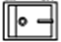 | Power on-off button | Power on/off button.
2 | VGA | VGA video output  port | VGA video output port. Output analog video signal. Can connect to the monitor to view ananlog video output.
3 |  | USB2.0 port | Connect to USB storage device, mouse, burning DVD-ROM and etc.
4 | AUDIO IN | Audio input port | Connect to audio input device such as microphone.
5 | VIDEO IN | Video input port | Connect to analog camera, video input signal.
6 |  | GND | Ground end
7 |  | Power input port | Input 12V DC.
8 | A | RS485（RS-485）communication port | RS485_A port. It is the cable A. You can connect to the control devices such as speed dome PTZ.
8 | B | RS485（RS-485）communication port | RS485_B.It is the cable B. You can connect to the control devices such as speed dome PTZ.
9 |  | Network port | 100M Ethernet port
10 | HDMI | High definition media interface | High definition audio and video signal output port. It transmits uncompressed high definition video and multiple-channel data to the HDMI port of the display device.
11 | AUDIO OUT | Audio output port | Connect to video output device such as sound box.

2.3 Device Connection Example

The below diagram provides an example of the variety of devices the DVR can interface and connect with.

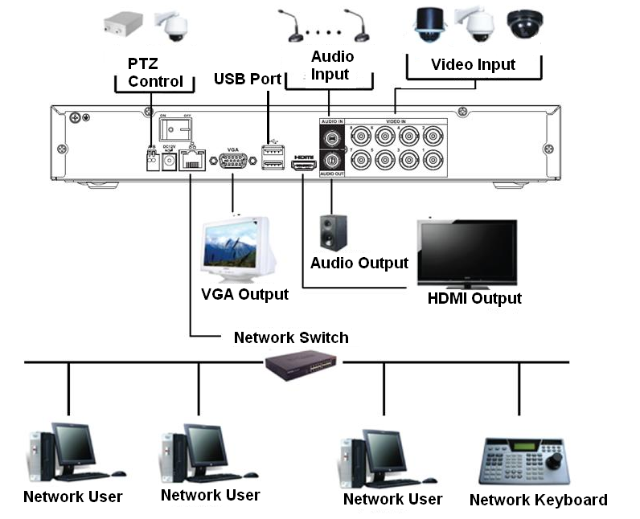

2.4 Remote Control

The diagram below shows the remote control that comes with the Amcrest HDCVI System.
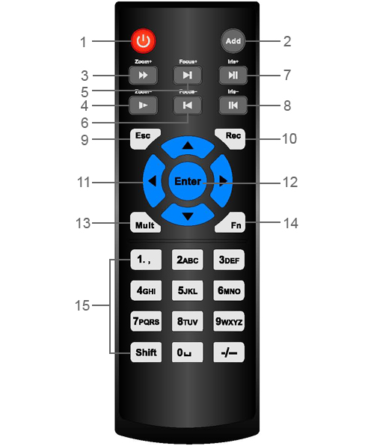

Serial Number | Name | Function
1 | Power button | Click it to boot up or shut down the device.
2 | Address | Click it to input device number, so that you can control it.
3 | Forward | Various forward speeds and normal speed playback.
4 | Slow play | Multiple slow play speeds or normal playback.
5 | Next record | In playback mode, playback the next video.
6 | Previous record | In playback mode, playback the previous video.
7 | Play/Pause | In pause mode, click this button to start normal playback.
7 | Play/Pause | In normal playback click this button to pause playback.
7 | Play/Pause | In real-time monitor mode, click this button to enter video search menu.
8 | Reverse/pause | Reverse playback pause mode, click this button to start normal playback.
8 | Reverse/pause | In reverse playback click this button to pause playback.
9 | Cancel | Go back to previous menu or cancel current operation (close upper interface or control)
10 | Record | Start or stop record manually  In record interface, work with the direction buttons to select the record channel.  Click this button for at least 1.5 seconds and the system will go to the Manual Record interface.
11 | Direction keys | Switch current activated control, go left or right.  In playback mode, click up/down button to switch playback channel. In 1-window playback mode, click left/right button to control playback speed.  Aux function(such as switch the PTZ menu, enable/disable reuse button)
12 | Confirm /menu key | Go to default button  Go to the menu
13 | Multiple-window switch | Switch between multiple-window and one-window.
14 | Auxiliary key | In 1-ch monitor mode: pop up assistant function：PTZ control and Video color.
14 | Auxiliary key | Switch the PTZ control menu in PTZ control interface.
14 | Auxiliary key | In motion detection interface, working with direction keys to complete setup.
14 | Auxiliary key | In text mode, click it to delete character.
15 | 0-9 number key | Input password, channel or switch channel.
15 | 0-9 number key | Shift is the button to switch the input method.

2.5 Mouse Control

The following table details the different uses for a computer mouse in regards to the DVR’s controls.

Left click mouse | System pops up password input dialogue box if you have not logged in.  In real-time monitor mode, you can go to the main menu.
Left click mouse | When you have selected one menu item, left click mouse to view menu content.
Left click mouse | Implement the control operation.
Left click mouse | Modify checkbox or motion detection status.
Left click mouse | Click combo box to pop up drop down list
Left click mouse | In the input box, you can select input methods. Left click the corresponding button on the panel and you can input numeral/English character (small/capitalized). Here, ← stands for backspace button. ＿ stands for the space button.  In English input mode: _ stands for input a backspace icon and ← stands for deleting the previous character.  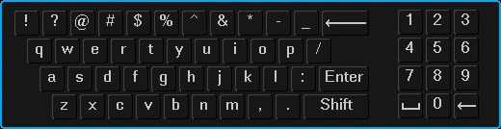
Double left click mouse | Implement special control operation such as double click one item in the file list to playback the video.
Double left click mouse | In multiple-window mode, double left click one channel to view in full-window.  Double left click current video again to go back to previous multiple-window mode.
Right click mouse | In real-time monitor mode, pops up shortcut menu: one-window, four-window, nine-window and sixteen-window, Pan/Tilt/Zoom, color setting, search, record, alarm input, alarm output, main menu.  Among which, Pan/Tilt/Zoom and color setting applies for current selected channel.  If you are in multiple-window mode, system automatically switches to the corresponding channel.  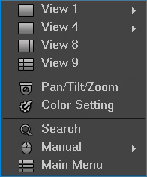
Right click mouse | Exit current menu without saving the modification.
Press middle button | In numeral input box: Increase or decrease numeral value.
Press middle button | Switch the items in the check box.
Press middle button | Page up or page down
Move mouse | Select current control or move control
Drag mouse | Select motion detection zone
Drag mouse | Select privacy mask zone.

Connection and Installation

3.1 Check Hardware

When you receive the DVR system in the packaging, unpack it, and check all sides of the DVR to see if there is any physical damage. The protective materials used for the packaging of the DVR can protect most accidental damage during transportation, but to ensure that your equipment is operating as expected, it is recommended to inspect the product before proceeding further.

On the DVR unit, check specifically that the label on the bottom of the DVR is not damaged. The serial number of the unit is usually needed to provide support.

Please check that all required items for your DVR are present and accounted for. To check what is included with your purchase, go to http://amcrest.com/hdcvi-security-camera-systems.html/ and find the product you purchased, then scroll down and click the “What’s Included” tab. If any item is missing, please contact us as soon as possible so we can send you the missing component.

3.2 Hard Drive Installation

You can refer to the Appendix for recommended HDD brands and models. Please use a HDD of 7200rpm or higher.
Please follow the instructions below to install a hard disk drive (HDD).
All the figures listed below are for reference only. Slight differences may be found on the front or rear panel.

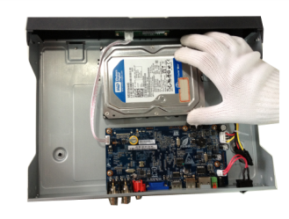
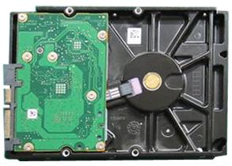

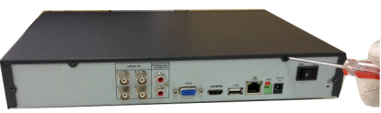
3. Place the HDD in accordance with the four holes on the bottom.
2. Attach four screws in the HDD (Turn three times).

1. Loosen the screws of the upper cover and side panel.

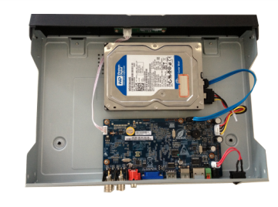

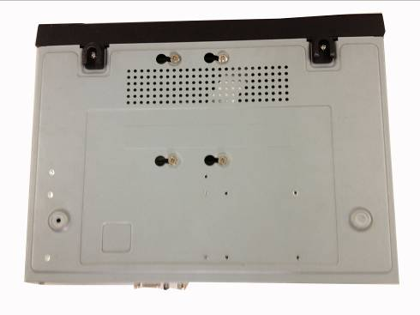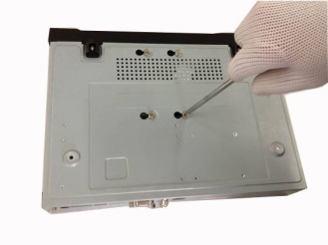
6. Connect the HDD cable and power cable.

5. Attach the HDD firmly.

4. Turn the device upside down and then turn the screws in firmly in the chassis.

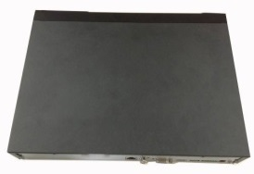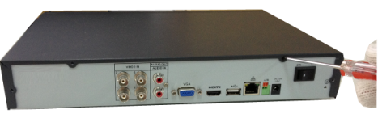
8. Secure the screws in the rear panel and the side panel.
7. Put the cover on in accordance with the clip and then place the upper cover back on.

Note:
- An HDD is included with the DVR by default.
- To connect the HDD, connect the HDD data cable and the power cable before attaching the HDD in the device.
- To remove the front cover, push the clip first, and then slide the cover off.

3.3 Connection Port Information

3.3.1 Power Supply Connection

Please check to make sure the input voltage is correct and the power button is in the off position when connecting the power supply.
We recommend you use an Uninterruptible Power Supply (UPS) to guarantee steady operation of the DVR, as well as to elongate the life span of the DVR and other peripheral equipment such as attached cameras and other accessories.

3.3.2 Video Input/Output Connections

3.3.2.1 Video Input Connection Information

The video input interface is BNC.
The input video format includes: PAL/NTSC BNC (1.0VBP- P, B75Ω)
The video signal should comply with your national standards.
The input video signal should have high SNR, low distortion; low interference, natural color and suitable brightness.
To guarantee the stability and reliability of the camera signal, the camera should be installed in a cool, dry place away from direct sunlight, flammable materials, explosive substances, etc.
The camera and the DVR should have the same grounding to ensure the normal operation of the camera.
Guarantee stability and reliability of the transmission line
Please use high quality, well shielded BNC cable. Please select suitable BNC model according to the transmission distance.
If the distance is too long, you should use twisted pair cable. You can add video compensation devices or use optical fiber to ensure video quality.
You should keep the video signal away from the strong electromagnetic interference, especially power lines.
Keep connection lugs closely contacted.
The signal line and shielded wire should be fixed firmly and in well connection. Avoid dry joint, lap welding, and oxidation.

3.3.2.2 Video Output Connection Information

Video output includes a BNC (PAL/NTSC1.0VP-P，75Ω）output, a VGA output, and a HDMI output. The system supports BNC, VGA and HDMI output at the same time.
When you are using pc monitor, please pay attention to the following points:
- To defer aging, do not allow the pc monitor to run for a long time.
- Regular demagnetization will keep your device in proper working condition.
- Keep it away from strong electromagnetic interference devices.

Using a TV as video output device is not a reliable substitution method. When using a TV as a video output device, it is advised to turn off the TV from time to time in order to ensure its longevity. The use of a low quality TV may result in the damage of the device.

3.3.3 Audio Input/Output Connections

3.3.3.1 Audio Input Connection Information

The DVR audio input ports uses a BNC type connection.
Due to high impedance of audio input, please use an active sound microphone to get the best audio quality.

Audio transmission is similar to video transmission. Try to avoid interference, look out for dry joints, loose contacts, and keep the audio devices and cables away from power lines.

3.3.3.2 Audio Output Connection Information

The audio output signal parameter is usually over 200mv 1KΩ (BNC or RCA).
It can directly connect to a low impedance earphone, active speaker, or amplifier-drive audio output device.
If the speaker and the microphone cannot be separated spatially, it may create a feedback loop. In this case you can adopt the following measures:
- Use a better directional microphone.
- Reduce the volume of the speaker.
- Using more sound-absorbing materials in the surrounding area can reduce voice echo and improve the acoustic environment.
Adjust the layout of the audio output cables to reduce the occurrence of a feedback loop.
3.3.4 Alarm Input/Output Connections
Please read the following before connecting any alarm devices
3.3.4.1 Alarm Input Connection Information
- Please make sure the alarm input mode is grounded.
- A grounding signal is needed for alarm input.
- Alarm input uses a low level voltage signal.
- Alarm input mode can be either NO (Normal Open) or NC (Normal Close).
- When you are connecting two DVRs, or one DVR and one other device, please use a relay to separate them.

3.3.4.2 Alarm Output Connection Information

The alarm output port should not be connected to a high power load directly (The power load should be less than 1 amp) to avoid high current which may result in relay damage.

3.3.4.3 Connecting a PTZ Decoder

- Ensure that the decoder has the same grounding with the DVR, otherwise you may not be able to control the PTZ. Shielded twisted wire is recommended and the shielded layer is used to connect to the ground.
- Avoid high voltage. Ensure proper wiring and take some thunder protection measures.
- For signal wires that are too long, 120Ω should be connected in parallel between A, B lines on the far end to reduce reflection and guarantee the signal quality.
- “485 A, B” of DVR cannot parallel connect with “485 port” of another device.
- The voltage between the A,B lines of the decoder should be less than 5v.

3.3.4.4 Alarm Input/Output Details

Important!
Please refer to the specifications for the alarm input and output channel amount. Do not merely count the alarm input and output channel amount according to the ports on the rear panel.
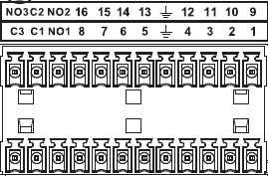
The following interface is based on the 8-channel advanced 1080P (V2) mini 1U Series.

1，2，3，4，5，6，7，8，9，10，11，12，13，14，15，16 | ALARM 1 to ALARM 16. The alarms become active in low voltage.
NO1 C1，NO2 C2，NO3 C3， | Three normal open groups (on/off signal)
 | Earth cable.

3.3.4.5 Alarm Input Ports
- Grounding alarm inputs. (Normal Open or Normal Close type)
- Please parallel connect COM end and GND end of the alarm detector (Provide external power to the alarm detector).
- Please parallel connect the Ground of the DVR and the ground of the alarm detector.
- Please connect the NC port of the alarm sensor to the DVR alarm input (ALARM)
- Use the same ground with that of DVR if you use external power to the alarm device.
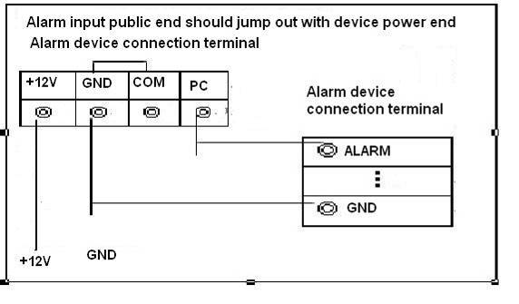

3.3.4.6 Alarm Output Ports

- Provide external power to any external alarm device.
- To avoid overloading, please read the following relay parameters sheet carefully.
- RS485 A/B cable is for the A/B cable of the PTZ decoder.
- T+,T-,R+,R- are four-wire double duplex RS485 port.
T+ T-: output wire
R+ R-: input wire

Relay Specification
Model: |  | JRC-27F
Material | Silver
Rating  (Resistance Load) | Rated switch capacity |  | 30VDC 2A, 125VAC 1A
Rating  (Resistance Load) | Maximum switch power |  | 125VA 160W
Rating  (Resistance Load) | Maximum switch voltage |  | 250VAC, 220VDC
Rating  (Resistance Load) | Maximum switch currency |  | 1A
Insulation | Between contacts with same polarity |  | 1000VAC 1 minute
Insulation | Between contacts with different polarity |  | 1000VAC 1 minute
Insulation | Between contacts and winding |  | 1000VAC 1 minute
Surge voltage | Between contacts with same polarity |  | 1500V (10×160us)
Length of open time | 3ms maximum
Length of close time | 3ms maximum
Longevity | Mechanical |  | 50×106 times (3Hz)
Longevity | Electrical |  | 200×103 times (0.5Hz)
Temperature | -40°C~+70°C

3.3.5 RS485 Port

When the DVR receives a camera control command, it transmits that command up the coaxial cable to the PTZ device. RS485 is a single-direction protocol; the PTZ device can’t return any data to the unit. To enable the operation, connect the PTZ device to the RS485 (A,B) input on the DVR.

Since RS485 is disabled by default for each camera, you must enable the PTZ settings first. This series DVR supports multiple protocols such as Pelco-D, Pelco-P.

To connect PTZ devices to the DVR:
1. Connect RS485 A,B on the DVR rear panel.
2. Connect the other end of the cable to the proper pins in the connector on the camera.
3. Please follow the instructions to configure a camera to enable each PTZ device on the DVR.

3.3.6 USB Port

On the device there is a standard USB port. For information on which devices are supported by this USB port, please see Appendix F.

3.4 DVR Assembly Guide

Before setting up the HDCVI DVR, you will probably need the following items. These items are not included:
- A computer monitor or TV with either an HDMI or VGA input
- A power strip with room for 4 large power plugs

Note: It is recommended to connect all components of the system as shown below BEFORE mounting any of the cameras. This is to ensure all components are working. If any components are not functioning, please contact Amcrest Support.
To set up the DVR hardware, there are 7 major steps:
- Connecting a monitor to the DVR. The DVR is compatible with any monitor that uses a VGA or HDMI connection. For purposes of this guide, we will use a VGA connection.
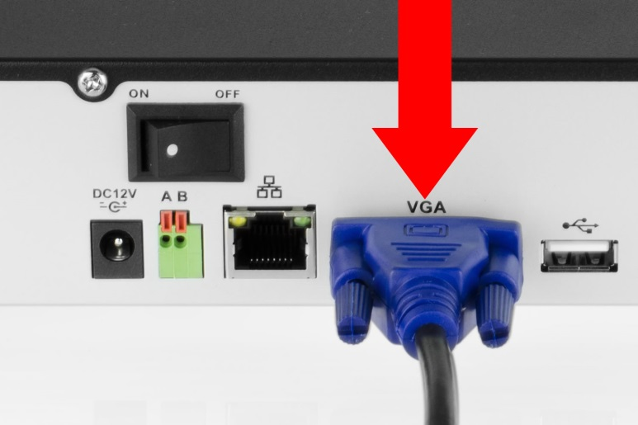
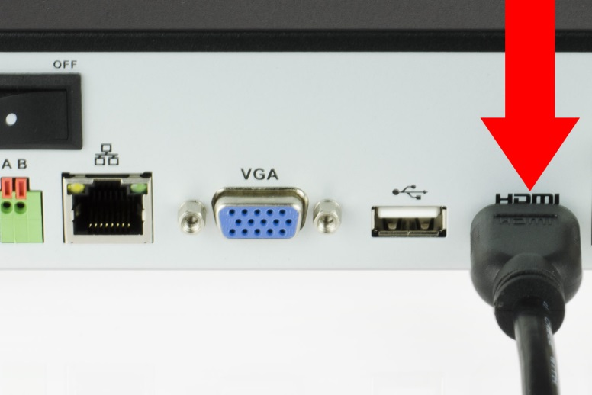
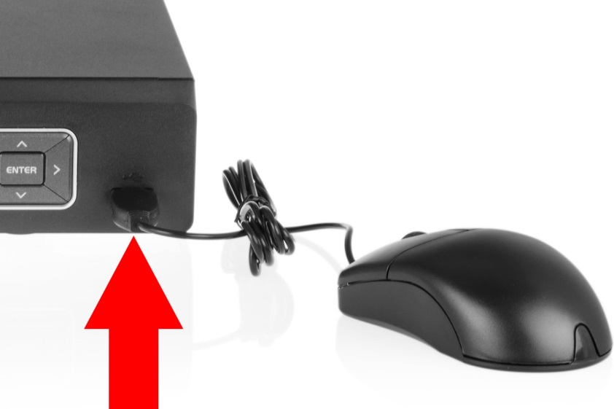
- Connect a USB mouse to the front of the DVR.

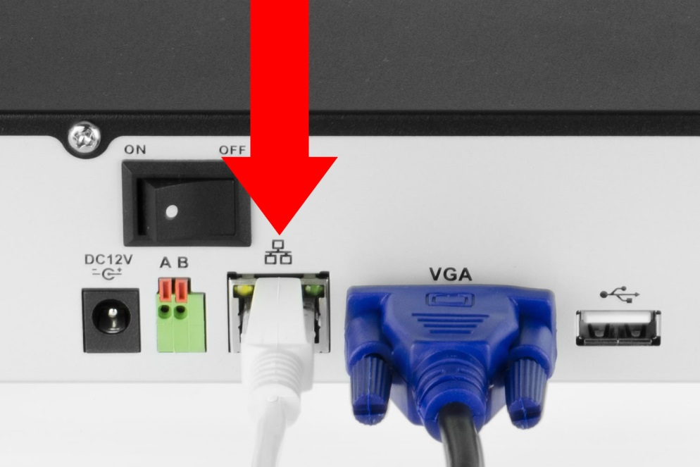
- Connect an Ethernet cable to your router, and then connect the other end of the cable to the DVR.

- Connect the camera video extension cable to the camera’s video cable and connect the camera power extension cable to the camera’s power cable. There should be a tag on the video cable to help you make sure the right end of the cable is at hand.
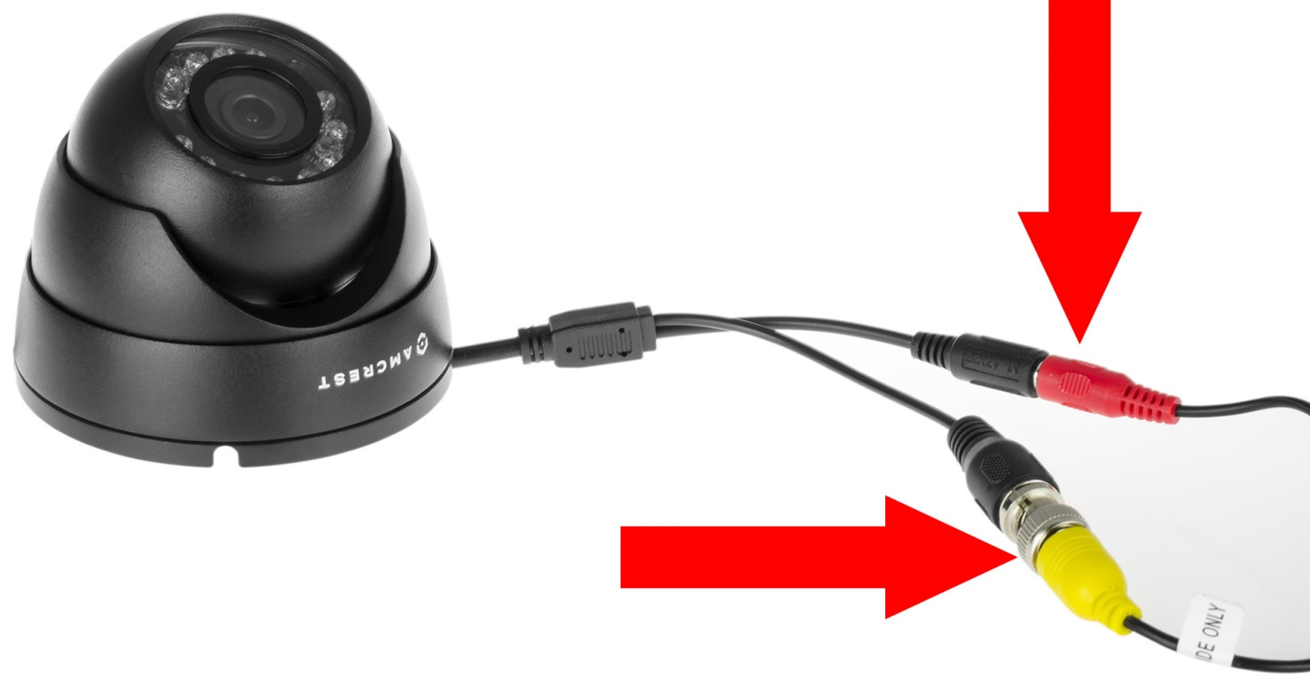
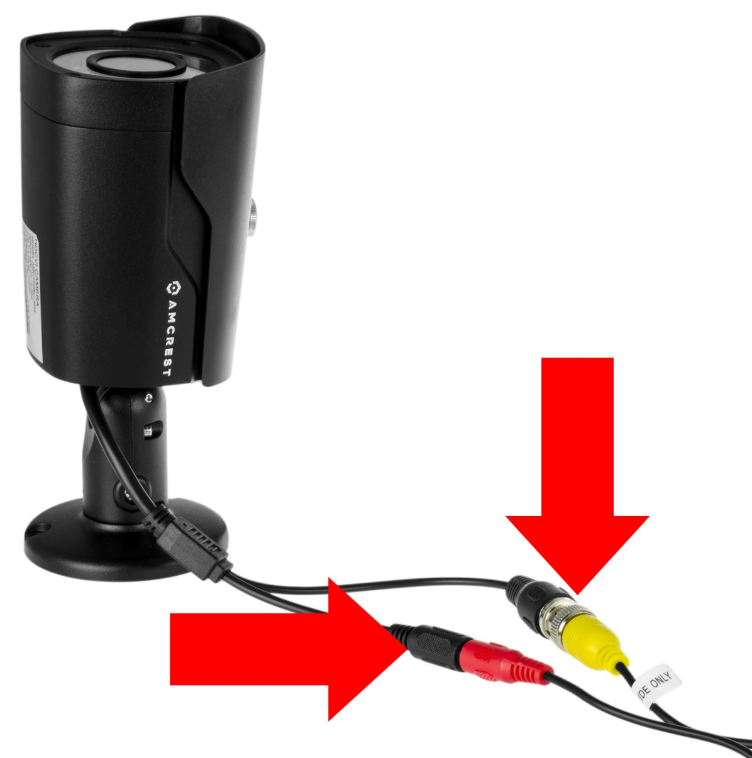
- Connect the camera cable to any of the video input ports.
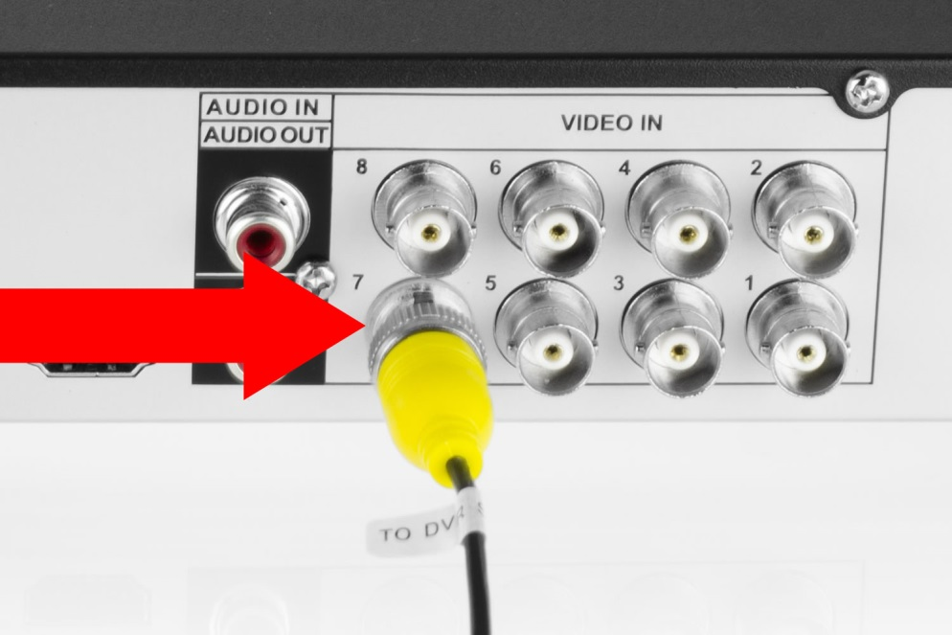
- Connect the camera power extension cable to one of the camera power cables, connect this power cable into the power brick, and then plug the cable into an electrical socket. 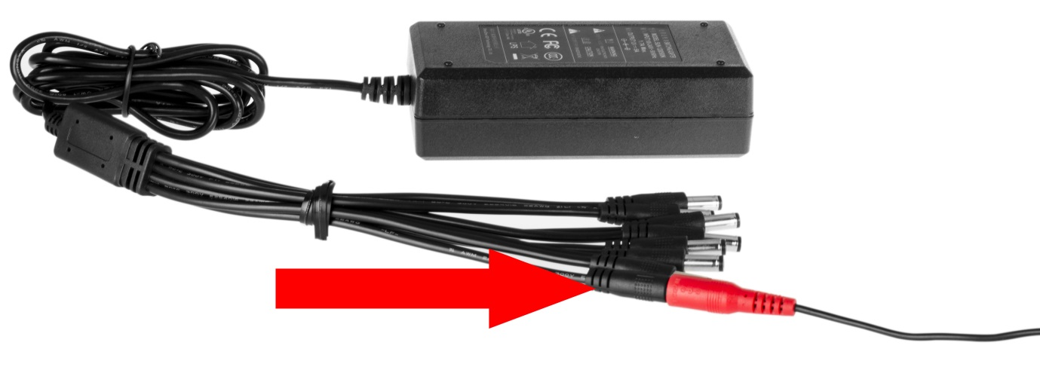
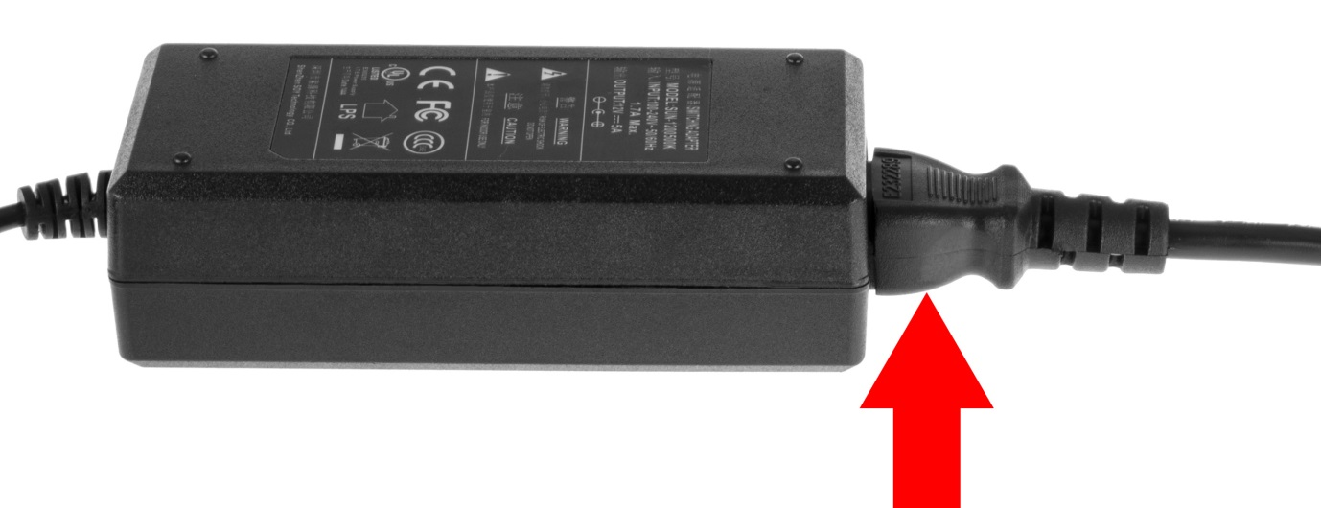
- Connect the DVR power cable into the back of the DVR, and then plug in the DVR power adapter into an electrical socket.
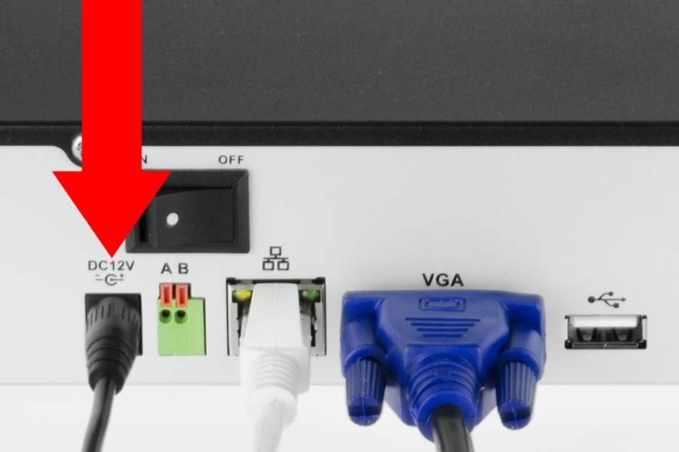

Overview of Navigation and Controls

4.1 Startup and Shutdown

4.1.1 Startup

Before initial startup, please make sure:
- The rated input voltage matches the output voltage at your location. Please make sure the power wire connection is secure before pressing the power on-off button.
- Always use a stable current. If necessary, an Uninterruptable Power Supply (UPS) is a good way to ensure power stability.

Please follow the steps listed below to boot up the device:
- Plug the power adapter into a wall outlet.
- Connect the power cable to the DVR
- Click the power switch on the DVR’s rear panel to supply power to the device.
- Wait a few seconds, and then push the power button on the front of the device to fully power it on.

4.1.2 Shutdown
Note:
- When you see the corresponding dialogue box “System is shutting down…” Do not click the power on-off button directly.
- Do not unplug the power cable or click the power on-off button to shutdown the device directly when device is running (especially when it is recording.)

There are three ways for you to log out.

- Main menu (RECOMMENDED)
From Main Menu->Shutdown, select shutdown.
Click the OK button and you can see device shuts down.
- From power on-off button on the front panel or remote control
Press the power on-off button on the DVR front panel or remote control for more than 3 seconds to shutdown the device.
- From power on-off button on the rear panel.

4.1.3 Auto Resume Feature

The HDCVI has an auto resume feature that allows the system to automatically backup video and resume previous working status after power failure.

4.1.4 Button Battery Replacement

The DVR has a button battery that’s used to ensure accurate system time. The battery is a CR2032 watch battery, and it is recommended that the batter is replaced once a year.

Note: Before replacement, please save the system setup, otherwise, you may lose data completely!

4.2 Startup Wizard

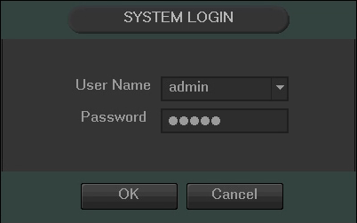
After turning the system on, the default video display shows multiple windows. To bring up the login screen, left click the mouse or hit enter on the keyboard. The login screen should look like this:

4.2.1 Default Account Usernames and Passwords

To login to the system for the first time, use one of the following default username/password combinations. Once you’ve successfully logged in, it is highly recommended to change your password for security reasons.

The system consists of two accounts that come standard with the DVR:
- Username: admin Password: admin (administrator, local and remote access)
- Username: default Password: default (hidden user)
Note:
- If three failed logins are attempted within a 30 minute time period, the system will set off an alarm. After five login failures, the account will be locked.
- These settings configured in the startup wizard can be changed at any time by accessing the settings menu. Information on each of these settings screens can be found in the Overview of Navigation and Controls -> Main Menu Interface section.
- If the password for the administrator account is misplaced, forgotten, or a user is locked out, contact Amcrest Support via one of the following options as a hard password reset may be needed:
  - Visit http://amcrest.com/contacts and use the email form
  - Call Amcrest Support using one of the following numbers
Toll Free: (888) 212-7538
International Callers (Outside of US): +1-713-893-8956
USA: 713-893-8956
Canada: 437-888-0177
UK: 203-769-2757
  - Email Amcrest Customer Support support@amcrest.com
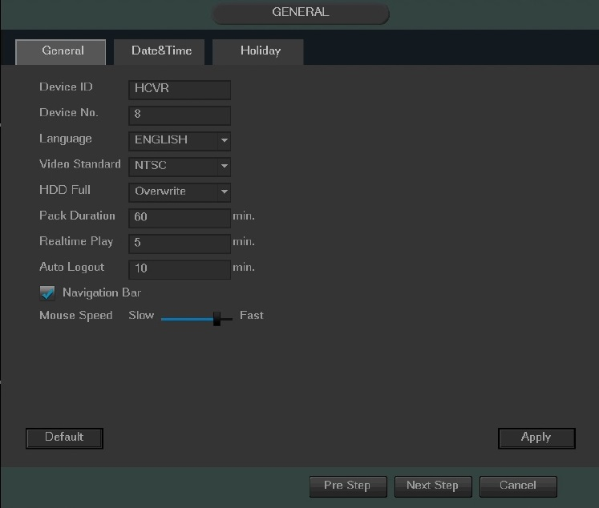
The next screen that comes up is the General Settings Screen. Make sure to click the tabs at the top for Date & Time, as well as Holiday to configure those settings as well. Once you are satisfied with the settings on this screen, click the “Next Step” button at the bottom of the screen.

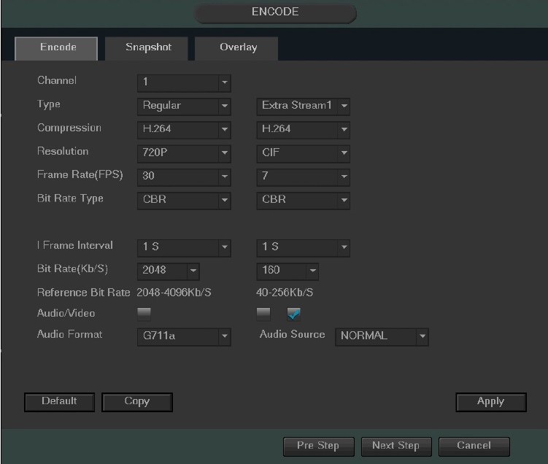
The next screen that comes up is the Encode settings screen. Make sure to click the tabs at the top for Snapshot and Overlay to configure those settings as well. Once you are satisfied with the settings on this screen, click the “Next Step” button at the bottom of the screen.
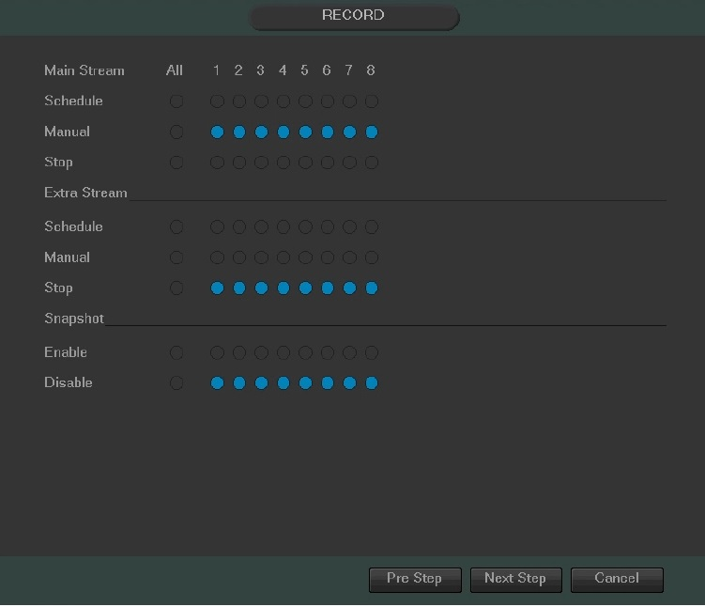
The next screen that comes up is the Record settings screen. Once you are satisfied with the settings on this screen, click the “Next Step” button at the bottom of the screen.

The next screen that comes up is the Schedule settings screen. Make sure to click the tabs at the top for Record and Snapshot to configure those settings as well. Once you are satisfied with the settings on this screen, click the “Next Step” button at the bottom of the screen.
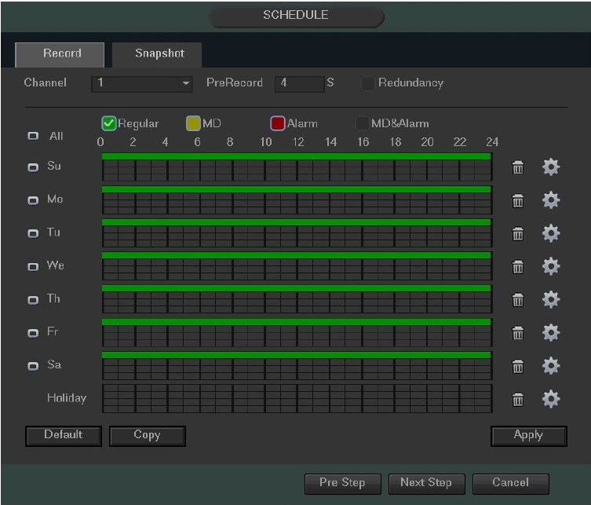

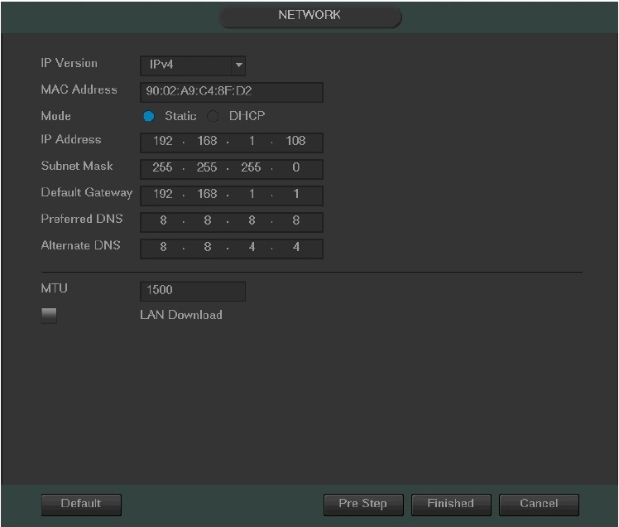
The final screen in the setup process is the Network settings screen. Once you are satisfied with the settings on this screen, click the “Finished” button at the bottom of the screen. Once more, note that these settings can be changed at any time by accessing the settings menu.

Once the setup process is finished and you have clicked the “Finished” button, you should see the below dialog box:

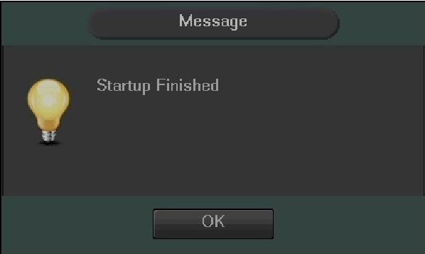

4.3 Live View

When you log in, the system will be in live view mode. You can see the system date, time, channel name and window number. If you want to change the system date and time, you can refer to the general settings (Main Menu->Setting->System->General). If you want to modify the channel name, please refer to the display settings (Main Menu->Camera->CAM name).
1 |  | Recording status | 3 |  | Video loss
2 |  | Motion detection | 4 |  | Camera lock

Tips:
- Preview drag: If you want to change the position of channel 1 and channel 2 when you are viewing, you can click and hold the left mouse button on the channel 1 window and then drag it to the channel 2 window, then release the left mouse button. This will switch channel 1 with channel 2’s position.
- Use the middle mouse button to control how the windows are split: You can use the middle mouse button to switch the window split amount.

Preview Control:
The preview control function has the following features.
- Supports preview playback.
  - In the preview desktop, the system can playback the previous 5-60 minutes of recorded video of the current channel. Please go to the Main Menu->General to set real-time playback time.
  - Supports drag and play function. You can use your mouse to select any playback start time.
  - Supports playback, pause, and exit functions.
  - Right now the system does not support slow playback or backwards playback functionality.
- Supports digital zoom function.
- Supports real-time backup function.
You can follow the contents listed below for operating instructions.

Preview Control Interface
Move your mouse near the center at the top of the video of the current channel. You will notice that the system pops up the preview control interface as shown below.
If your mouse stays in this area for more than 6 seconds without any action, the control bar will auto-hide.
1 2 3 4 5


- Mute
Click to mute. Click again to enable audio when in preview mode.
Please note that this function only works when viewing one window/channel.

- Digital zoom
This is used to zoom into a specified zone of the current channel.
Click the button, and the button will then show as .

There are two ways for you to zoom in.
- Click and drag the mouse to select a zone. You can see the interface shown below.
- Push the middle mouse button at the center of the zone you want to zoom into, and move the mouse. You can see the interface as shown below.

Right click the mouse to cancel zoom and go back to the original interface view.

- Manual record function
This is used to back up the current channel’s video to the USB device. The DVR cannot backup multiple channels of video at the same time.
Click the button begin recording. Clicking it again causes the system to stop recording. You can find recorded files on the flash drive.

- Real-time playback

This button is used to playback the previous 5-60 minutes recorded from the current channel.
Please go to the Main menu->Setting->->System->General screen to set real-time playback.
The system may pop up a dialog box if there are no recordings on the current channel.

- Manual Snapshot
Click  to take 1-5 snapshots at a time. The snapshot file is saved on the USB device or HDD. You can go to the Search interface to view these snapshots.

4.4 Right-Click Menu

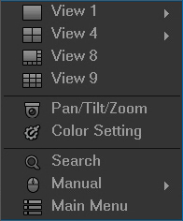
By right-clicking the mouse on the screen, the following menu opens up:

4.4.1 Video Viewing Options

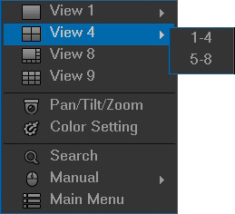
The DVR supports many different video viewing options of the live streamed channels. The desired view can be selected from the dropdown list as shown below:

4.4.2 Pan/Tilt/Zoom (PTZ) Control

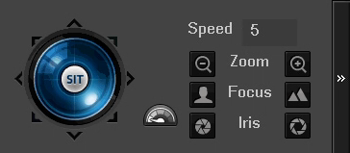
The PTZ control setup is shown below:

Note: The name of the command will be grayed out if the function is not supported.

Here you can control PTZ direction, speed, zoom, focus, iris, preset, tour, scan, pattern aux function, light, wiper, rotation, etc.
The speed field controls PTZ movement speed. The value ranges from 1 to 8. 8 is the fastest and 1 is the slowest. The remote control’s numeric keypad can be used to enter in a value.

To adjust values for Zoom, Focus, and Iris, click the buttons on either side of the function to adjust them. The following chart will provide guidance on how to use the buttons to adjust the PTZ functionality.

Name | Function  Button | function | Shortcut key | Function  Button | function | Shortcut  key
Zoom |  | Near |  |  | Far
Focus | 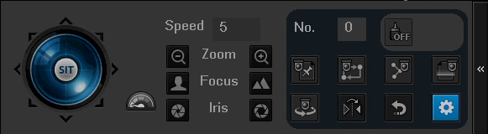 | Near | │ |  | Far | ►│
Iris |  | Close |  |  | Open

The PTZ control panel also supports the rotation of the camera in 8 different directions. If the buttons on the front panel of the DVR are used, then only four of the directions will be accessible (up/down/left/right).

In the middle of the eight directional arrows, there is a button to activate the 3D Intelligent Positioning function. To use the 3D Intelligent Positioning function, your PTZ enabled device should support this function, and a compatible USB mouse should be plugged into the DVR.

By clicking the  button and activating the 3D Intelligent Positioning, the system will go to single screen mode. Once activated, section size can be adjusted using the mouse. The zone selected supports 4x to 16x speeds and can use PTZ automatically to move the camera field. The smaller the designated zone, the higher the movement speed within the zone.

Additional functions within the PTZ control panel can be opened by clicking the button. See the chart below to see which additional functions are available.

Icon | Function | Icon | Function
 | Preset |  | Flip
 | Tour |  | Reset
 | Pattern |  | Settings
 | Scan |  | Aux on-off button
 | Rotate |  | Go to menu

Note: The name of the command will be grayed out if the function is not supported. See below for detailed information on each PTZ function.

To configure the functions above, click the Settings button.

4.4.2.1 Preset

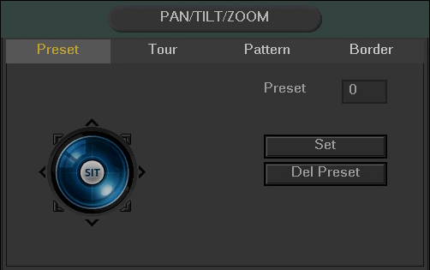
This function allows for the creation and editing of preset camera configurations.

To create and manage preset camera configurations, follow the steps below:
- Configure the camera positioning as needed.
- Click the Set button and then input the preset number.
- Click the Set button to save the current preset.
- Click Del Preset to delete the current preset.

4.4.2.2. Tour

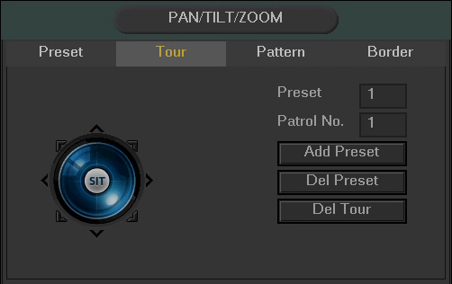
The tour function allows for the use of multiple presets stringed together.

To create and manage tours, follow the steps below:
- Ensure you have more than 1 preset configured already.
- Input the tour value, and the preset value.
- Click the Add Preset button to add another preset.
- Continue adding presets as needed.
- Click Del Preset to remove a preset from the tour.
- Click Del Tour to delete the entire tour.

4.4.2.3 Pattern

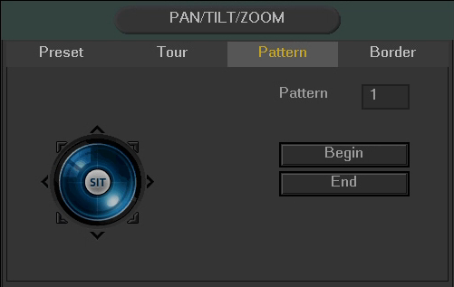
The pattern function allows for a custom tour to be created on the fly using the PTZ controls.
To create a pattern, click Begin, then use the PTZ controls to move the camera around. Once finished, click End to end and save the pattern. During the use of pattern mode, zoom/focus/iris cannot be modified.

4.4.2.4 Border

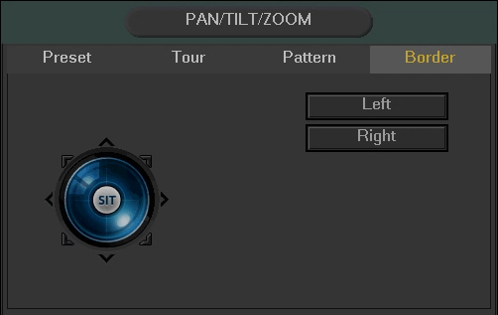
The border function allows for constraining the area of movement for the cameras during any PTZ function.

To set up borders, move the camera using the PTZ controls to the left limit, then click Left to designate that position as the left limit. Then move the camera to the right limit, and then click Right to designate that position as the right limit.

4.4.2.5 Rotate

The rotate button enables camera rotation.

4.4.2.6 Flip

The flip button flips the present camera configuration on a vertical axis.

4.4.2.7 Reset

The reset button restores the camera to its original configuration settings.

4.4.2.8 Aux On/Off
The camera may have an auxiliary function, and this feature enables its use. The aux number corresponds to the device’s slot on the PTZ decoder.
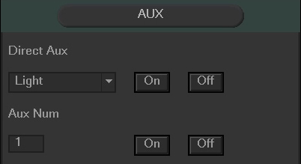

4.4.3 Color Settings
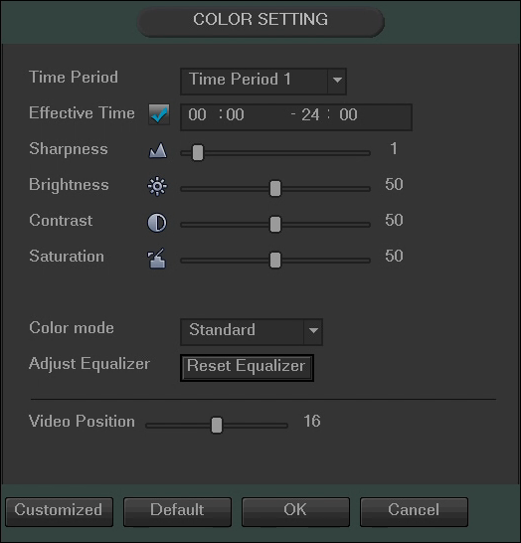
Using this screen, the color settings can be configured for the camera display.
The following chart shows which settings can be configured by Color Settings:
Item | Note
Period | There are two periods in one day. You can set different sharpness, brightness, and contrast setup for different periods.
Effective Time | Check the box here to enable this function and then set the period time.
Sharpness | The value here is used to adjust the sharpness of the video. The value ranges from 0 to 100. The larger the value is, the clearer the edges are and vice versa. Note: The higher the value, the higher likelihood of picture noise occurring. The default value is 50 and the recommended value ranges from 40 to 60.
Brightness | This is used to adjust monitor window brightness. The value ranges from 0 to 100. The default value is 50.  The larger the number, the brighter the video is. When you input the value here, the bright section and the dark section of the video will be adjusted accordingly. You can use this function when the whole video is too dark or too bright. Please note the video may become hazy if the value is too high. The recommended value ranges from 40 to 60.
Contrast | This is used to adjust monitor window contrast. The value ranges from 0 to 100. The default value is 50.  The larger the number, the higher the contrast is. You can use this function when the whole video brightness is OK but the contrast is not correct. Please note the video may become hazy if the value is too low. If this value is too high, the dark section may lack brightness while the bright section may over expose the picture. The recommended value ranges from 40 to 60.
Saturation | This is used to adjust monitor window saturation. The value ranges from 0 to 100. The default value is 50.  The larger the number, the strong the color is. This value has no effect on the general brightness of the whole video. The video color may become too strong if the value is too high. For the grey part of the video, the distortion may occur if the white balance is not accurate. Please note the video may not be clear if the value is too low. The recommended value ranges from 40 to 60.
Gain | The gain adjust is to set the gain value. The default value may vary due to different device models. The smaller the value, the lower the noise, but brightness is also affected and may be too low in dark environments. This setting can enhance the video brightness if the value is high, and it may cause the picture noise level to rise to high levels.
Color Mode | It includes several modes such as standard, color, bright, and gentle. Select a color mode, the sharpness, brightness, contrast, etc. and it will automatically switch to the corresponding setup.

4.4.4 Search

Please refer to section 4.8.1 for more detailed information.

4.4.5 Manual Recording

Please refer to section 4.10.5.3 for more detailed information.

4.5 Navigation Bar

To enable Navigation Bar functionality, go to Main Menu -> Settings -> System -> General and check the “Enable Navigation Bar” box.

The Navigation Bar looks like the picture below:

4.5.1 Main Menu

Click the 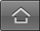 button to go to the main menu interface.

4.5.2 Video Viewing Options

These buttons allow the user to select a viewing mode for live viewing.

4.5.3 Favorites

Click the  button and the system displays the favorites drop down menu. Once the desired layout of cameras is achieved, click this button and select “Add to Favorites”. A window will appear for you to name the favorite. To remove a favorite, select “Trim Collection”.

4.5.4 Color Settings

Click the button and the system goes to the color interface. Please refer to chapter 4.4.3 for more detailed information on color settings.

4.5.5 Search

Click the button and the system goes to the search interface. Please refer to section 4.8.1 for more detailed information.

4.5.6 Alarm Status
Click the button and the system goes to the alarm status interface. It is used to view device status and channel status. Please refer to chapter 4.10.3 for more information.

4.5.7 USB Manager
Click the button and the system goes to the USB Manager interface. It is used to view USB information, backup, and update. Please refer to chapter 4.8.2 for more information.

4.5.8 HDD Manager
Click the button and the system goes to the HDD manager interface. It is used to view and manage HDD information. Please refer to chapter 4.10.5.2 for more information.

4.5.9 Network
Click the button and the system goes to the network interface. It is used to set the network IP address, default gateway and etc. Please refer to chapter 4.10.2 for more information.

4.5.10 PTZ

Click the button and the system goes to the PTZ control interface. Please refer to chapter 4.4.2 for more information.

4.5.11 Tour
Click the button to enable tour. The icon becomes and you can see the tour is in process.

4.5.12 Channel Info

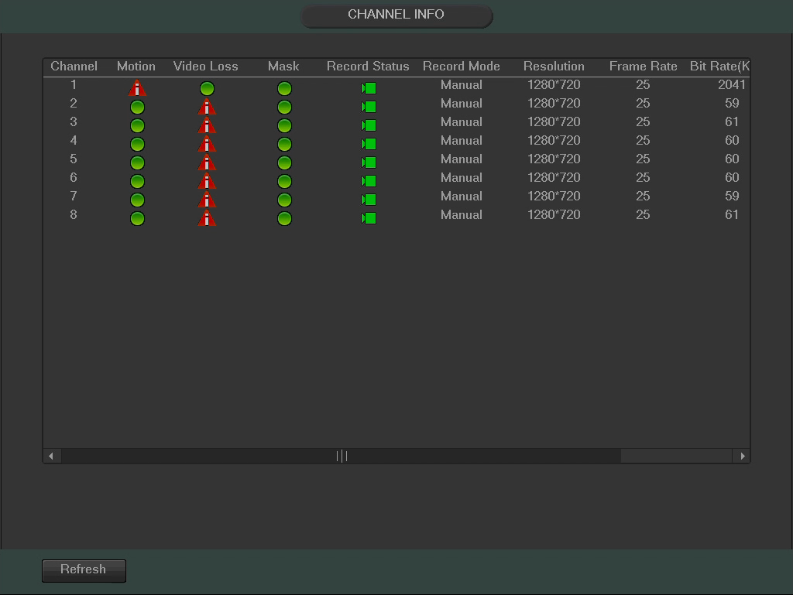
Click the button and the system goes to the channel information interface. It is used to view information about the corresponding channel. See the image below to view the Channel Information screen:

4.6 USB Device Auto Popup

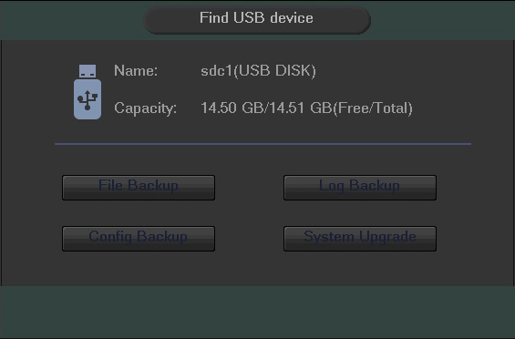
When you insert the USB device, the system will auto detect it and pop up the following dialogue box. It allows you to conveniently backup files, logs, configurations or update the system. See the image below for the USB Device Popup screen. (Please refer to chapter 4.8.2, chapter 4.9.4, chapter 4.10.6.7, and chapter 4.10.6.9 for detailed information.)

4.7 Main Menu
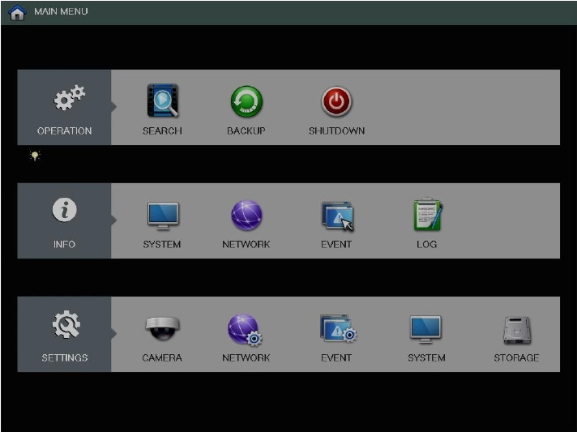

The Main Menu Interface is shown below:

Below are short descriptions for each of the menu items on the main menu:

Operation -> Search: Search and playback recorded video.
Operation - > Backup: Backup recorded files onto a CD or USB drive.
Operation - > Shutdown: Logout, shutdown, or restart the system.

Info -> System: View information about the recordings, hard drive statistics, or version information.
Info - > Network: View information about the network or test the network status
Info -> Event: Display information about events that triggered recording.
Info -> Log: Display system logs of critical events.

Settings -> Camera: Review or edit settings for each camera.
Settings -> Network: Review or edit network settings for the DVR.
Settings -> Event: Review or edit settings that trigger recording events.
Settings -> System: Review or edit system parameters or configuration.
Settings -> Storage: Review or edit storage parameters and settings.

For more detailed information on the Main Menu, refer to chapters 4.8, 4.9, and 4.10.

4.8 Main Menu: Operation

4.8.1 Search

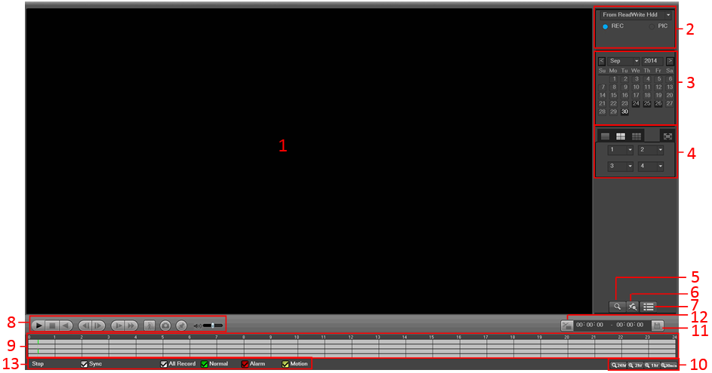
To access this screen, click the Search button in the Operation row of the Main Menu. The Search screen interface is shown below:

Please refer to the following table for more information:
SN | Name | Function
1 | Display window | - Here is where the searched picture or file will be displayed.  - Supports 1/4/8-window playback.
2 | Search type | - Here you can select to search the picture or the recorded file.  - You can select to play from the read-write HDD, from a peripheral device, or from a redundancy HDD.  - Before you select to play from the peripheral device, please connect the corresponding peripheral device. You can view all recorded files in the root directory of the peripheral device. Click the Browse button; you can select the file you want to play.  Important:  - Redundancy HDD does not support picture backup function, but it supports picture playback function. You can select to play from redundancy HDD if there are pictures on the redundancy HDD.
3 | Calendar | - The blue highlighted date means there is picture or file. Otherwise, there is no picture or file.  - In any playback mode, click the date you want to see, and you can see the corresponding recorded file tracers in the time bar.
4 | Playback mode and channel selection pane. | - Playback mode：1/4/9  - In 1-window playback mode: you can select 1-16 channels.  - In 4-window playback mode: you can select 4 channels according to your requirement.  - In 9-window playback mode: you can switch between 1-8 and 9-16 channels.  - The time bar will change once you modify the playback mode or the channel option.
5 | Card number search | The card number search interface is shown as below. Here you can view card number/field setup bar. You can implement an advanced search.
6 | Mark file list button | Click this button to go to mark file list interface. You can view all marked information in the current channel by time. Please refer to chapter 4.8.1.3 for detailed information on how to mark video for playback.
7 | Advanced Search | - Click this button and you can view the picture/recorded file list of the current day.  - The file list is used to display the first channel of the recorded file.  - The system can display a maximum of 128 files at one time. Use the │and │ or the mouse to view the file. Select one item, and then double click the mouse or click the ENTER button to playback.  - You can input the period in the following interface to begin a precise search.  - File type：R—regular record； A—external alarm record；M—Motion detect record.  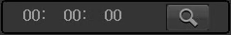  - Lock file: Click the file you want to lock and click the button 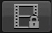 to lock. The file you locked will not be overwritten.  - Search Locked Files: Click the button 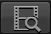 to view the locked file.  Please note:  - Any file that is currently writing or overwriting cannot be locked until it is no longer being accessed.
8 | Playback control pane | ►/ | Play/Pause  There are three ways for you to begin playback.  - The play button  - Double click the valid period of the time bar.  - Double click the item in the file list.  In slow play mode, click it to switch between play/pause.
8 | Playback control pane | ■ | Stop
8 | Playback control pane |  | Backward Play  In normal play mode, left click the button, the file begins backward play.  Click it again to pause current play.  In backward play mode, click ►/ to restore normal play.
8 | Playback control pane | │/│ | In the playback mode, click it to play the next or the previous section. You can click continuously when you are watching the files from the same channel.  In normal play mode, when you pause the video, you can click │ and │ to begin frame by frame playback.  In frame by frame playback mode, click ►/ to restore normal playback.
8 | Playback control pane | ► | Slow play  In playback mode, click it to use various slow play modes such as slow play 1, slow play 2, and etc.
8 | Playback control pane |  | Fast forward  In playback mode, click to play various fast play modes such as fast play 1, fast play 2, etc.
8 | Playback control pane |  | Smart search
8 | Playback control pane |  | The volume of the playback
8 | Playback control pane |  | Click the snapshot button in the full-screen mode. The system will take a snapshot.  The System supports a custom snapshot save path. Please connect a peripheral device first, click snap button on the full-screen mode, you can select or create path. Click the Start button, the snapshot picture will be saved to the specified path.
8 | Playback control pane |  | Mark button.  Allows for the marking of a file for later ease of access.  You can refer to chapter 4.8.1.3 for detailed information.
9 | Time bar | - This is used to display the record type and its period in the current search criteria.  - In 4-window playback mode, there are four corresponding time bars. In other playback modes, there is only one time bar.  - Use the mouse to click one point of the color zone in the time bar and the system will begin playback.  - The time bar begins with 00:00 when you are setting the configuration. The time bar zooms in on the period of the current playback time when you are playing the file.  - The green color stands for regular record files. The red color stands for external alarm record files. The yellow stands for motion detect record files.
10 | Time bar zooming | - The option includes: 24H, 12H, 1H and 30M. The smaller the unit, the larger the zoom rate. You can accurately set the time in the time bar to playback the recording.  - The time bar begins at 0 o'clock when you are setting the configuration. The time bar zooms in on the period of the current playback time when you are playing the file.
11 | Backup | - Select the file(s) you want to backup from the file list. You can mark from the list then click the backup button. Now you can see the backup menu. System supports a customized path setup. After selecting or creating new folder, click the Start button to begin the backup operation. The recorded file(s) will be saved in the specified folder.  - Check the file again and you can cancel current selection. System supports maximum of 32 files from one channel displayed.  - After you click on the recorded file, click the Backup button and you can save it.  - For one device, if there is a backup in process, you cannot start a new backup operation.
12 | Clip | - This is used to edit the file and specify which parts of a file to save.  - Please play the file you want to edit and then click this button when you want to edit. You can see the corresponding slide bars in the time bar of the corresponding channel. You can adjust the slide bar or input the accurate time to set the file end time.  - After the clip end time is set, you can click the Clip button again to edit the second period. You can see the slide bar restore its previous position.  - Click the Backup button after clip to save current content in a new file.  - You can clip one channel or multiple-channels. The multiple-channel clip operation is similar to the one-channel operation.  Please note:  - System supports maximum of 1024 file backups at the same time.  - You cannot operate the clip operation if there are any files that have been checked in the file list.
13 | Record type | In any play mode, the time bar will change once you modify the search type.
Other Functions
14 | Smart search | - When system is playing, you can select a zone in the window to begin smart search. Click the motion detect button to begin play.  - Once the motion detect file play has started, clicking the button again will terminate current motion detect file play.  - There is no motion detection zone by default.  - If you select to play another file in the file list, the system switches to motion detection playback for the other file.  - During the motion detect play process, you cannot implement operations such as change time bar or frame by frame playback.  - Please refer to chapter 4.8.1.1 Smart Search for detailed operation.
15 | Other channel synchronization switch to play when playback | When playing the file, click the number button. The system will switch to the same time period of the corresponding channel to play.
16 | Digital zoom | When the system is in full-screen playback mode, left click the mouse on the screen. Drag your mouse to select a section and then left click the mouse to activate digital zoom. You can right click the mouse to exit.
17 | Manually switch channel when playback | During the file playback process, you can switch to another channel via the dropdown list or scrolling the mouse.  This function is null if there is no recorded file or system is in the smart search mode.

4.8.1.1 Smart Search

The Smart Search feature enables searching for motion within the recorded file for a specific channel. This feature is useful, as it allows users to search a channel’s recorded files for motion without having to change the recording type to a motion detection recording.
During the multiple-channel playback mode, double click one channel and then click the button and the system begins smart search. The system supports 396(22*18 PAL) and 330(22*15 NTSC) zones. Please left click mouse to select smart search zones. See the image below:
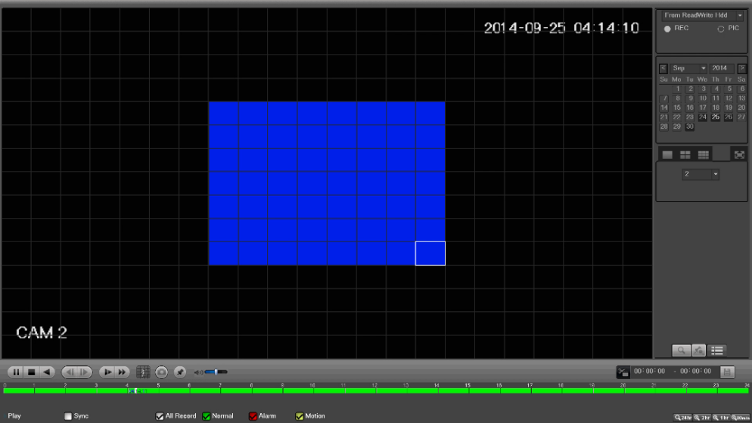

Click the and you can go to the smart search playback. Click it again and the system stops smart search playback.

Important:
- The system does not support motion detection zone setup while in full-screen mode.
- During the multiple-channel playback, the system stops playback for the rest of the channels if one-channel smart search is used.

4.8.1.2 Precise Playback by Time

This feature allows for searching through recordings by time stamp.

Select recordings from one day, click advanced search, and go to the file list interface. The user can input the time at the top right corner to search recordings by time. See image on the left side of the images below.
For example, inputting the time 11:00.00 and then clicking the Search button allows for viewing all of the recorded files after 11:00.00 (The recordings include current times). Double click a file name to playback.
Note
- After searching files, system implements accurate playback for the first time Play is clicked.
- System does not support precise playback for screenshots.
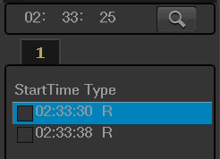
- System supports synchronized playback and non-synchronized playback. The synchronized playback supports all channels and non-synchronized playback only supports precise playback of the currently selected channel.

4.8.1.3 Marked Playback

When playing back a recorded file, you can mark the record when there is important information. After playback, you can use time or the mark button to search a corresponding record and then play it. This feature allows for easy playback of key events within a recording.

- Add Mark
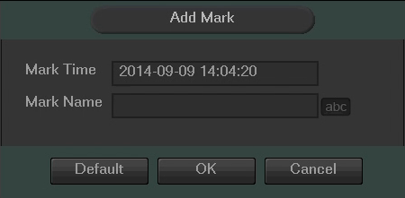
When a file is being played, click the Mark button, and the following interface will appear:
- Playback Mark
While in 1-window playback mode, click mark file list button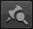 to go to the marked file list interface. Double click one mark file and you can begin playback from the marked time.
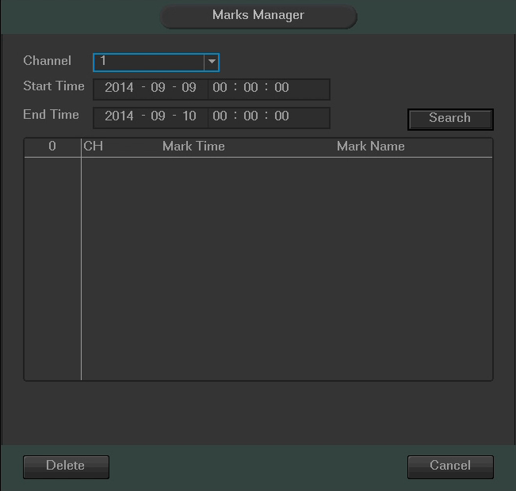
- Marks Manager
Click the mark manager button on the Search interface; you will go to the Marks Manager interface. The system can manage all the recorded mark information of the current channel by default. You can view all marked information in the current channel by time.

- Modify
Double click one marked information item. The system pops up a dialogue box that allows for editing of the marked information. The marked information’s name can be changed from this dialog box.

- Delete
By selecting the marked item and clicking the delete button, the marked item can be removed.
Note:
- After you go to the mark management interface, the system needs to pause the current playback. System resumes playback after you exit the mark management interface.
- If the mark file you want to playback has been removed, system will begin playback from the first file in the list.

4.8.2 Backup

The DVR supports backup of recorded files to CD-RWs, DVDs, USB devices, eSATA devices, and through network download. In this section, USB and eSATA backup will be discussed. Network download backup options are discussed in Chapter 5 of this user manual.

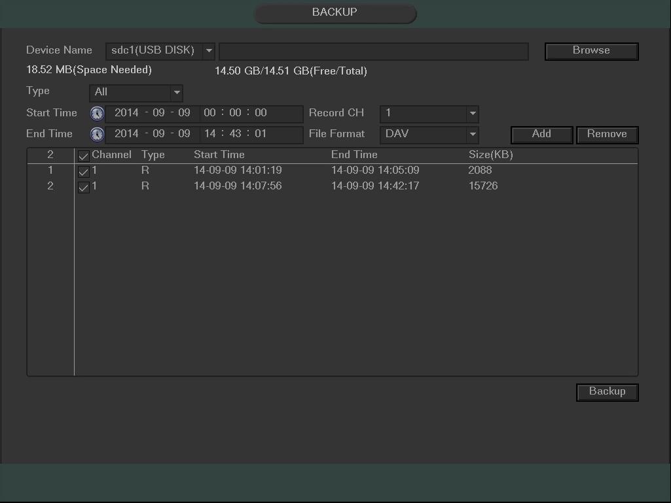
Clicking the backup button from the Main Menu opens the Backup screen. On this screen, all available backup devices are shown with their name, total space, and free space. This list can include CD-RW burners, DVD burners, USB devices, and eSATA devices.
To backup recorded files, select the backup device, the channel, file start time, the end time, then click the add button so the system can begin a search for the selected files. Once the files are found, they are listed and can be selected for backup.

The system automatically calculates the capacity needed and the capacity remaining on each backup device.

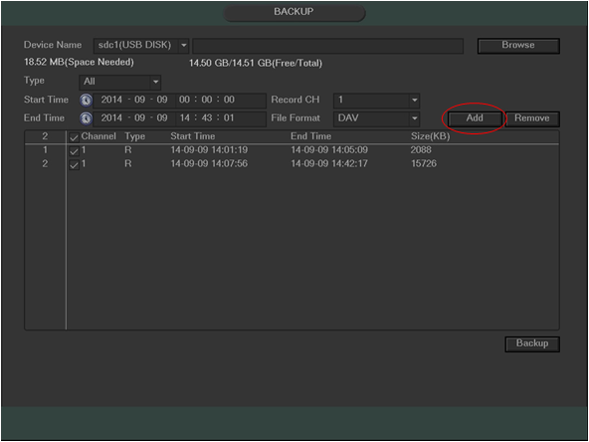
Select the desired backup file format by clicking the dropdown box next to the file format field, and then select the files for backup by clicking the checkboxes next to each line item. Once the items have been selected, click the Add button to add them to the backup queue.

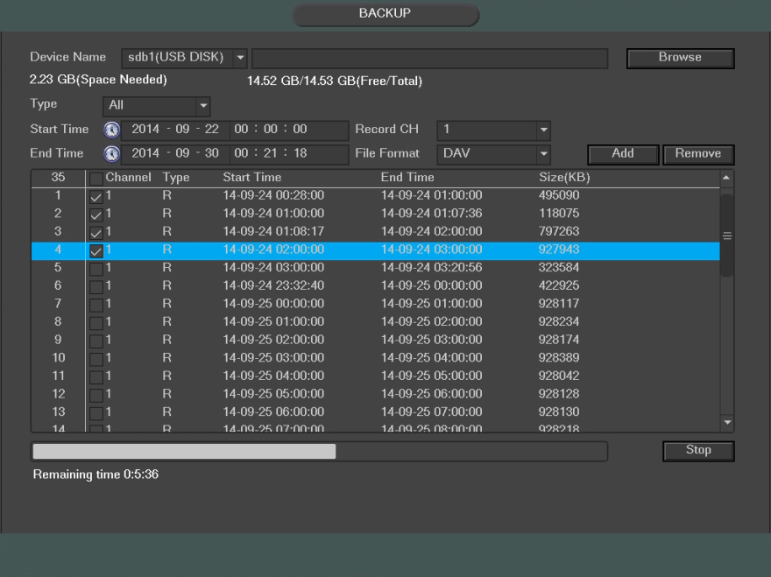
To start the backup, click the backup button on the bottom right of the screen. Once the backup button is clicked, the backup will begin, and the backup button turns into a stop button that allows for the cancellation of the backup. The remaining time and progress bar will show on the bottom of the screen.

When the system completes the backup, a dialogue box appears informing the user about a successful backup.
Note:
- There are two file format options: DAV/ASF
- The file name format is usually: Channel number+Record type+Time.
- In the file name, the YDM format is Y+M+D+H+M+S. File extension name is .dav or .asf
- When you click the stop button during the burning process, the stop function is activated immediately. For example, if there are ten files, when you click stop after the system has just backed up five files, system only saves the previous 5 files in the device (but you can view ten file names).

Tip:
- During the backup process, the user can click ESC to exit the current interface to use the DVR for other functions. The system will not terminate the backup process.

4.8.3 Shutdown

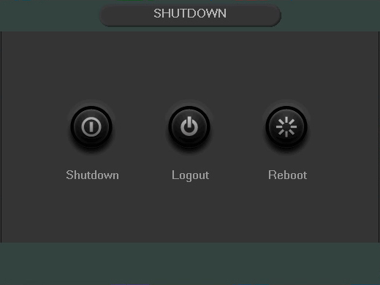
From the Main Menu, clicking the Shutdown button will result in the appearance of a box with three options:

The Shutdown option turns off the DVR.
The Logout option logs off the current user, and shows the login screen so another user may login.
The Reboot option reboots the DVR.

Note: If the proper authorized user is not logged in, they will be prompted to enter the administrator password to shutdown the DVR.

4.9 Main Menu: Information

4.9.1 System Information

From this screen, system information can be viewed. There are a total of 4 screens that each display different aspects of the system.

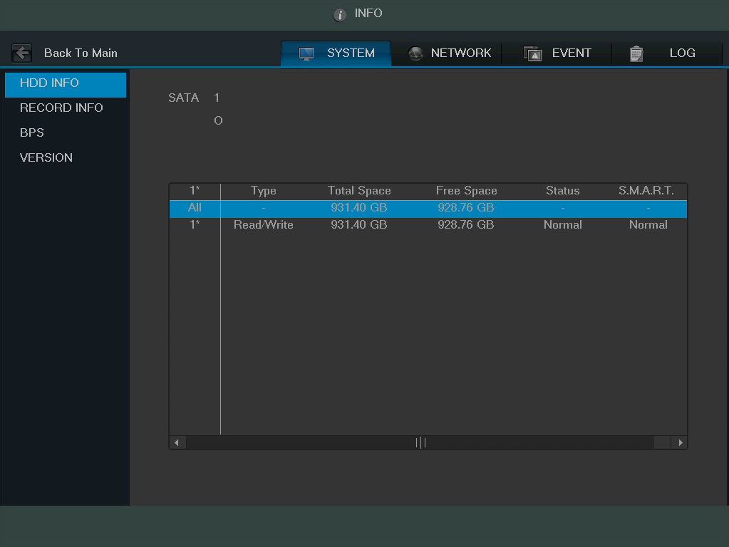
4.9.1.1. HDD Information

- SATA:
  - This shows how many hard drives the system can support.
  - 1 here means the system supports a maximum of 1 HDD.
  - The symbol on the next row shows the status of the connected hard drive.
    - 0 means that the current HDD is functioning normally.
    - X means there is an error with the hard drive connection, or that there is no connected hard drive.
    - ? means that the hard drive is damaged and should be replaced.
- Type: This field shows the read/write properties of the connected hard drive.
- Total space: This field shows the total capacity of the connected hard drive.
- Free space: This field shows the remaining free space on the connected hard drive.
- Status: This field shows whether the connected hard drive is working properly or not.
- SMART: This field displays SMART status for the connected hard drive.
  - To access SMART information for the connected hard drive, double click the hard drive line item.
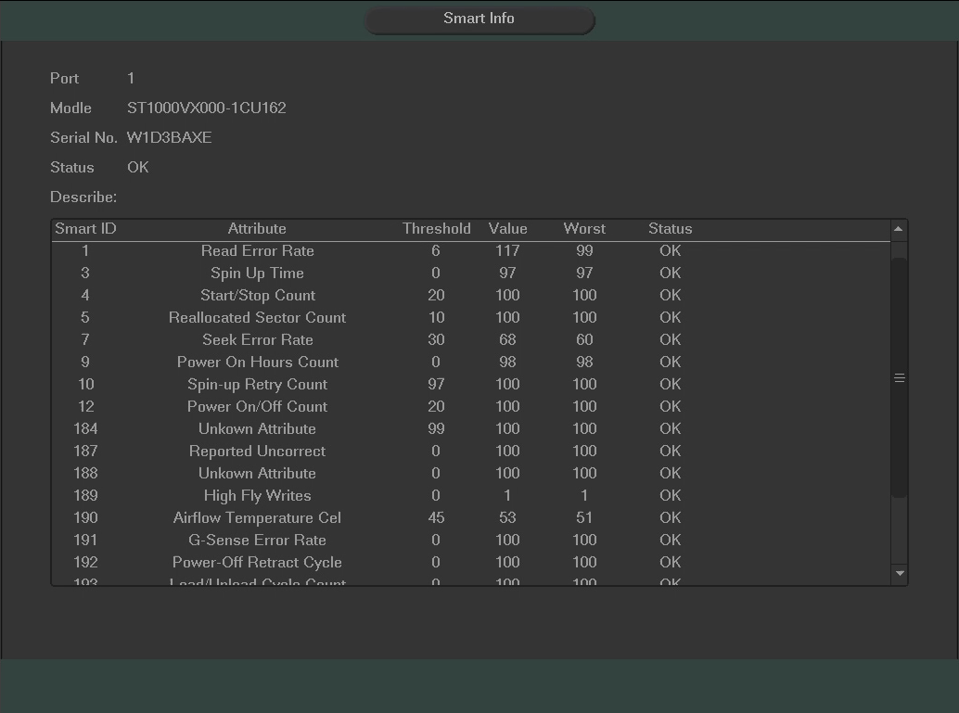
The image below shows the SMART information for the hard drive selected.

4.9.1.2 Record Info

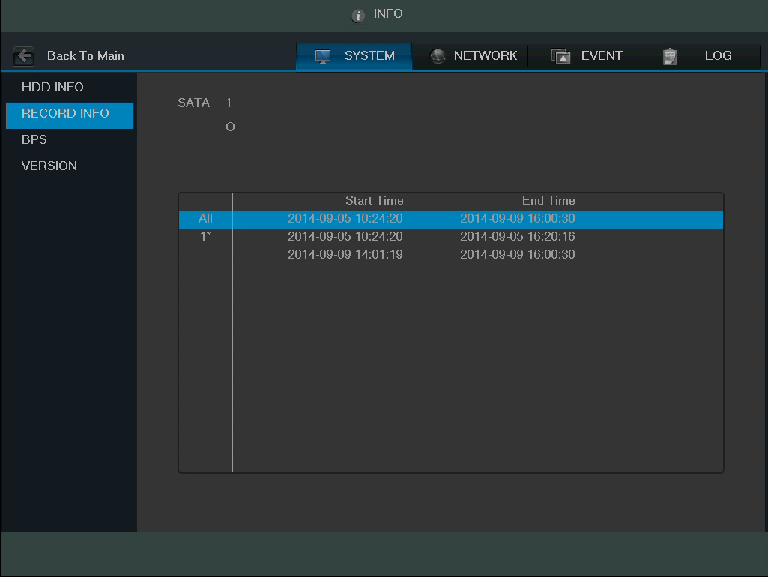
This screen is used to view information on recorded video, specifically recording start time and end time for all media based on each hard drive.

4.9.1.3 BPS

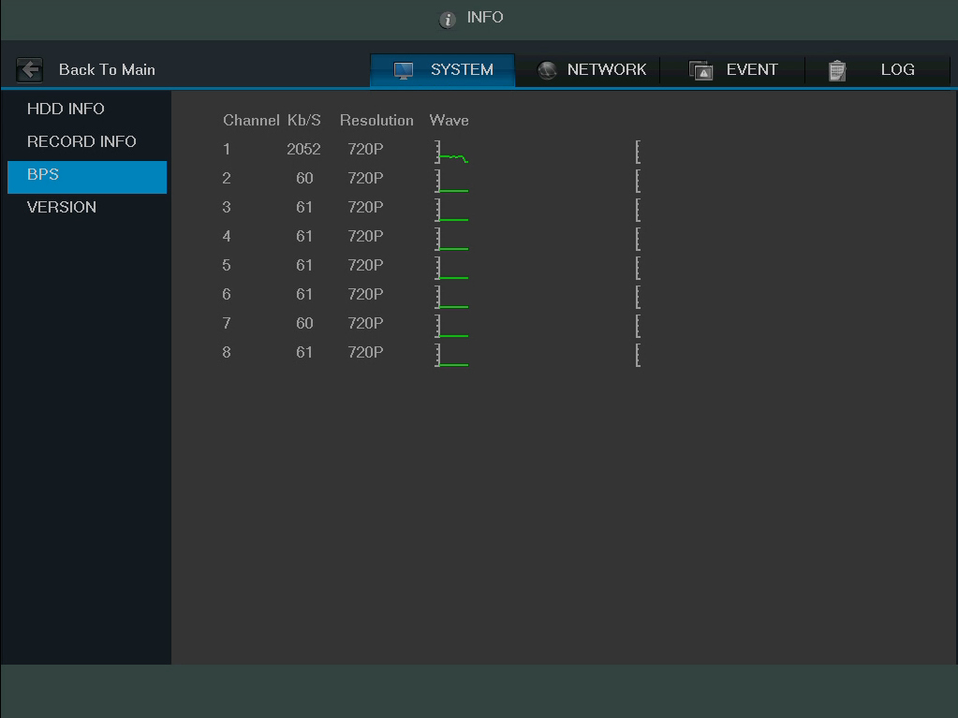
On this screen, current video data stream information can be viewed, as well as resolution used for each camera. All data is measured in Kilobytes per Second (KB/s).

4.9.1.4 Version
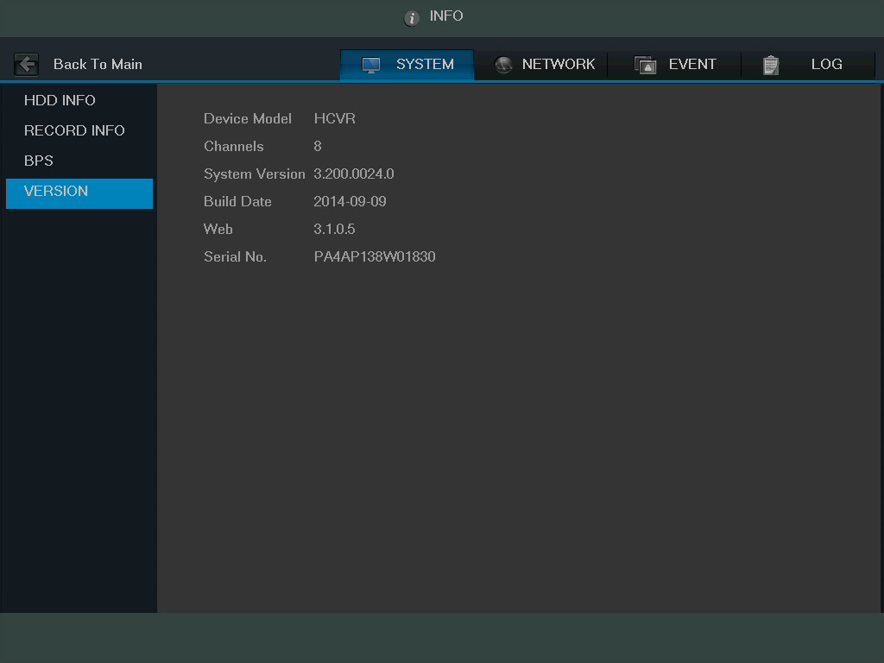
This screen shows version information for the DVR. Here information such as device model, channels, system version, build date, web interface version, and serial number can be found.

4.9.2 Event

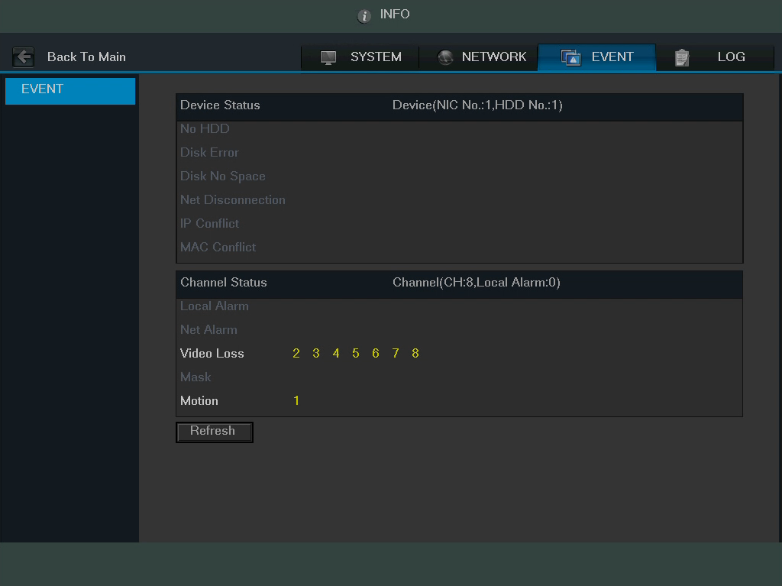
This screen is used to display device and channel status.

4.9.3. Network

This screen is used to display network information. It consists of 3 screens, Online Users, Load, and Test.

4.9.3.1 Online Users
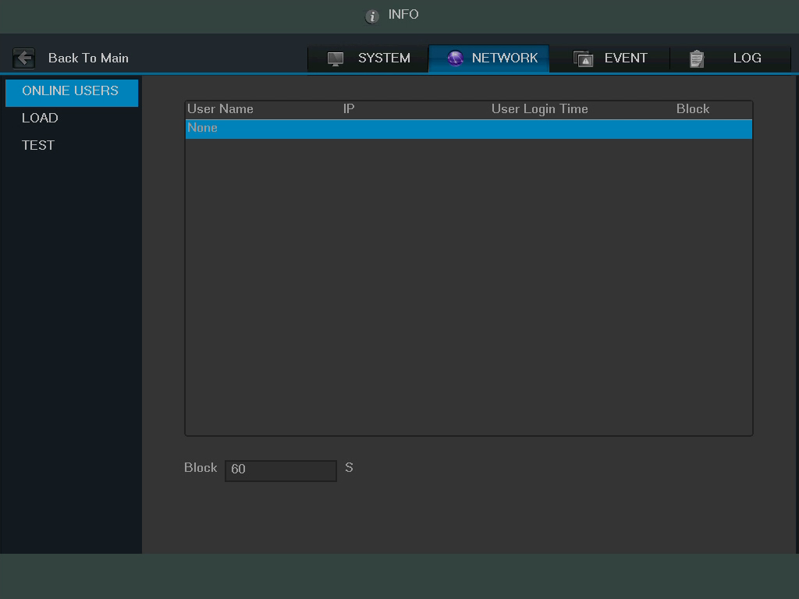
This screen is used to monitor and manage users who are online. With the proper system access level, users can be disconnected or blocked. The system refreshes this list automatically every five seconds.

4.9.3.2 Network Load

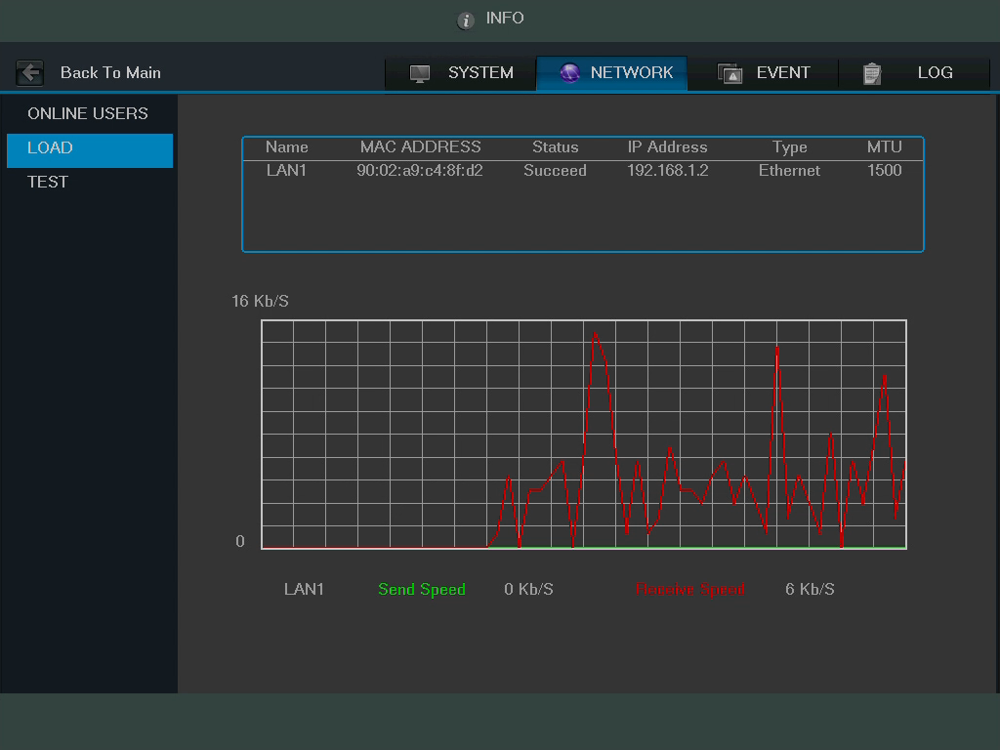
This screen shows the amount of bandwidth consumed on the network by the DVR. The connection status is shown as offline if the DVR is disconnected from the internet. The bottom panel is a graph that shows the fluctuation in the send and receive speed.

4.9.3.3 Network Test

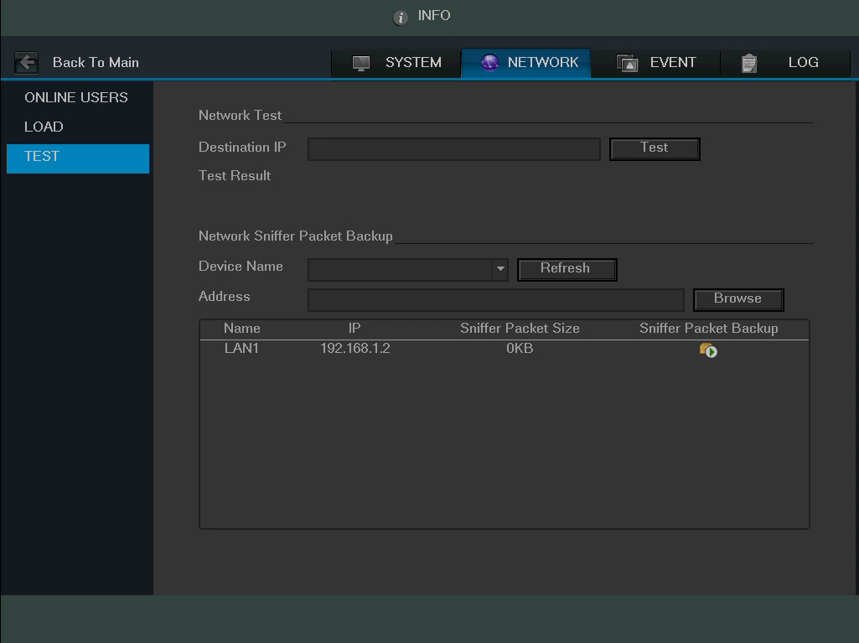
This screen is used to test the network connection for the DVR. It can send data to a specific IP in order to see if it can transmit data to it.
Below is an explanation of each of the fields:
- Destination IP: Input a valid IPV4 address or domain name to test connection with.
- Test: This button is clicked to test the connection with the destination IP address. The test results can display average delay and packet loss rate, and network status can be viewed.
  - OK means that the connection works, bad means the connection is spotty, and no connection means that no connection was made.
- Network Sniffer Backup: To use the network sniffer feature, insert a USB2.0 network sniffer device and click the Refresh button. You can view the device on the following column. You can use the dropdown list to select the peripheral device. Click the Browse button to select the path.

You can view all connected network adapter names (including Ethernet, PPPoE, and WIFI). You can click the button on the right panel to begin the Sniffer. Click the grey stop button to stop. Please note the system cannot sniff several network adapters at the same time.

After the Sniffer begins, you can exit to implement corresponding network operation such as web monitor login. Please go back to Sniffer interface and click to stop the Sniffer. The system can save the packets to the specified path. The file is named after “Network adapter name+time”. You can use software such as Wireshark to open the packets on the PC for a professional engineer to solve advanced network problems.

Tip:
- During the network sniffer process, the user can click ESC to exit the current interface to use the DVR for other functions. The system will not terminate the backup process.

4.9.4 Log

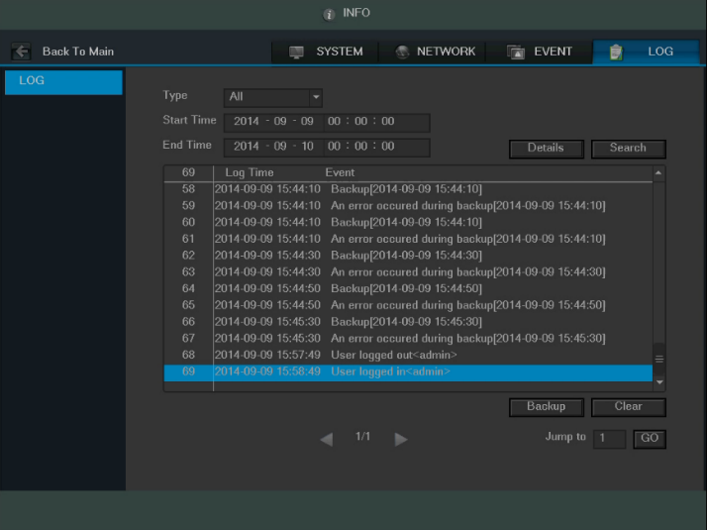
On this screen, you can view the system log file.
The system lists the following information:

- System Operation
- Configuration Operation
- Data Management
- Alarm Events
- Record Operation
- Account Manager
- Log Clear
- File Operation
- Reboot Type
Note:
- The system can only show a maximum of 100 logs on one page.
- The system can save a maximum of 1024 log files.
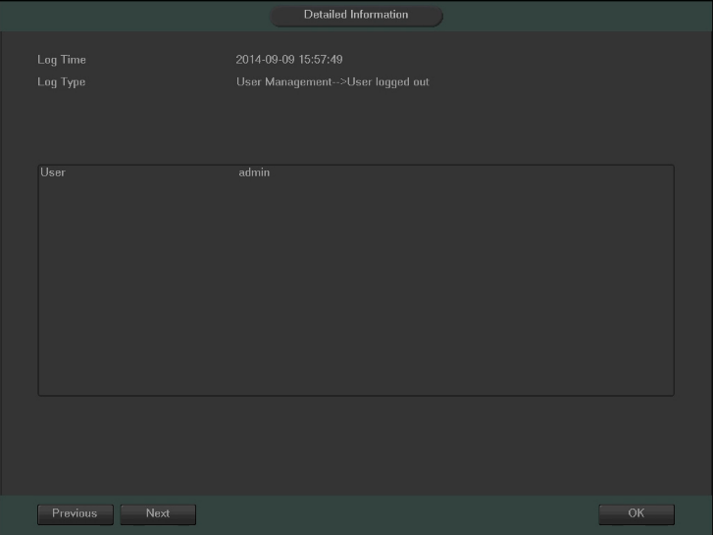
Using the fields at the top of the page, the user can search for log items, and view details for each one. Start Time and End Time allow the user to narrow the range in which a log item resides, and the Type dropdown box allows for filtering on what type of event the user is looking for. Once the parameters are set, click Search in order to show log items that match the criteria. Clicking on a line item then clicking the Details button (or double clicking the line item) shows the detail screen:
The backup button allows a user to backup log files. Once the backup button is clicked, the system will prompt the user to select a folder to save the log data to.

4.10 Main Menu: Settings

This set of menu items allows the user to change settings for a variety of functions.

4.10.1 Camera

4.10.1.1 Image Settings
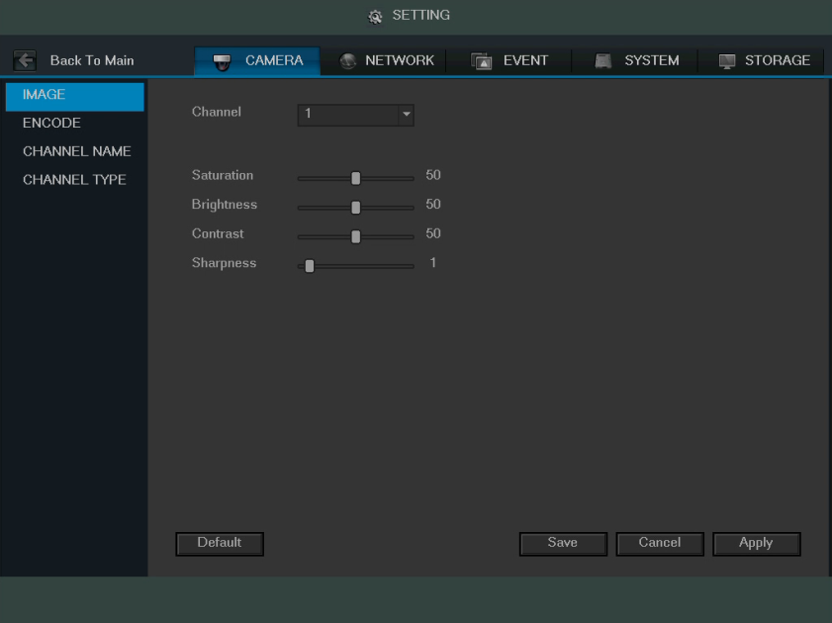
This screen is allows the user to adjust the image settings for each channel. See below for a screenshot of the image settings screen:
Below is an explanation for each of the fields on the Image Settings screen:
- Channel: This dropdown box allows the user to select a channel from the dropdown list to modify.
- Period: This dropdown box allows the user to select a period of time for which to modify the image settings. The user can configure up to 2 periods to encompass the entire 24 hours in the day. Click the checkbox to enable the period image settings changes.
- Saturation: This slider is used to adjust monitor window saturation. The value ranges from 0 to 100. The default value is 50. The larger the number, the strong the color is. This value has no effect on the general brightness of the whole video. The video color may become too strong if the value is too high. For the grey part of the video, the distortion may occur if the white balance is not accurate. Please note the video may not be clear if the value is too low. The recommended value ranges from 40 to 60.
- Brightness: This slider is used to adjust monitor window brightness. The value ranges from 0 to 100. The default value is 50. The larger the number, the brighter the video is. When you input the value here, the bright section and the dark section of the video will be adjusted accordingly. You can use this function when the whole video is too dark or too bright. Please note the video may become hazy if the value is too high. The recommended value ranges from 40 to 60.
- Contrast: This slider is used to adjust monitor window contrast. The value ranges from 0 to 100. The default value is 50. The larger the number is, the higher the contrast is. You can use this function when the whole video brightness is OK but the contrast is not correct. Please note the video may become hazy if the value is too low. If this value is too high, the dark section may lack brightness while the bright section may over expose. The recommended value ranges from 40 to 60.
- Sharpness: This slider is used to adjust the sharpness of the video. The value ranges from 0 to 100. The larger the value is, the clearer the edges are and vice versa. Note: The higher the value, the higher likelihood of picture noise occurring. The default value is 50 and the recommended value ranges from 40 to 60.

To revert to default settings, click the Default button near the bottom left hand corner. To confirm settings, click the Save button near the bottom right hand corner. To cancel any modifications, click the Cancel button near the bottom right hand corner. To apply the settings, click the Apply button near the bottom right hand corner. After completing the setup please click the save button to go back to the previous menu.

4.10.1.2 Encode

4.10.1.2.1 Encode

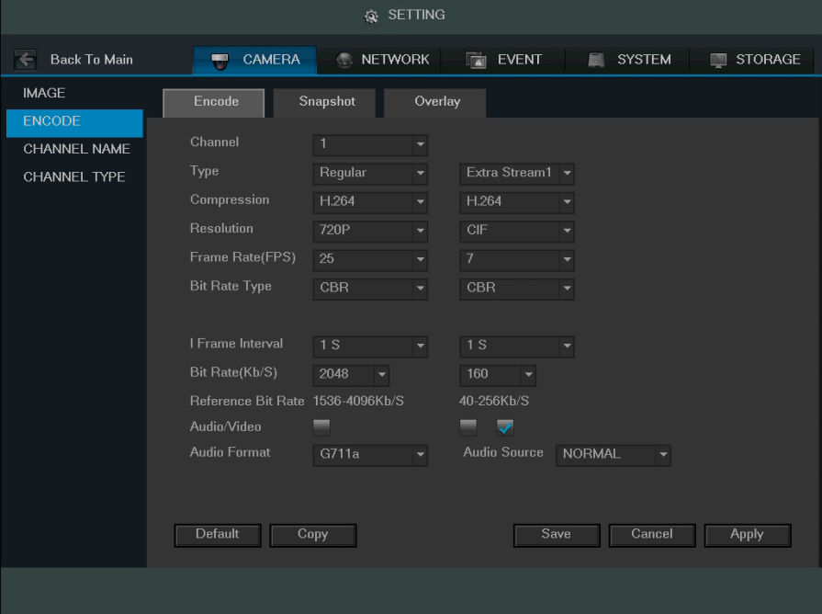
This tab is used to set the video encoding settings for each channel. See below for a screenshot of the tab:

Below is an explanation of the fields on the Encode settings screen:

- Channel: This dropdown box allows the user to select a channel from the dropdown list to modify.
- Type: This dropdown box allows the user to select one of 3 channel types: regular, motion detect, and alarm. Various encode parameters can be for different record types.
- Compression: This dropdown box allows the user to select a compression protocol. The system supports H.264 and MJPEG video compression protocols.
- Resolution: This dropdown box allows the user to set the resolution. The system supports various resolutions and they can be selected from this dropdown list.
- Frame Rate: This dropdown box allows the user to select a frame rate. Frame rate settings range from 1f/s to 25f/s in NTSC mode and 1f/s to 30f/s in PAL mode.
- Bit Rate Type: This dropdown box allows the user to select a bit rate type. The system supports two bit rate types: CBR and VBR. In VBR mode, video quality can be set.
- Video/Audio: This checkbox allows the user to enable or disable Video/Audio. Audio formal can be selected as well.

To revert to default settings, click the Default button near the bottom left hand corner. To copy settings to another channel, click the Copy button near the bottom right hand corner. To confirm settings, click the Save button near the bottom right hand corner. To cancel any modifications, click the Cancel button near the bottom right hand corner. To apply the settings, click the Apply button near the bottom right hand corner. After completing the setup please click the save button to go back to the previous menu.

4.10.1.2.2 Snapshot

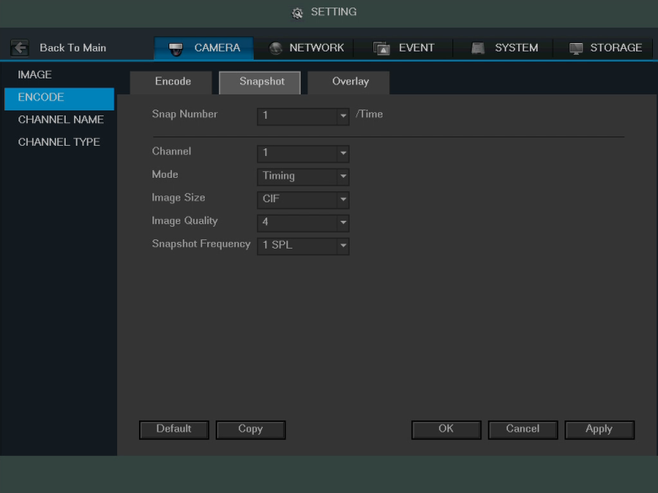
This tab allows for the selection of snapshot settings. See below for a screenshot of the Snapshot tab:

Below is a list of snapshot settings that can be modified on this screen:

- Snapshot Mode: This dropdown box allows the user to select a snapshot mode. There are two snapshot modes: regular and trigger.
  - Regular: Based on timing and happens at a set interval.
  - Trigger: Based on motion detection or alarm activation.
- Image Size: This dropdown box allows the user to select an image size.
  - There are 4 settings: D1, HD1, 2CIF, and CIF.
- Image Quality: This dropdown box allows the user to select image quality. Quality is adjusted on a scale of 1-10.
- Snapshot Frequency: This dropdown allows the user to select the snapshot interval. The value ranges from 1 to 7 seconds. The maximum setting for a customized interval is 3600s/picture.

To revert to default settings, click the Default button near the bottom left hand corner. To copy settings to another channel, click the Copy button near the bottom right hand corner. To confirm settings, click the Save button near the bottom right hand corner. To cancel any modifications, click the Cancel button near the bottom right hand corner. To apply the settings, click the Apply button near the bottom right hand corner. After completing the setup please click the save button to go back to the previous menu.

4.10.1.2.3 Overlay

The overlay tab allows the user to change overlay settings for each channel.
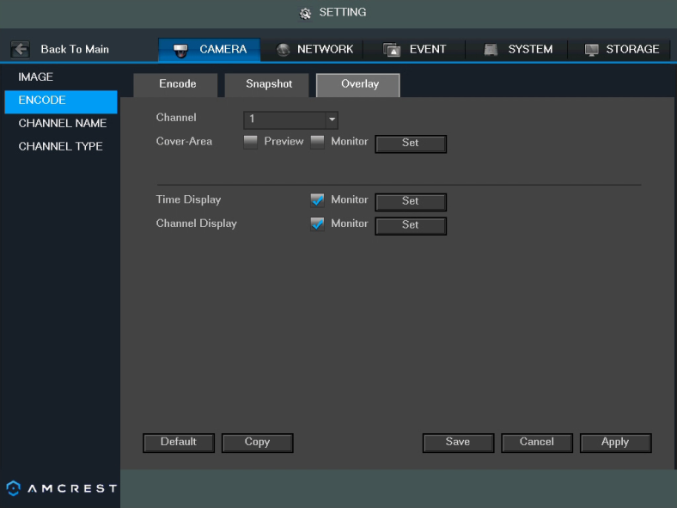
Below is a screenshot of the overlay tab:

Below is an explanation of fields that can be modified on the overlay settings screen:
- Channel: This dropdown box allows the user to select a channel from the dropdown list to modify.
- Cover Area: This button allows the user to set the cover area. Drag the mouse to set the proper section size. The system supports a maximum of 4 zones in one channel.
- Preview/Monitor: There are two types of cover areas
  - Preview means the privacy mask zone cannot be viewed by user when system is in preview status.
  - Monitor means the privacy mask zone cannot be viewed by the user when system is in monitor status.
- Time Display: This button allows the user to select whether or not the system displays time on playback video. Clicking the set button and allows the user to drag the timestamp to the desired position on the screen.
- Channel Display: This button allows the user to select whether or not the system displays channel number on playback video. Clicking the set button allows the user to drag the title to the corresponding position on the screen.

To revert to default settings, click the Default button near the bottom left hand corner. To copy settings to another channel, click the Copy button near the bottom right hand corner. To confirm settings, click the Save button near the bottom right hand corner. To cancel any modifications, click the Cancel button near the bottom right hand corner. To apply the settings, click the Apply button near the bottom right hand corner. After completing the setup please click the save button to go back to the previous menu.

4.10.1.3 Channel Name

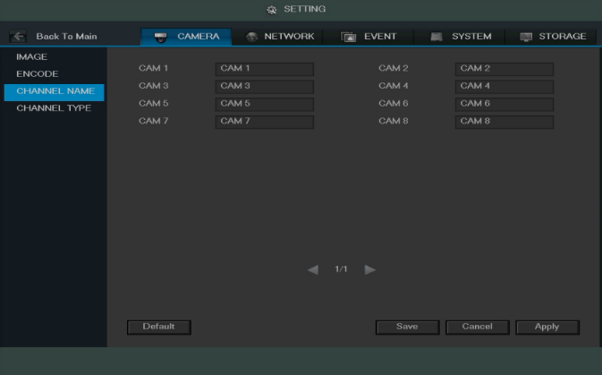
This screen is used to modify the channel names. Each field supports a maximum of 31 characters.

To revert to default settings, click the Default button near the bottom left hand corner. To confirm settings, click the Save button near the bottom right hand corner. To cancel any modifications, click the Cancel button near the bottom right hand corner. To apply the settings, click the Apply button near the bottom right hand corner. After completing the setup please click the save button to go back to the previous menu.

4.10.1.4 Channel Type

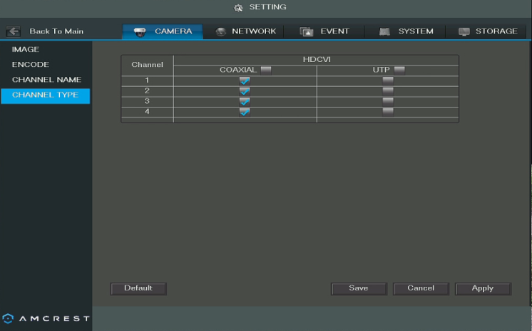
This screen is used to set the channel type. The supported channel types are coaxial, UTP, and IP.

To revert to default settings, click the Default button near the bottom left hand corner. To confirm settings, click the Save button near the bottom right hand corner. To cancel any modifications, click the Cancel button near the bottom right hand corner. To apply the settings, click the Apply button near the bottom right hand corner. After completing the setup please click the save button to go back to the previous menu.

4.10.2 Network

This menu controls all network related functions for the DVR and governs how the DVR interacts with the network it is connected to.

4.10.2.1 TCP/IP

TCP/IP stands for Transmission Control Protocol/Internet Protocol and it is the language/protocol that allows communication between internet connected devices, whether on a local network, or a on the Internet at large. This screen allows for TCP/IP settings to be modified in order for the DVR to establish connection to the network.

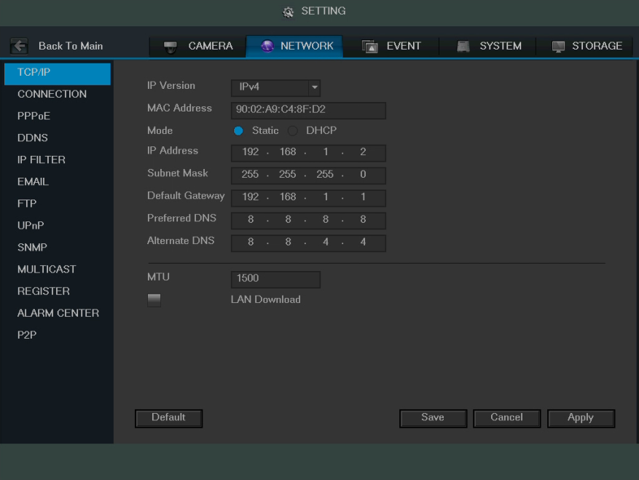
Below is a screenshot of the TCP/IP settings screen:

Below is an explanation of the fields on the TCP/IP settings screen:
- IP Version: This dropdown allows the user to select the IP version. The two options are IPV4 and IPV6.
- MAC address: This field shows the DVR’s MAC address, which is unique to this device. This number is read-only and is used to access a local area network (LAN).
- Static vs DHCP: This check box allows the user to choose between a static IP address, and a dynamic IP address. DHCP stands for Dynamic Host Configuration Protocol, and this enables the DVR to automatically obtain an IP address from another network device such as a server or more commonly, a router. When the DHCP function is enabled, the user cannot modify the IP address, Subnet Mask, or Gateway, as these values are obtained from the DHCP function. To view the current IP address, DHCP needs to be disabled. Note: When PPPoE is enabled, modification of IP Address, Subnet Mask, and Gateway becomes prohibited.
- IP Address: This field allows the user to enter a custom IP address.
- Subnet Mask: This field allows the user to enter a custom subnet mask. The default subnet mask is 255.255.255.0. This number is used to determine which subnetwork the IP address belongs to.
- Default Gateway: This field allows the user to enter the default gateway for the network. The default gateway should be on the same IP subnet as the DVR’s IP. That is to say, the specified length of the subnet prefix should have the same string. For example, if the IP address is 192.168.0.25, the default gateway should start with 192.168.0.X. The default gateway is usually the IP address of the router.
- MTU: MTU stands for Maximum Transmission Unit. This field allows the user to set the MTU value of the network adapter. The value ranges from 1280-7200 bytes. The default value is 1500 bytes. Please note MTU modification may result in network adapter reboot and the network turning off. That is to say, MTU modification can affect the current network service. The system may pop up a dialog box to confirm setup when the MTU value is changed. Click the OK button to confirm current value and reboot, or can click the Cancel button to terminate the current modification. Before the modification, you can check the MTU of the gateway; the MTU of the DVR should be the same or lower than the MTU of the gateway. This way, packets can be reduced and the network transmission efficiency be enhanced. The following MTU values are for reference only.
  - 1500: Ethernet information packet maximum value and it is also the default value. It is the typical setup when there is no PPPoE or VPN. It is the default setup of some routers, switches, and network adapters.
  - 1492: Recommend value for PPPoE.
  - 1468: Recommend value for DHCP.
- Preferred DNS server: This field allows the user to enter the DNS server IP address.
- Alternate DNS server: This field allows the user to enter the Alternate DNS server IP address.
- LAN download: This checkbox allows the user to enable the user to process the downloaded data first. The download speed is 1.5X or 2.0X compared to the normal streaming speed.

To revert to default settings, click the Default button near the bottom left hand corner. To confirm settings, click the Save button near the bottom right hand corner. To cancel any modifications, click the Cancel button near the bottom right hand corner. To apply the settings, click the Apply button near the bottom right hand corner. After completing the setup please click the save button to go back to the previous menu.

4.10.2.2. Connection

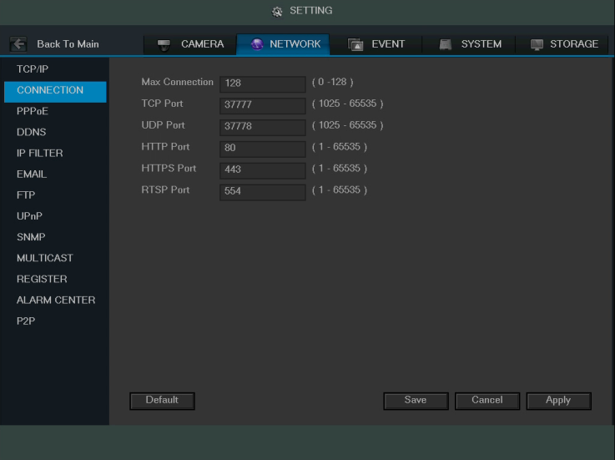
This screen allows users to configure port connections. It is important that the system is rebooted if any changes are made to the settings on this screen. Also, ensure that port values do not conflict.
Below is a screenshot of the connection screen:
Below is an explanation of the fields on the Connection settings screen:
- Maximum Connection: This field represents the maximum amount of users that can be connected to the DVR at the same time. The maximum number of users the DVR can support at one time is 128.
- TCP Port: This field designates the Transmission Control Protocol (TCP) port number. The default value is 37777.
- UDP Port: This field designates the User Datagram Protocol (UDP) port number. The default value is 37778.
- HTTP Port: This field designates the Hypertext Transfer Protocol (HTTP) port number. The default value is 80.
- HTTPS Port: This field designates the Hypertext Transfer Protocol Secure (HTTPS) port number. The default value is 443.
- RTSP Port: This field designates the Real Time Streaming Protocol (RTSP) port number. The default value is 554.

To revert to default settings, click the Default button near the bottom left hand corner. To copy settings to another channel, click the Copy button near the bottom right hand corner. To confirm settings, click the Save button near the bottom right hand corner. To cancel any modifications, click the Cancel button near the bottom right hand corner. To apply the settings, click the Apply button near the bottom right hand corner. After completing the setup please click the save button to go back to the previous menu.

4.10.2.3 PPPoE

PPPoE stands for Point-to-Point Protocol over Ethernet. This screen allows users to configure PPPoE connections.
Below is a screenshot of the PPPoE screen:
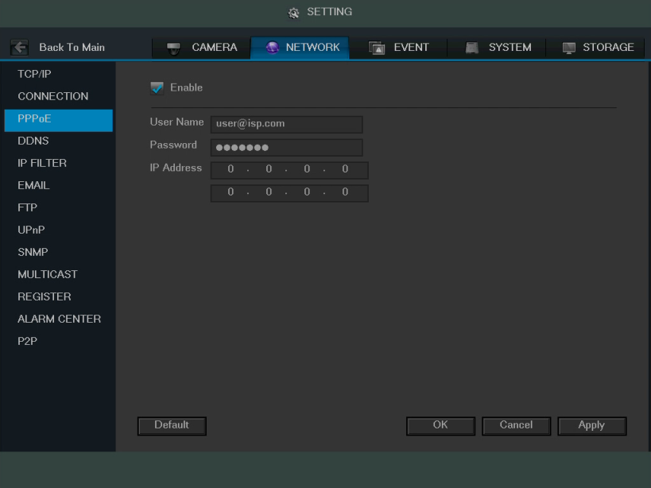

To revert to default settings, click the Default button near the bottom left hand corner. To copy settings to another channel, click the Copy button near the bottom right hand corner. To confirm settings, click the OK button near the bottom right hand corner. To cancel any modifications, click the Cancel button near the bottom right hand corner. To apply the settings, click the Apply button near the bottom right hand corner. After completing the setup please click the save button to go back to the previous menu.

4.10.2.4 DDNS

DDNS stands for Dynamic Domain Name Server. This technology is used to automatically update name servers in real time in order to help the DVR maintain a persistent address despite changes in location or configuration. What this means is that even when the DVR is restarted, moved, or reconfigured, it can keep the same IP address, thus allowing remote users uninterrupted access to the DVR, rather than having to request a new IP address to use for remote access anytime a change is made.

To use this feature, users will need to setup an account with a DDNS service. The DVR supports a variety of DDNS services such as Quick DDNS, NO-IP DDNS, CN99 DDNS, Dyndns DDNS, and private DDNS services. Based on which service is selected, different options may show on this screen. For purposes of this guide, QuickDDNS will be used.
To use Quick DDNS, go to http://www.quickddns.com and register for an account. If the account is inactive for a year, Quick DDNS may take back the domain name, but an email will be sent beforehand as a warning.
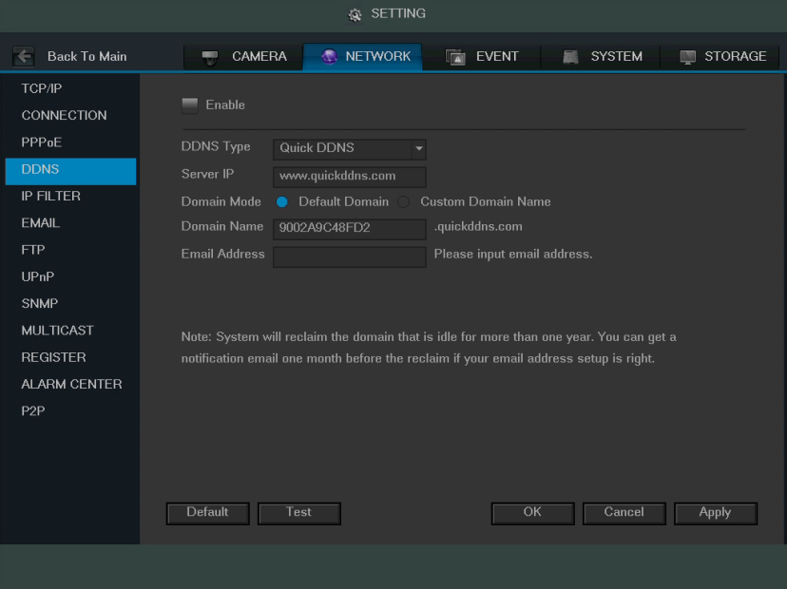
Below is a screenshot of the DDNS settings screen, configured to QuickDDNS:

Below is an explanation of the fields that can be configured on DDNS settings screen when set to Quick DDNS type. Fields with a ‘*’ next to them appear when Quick DDNS is selected:
- Enable: This checkbox allows the user to enable DDNS on the DVR.
- DDNS Type: This dropdown box allows the user to select which DDNS service is being used on the DVR.
- *Server IP: This field allows the user to enter the IP address for the server used by the specific DDNS service.
For Quick DDNS, the default address is www.quickddns.com
- *Domain Mode: This radio button allows the user to choose a custom domain names, or the default one generated by the Quick DDNS system.
- *Domain Name: This field allows the user to enter the domain name from the Quick DDNS service.
- *Email Address: This field allows the user to enter the email address associated with the Quick DDNS account.

To revert to default settings, click the Default button near the bottom left hand corner. To test the current settings, click Test near the bottom left hand corner. To confirm settings, click the OK button near the bottom right hand corner. To cancel any modifications, click the Cancel button near the bottom right hand corner. To apply the settings, click the Apply button near the bottom right hand corner.

4.10.2.5 IP Filter

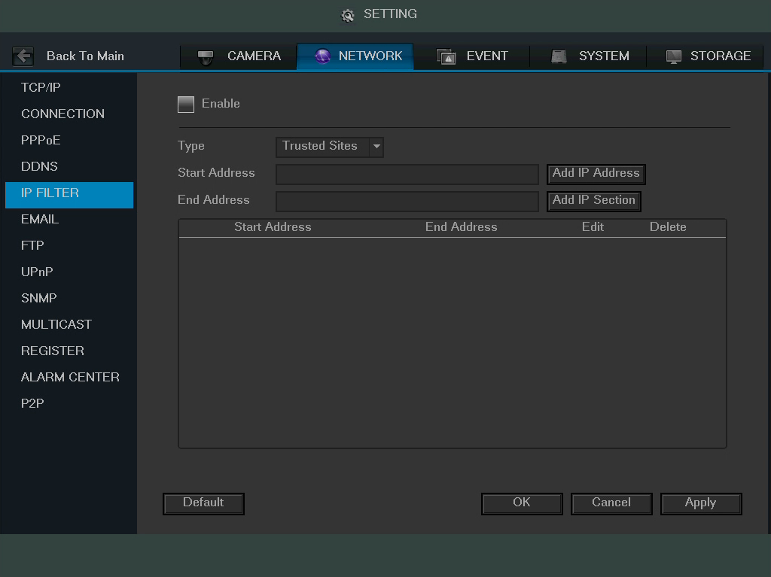
This screen allows for the filtering of IP addresses, either blocking them, or granting them access to the DVR. This feature helps make the DVR more secure by limiting remote access only to approved users. Below is a screenshot of the IP Filter screen:
Below is an explanation of fields on the IP Filter settings screen:
- Enable: This checkbox allows the user to enable the IP Filter feature. Many of the other fields below cannot be edited if this checkbox is not checked.
- Type: This dropdown box allows the user to select an IP address type. There are two types of IP addresses that can be used by this feature. Only one of them can be activated at a time.
  - Trusted Sites: This setting allows the user to enter trusted IP addresses. All other addresses will be blocked.
  - Blocked Sites: This setting allows all IP addresses, but blocks the ones that are specified.
- Start Address/End Address: This field allows the user to enter IP addresses, and depending on which button is clicked, it can either add a single IP address, or a section of IP addresses to the IP Filter list.
  - The DVR can support a maximum of 64 IP addresses on this list.
  - Newly added IP addresses are enabled by default, but can be disabled or added to the block list. If the system is in trusted sites mode, select the IP address, and delete it to remove it from the list. If the system is in blocked sites mode, add the IP address to the blocked sites list to prevent that IP from getting access.
  - The IP address column supports both IPV4 and IPV6 IP address formats. For IPV6 addresses, the system can optimize them to make the addresses more readable.
    - aa:0000: 00: 00aa: 00aa: 00aa: 00aa: 00aa can be optimized to
aa:: aa: aa: aa: aa: aa: aa
  - IP addresses automatically have spaces before or after the address removed as they are entered.
  - For adding a single IP, enter it in the Start Address field. For entering in a section of IP addresses, enter in IP addresses in both fields, ensuring that the larger number IP address is in the End Address field.
  - Note: The system also supports the adding of MAC addresses.
- Delete: This button allows a user to remove a specific IP address from the IP Filter list.
- Edit: This button allows a user to edit start or end addresses.

To revert to default settings, click the Default button near the bottom left hand corner. To test the current settings, click Test near the bottom left hand corner. To confirm settings, click the OK button near the bottom right hand corner. To cancel any modifications, click the Cancel button near the bottom right hand corner. To apply the settings, click the Apply button near the bottom right hand corner.

4.10.2.6 Email

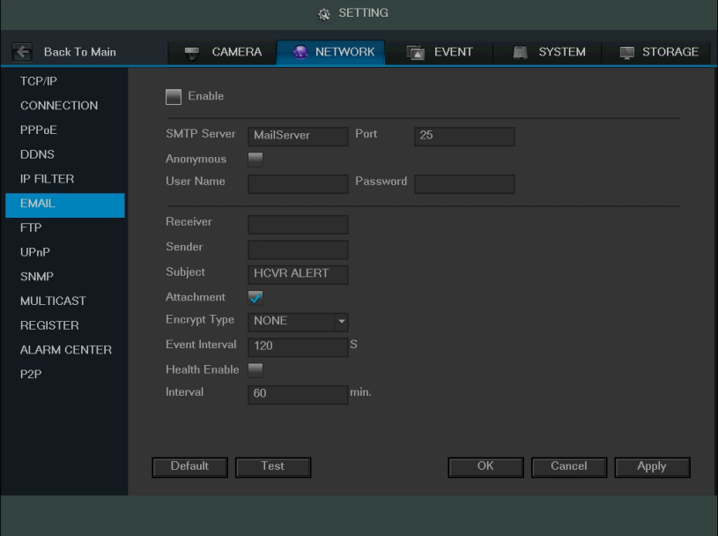
This screen allows for the configuring of email settings in order to permit the DVR to send emails when the connected cameras or alarms are triggered. Below is a screenshot of the email settings screen:
Below is an explanation of the fields on the Email settings screen:
- Enable: This checkbox allows the user to enable the email feature.
- SMTP Server: SMTP stands for Simple Mail Transfer Protocol. This field allows the user to enter the SMTP server used by the email service.
- Port: This field allows the user to enter the port that corresponds to the selected SMTP server.
- User Name: This field allows the user to enter the username used to login to the selected SMTP server.
- Password: This field allows the user to enter the password associated with the SMTP username.
- Sender: This field allows the user to enter the sender email address. This email address will be the one that sends out all emails pertaining to the alerts and alarm emails sent by the DVR.
- Receiver: This field allows the user to enter the receiver email address. These email addresses are the ones that will receive any emails pertaining to alert and alarm emails sent by the DVR. Up to 3 email addresses can be entered in this field.
- Subject: This field allows the user to define the subject line of the email that is sent to the receivers.
- Attachment: This checkbox allows the user to enable the attachment of screenshots with emails.
- Encrypt Type: This dropdown box allows the user to select an encryption type. There are two types of email encryption that are available.
  - SSL: Secure Socket Layer
  - TLS: Transport Layer Security
- Event Interval: This field allows the user to define, in seconds, how many events can be triggered concurrently.
- Health Enable: This checkbox allows the user to enable the function that causes the system to send out a test email to ensure if the connection is OK or not.
- Interval: This field allows the user to define, in minutes, how often emails can be sent by the system. This helps to curb heavy load on the email server when multiple events are occurring.

To revert to default settings, click the Default button near the bottom left hand corner. To test the current settings, click Test near the bottom left hand corner. To confirm settings, click the OK button near the bottom right hand corner. To cancel any modifications, click the Cancel button near the bottom right hand corner. To apply the settings, click the Apply button near the bottom right hand corner.

4.10.2.7 FTP

FTP stands for File Transfer Protocol. This protocol allows for remote uploading of files to a server. This feature requires the use of a FTP tool on a computer in order to enable the use of FTP features on the DVR.

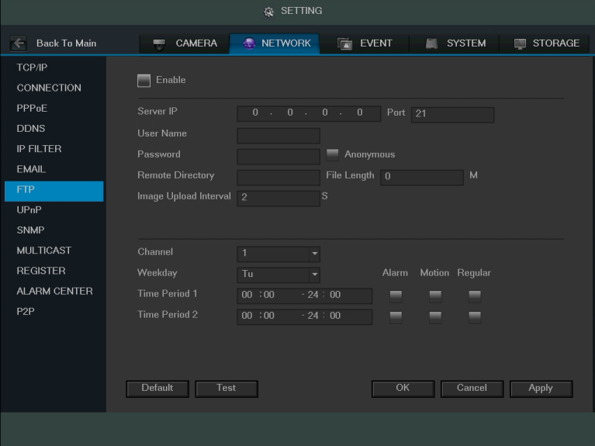
Once an FTP tool has been acquired, installed, and configured to allow read, write, append, and delete access, then the DVR can be configured to use FTP. Below is a screenshot of the FTP menu screen:

Below is an explanation of the fields on the FTP settings screen:
- Enable: This checkbox allows the user to enable the FTP feature for the DVR.
- Server IP: This field allows the user to enter the FTP server IP address and port.
- User Name: This field allows the user to enter the FTP username.
- Password: This field allows the user to enter the FTP server password. The checkbox next to this field enables anonymous access to the FTP.
- Remote Directory: This field allows the user to designate which folder the DVR will upload files to.
- File Length: This field allows the user to dictate how large upload files can be.
- Image Upload Interval: This field allows the user to define, in seconds, how often images can be uploaded to the FTP server.
- Channel: This field allows the user to pick a channel to set FTP settings for.
- Weekday: This field allows the user to pick a day of the week to set FTP settings for.
- Time Period 1: This field allows the user to specify a time period and what types of files to upload (Alarm, Motion, Regular).
- Time Period 2: This field allows the user to specify a time period and what types of files to upload (Alarm, Motion, Regular).

To revert to default settings, click the Default button near the bottom left hand corner. To test the current settings, click Test near the bottom left hand corner. To confirm settings, click the OK button near the bottom right hand corner. To cancel any modifications, click the Cancel button near the bottom right hand corner. To apply the settings, click the Apply button near the bottom right hand corner.

4.10.2.8 UPnP

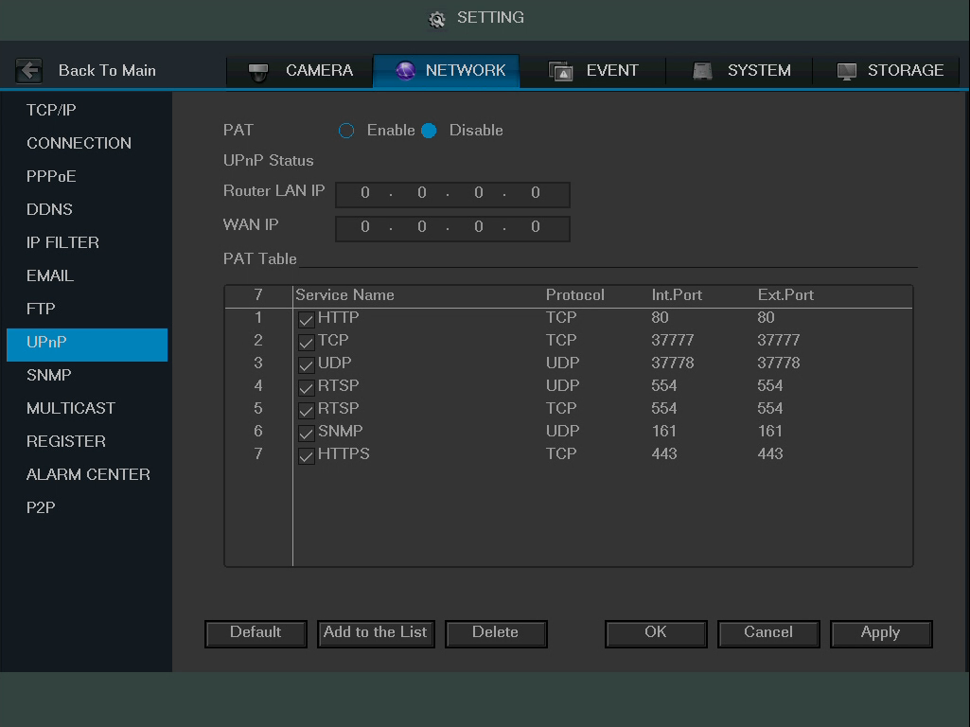
UPnP stands for Universal Plug and Play, and it is a protocol used to easily connect devices to the internet. In the case of this DVR, it allows the DVR to connect to the router in an easy manner to quickly allow for remote connection. Below is a screenshot of the UPnP settings screen:
Below is an explanation of the fields in the UPnP settings screen:
- PAT: PAT stands for Port Address Translation, and it is something that the UPnP protocol handles. This checkbox allows the user to enable UPnP on the device.
- UPnP Status: This field shows the UPnP status and has two options:
  - Unknown: This means that UPnP is offline.
  - Successful: This means that UPnP is working.
- Router LAN IP: This field allows the user to enter the IP address of the router that the DVR is trying to connect to.
- WAN IP: This field is where the DVR Wide Area Network (WAN) IP is populated. This IP address is what is used to remotely access the DVR through web access.
- PAT Table: This table is used to show how the ports for each protocol listed below have been remapped by the UPnP protocol.
  - The first column shows the order of the services.
  - The second column shows the name of the services. To edit this, double click on the service line item.
  - The third column shows the name of the protocol used by that service. To edit this, double click on the service line item.
  - The fourth column shows the Internal Port used by that service. To edit this, double click on the service line item.
  - The fifth column shows the External Port used by that service. To edit this, double click on the service line item.

To revert to default settings, click the Default button near the bottom left hand corner. To add a service to the list, click Add Service near the bottom left hand corner. To delete a service, click Delete near the bottom left hand corner. To confirm settings, click the OK button near the bottom right hand corner. To cancel any modifications, click the Cancel button near the bottom right hand corner. To apply the settings, click the Apply button near the bottom right hand corner.

To view a video on how to remotely access your DVR using UPnP, go to http://amcrest.com/videos and view the video titled “How to Gain Remote Access to Your HDCVI DVR with Universal Plug and Play”.

To view more information on how to set up the HDCVI DVR for remote access using UPnP, see section 5.2.1.

4.10.2.9 SNMP

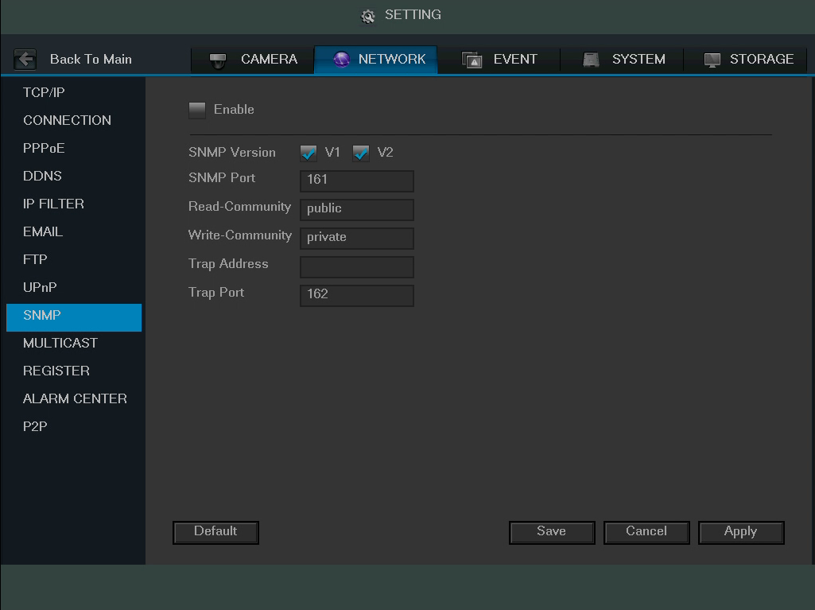
SNMP stands for Simple Network Management Protocol. This protocol is used to provide a basic framework in order to allow connection between various network devices. Below is a screenshot of the SNMP settings screen:
Use of SNMP required additional software to create a Management Information Base (MIB) database. A popular set of tools for this purpose are MIB Builder and MG-SOFT MIB Browser. Using these tools, two MIB files need to be created: BASE-SNMP-MIB and DVR-SNMP-MIB. To configure SNMP, follow the steps below:
- On the SNMP screen, check the text box to enable the SNMP function. Input the IP address of the PC that is running the MIB software in the Trap address. Default values may be used for the rest of the fields.
- Compile the above mentioned two MIB files via the software MIB Builder.
- Run the MG-SOFT MIB Browser to load the file from the previous step into the software.
- Input the device IP you want to manage in the MG-SOFT MIB Browser. Please set the corresponding version for your future reference.
- Open the tree list on the MG-SOFT MIB Browser. This software shows device configuration. Using this software, the user can see how many video channels and audio channels the device has, as well as view other information about the DVR.

Note: SNMP port number and Trap number should not be the same, as it will cause a port conflict and neither will work.
Below is an explanation about the different fields in the SNMP settings screen:
- Enable: This checkbox allows the user to enable the SNMP feature for the DVR.
- SNMP Version: These checkboxes allow the user to select which versions of SNMP are used
- SNMP Port: This field allows the user to specify which port is used for SNMP.
- Read-Community: This field allows the user to specify which user community has read access.
- Write-Community: This field allows the user to specify which user community has write access.
- Trap Address: This field allows the user to enter the IP address of the PC running the MIB software.
- Trap Port: This field allows the user to enter the port number of the PC running MIB software.

To revert to default settings, click the Default button near the bottom left hand corner. To confirm settings, click the Save button near the bottom right hand corner. To cancel any modifications, click the Cancel button near the bottom right hand corner. To apply the settings, click the Apply button near the bottom right hand corner.

4.10.2.10 Multicast

Multicast is a feature that enables the DVR to broadcast it’s live view to multiple computers on the same network.
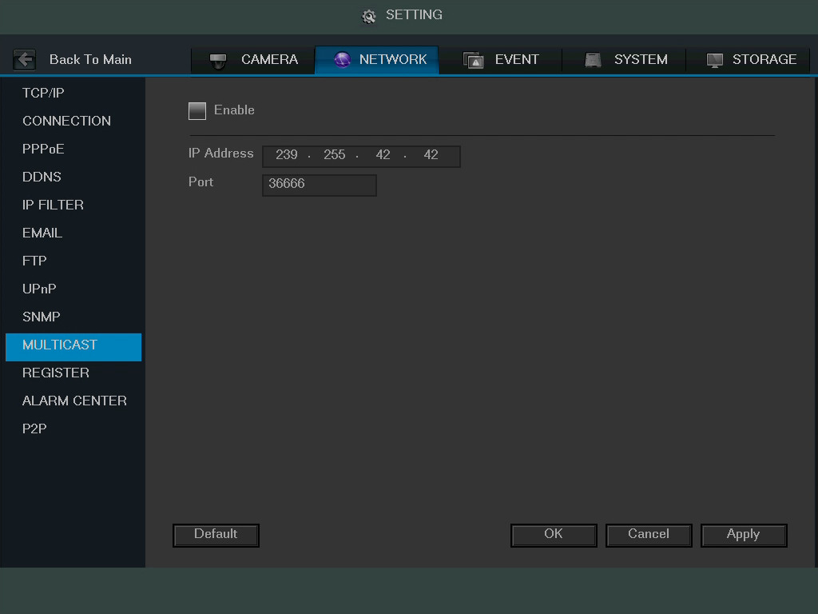
Below is a screenshot of the multicast screen:

Below is an explanation of the fields in the Multicast settings screen:
- Enable: This checkbox allows the user to enable the Multicast feature for the DVR.
- IP Address: This field allows the user to enter the multicast IP address.
- Port: This field allows the user to enter the port number for the multicast IP address.

For more information on how to configure multicast, see the information below.

Multicast IP Address Range (IPV4): 224.0.0.0 through 239.255.255.255

Well-known IPv6 multicast addresses
Address | Description
ff02::1 | All nodes on the local network segment
ff02::2 | All routers on the local network segment
ff02::5 | OSPFv3 All SPF routers
ff02::6 | OSPFv3 All DR routers
ff02::8 | IS-IS for IPv6 routers
ff02::9 | RIP routers
ff02::a | EIGRP routers
ff02::d | PIM routers
ff02::16 | MLDv2 reports (defined in RFC 3810)
ff02::1:2 | All DHCP servers and relay agents on the local network segment (defined in RFC 3315)
ff02::1:3 | All LLMNR hosts on the local network segment (defined in RFC 4795)
ff05::1:3 | All DHCP servers on the local network site (defined in RFC 3315)
ff0x::c | Simple Service Discovery Protocol
ff0x::fb | Multicast DNS
ff0x::101 | Network Time Protocol
ff0x::108 | Network Information Service
ff0x::181 | Precision Time Protocol (PTP) version 2 messages (Sync, Announce, etc.) except peer delay measurement
ff02::6b | Precision Time Protocol (PTP) version 2 peer delay measurement messages
ff0x::114 | Used for experiments

To revert to default settings, click the Default button near the bottom left hand corner. To confirm settings, click the OK button near the bottom right hand corner. To cancel any modifications, click the Cancel button near the bottom right hand corner. To apply the settings, click the Apply button near the bottom right hand corner.

4.10.2.11 Register

The register feature allows the DVR to register itself with a specified proxy, so that the DVR can be remotely accessed via a proxy. A proxy is a computer server that acts as an intermediary between client computers that are seeking resources from a server. Below is a screenshot of the Register settings screen:
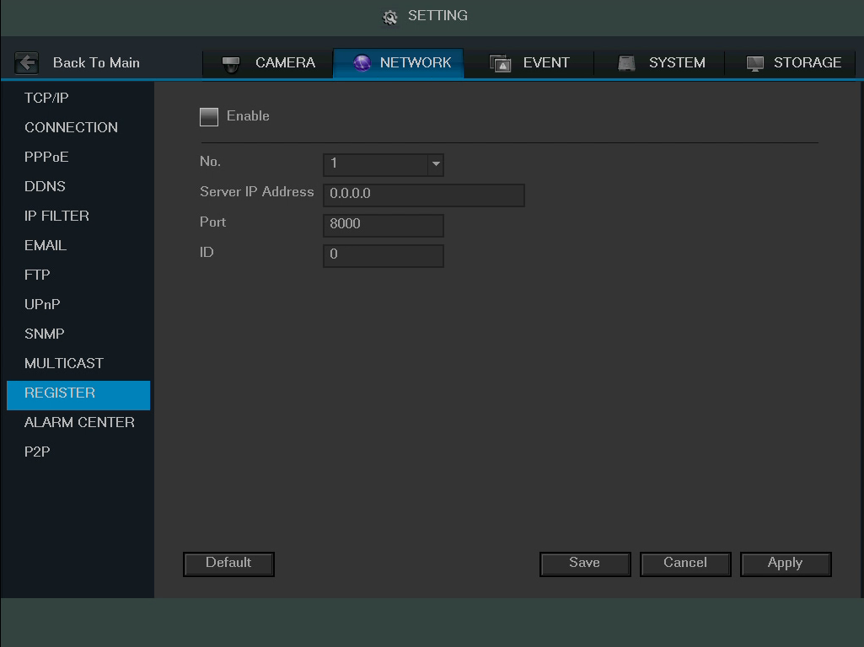

Below is an explanation of the fields on the Register settings screen:
- Enable: This checkbox allows the user to enable the Register feature for the DVR.
- No: This dropdown box allows the user to select the proxy number. Currently the DVR can only configure one proxy.
- Server IP Address: This field allows the user to enter the proxy server IP address.
- Port: This field allows the user to enter the proxy port number.
  - Note: Do not enter a network default port for this port number. It may result in a port conflict.
- ID: This field allows the user to enter the proxy ID number.

To revert to default settings, click the Default button near the bottom left hand corner. To confirm settings, click the Save button near the bottom right hand corner. To cancel any modifications, click the Cancel button near the bottom right hand corner. To apply the settings, click the Apply button near the bottom right hand corner.

4.10.2.12 Alarm Center

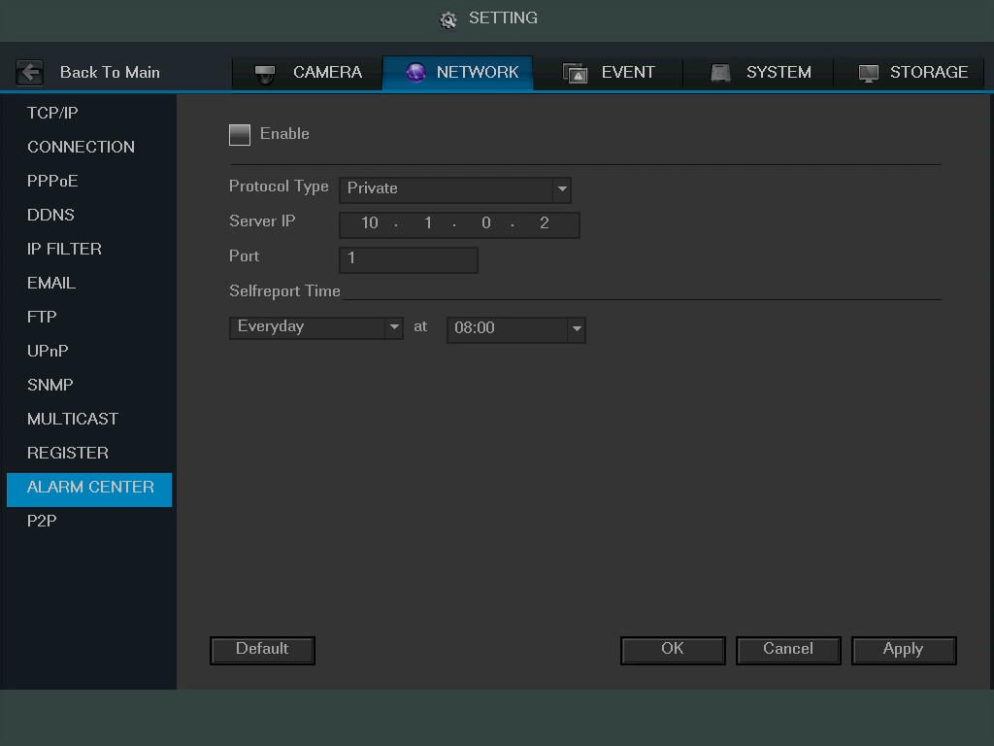
The alarm center feature is used to allow users to connect the DVR to their alarm server, so the server can receive a notice when certain events happen. One common use for the alarm center is to send daily reports on the status of the DVR’s connection to the network. Below is a screenshot of the Alarm Center settings screen:
Below is an explanation of the fields on the Alarm Center settings screen:
- Enable: This checkbox allows the user to enable the Alarm Center feature for the DVR.
- Protocol Type: This field allows the user to select which protocol type they want to use for the alarm. Currently, only the private protocol type is available.
- Server IP: This field allows the user to enter the IP address of the alarm server.
- Port: This field allows the user to enter the port number of the alarm server.
- Self-Report Time: This field allows the user to enter a time of the day when they want to receive a report about the DVR’s connection to the network each day.

To revert to default settings, click the Default button near the bottom left hand corner. To confirm settings, click the Save button near the bottom right hand corner. To cancel any modifications, click the Cancel button near the bottom right hand corner. To apply the settings, click the Apply button near the bottom right hand corner.

4.10.2.13 P2P

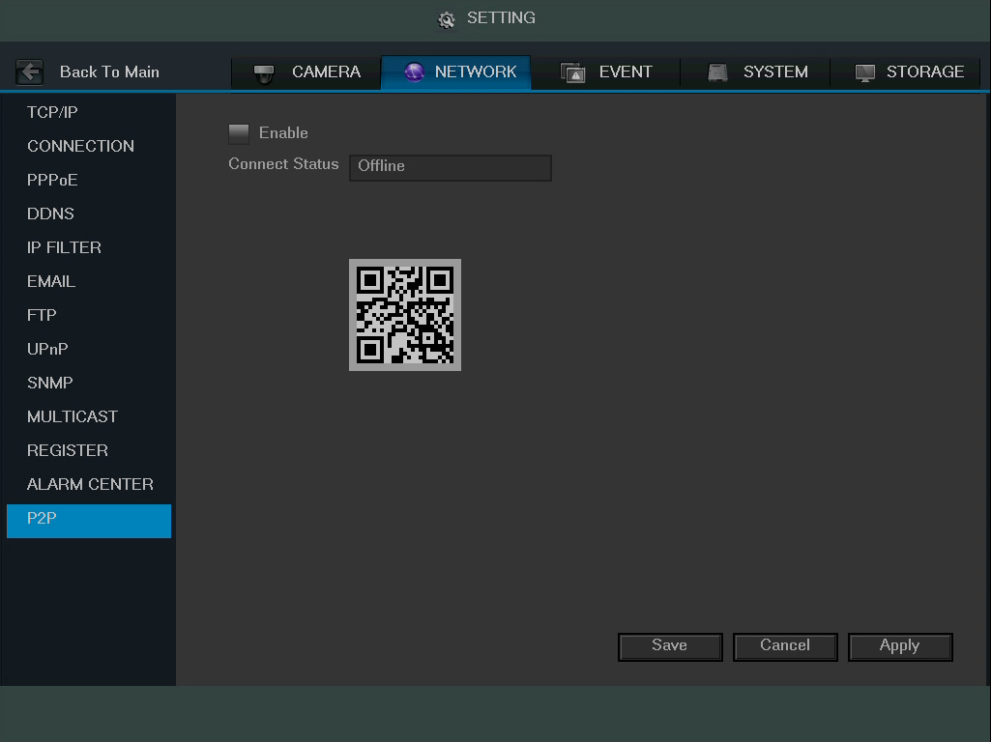
The P2P settings screen is where users can use a QR code to connect their smartphone or tablet to the DVR. The HDCVI uses an app called Amcrest View, and it is available on both iOS and Android. Below is a screenshot of the P2P settings screen:

Below is an explanation of the fields on the P2P settings screen:
- Enable: This checkbox allows the user to enable the P2P feature for the DVR.
- Connect Status: This field shows the status of the P2P connection. Once connected using the app, this field should display the word Online.
- QR Code: This is the unique QR code used to help the app user connect to the DVR.
  - Note: The physical design of the QR code may change based on the network settings used. All QR code connections should be made with the image that displays on this screen, and not through any static saved images.

To confirm settings, click the Save button near the bottom right hand corner. To cancel any modifications, click the Cancel button near the bottom right hand corner. To apply the settings, click the Apply button near the bottom right hand corner.

4.10.3 Event

4.10.3.1 Detect

Main Menu -> Settings -> Event -> Detect opens up the Detection interface. Here there are 3 options, each representing a detection type: Motion Detection, Video Loss, and Tampering.

Tips:
- The video loss and tampering screens have no detection regions or sensitivity setup.
- The motion detection icon will be present if the motion detection alarm has been triggered on the current channel.
- To set the motion detection region, click and drag the mouse over the region desired. Once the region has been set, click the OK button to save the current region setup, and right click on the mouse to exit the motion detection interface.

4.10.3.1.1 Motion Detect

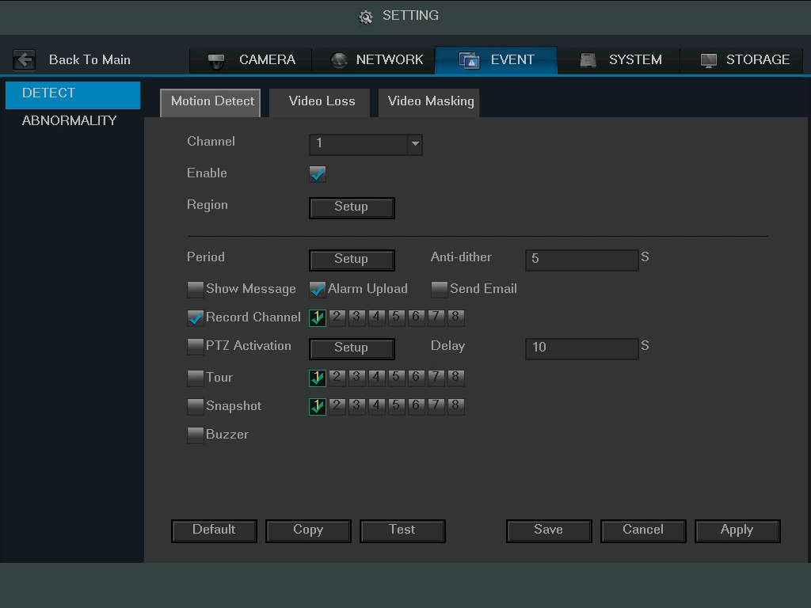
The motion detection settings screen is where motion detection can be setup for each individual channel. Based on the active motion detection region, the DVR can generate a motion detection alarm when a moving signal is detected in a specified area. Below is a screenshot of the motion detection settings screen:
Below is a description of the fields on the Motion Detection settings page:
- Channel: This dropdown box allows the user to pick which channel they would like to change motion detection settings for.
- Enable: This checkbox allows the user to enable the motion detection function for a specific channel.
- Region: The setup button takes the user to the motion detection region setup screen for that specific channel. On the next page is a screenshot of the motion detection region screen.

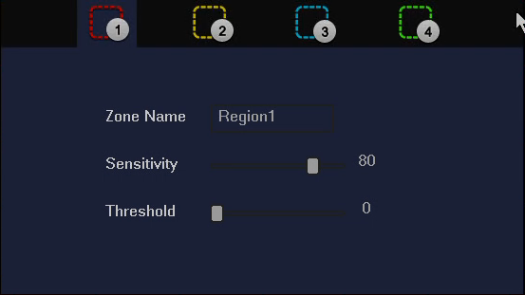
  - When the setup button is clicked, the current channel’s interface comes into a full screen view. The user can then set up to 4 regions, each with their own region name, sensitivity (1-100), and threshold (1-100). Each region has a specific color, and the region selector tool is displayed when the mouse is moved to the top of the screen.
    - Sensitivity is the amount of change required to increase the motion detected by a percentage. The lower the sensitivity, the more movement is required to trigger an alarm.
    - Threshold is the level that the motion detection needs to reach in order to trigger an alarm. The lower the threshold, the more likely that motion will trigger an alarm.
  - To designate a zone, click and drag the mouse over the area desired. When a colored box is displayed over the live feed, that area is now enabled for motion detection. Clicking the FN button will switch the mode between armed and disarmed, so that clicking and dragging the mouse can either designate a motion detection zone, or remove any motion detection zone markers.
  - After the motion detection zone is set, click the enter button to exit the motion detection screen. Remember to click the save button on the motion detection settings screen, otherwise the motion detection zones will not go into effect. Clicking the escape button to leave the motion detection zone and will not save the zone setup.
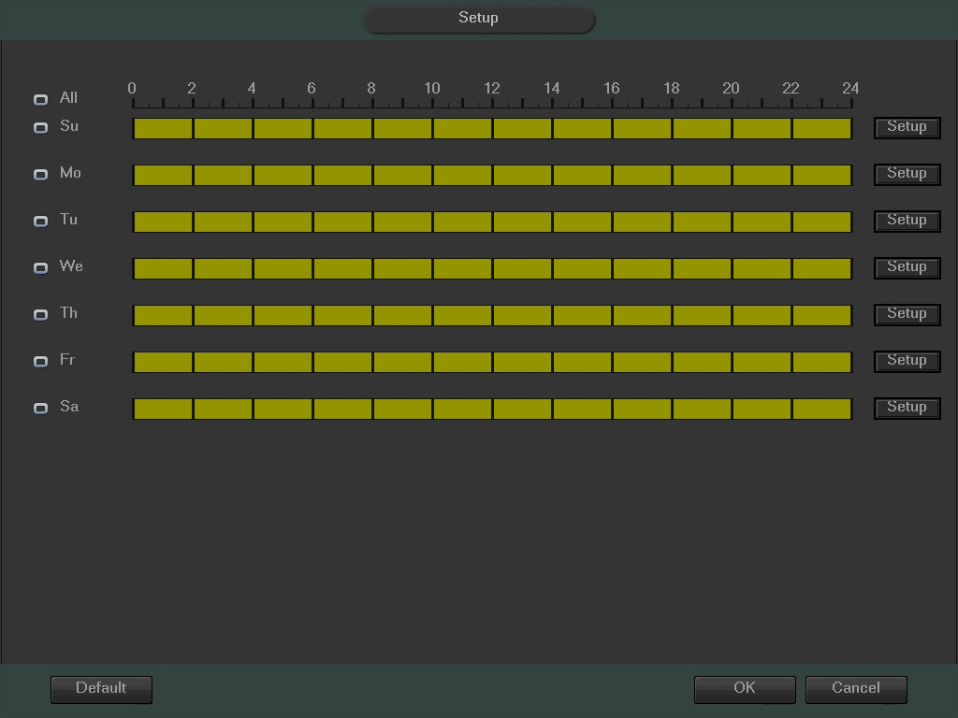
- Period: This setup button takes the user to the motion detection period settings screen. Below is a screenshot of the motion detection period settings screen.
  - Click and drag on the yellow bars to specify time zones for motion detection. To edit multiple days at once, either click the checkboxes next to the names, or click the checkbox next to All in order to edit all of the days at once. Once the checkbox is clicked, it will turn into this icon in order to indicate that all of those days can be changed together. Click OK to return to the motion detection setup screen. Click Cancel to undo any changes and return to the motion detection settings screen. Click Default to use the default settings.
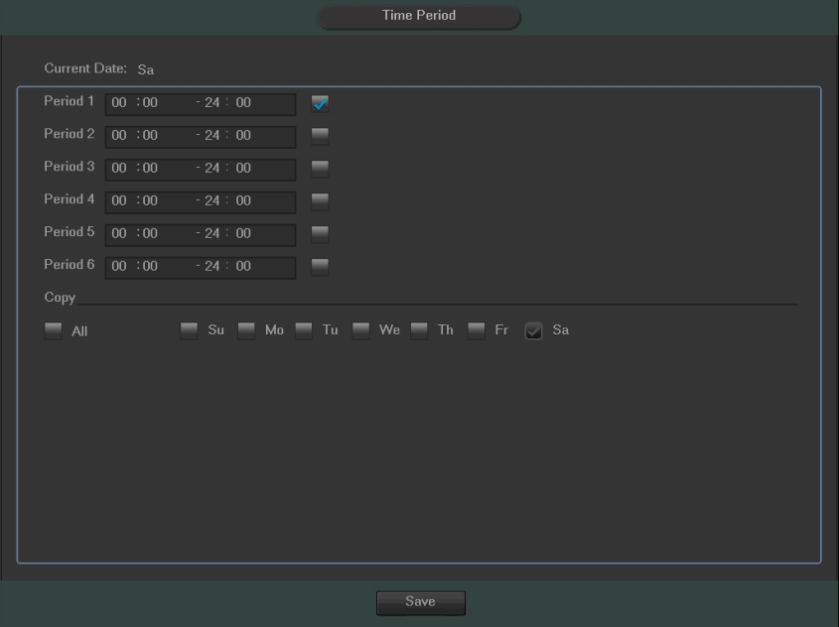
  - In order to specify time zones in greater detail for each day, click the Setup button to the left of the time bar, and the Time Period setup screen will appear. The screenshot below shows the Time Period settings screen:

  - The system allows for the configuration of up to 6 different time periods. Click the checkbox to the left of the time period to enable that time period. Click the text next to each period to edit the time period. To copy time periods, click the checkboxes next to the days of the week that you’d like to copy the settings to. Once finished on this screen, click Save to return to the time period settings screen.
- Anti-Dither: This field allows the user to set the anti-dither time. The values in this field can range from 5 to 600 seconds. This time value controls how long the alarm signal lasts. Based on motion detection, a buzzer can go off, a tour can begin, PTZ can be activated, a snapshot can be taken, or a channel can begin recording.
  - For example, if the anti-dither time is set to 10 seconds, each alarm may last 10 seconds if the local alarm is activated. During the process, if the system detects another local alarm signal at the fifth second, the buzzer, tour, PTZ activation, snapshot, record channel functions will begin another 10 seconds while the screen prompt, alarm upload, email will not be activated again. After 10 seconds, if system detects another alarm signal, it can generate a new alarm since the anti-dither time has expired.
- Show Message: This checkbox allows the user to enable the system to show an on-screen message when a motion detection alarm is triggered.
- Alarm Upload: This checkbox allows the user to enable the system to upload alarm information when a motion detection alarm is triggered.
- Send Email: This checkbox allows the user to enable the system to send an email when a motion detection alarm is triggered.
- Record Channel: This checkbox allows the user to enable the system to record video for that channel when a motion detection alarm is triggered.

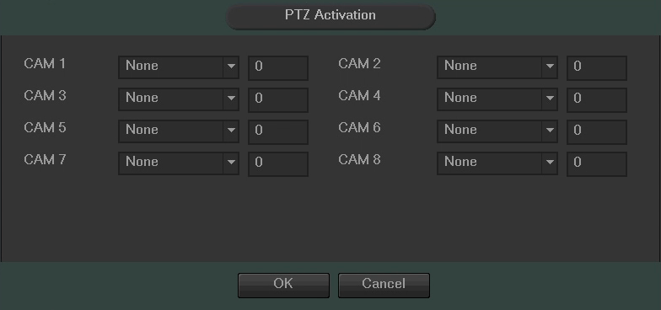
- PTZ Activation: This checkbox allows the user to enable the system to activate PTZ movement when a motion detection alarm is triggered. To setup the PTZ activation settings, click the setup button next to PTZ activation. The screenshot on the next page shows the PTZ activation setup screen:
  - On this screen, each camera can be setup to perform a preset PTZ action based upon motion detection.
  - Delay: This field specifies in seconds how long the delay between alarm activation and PTZ activation should be.
- Tour: This checkbox allows the user to enable the system to cause a PTZ tour to occur when a motion detection alarm is triggered. Multiple cameras can be specified to perform a tour.
- Snapshot: This checkbox allows the user to enable the system to take a snapshot when a motion detection alarm is triggered. Multiple cameras can be specified to perform a tour.
- Buzzer: This checkbox allows the user to enable the system to activate a buzzer when a motion detection alarm is triggered.

To revert to default settings, click the Default button near the bottom left hand corner. To copy settings to another channel, click Copy near the bottom left hand corner. To test a channel’s motion detection, click Test near the bottom left hand corner. To confirm settings, click the OK button near the bottom right hand corner. To cancel any modifications, click the Cancel button near the bottom right hand corner. To apply the settings, click the Apply button near the bottom right hand corner.

4.10.3.1.2 Video Loss

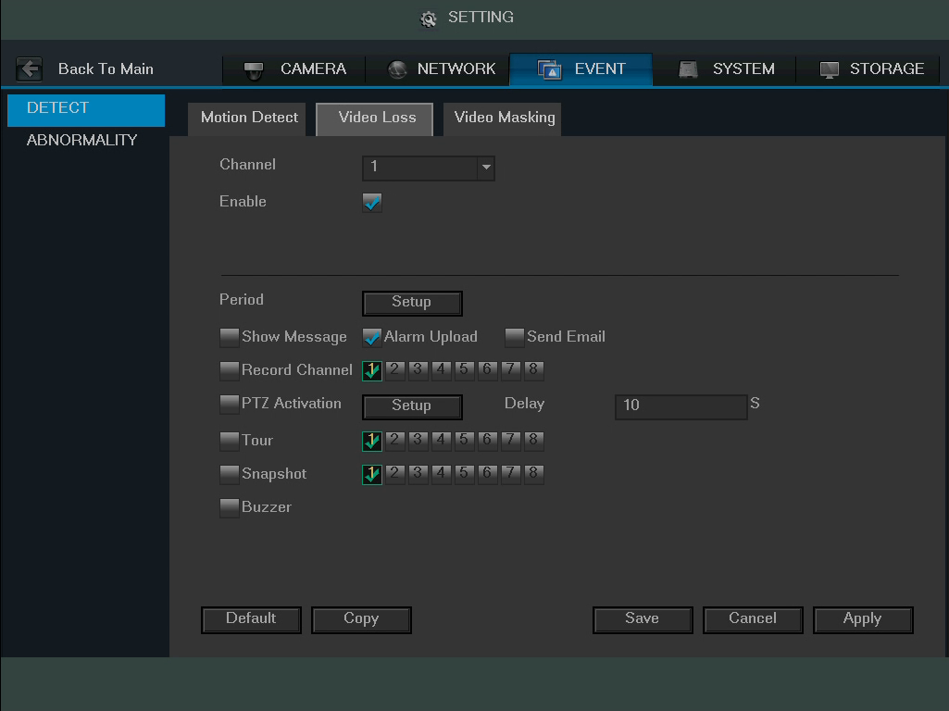
The video loss settings screen is where the DVR can be setup to notify the user any time there is video loss on any of the channels. Below is a screenshot of the video loss settings screen:

Below is a description of the fields on the Video Loss settings page:
- Channel: This dropdown box allows the user to pick which channel they would like to change video loss settings for.
- Enable: This checkbox allows the user to enable the video loss function for a specific channel.
- Period: This setup button takes the user to the video loss period settings screen. Below is a screenshot of the video loss period settings screen.
  - Click and drag on the yellow bars to specify time zones for video loss. To edit multiple days at once, either click the checkboxes next to the days desired, or click the All checkbox in order to edit all of the days at once. Once the checkbox is clicked, it will turn into this icon in order to indicate that all of those days can be changed together. Click OK to return to the video loss settings screen. Click Cancel to undo any changes and return to the video loss setup screen. Click Default to use the default settings.
  - In order to specify time zones in greater detail for each day, click the Setup button to the left of the time bar, and the Time Period setup screen will appear. The screenshot below shows the Time Period settings screen:
  - The system allows for the configuration of up to 6 different time periods. Click the checkbox to the left of the time period to enable that time period. Click the text next to each period to edit the time period. To copy time periods, click the checkboxes next to the days of the week that you’d like to copy the settings to. Once finished on this screen, click Save to return to the time period settings screen.
- Show Message: This checkbox allows the user to enable the system to show an on-screen message when a video loss alarm is triggered.
- Alarm Upload: This checkbox allows the user to enable the system to upload alarm information when a video loss alarm is triggered.
- Send Email: This checkbox allows the user to enable the system to send an email when a video loss alarm is triggered.
- Record Channel: This checkbox allows the user to enable the system to start recording video when a video loss alarm is triggered. Multiple cameras can be specified to start recording based on this function.
- PTZ Activation: This checkbox allows the user to enable the system to activate PTZ movement when a video loss alarm is triggered. To setup the PTZ activation settings, click the setup button next to PTZ activation. The screenshot on the next page shows the PTZ activation setup screen:

  - On this screen, each camera can be setup to perform a preset PTZ action based upon video loss.
  - Delay: This field specifies in seconds how long the delay between alarm activation and PTZ activation should be.
- Tour: This checkbox allows the user to enable the system to cause a PTZ tour to occur when a video loss alarm is triggered. Multiple cameras can be specified to perform a tour.
- Snapshot: This checkbox allows the user to enable the system to take a snapshot when a video loss alarm is triggered. Multiple cameras can be specified to perform a tour.
- Buzzer: This checkbox allows the user to enable the system to activate a buzzer when a video loss alarm is triggered.

To revert to default settings, click the Default button near the bottom left hand corner. To copy settings to another channel, click Copy near the bottom left hand corner. To test a channel’s motion detection, click Test near the bottom left hand corner. To confirm settings, click the OK button near the bottom right hand corner. To cancel any modifications, click the Cancel button near the bottom right hand corner. To apply the settings, click the Apply button near the bottom right hand corner.

4.10.3.1.3 Video Masking

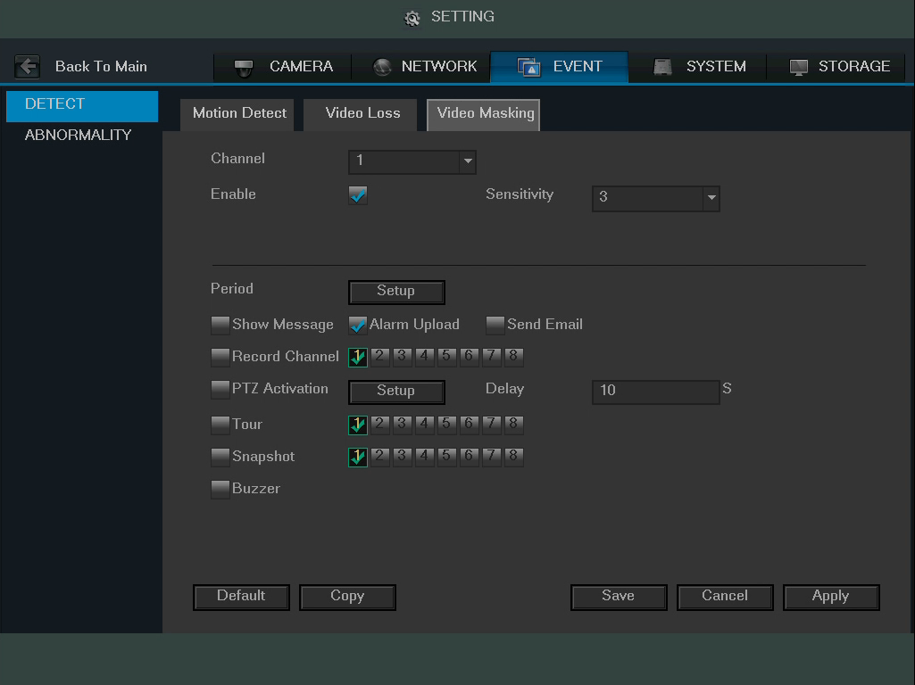
The video masking settings screen is where the DVR can be setup to notify the user any time a camera is tampered with or if the output video is only displaying in one color. Below is a screenshot of the video masking settings screen:

Below is a description of the fields on the Video Masking settings page:
- Channel: This dropdown box allows the user to pick which channel they would like to change video masking settings for.
- Enable: This checkbox allows the user to enable the video masking function for a specific channel.
  - Sensitivity: This dropdown box enables the user to select the video masking sensitivity. The higher the number, the more sensitive the system is to video masking or tampering. The highest value is 6, and the lowest value is 1.
- Period: This setup button takes the user to the video masking period settings screen. Below is a screenshot of the video masking period settings screen.
  - Click and drag on the yellow bars to specify time zones for video masking. To edit multiple days at once, either click the checkboxes next to the days desired, or click the All checkbox in order to edit all of the days at once. Once the checkbox is clicked, it will turn into this icon in order to indicate that all of those days can be changed together. Click OK to return to the video masking settings screen. Click Cancel to undo any changes and return to the video masking setup screen. Click Default to use the default settings.
  - In order to specify time zones in greater detail for each day, click the Setup button to the left of the time bar, and the Time Period setup screen will appear. The screenshot below shows the Time Period setup screen:
  - The system allows for the configuration of up to 6 different time periods. Click the checkbox to the left of the time period to enable that time period. Click the text next to each period to edit the time period. To copy time periods, click the checkboxes next to the days of the week that you’d like to copy the settings to. Once finished on this screen, click Save to return to the time period setup screen.
- Show Message: This checkbox allows the user to enable the system to show an on-screen message when a video masking alarm is triggered.
- Alarm Upload: This checkbox allows the user to enable the system to upload alarm information when a video masking alarm is triggered.
- Send Email: This checkbox allows the user to enable the system to send an email when a video masking alarm is triggered.
- Record Channel: This checkbox allows the user to enable the system to start recording video when a video masking alarm is triggered. Multiple cameras can be specified to start recording based on this function.
- PTZ Activation: This checkbox allows the user to enable the system to activate PTZ movement when a video masking alarm is triggered. To setup the PTZ activation settings, click the setup button next to PTZ activation. The screenshot on the next page shows the PTZ activation settings screen:

  - On this screen, each camera can be setup to perform a preset PTZ action based upon video masking.
  - Delay: This field specifies in seconds how long the delay between alarm activation and PTZ activation should be.
- Tour: This checkbox allows the user to enable the system to cause a PTZ tour to occur when a video masking alarm is triggered. Multiple cameras can be specified to perform a tour.
- Snapshot: This checkbox allows the user to enable the system to take a snapshot when a video masking alarm is triggered. Multiple cameras can be specified to perform a tour.
- Buzzer: This checkbox allows the user to enable the system to activate a buzzer when a video masking alarm is triggered.

To revert to default settings, click the Default button near the bottom left hand corner. To copy settings to another channel, click Copy near the bottom left hand corner. To test a channel’s motion detection, click Test near the bottom left hand corner. To confirm settings, click the OK button near the bottom right hand corner. To cancel any modifications, click the Cancel button near the bottom right hand corner. To apply the settings, click the Apply button near the bottom right hand corner.

4.10.3.2 Abnormality

This screen is used to specify system action in the case of either hard drive abnormality, or network abnormality.

4.10.3.2.1 HDD

This screen allows the user to specify actions that occur when there is an abnormality with the DVR’s hard disk drive (HDD). Below is a screenshot of the HDD Abnormality settings screen:
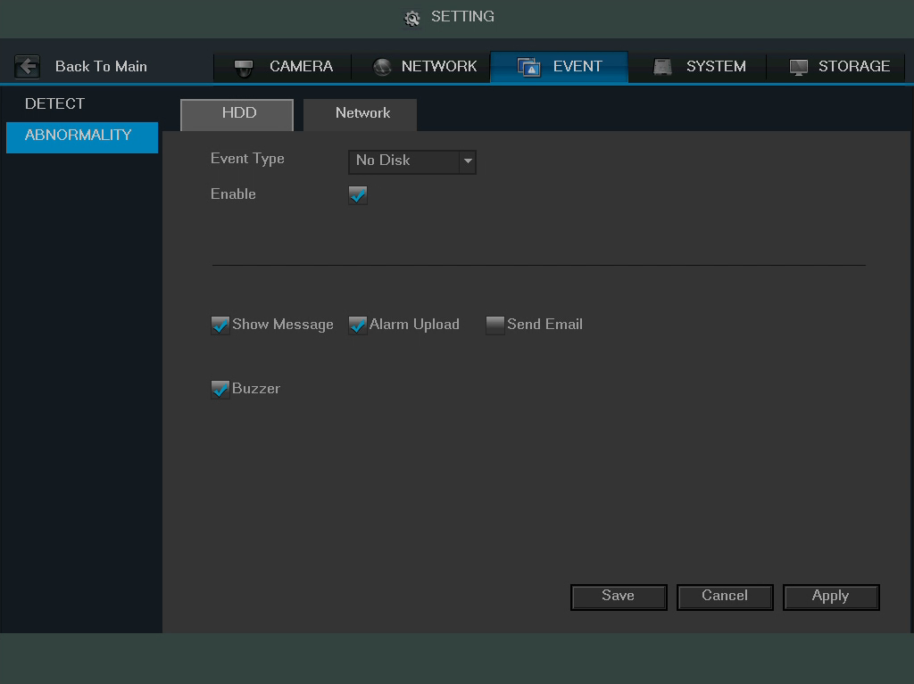

Below is an explanation of the fields on the HDD Abnormality settings screen:
- Event Type: This field allows the user to specify which HDD abnormality event type they would like to configure settings for.
  - No Disk: No hard drive is detected.
  - Disk Error: The hard drive has an error.
  - Disk No Space: The hard drive is about to, or has run out of space.
    - Less Than: This field allows the user to specify at what percentage of free disk space this condition should be triggered.
- Enable: This checkbox allows the user to enable the features below for the specified event type.
- Show Message: This checkbox allows the user to enable the system to show an on-screen message when an HDD abnormality occurs.
- Alarm Upload: This checkbox allows the user to enable the system to upload alarm information when an HDD abnormality occurs.
- Send Email: This checkbox allows the user to enable the system to send an email when an HDD abnormality occurs.
- Buzzer: This checkbox allows the user to enable the system to activate a buzzer when an HDD abnormality occurs.

To save settings, click the Save button near the bottom right hand corner. To cancel any modifications, click the Cancel button near the bottom right hand corner. To apply the settings, click the Apply button near the bottom right hand corner.

4.10.3.2.2 Network

This screen allows the user to specify actions that occur when there is an abnormality with the DVR’s network connection. Below is a screenshot of the Network Abnormality settings screen:
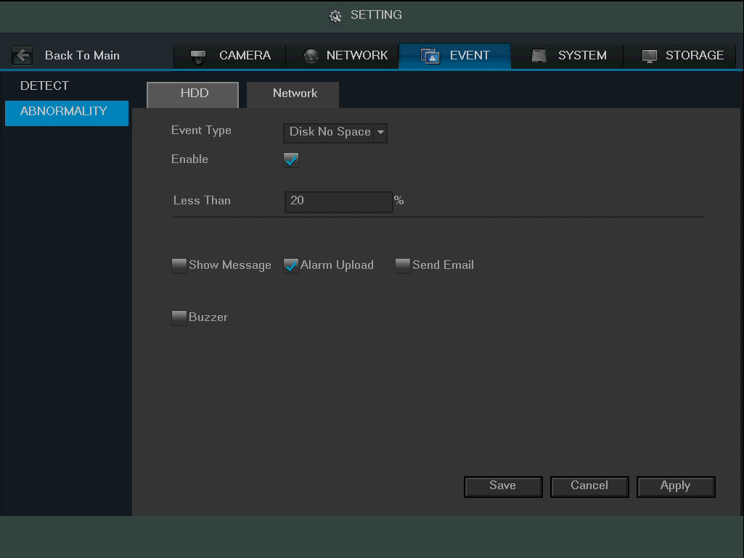

Below is an explanation of the fields on the Network Abnormality settings screen:
- Event Type: This field allows the user to specify which Network abnormality event type they would like to configure settings for.
  - Net Disconnected: The network connection has been disconnected.
  - IP Conflict: There is a device on the network with the same IP address.
  - MAC Conflict: There is a device on the network with the same MAC address.
- Enable: This checkbox allows the user to enable the features below for the specified event type.
- Show Message: This checkbox allows the user to enable the system to show an on-screen message when a network abnormality occurs.
- Send Email: This checkbox allows the user to enable the system to send an email when a network abnormality occurs.
- Record Channel: This checkbox allows the user to enable the system to start recording video when a network abnormality occurs. Multiple cameras can be specified to start recording based on this function.
- Buzzer: This checkbox allows the user to enable the system to activate a buzzer when a network abnormality occurs.
  - Delay: This field specifies in seconds how long the delay between alarm activation and buzzer activation should be.

To save settings, click the Save button near the bottom right hand corner. To cancel any modifications, click the Cancel button near the bottom right hand corner. To apply the settings, click the Apply button near the bottom right hand corner.

4.10.4 System

4.10.4.1 General

4.10.4.1.1 General

This screen displays general settings for the DVR. Below is a screenshot of the general settings screen:
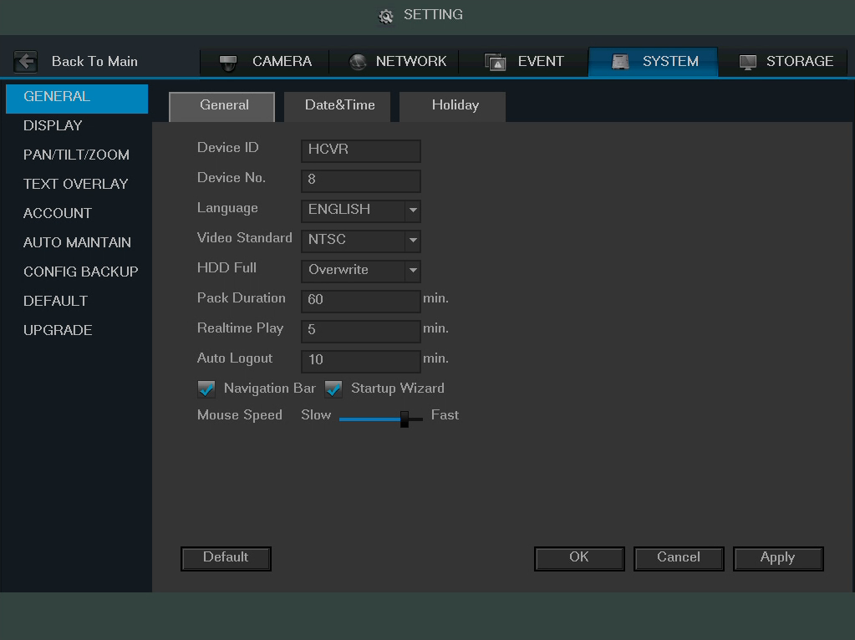

Below is an explanation of the fields on the General settings screen:
- Device ID: This field allows the user to customize the name of the HDCVI.
- Device No: This field allows the user to customize the device’s number.
- Language: This dropdown box allows the user to select a language for the DVR. Options include English, Simplified Chinese, Traditional Chinese, Italian, Japanese, French, and Spanish.
- Video Standard: This dropdown box allows the user to select a video standard. The options are between PAL and NTSC.
- HDD Full: This dropdown box allows the user to specify what to do when the HDD is full. There are two options:
  - Overwrite: This option lets the DVR overwrite the oldest recorded video on the DVR.
  - Stop Record: This option causes the DVR to stop recording once the HDD is full.
- Pack Duration: This field allows the user to define the recording duration. The default value is 60 minutes.
- Realtime Play: This field allows the user to set the playback time frame that is viewed in the preview interface. This value can range from 5 to 60 minutes.
- Auto Logout: This field allows the user to define in minutes how long the system can stay idle before a user is logged out. The value can range from 0 to 60 minutes.
- Navigation Bar: This checkbox allows the user to enable the navigation bar that shows on the main screen.
- Startup Wizard: This checkbox allows the user to enable the startup wizard the next time the system is restarted.
- Mouse Speed: This sliding scale allows the user to increase the movement and double click speed of the mouse.

To rest to default settings, click the Default button near the bottom left hand corner. To confirm settings, click the OK button near the bottom right hand corner. To cancel any modifications, click the Cancel button near the bottom right hand corner. To apply the settings, click the Apply button near the bottom right hand corner.

4.10.4.1.2 Date and Time

This screen displays date and time settings for the DVR. Below is a screenshot of the Date & Time settings screen:
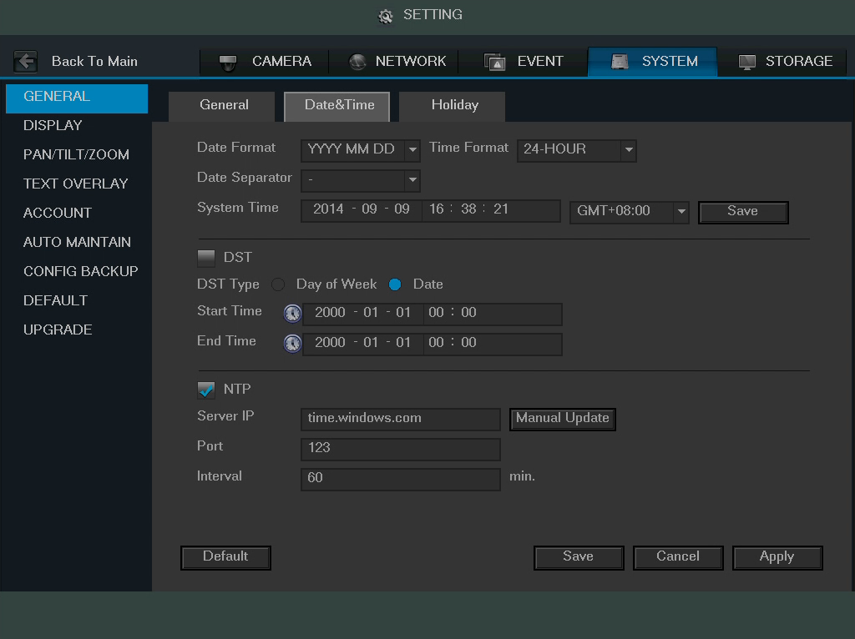
Below is an explanation of the fields on the Date & Time settings screen:
- Date Format: This dropdown box allows the user to specify a date and time format for the DVR to use. There are 3 options.
  - YYYY MM DD: Year, Month, Day.
  - MM DD YYYY: Month, Day, Year.
  - DD MM YYYY: Day, Month, Year.
- Time Format: This dropdown box allows the user to specify a time format for the DVR to use. There are two options.
  - 24 Hour
  - 12 Hour
- Date Separator: This dropdown box allows the user to specify a date separator. There are 3 options:
  - – Dash
  - / Forward Slash
  - _ Underscore
- System Time: This field allows the user to set the system time and time zone. Click Save to save the system time as it is shown in the display.
- Time Zone: This dropdown box allows the user to specify a time zone for the DVR to use.
- DST: This checkbox allows the user to activate DST for the system.
- DST Type: This field allows the user to pick whether DST starts on a specific day of the week, or on a specified.
- Start Time: This field allows the user to enter a start date and time for DST to begin.
- End Time: This field allows the user to enter an end date and time for DST to end on.
- NTP: NTP stands for Network Time Protocol. This checkbox allows the user to enable the use of an NST server to synchronize the date and time settings on the DVR.
- Server IP: This field allows the user to set the NTP server IP address. Clicking the Manual Update button pulls a time update from the server.
- Port: This field allows the user to set the NTP server port number.
- Interval: This field allows the user to set the NTP synchronization interval. This number determines how often the DVR queries the NTP server to get accurate date and time information. This value can be between 0 and 60 minutes.

To revert to default settings, click the Default button near the bottom left hand corner. To save settings, click the save button near the bottom right hand corner. To cancel any modifications, click the Cancel button near the bottom right hand corner. To apply the settings, click the Apply button near the bottom right hand corner.

4.10.4.1.3 Holiday

This screen displays the holiday settings for the DVR. Below is a screenshot of the Holiday settings screen:
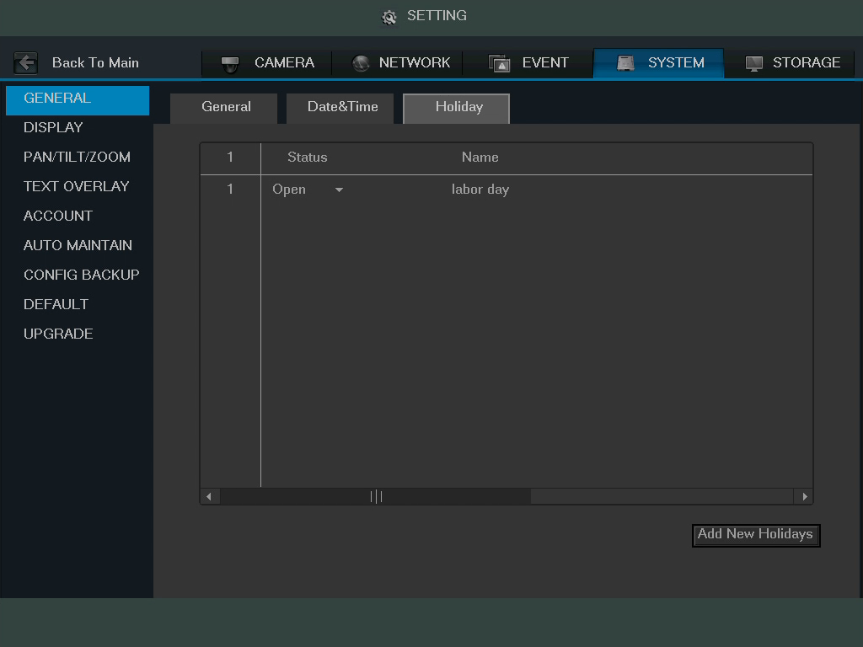

Below is an explanation of the fields on the Holiday settings screen:
- 1: This number indicates how many holidays are in the system. Each line item has a number to signify its place in the list.
- Status: This dropdown box indicates the status of the holiday. There are two options:
  - Open: The holiday is active, and the DVR will stop recording for that holiday period.
  - Stop: The holiday is inactive, and the DVR will continue normal operation for that holiday period.
- Name: This column is where the name of the holiday is displayed.
- Date: This column shows the date that the holiday occurs on.
- Period: This column shows the range in which the holiday occurs.
- Edit: This column has a button that allows for the editing of the holiday.
- Delete: This column has a button that allows for the deletion of the holiday.
- Add New Holidays: This button allows the user to add a holiday. Below is screenshot of the Add New Holidays screen.
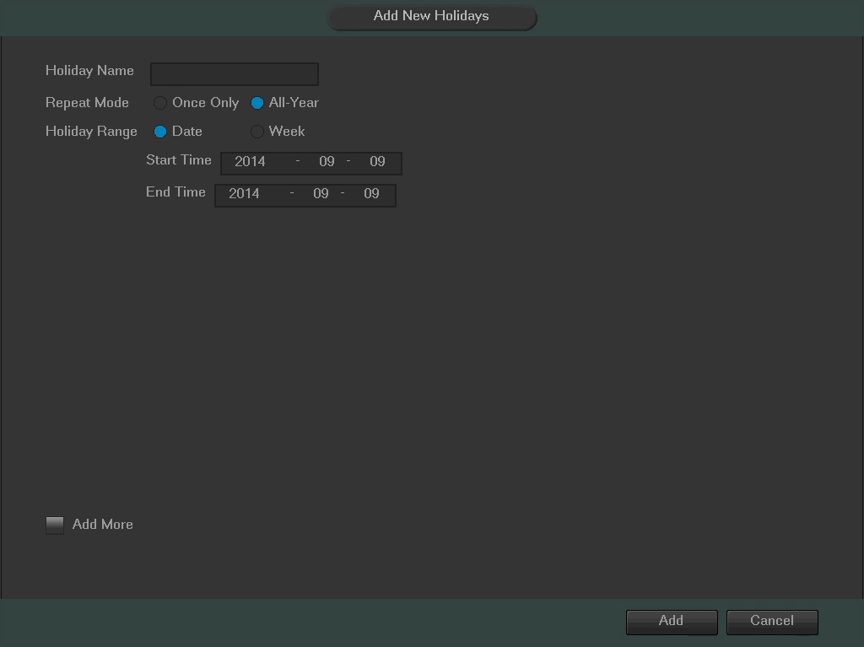

Note:
- Holidays take precedence over the scheduled setup.
- Holidays do not roll over based on their inherent date. Meaning, if a holiday is set for October 30th, then the system will treat every October 30th as a holiday.

4.10.4.2 Display

4.10.4.2.1 Display

This screen is used to set display settings for the DVR. Below is a screenshot of the display settings screen:
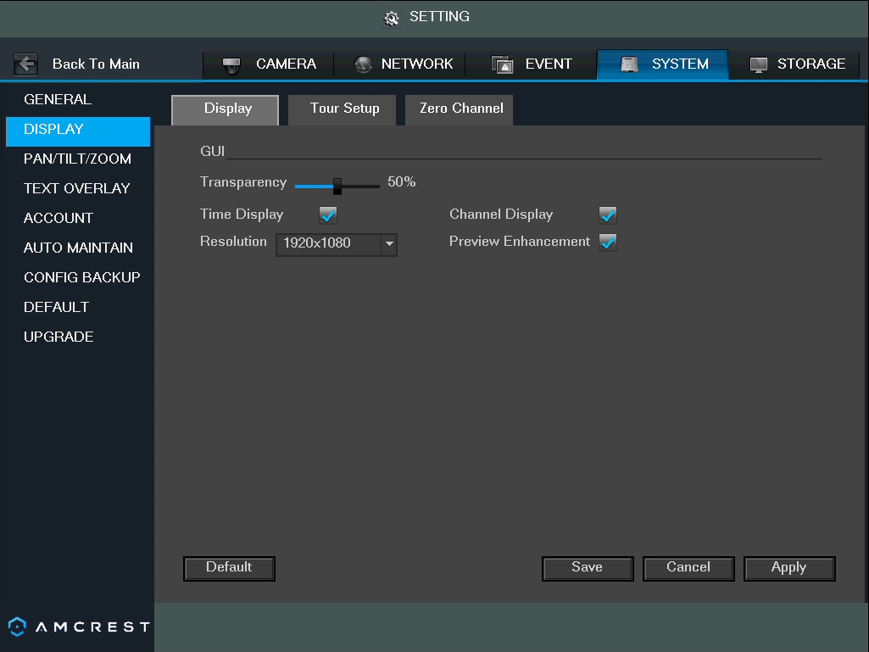

Below is an explanation of the fields on the Display settings screen:
- Transparency: This slider allows the user to change the transparency of the menu screens on the DVR. The range goes from 0% to 100%.
- Time Display: This checkbox allows the user to choose whether or not the time stamp shows in the playback video.
- Channel Display: This checkbox allows the user to choose whether or not the channel number is displayed in the playback video.
- Resolution: This dropdown box allows the user to change the resolution of the DVR. There are 4 options:
  - 1920×1080
  - 1280×1024 (default)
  - 1280×720
  - 1024×768
- Preview Enhancement: This checkbox allows the user to optimize the margin of the playback video.

To revert to default settings, click the Default button near the bottom left hand corner. To save settings, click the save button near the bottom right hand corner. To cancel any modifications, click the Cancel button near the bottom right hand corner. To apply the settings, click the Apply button near the bottom right hand corner.

4.10.4.2.2 Tour Setup

This screen is used to activate tour functionality for the live preview. Below is a screenshot of the Tour Setup screen:
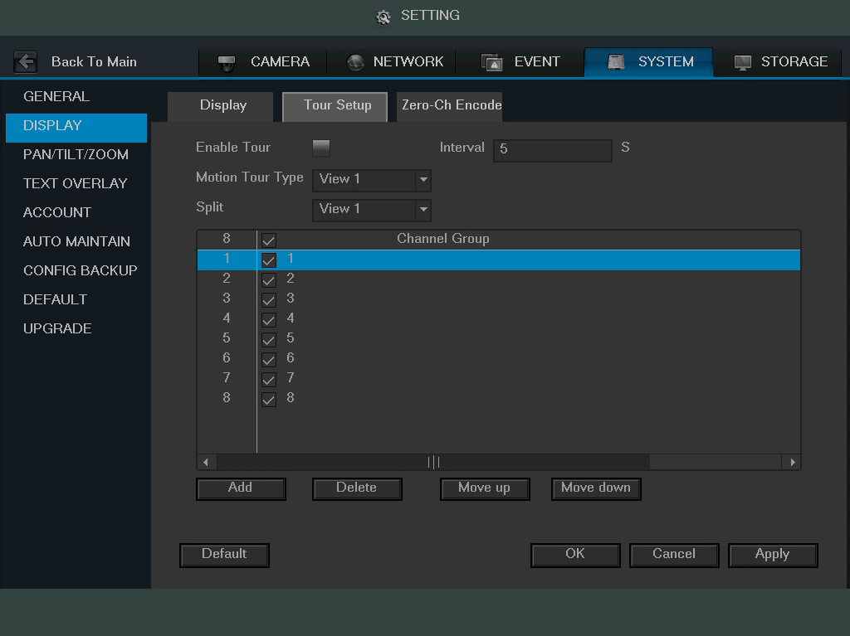

Below is an explanation of the fields on the Tour Setup settings screen:
- Enable Tour: This checkbox allows the user to enable the tour functionality.
  - An alternate way to enable or disable tour is by clicking or on the navigation bar.
- Interval: This field allows the user to set an interval in seconds for how quickly the tour cycles through channels. This value ranges from 5 to 120 seconds.
- Motion Tour Type: This dropdown box allows the user to select whether they want to see 1 or 4 cameras at a time in the tour.
- Channel List: This list allows the users to select channels add as a part of the tour. The number in the corner indicates how many channels are available.
  - Add: This button allows the user to add a channel to the tour.
  - Delete: This button allows the user to remove a channel from the tour.
  - Move Up: This button allows the user to move a camera up in the tour queue.
  - Move Down: This button allows the user to move a camera down in the tour queue.

To revert to default settings, click the Default button near the bottom left hand corner. To confirm settings, click the OK button near the bottom right hand corner. To cancel any modifications, click the Cancel button near the bottom right hand corner. To apply the settings, click the Apply button near the bottom right hand corner.

4.10.4.2.3 Zero-Ch Encode

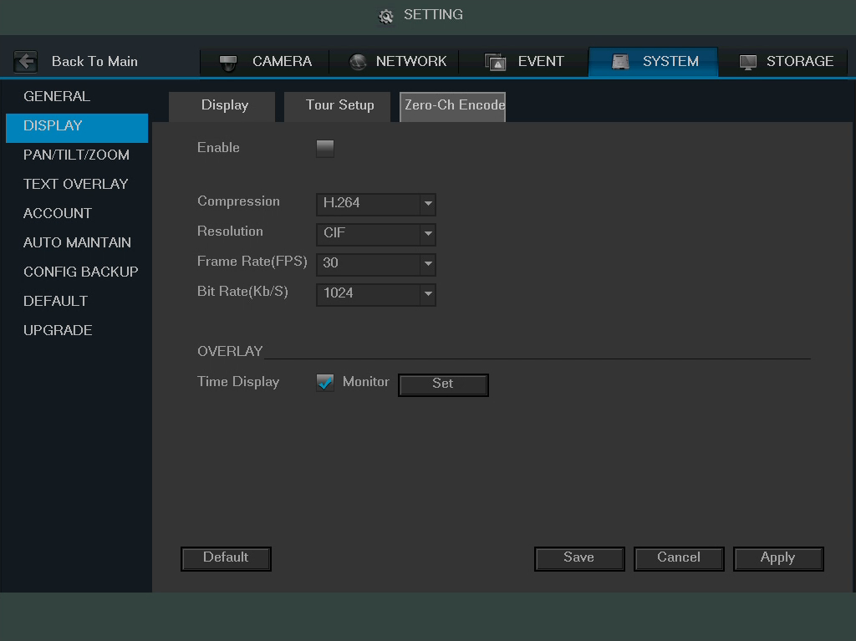
This screen is used to configure zero channel encoding functionality. This feature allows for the preview of several channels in one channel’s window. Note: This feature only works on the Web Access view. Below is a screenshot of the Zero-Channel Encoding settings screen:

Below is an explanation of the fields on the Zero-Channel Encoding settings screen:
- Enable: This checkbox allows the user to enable the zero-channel encoding functionality.
- Compression: This dropdown box allows the user to select the compression settings used by the system for zero-channel encoding. The default is H.264.
- Resolution: This dropdown box allows the user to select the resolution used by the system for zero-channel encoding. There are 2 options for resolution (in pixels):
  - CIF: 352 x 240
  - D1 720 x 480
- Frame Rate: This dropdown box allows the user to select the frame rate used by the system for zero-channel encoding. The range is between 1 and 30 frames per second.
- Bit Rate: This dropdown box allows the user to select the bit rate used by the system for zero-channel encoding. There are 7 options and all are measures in kilobytes per second (Kb/S):
  - 896
  - 1024
  - 1280
  - 1536
  - 1792
  - 2048
  - 4016
- Overlay: This checkbox allows the user to enable a timestamp on the zero-channel encoded video.
  - Set: This button allows the user to set a time stamp position on the video.
To revert to default settings, click the Default button near the bottom left hand corner. To save settings, click the save button near the bottom right hand corner. To cancel any modifications, click the Cancel button near the bottom right hand corner. To apply the settings, click the Apply button near the bottom right hand corner.

4.10.4.3 Pan/Tilt/Zoom

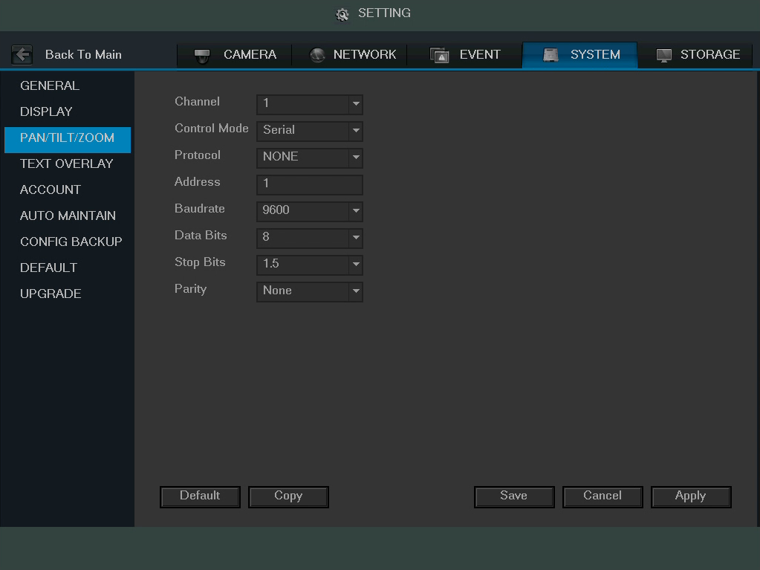
This screen is used to configure Pan/Tilt/Zoom (PTZ) functionality. Below is a screenshot of the PTZ settings screen:

Below is an explanation of the fields on the PTZ settings screen:
- Channel: This dropdown box allows the user to pick which channel they would like to change PTZ settings for.
- Control Mode: This dropdown box allows the user to pick which control move they would like to use for the specified channel. The two options are Serial and HDCVI.
- Protocol: This dropdown box allows the user to pick a protocol for the specified channel. Default is HDCVI.
- Address: This dropdown box allows the user to pick the corresponding PTZ address for the channel.
- Baud Rate: This dropdown box allows the user to pick a baud rate for the PTZ channel. The options are 1200, 2400, 4800, 9600, 19200, 38400, 57600, or 115200.
- Data Bits: This dropdown box allows the user to pick the amount of data bits for the PTZ transmission. The options are 5, 6, 7, or 8.
- Stop Bits: This dropdown box allows the user to pick the amount of stop bits for the PTZ transmission. The options are 1, 1.5, or 2.
- Parity: This dropdown box allows the user to pick the parity for the PTZ transmission. The options are none, odd or even.

To revert to default settings, click the Default button near the bottom left hand corner. To copy settings to another channel, click Copy near the bottom left hand corner. To save settings, click the save button near the bottom right hand corner. To cancel any modifications, click the Cancel button near the bottom right hand corner. To apply the settings, click the Apply button near the bottom right hand corner.

4.10.4.4 Text Overlay

This screen is used to configure Text Overlay settings. This allows the DVR to record data brought in from Automated Teller Machines (ATMs) or Point of Sales (POS) systems and overlay the text onto the recorded video. Below is a screenshot of the Text Overlay settings screen:
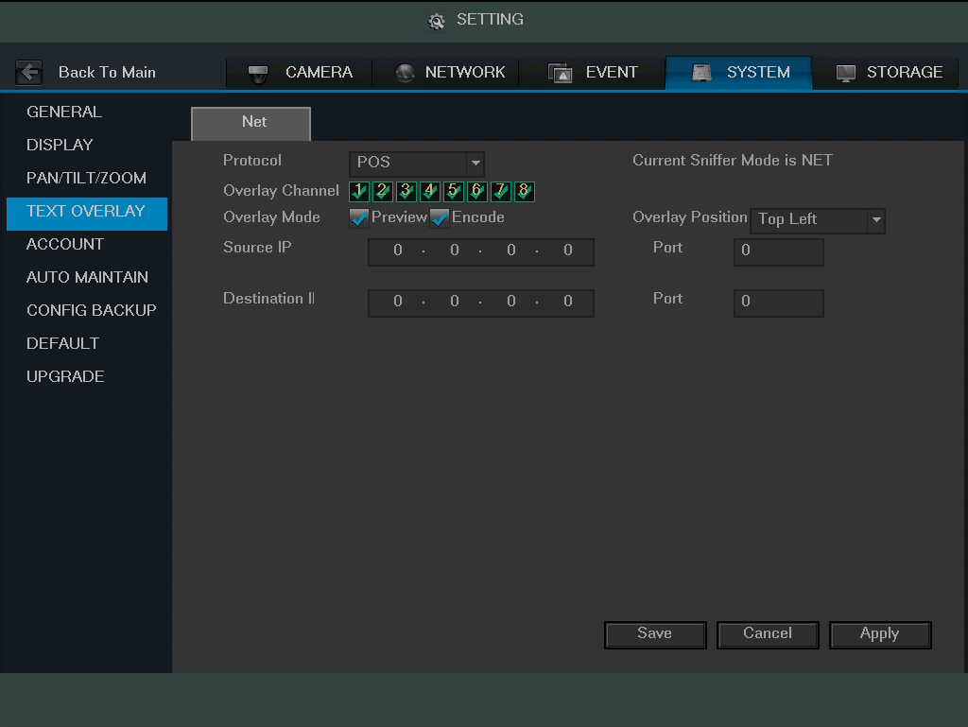

Below is an explanation of the fields on the Text Overlay settings screen:
- Protocol: This dropdown box allows the user to pick a protocol for text overlay. The options are ATM/POS and POS. Default is POS.
- Overlay Channel: This field allows the user to pick which overlay channels should be used with the video.
- Overlay Mode: These checkboxes allow the user to preview and enable the text overlay feature.
- Overlay Position: This dropdown box allows the user to pick which position for the overlaid text appears.
- Source IP: This field allows the user to enter the ATM or POS IP address and port number from which the text overlay data is gathered.
- Destination IP: This field allows the user to enter the ATM or POS IP address and port number to which the text overlay data is sent.

To save settings, click the save button near the bottom right hand corner. To cancel any modifications, click the Cancel button near the bottom right hand corner. To apply the settings, click the Apply button near the bottom right hand corner.

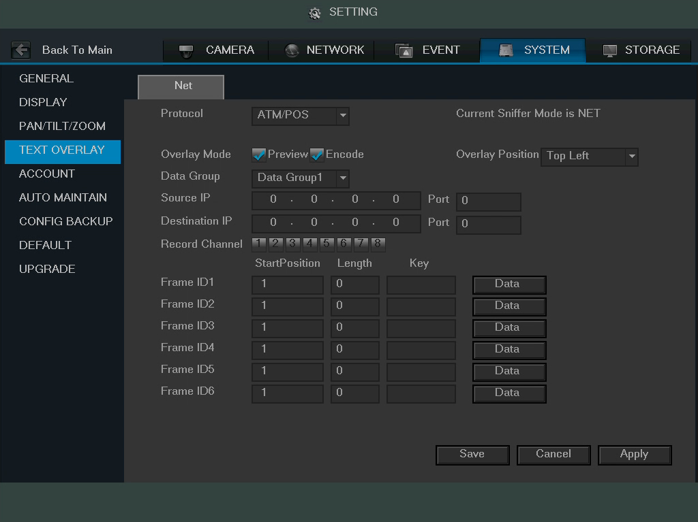
When the protocol ATM/POS is selected, the screen looks like the picture below:

4.10.4.5 Account

This menu is used to manage user accounts, user account passwords, and user groups. Below are a few considerations to keep in mind when editing this information:

- The DVR comes with 2 usernames by default:
  - Username: admin Password: admin
  - Username: default Password: default
- It is highly recommended to change the passwords for the admin and default accounts.
- Each user name and user group name can only contain letters, numbers, underline marks, dashes, or dots. No empty spaces are allowed.
- The maximum number of users is 64, and the maximum number of users that can be in one group is 20.
- There are two levels for user management: administrator and user. Administrator has more rights than a normal user and can modify key DVR settings.
- Each user can belong to only one group, and user rights cannot exceed group rights.

4.10.4.5.1 User

This screen is used to configure User Account settings. Below is a screenshot of the User Account settings screen:
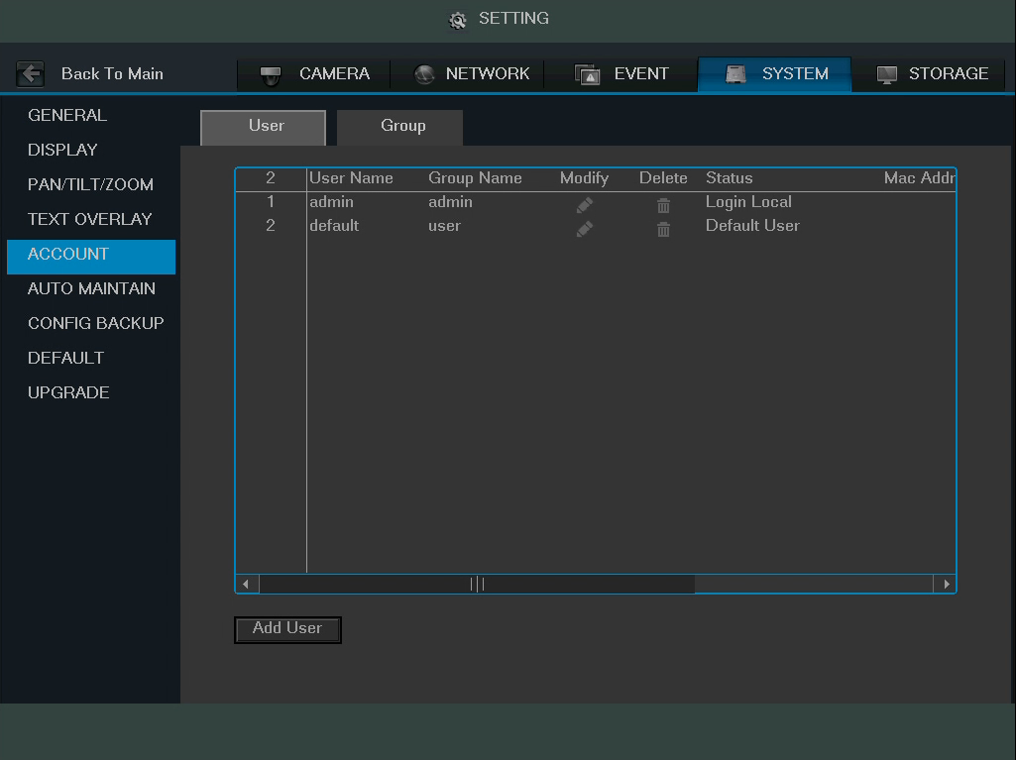

Below is an explanation of the fields on the User Account settings screen:
- Number: This number indicates how many users are in the system. Each line item has a number to signify its place in the list.
- User Name: This column indicates an account's username.
- Group Name: This column shows which group the username belongs to.
- Modify: This column has a button that allows for the account's properties to be edited.
- Delete: This column has a button that allows for the account's properties to be deleted.
- Status: This column shows what the status of a certain account is.
- MAC Address: This column shows the account's MAC address.
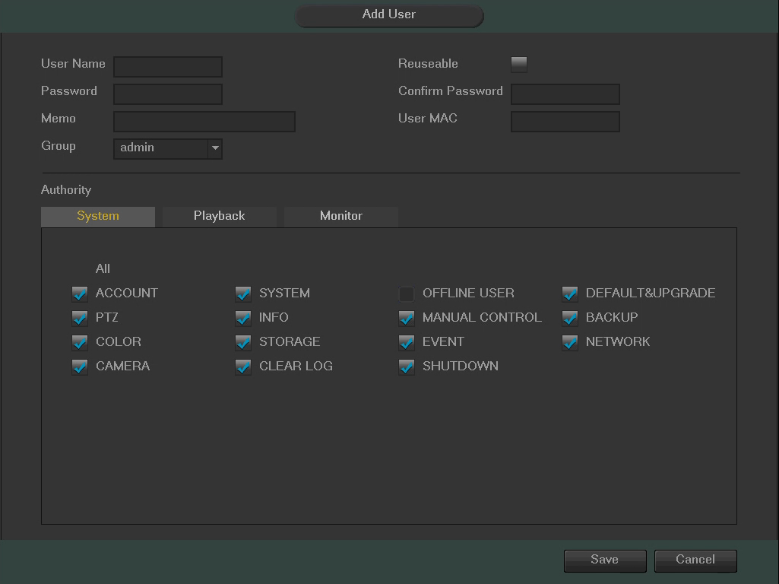
- Add User: This button allows the user to add another user account. Below is a screenshot of the Add User screen.

Note:
- It is recommended to give the general user fewer rights than an administrative one.
- When a new user is created, a MAC address can be entered for the user. This can limit the user's ability to logon from another device. If left blank, the user can logon from any MAC address.
- There are a total of 98 rights that can be assigned to a user.

4.10.4.5.2 Group

This screen is used to configure Group Account settings. Below is a screenshot of the Group Account settings screen:
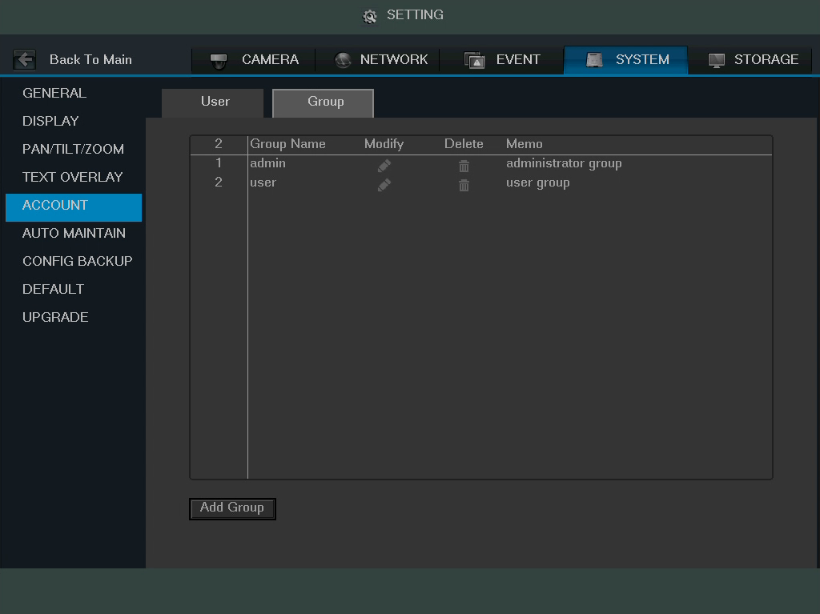

Below is an explanation of the fields on the User Group settings screen:
- Number: This number indicates how many groups are in the system. Each line item has a number to signify its place in the list.
- Group Name: This column indicates an account's username.
- Modify: This column has a button that allows for the account's properties to be edited.
- Delete: This column has a button that allows for the account's properties to be deleted.
- Memo: This column indicates any notes about the user group.
- Add Group: This button allows the user to add another user group. On the next page is a screenshot of the Add Group screen.

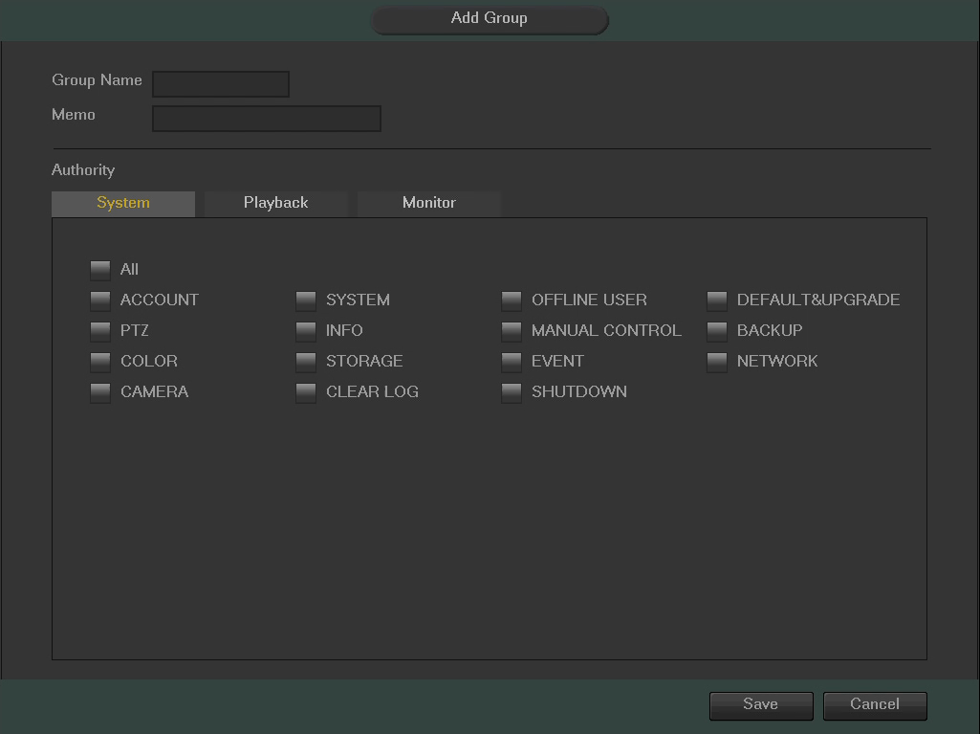
Note:
- It is recommended to give the general user fewer rights than an administrative one.
- There are a total of 98 rights that can be assigned to a user.

4.10.4.6 Auto Maintain

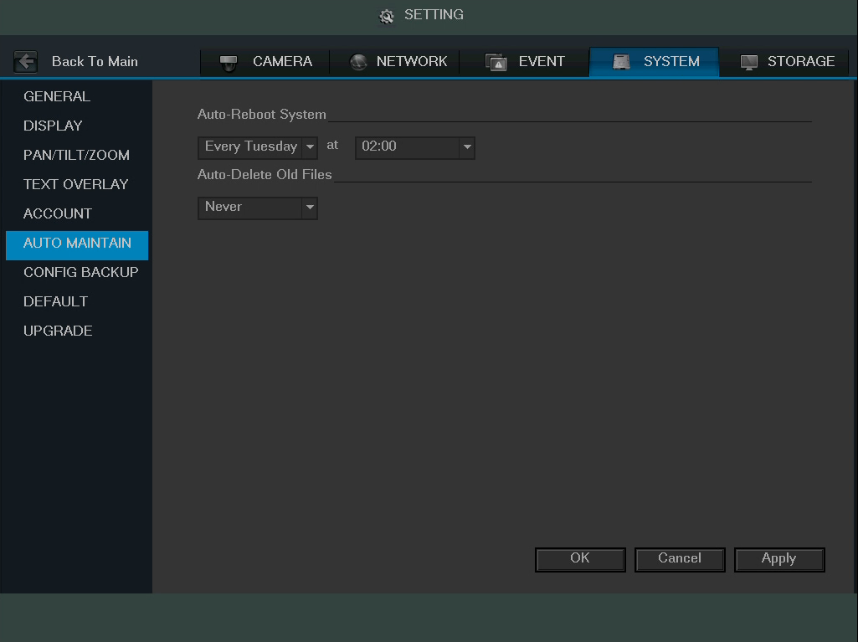
This screen is used to configure Auto Maintenance settings for the DVR. Below is a screenshot of the Auto Maintain settings screen:

Below is an explanation of the fields on the Auto Maintain settings screen:
- Auto Reboot System: This dropdown field allows the user to set a day of the week and time to automatically reboot the system in order to keep the system healthy.
- Auto Delete Old Files: This dropdown field allows the user to delete old files. The two settings are Never and Customized. When customized is selected, a number of days can be specified. Any files that exist past that many days in the past are deleted to create space on the DVR's hard drive.

To confirm settings, click the OK button near the bottom right hand corner. To cancel any modifications, click the Cancel button near the bottom right hand corner. To apply the settings, click the Apply button near the bottom right hand corner.

4.10.4.7 Config Backup

This screen is used to manage importing and exporting of system configurations. This feature can be used to clone the settings from one DVR to another. Below is a screenshot of the Config Backup settings screen:
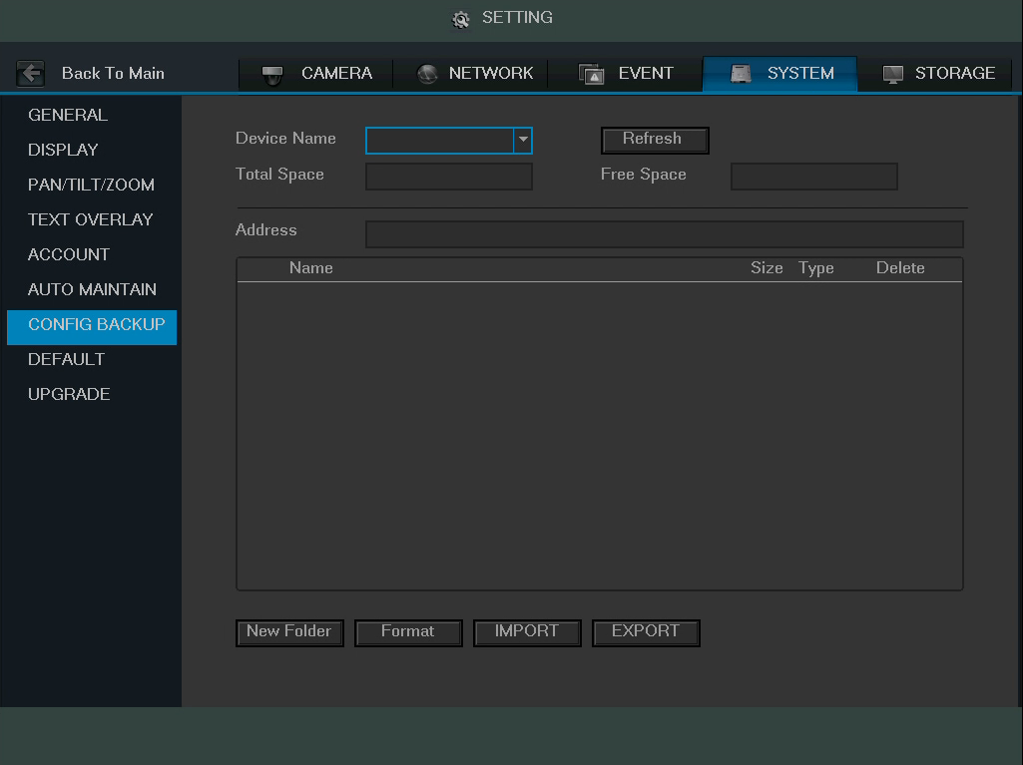

Below is an explanation of the fields on the Config Backup settings screen:
- Device Name: This dropdown field allows the user to select a device to pull configuration data from.
- Refresh: This button refreshes the list of devices connected to the DVR.
- Total Space: This field displays the total storage capacity on the selected device.
- Free Space: This field displays the remaining storage capacity on the selected device.
- New Folder: This button allows the user to create a new folder on the selected device.
- Format: This button allows the user to format the selected device.
- Import: This button allows the user to import configuration data to the DVR.
- Export: This button allows the user to export current configuration data to another device.

4.10.4.8 Default

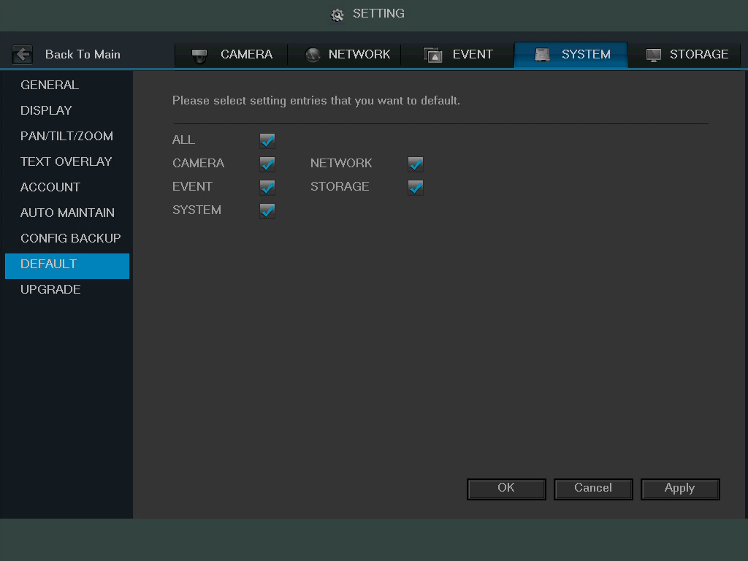
This screen is used to revert the DVR back to its default settings. This feature can be used to restore the DVR to its factory setup conditions. Below is a screenshot of the Default settings screen:
There are 5 different settings areas that can be reset to default settings: Camera settings, Event settings, Network settings, System settings, and Storage settings. All of these settings can be reset by the use of the All checkbox.
The following settings are also reset with a factory reset:
- System Menu Color
- Language
- Time Display Mode
- Video Format
- IP Address
- User Accounts
To confirm settings, click the OK button near the bottom right hand corner. To cancel any modifications, click the Cancel button near the bottom right hand corner. To apply the settings, click the Apply button near the bottom right hand corner.

4.10.4.9 Update

This screen is used to update the DVR's firmware to the latest version. To conduct a system update, it is required to put an update file onto a USB storage device and plug it into the DVR. Ensure the update file is named update.bin.

Below is a screenshot of the Update screen:
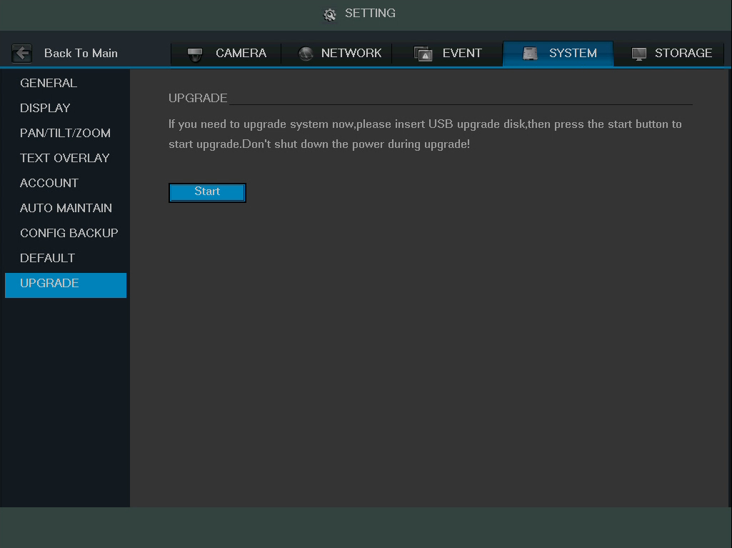

Once the USB device with the firmware update is plugged in, navigate to this screen and click the Start button to begin the firmware update process.

4.10.5 Storage

This set of menu items deal with storage of data on the DVR.

4.10.5.1 Schedule

This screen is used to specify the recording schedule for both recorded video and snapshots.

4.10.5.1.1 Record

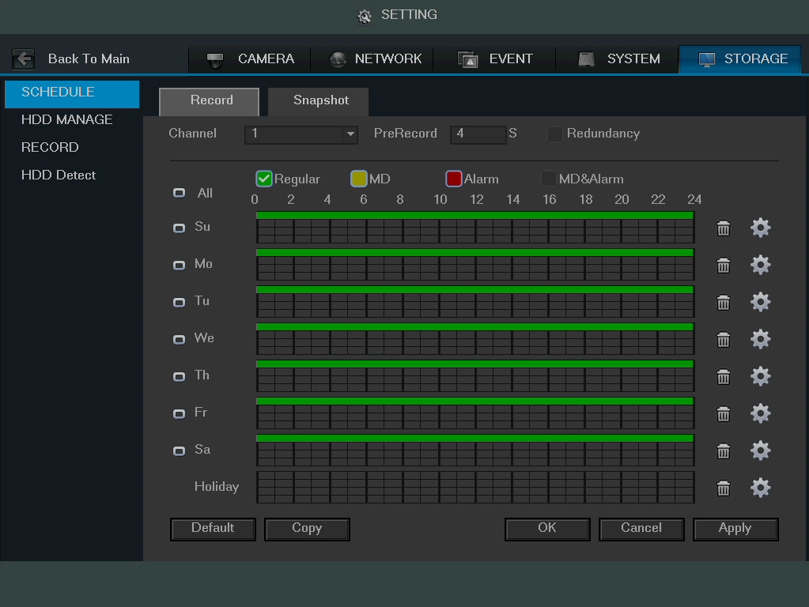
This tab is where video recording settings are configured. Below is a screenshot of the Record settings screen:

Below is an explanation of the fields on the Record settings screen:
- Channel: This dropdown box allows the user to pick which channel they would like to change video recording settings for.
- PreRecord: This field allows the user to capture extra video that occurs before an event. Up to 30 seconds of video prior to a recording event can be captured in order to provide context to a recording.
- Redundancy: This checkbox allows the user to enable the redundancy backup feature. This feature allows the DVR to record video to two hard drives concurrently in order to ensure that in the case of a hard drive failure, the recorded data may be backed up to another hard drive.
  - Note: This function only works if the HDD has two hard drives installed.
  - Note: One hard drive has to be designated as redundant from the HDD Manager menu. See section 4.10.5.2 for more details.
- Record Type: These checkboxes allow the user to select which recording type they want to configure on the schedule. There are 4 types of recordings:
  - Regular: Regular recording means that the DVR captures all footage for the specified time period. Regular recording is represented by the color green.
  - MD: Motion Detection recording means that the DVR captures only footage when the motion detection alarm is activated. MD recording is represented by the color yellow.
  - Alarm: Alarm recording means that the DVR captures only footage when an alarm is activated. Alarm recording is represented by the color red.
  - MD & Alarm: This type of recording is a combination of motion detection and alarm footage, and records when either a motion detection alarm or general alarm is activated. MD & Alarm recording is represented by the color white.
- Video Recording Schedule: To specify a video recording range, first select the type of recording desired, then click and drag on time bar for the desired date. To edit multiple days at once, either click the checkboxes next to the days desired, or click the “All” checkbox in order to edit all of the days at once. Once the checkbox is clicked, it will turn into this icon in order to indicate that all of those days can be changed together. Click OK to return to the video loss settings screen. Click Cancel to undo any changes and return to the recording settings screen. Click Default to use the default settings.
  - In order to specify time zones in greater detail for each day, click the button to the left of the time bar, and the Time Period setup screen will appear. The screenshot below shows the Time Period settings screen:
  - The system allows for the configuration of up to 6 different time periods. Click the checkbox to the left of the time period to enable that time period. Click the text next to each period to edit the time period. To copy time periods, click the checkboxes next to the days of the week that you’d like to copy the settings to. Once finished on this screen, click Save to return to the time period settings screen.
  - To delete the video recording settings for a particular day, click the button next to the time bar for that day.
- Holiday: Holiday settings are configured in the System settings section. See section 4.10.4.1.3 for more information on holiday settings.

To revert to default settings, click the Default button near the bottom left hand corner. To copy settings to another channel, click Copy near the bottom left hand corner. To confirm settings, click the OK button near the bottom right hand corner. To cancel any modifications, click the Cancel button near the bottom right hand corner. To apply the settings, click the Apply button near the bottom right hand corner.

4.10.5.1.2 Snapshot

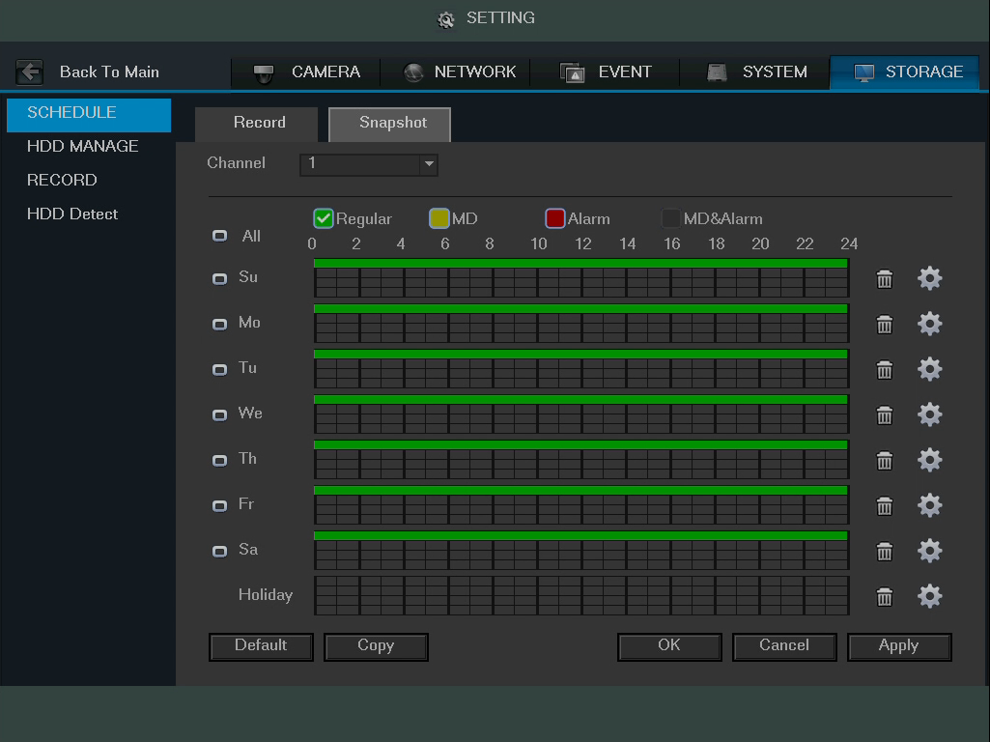
This tab is where snapshot recording settings are configured. Below is a screenshot of the Snapshot settings screen:

Note: Prior to setting up a schedule for snapshots in this menu, it is highly recommended to do the following 3 steps.

- Go to Main Menu -> Settings -> Storage -> Record and enable snapshot for any channels that may be using this feature. For more information, see section 4.10.5.3.
- Go to Main Menu -> Settings -> Camera -> Encode -> Snapshot Interface and configured the settings on this page. For more information, see section 4.10.1.2.2.
- Go to Main Menu -> Settings -> Event -> Detect and enable snapshot for any specified channels for motion detection, video loss, and video masking. For more information, see sections 4.10.3.1.1, 4.10.3.1.2, and 4.10.3.1.3.

Below is an explanation of the fields on the Snapshot settings screen:
- Channel: This dropdown box allows the user to pick which channel they would like to change video recording settings for.
- Record Type: These checkboxes allow the user to select which recording type they want to configure on the schedule. There are 4 types of recordings:
  - Regular: Regular recording means that the DVR captures all footage for the specified time period. Regular recording is represented by the color green.
  - MD: Motion Detection recording means that the DVR captures only footage when the motion detection alarm is activated. MD recording is represented by the color yellow.
  - Alarm: Alarm recording means that the DVR captures only footage when an alarm is activated. Alarm recording is represented by the color red.
  - MD & Alarm: This type of recording is a combination of motion detection and alarm footage, and records when either a motion detection alarm or general alarm is activated. MD & Alarm recording is represented by the color white.
- Snapshot Recording Schedule: To specify a snapshot recording range, first select the type of recording desired, then click and drag on time bar for the desired date. To edit multiple days at once, either click the checkboxes next to the days desired, or click the “All” checkbox in order to edit all of the days at once. Once the checkbox is clicked, it will turn into this icon in order to indicate that all of those days can be changed together. Click OK to return to the video loss settings screen. Click Cancel to undo any changes and return to the snapshot settings screen. Click Default to use the default settings.
  - In order to specify time zones in greater detail for each day, click the button to the left of the time bar, and the Time Period setup screen will appear. The screenshot below shows the Time Period settings screen:
  - The system allows for the configuration of up to 6 different time periods. Click the checkbox to the left of the time period to enable that time period. Click the text next to each period to edit the time period. To copy time periods, click the checkboxes next to the days of the week that you’d like to copy the settings to. Once finished on this screen, click Save to return to the time period settings screen.
  - To delete the snapshot recording settings for a particular day, click the button next to the time bar for that day.
- Holiday: Holiday settings are configured in the System settings section. See section 4.10.4.1.3 for more information on holiday settings.

Note: Alarm activated snapshots have higher recording priority than scheduled snapshots. If there is an overlap, alarm activated snapshots will take precedence.

Note: To enable FTP upload of snapshots, connection to an FTP server must be configured. See section 4.10.2.7 for more information.

To revert to default settings, click the Default button near the bottom left hand corner. To copy settings to another channel, click Copy near the bottom left hand corner. To confirm settings, click the OK button near the bottom right hand corner. To cancel any modifications, click the Cancel button near the bottom right hand corner. To apply the settings, click the Apply button near the bottom right hand corner.

4.10.5.2 HDD Manage

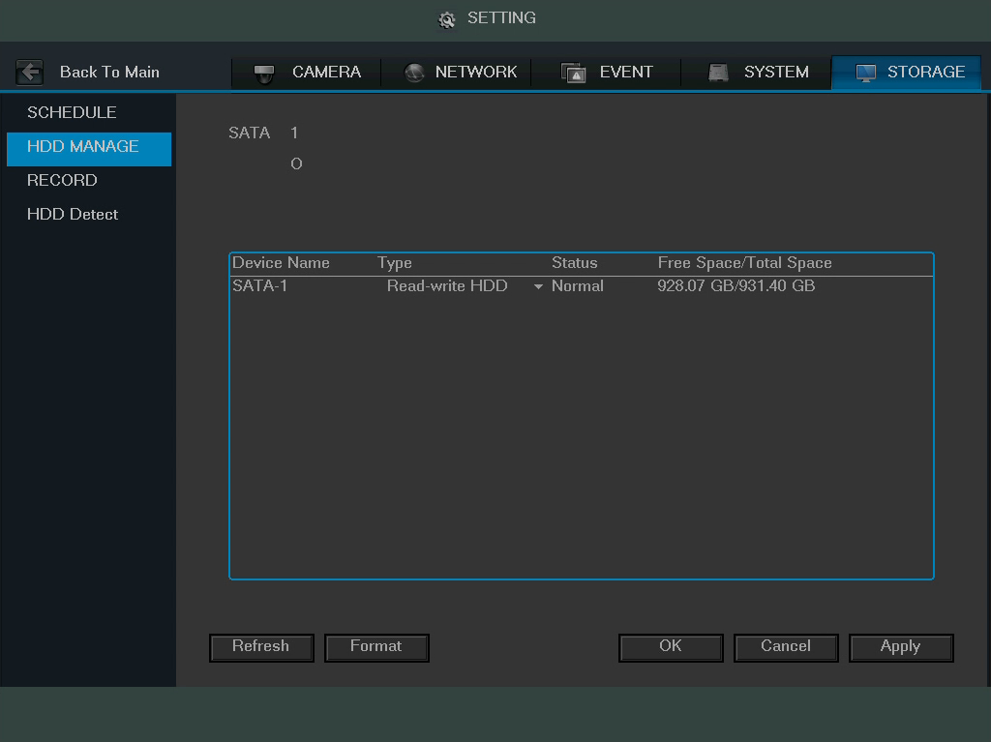
This screen is meant to help the user monitor the DVR’s hard drives. Using this screen, the user can see the current HDD type, status, and capacity. The user can also use this screen to format hard drives and change hard drive properties. Below is a screenshot of the HDD Manage settings screen:

Below is an explanation of the fields on the HDD Manage settings screen:
- SATA:
  - This shows how many hard drives the system can support.
  - 1 here means the system supports a maximum of 1 HDD.
  - The symbol on the next row shows the status of the connected hard drive.
    - 0 means that the current HDD is functioning normally.
    - X means there is an error with the hard drive connection, or that there is no connected hard drive.
    - ? means that the hard drive is damaged and should be replaced.
- Hard Drive List:
  - This shows what hard drives are currently connected to the DVR, and displays information about them.
  - Device Name: This column shows the names of the connected hard disk drives (HDD).
  - Type: This column shows the type of access the DVR has to the hard drive. To change a hard drive’s type, click the downward arrow next to the HDD’s type and select the desired type. There are 3 possible settings:
    - Read-Only: This allows the DVR to read the data, but not modify it in anyway.
    - Write-Only: This allows the DVR to write data to the HDD, but not read any data from it.
    - Read/Write: This allows the DVR to both read and write data on the HDD.
  - Status: This column shows the status of the connected hard drive. There are 3 statuses:
    - Normal: This means the hard drive is operating normally.
    - Error: This means the DVR is experiencing an error when attempting to access the hard drive.
    - Disconnected: This means that the HDD has disconnected from the DVR.
  - Free Space/Total Space: This field shows the free space on the hard drive compared to its total capacity.

To refresh the hard drive list, click Refresh near the bottom left hand corner. To format a hard drive, select a hard drive to format from the list, and then click Format near the bottom left hand corner. To confirm settings, click the OK button near the bottom right hand corner. To cancel any modifications, click the Cancel button near the bottom right hand corner. To apply the settings, click the Apply button near the bottom right hand corner.

4.10.5.3 Record

This screen allows the user to specify which channels are able to record and take snapshots. The settings on this screen supersede all others when it comes to allowing channels the ability to record information. Below is a screenshot of the Record screen:
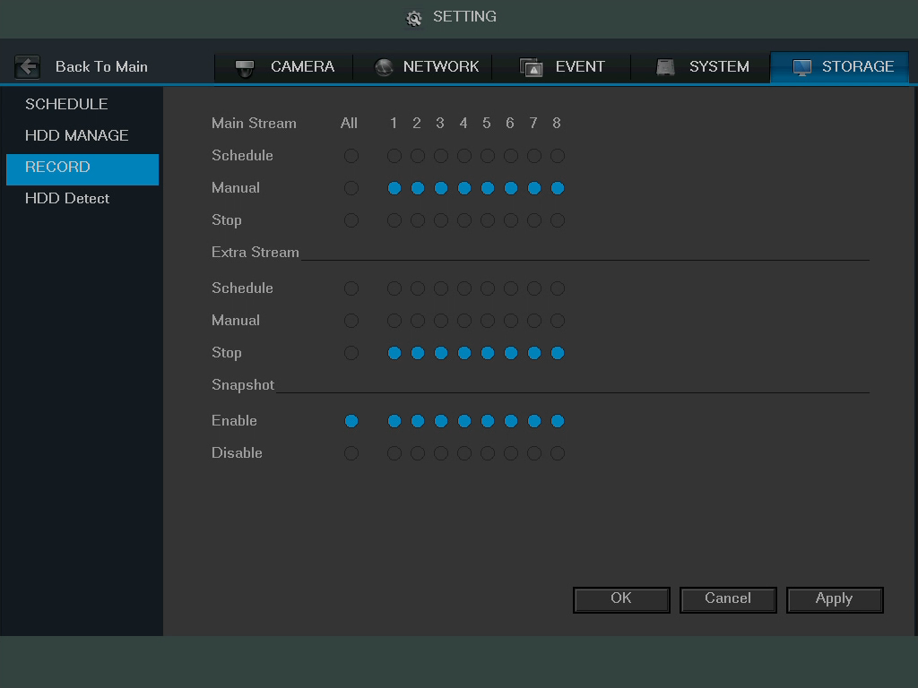

Below is an explanation of all of the fields on the Record settings page:
- Main Stream: The main stream is the stream through which the channels transmit data by default. There are 3 settings that can be used for the main stream.
  - Schedule: Channels will record as they have been scheduled, and not in any other capacity.
  - Manual: Channels will support all recording type. This includes scheduled recording.
  - Stop: Channels will not record in any capacity. This includes scheduled and manual recording.
- Extra Stream: Otherwise known as the sub stream, this stream allows for additional data to be transmitted. There are 3 settings that can be used for the main stream.
  - Schedule: Channels will record as they have been scheduled, and not in any other capacity.
  - Manual: Channels will support all recording type. This includes scheduled recording.
  - Stop: Channels will not record in any capacity. This includes scheduled and manual recording.
- Snapshot: This set of options can either enable or disable the snapshot functionality for specific channels.
To confirm settings, click the OK button near the bottom right hand corner. To cancel any modifications, click the Cancel button near the bottom right hand corner. To apply the settings, click the Apply button near the bottom right hand corner.

4.10.5.4 HDD Detect

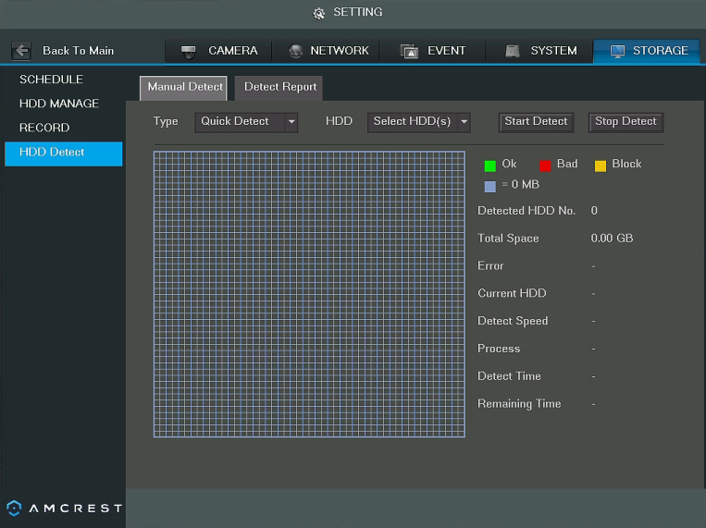
This screen allows the user to run an error detection report on the DVR’s hard drives. Below is a screenshot of the HDD Detect settings menu:

Below is an explanation of the fields on the HDD Detect settings page:
- Type: This dropdown box allows the user to select which type of HDD detection report to run. There are two options:
  - Quick Detect: Quick detect runs a quick hard drive error detection report.
  - Full Detect: Full detect runs a more detailed hard drive error report, and may take more time.
- HDD: This dropdown box allows the user to select which HDD to run the HDD detection report on. Multiple hard drives can be selected.
- Start Detect: This button started the HDD detection report.
- Stop Detect: This button stops the HDD detection report.

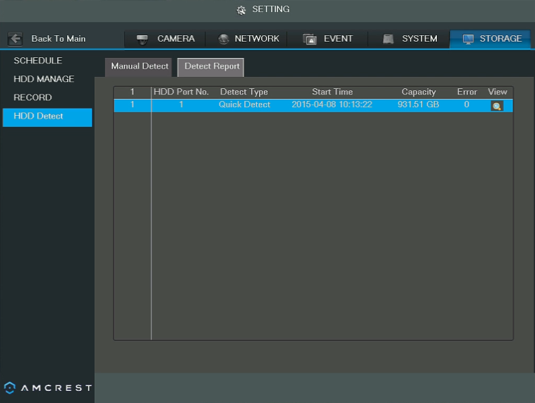
Once the report is done, the results show in the Detect Report tab. Below is a screenshot of the detect report tab:
To view detailed results of the report, double click the line item, or click the magnifying glass in the view column of the report. The detailed view looks like the screenshot below:
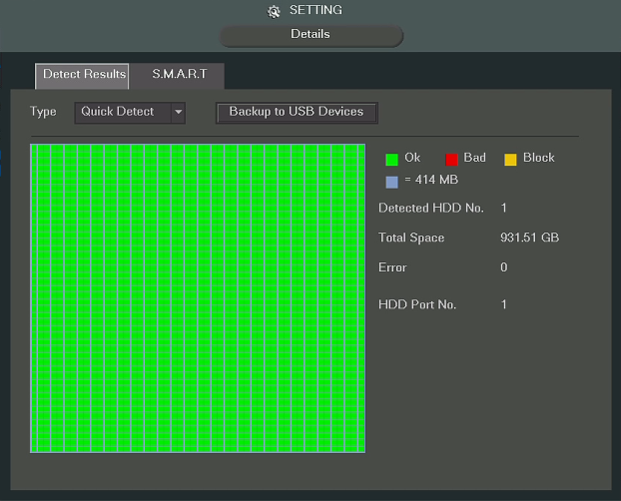

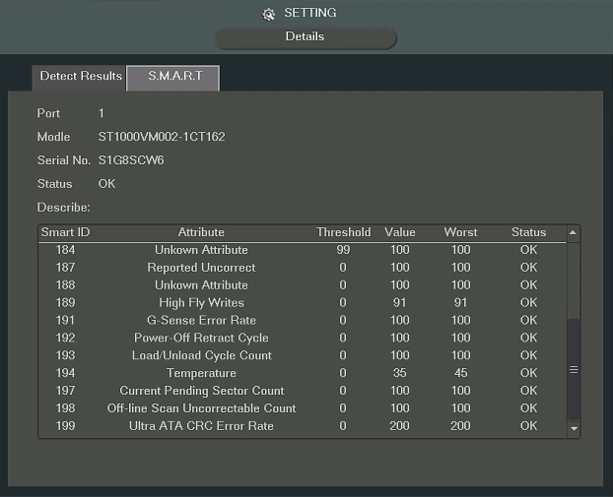
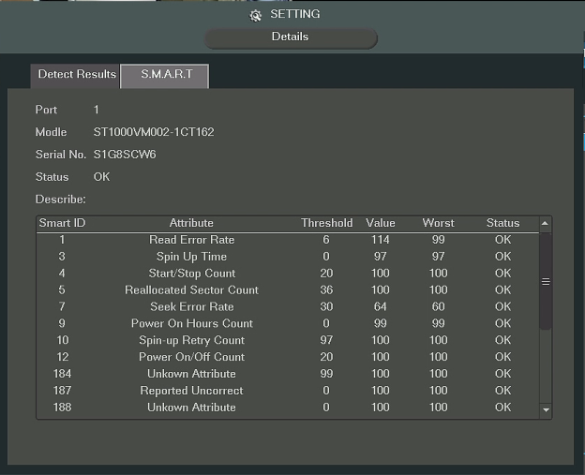
The Detect Results tab shows a visual representation of the hard drive scan results. The S.M.A.R.T. tab shows S.M.A.R.T. report results. For more information on S.M.A.R.T., see section 4.9.1.1. The S.M.A.R.T. tab looks like the screenshots below:

5 Web Operation

One of the main features of the Amcrest HDCVI DVR is the ability to access the DVR and all of its features through the web. Whether you want to view the live feed from remote location, or you want the ability to display the live feed on multiple computers on your local network, the Amcrest HDCVI DVR can accommodate all of those needs.

To enable web client operation, ensure the following items are completed:
- The DVR is connected to the Network via an Ethernet cable.
- The DVR and the PC are on the same network OR the DVR has been configured for remote access. Please refer to section 4.10.2 for more information.
- Use one of the following web browsers: Safari, Internet Explorer, Mozilla Firefox, or Google Chrome.

5.1 Local Web Access

To view a video on how to setup the HDCVI DVR for Local Access go to http://amcrest.com/videos and view the video titled
“How to Setup Amcrest HDCVI DVR for Local Access”.

Below is a step-by-step walkthrough that details how to setup the HDCVI for Local Web Access:

- Login to your DVR, open the main menu then go to Settings -> Network.
- Open the TCP/IP settings screen.
- By default, the DVR has the mode set to Static. Click the radio button next to DHCP to change this to DHCP. The IP Address, Subnet Mask, Default Gateway, Preferred DNS, and Alternate DNS should all change to 0s.
- Click Save to save these settings. This should now open the main menu.
- From the main menu, go to Settings -> Network.
- On the TCP/IP settings screen, the IP Address, Subnet Mask, Default Gateway, Preferred DNS, and Alternate DNS should all be populated.
- Click the radio button next to Static, to change the mode to Static.
- Write down the IP Address that is currently in the IP address field.
- Click the Save button.
- Open an internet browser, and type the IP address from step 8 into the address bar and hit enter.
- The browser may prompt you to install a plugin. Click install to download the plugin, and then click on the plugin installation file to install the plugin.
- If the browser prompts you to allow the plugin to work on the computer, hit Allow to ensure the plugin can run successfully.
- Enter in login details into the username and password fields.
- Click the LAN option, and then click Login.
- Once the main interface opens, click the plug icons next to each camera on the list on the left hand side, and activate the main stream for each of them to enable the live feed.

If the process above is not working, please contact Amcrest Support via one of the following options:
- Visit http://amcrest.com/contacts and use the email form
- Call Amcrest Support using one of the following numbers
Toll Free: (888) 212-7538
International Callers (Outside of US): +1-713-893-8956
USA: 713-893-8956
Canada: 437-888-0177
UK: 203-769-2757
- Email Amcrest Customer Support support@amcrest.com

5.2 Remote Web Access

There are two main methods for setting up remote access: UPnP/DDNS, and Port Forwarding.

5.2.1 UPnP/DDNS Remote Access Setup

Using Universal Plug and Play (UPnP) and Dynamic Domain Name Server (DDNS) functionality is the easiest way to setup stable remote access. For this method, your router should support the uPnP networking protocol and the protocol should be enabled. Please refer to your router manufacturer’s documentation to learn how to enable uPnP on your router.

To view a video on how to setup the HDCVI for UPnP/DDNS remote access go to http://amcrest.com/videos and view the video titled
“How to Gain Remote Access to Your HDCVI DVR with Universal Plug and Play”.

Below is a step-by-step walkthrough that details how to setup the HDCVI for Remote Web Access using UPnP and DDNS:

- Login to your DVR, open the main menu then go to Settings -> Network.
- Using the left hand menu, go to the Connection menu, and write down the HTTP port. It is recommended to ensure the port number is at least 5 digits long to prevent any port conflicts. If need be, change the port to a 5 digit number that is less than 65535, note the number down, and click save before proceeding to the next step.
- The system will prompt you to reset the DVR. Click OK and wait for the DVR to restart.
- Login to your DVR, open the main menu then go to Settings -> Network.
- Click the Connections menu item on the left hand menu, and ensure that the HTTP port has changed.
- Click the DDNS menu item on the left hand menu, click the enable checkbox, and then click the Apply button on the bottom right.
- Write down the entire Domain Name field, including the white text that says .quickddns.com
- Click the UPnP menu item on the left hand menu, and click the enable radio button at the top.
- While in the UPnP menu, double click the HTTP port, and change both the internal and external HTTP ports to match the number that was used in step 2.
- Uncheck the last 4 checkboxes in the PAT table on the UPnP menu.
- Click apply, and ensure the UPnP status field says “Searching.”
- Exit this menu to go back to the main menu, then re-enter the UPnP menu, and ensure the UPnP status says “Success”.
- Open a web browser and enter in the DDNS domain name address from step 3, enter in a colon, then type the port number from step 4 on to the end.
  - For example, if the DDNS domain name is http://abc123456789.quickddns.com and your HTTP Port is 33333, the URL would be http://abc123456789.quickddns.com:33333
- The browser may prompt you to install a plugin. Click install to download the plugin, and then click on the plugin installation file to install the plugin.
- If the browser prompts you to allow the plugin to work on the computer, hit Allow to ensure the plugin can run successfully.
- Enter in login details into the username and password fields.
- Click the WAN option, and then click Login.
- Once the main interface opens, click the plug icons next to each camera on the list on the left hand side, and activate the main stream for each of them to enable the live feed.

For more information on UPnP, see section 4.10.2.8. For more information on DDNS, see section 4.10.2.4.

If the process above is not working, please contact Amcrest Support via one of the following options:
- Visit http://amcrest.com/contacts and use the email form
- Call Amcrest Support using one of the following numbers
Toll Free: (888) 212-7538
International Callers (Outside of US): +1-713-893-8956
USA: 713-893-8956
Canada: 437-888-0177
UK: 203-769-2757
- Email Amcrest Customer Support support@amcrest.com

5.2.2 Port Forwarding Remote Access Setup

Port Forwarding is an alternative method to setting up remote access for the Amcrest HDCVI DVR. This method should only be used if the UPnP/DDNS Remote Access method did not work. For more information on how to setup the DVR using this method, see section 5.2.1.

To view a video on how to setup the HDCVI for Port Forwarding remote access go to http://amcrest.com/videos and view the video titled
“How to Gain Remote Access to Your HDCVI DVR with Port Forwarding”.

Below is a step-by-step walkthrough that details how to setup the HDCVI for Remote Web Access using UPnP:

- Login to your DVR, open the main menu then go to Settings -> Network.
- Open the TCP/IP settings screen.
- By default, the DVR has the mode set to Static. Click the radio button next to DHCP to change this to DHCP. The IP Address, Subnet Mask, Default Gateway, Preferred DNS, and Alternate DNS should all change to 0s.
- Click Save to save these settings. This should now open the main menu.
- From the main menu, go to Settings -> Network.
- On the TCP/IP settings screen, the IP Address, Subnet Mask, Default Gateway, Preferred DNS, and Alternate DNS should all be populated.
- Click the radio button next to Static, to change the mode to Static.
- Write down the IP Address that is currently in the IP address field.
- Click the Save button.
- Using the left hand menu, go to the Connection menu, and write down the TCP, UDP, and HTTP port number. It is recommended to ensure that these port numbers are at least 5 digits long to prevent any port conflicts. If need be, change each of these port numbers to a 5 digit number that is less than 65535, note the numbers down, and click save before proceeding to the next step.
- Go to http://www.canyouseeme.org/ and check to ensure each of the port numbers specified in step 10 are open.
- Write down the manufacturer name, brand, and model name for the router that the DVR is connected to, and then proceed to portforward.com on your web browser.
- Open the port forwarding guide section on the left hand side menu.
- Find the router brand name in the list, and click it.
- Find the router model number, and click it.
- Click the Default Guide link near the middle of the page.
- This guide will help you take the step necessary to port forward on the router. Follow these steps, and then return to the DVR.
- Login to your DVR, open the main menu then go to Settings -> Network.
- Click the DDNS menu item on the left hand menu, click the enable checkbox, and then click the Apply button on the bottom right.
- Write down the entire Domain Name field, including the white text that says .quickddns.com
- Open a web browser and enter in the DDNS domain name address from step 20, enter in a colon, then type the HTTP port number from step 10 on to the end.
  - For example, if the DDNS domain name is http://abc123456789.quickddns.com and your HTTP Port is 33333, the URL would be http://abc123456789.quickddns.com:33333
- The browser may prompt you to install a plugin. Click install to download the plugin, and then click on the plugin installation file to install the plugin.
- If the browser prompts you to allow the plugin to work on the computer, hit Allow to ensure the plugin can run successfully.
- Enter in login details into the username and password fields.
- Click the WAN option, and then click Login.
- Once the main interface opens, click the plug icons next to each camera on the list on the left hand side, and activate the main stream for each of them to enable the live feed.

If the process above is not working, please contact Amcrest Support via one of the following options:
- Visit http://amcrest.com/contacts and use the email form
- Call Amcrest Support using one of the following numbers
Toll Free: (888) 212-7538
International Callers (Outside of US): +1-713-893-8956
USA: 713-893-8956
Canada: 437-888-0177
UK: 203-769-2757
- Email Amcrest Customer Support support@amcrest.com

5.3 Web Access Interface

5.3.1 LAN Live View Interface

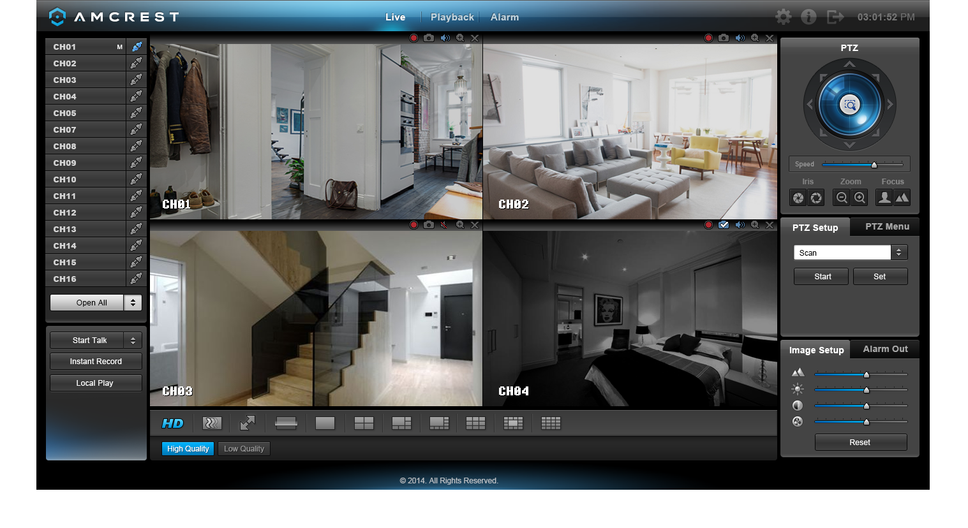
1
8
3
4
5
6
7
2
The interface on the LAN Live View consists of 8 major sections:
- Menu Bar: There are 6 menu items on the menu bar.
  - Live: This button takes the user to the Live View interface (pictured above)
  - Playback: This button takes the user to the Playback interface. See section 5.3.3.
  - Alarm: This button takes the user to the Alarm interface. See section 5.3.4.
  - Settings: This button takes the user to the Settings interface. See section 5.4.
  - Info: This button takes the user to the Information interface. See section 5.5.
  - Logout: This button logs the user out of the system. See section 5.6.
- Channel List: On this side bar, there is a list of all the channels available, as well as an Open All button. The Open All button enables/disables real-time channel monitoring for all of the channels.
  - To switch between the main stream and the sub stream, click the channel name and select which stream to use. For more information on main stream vs sub stream, see section 4.10.5.3.
- Start Talk Button: This button allows the user to broadcast audio via their audio-enabled camera or audio output device. Note: If the audio input port from the device to the client-end is using the first channel audio input port, during the bidirectional talk process, the system will not encode the audio data from the 1-channel. There are 4 bidirectional talk protocols available in the system:
  - Default
  - G711a
  - G711u
  - PCM
- Instant Record Button: This button allows the user to begin manual recording. Click the button again to restore the system to the previous recording mode.
- Local Play Button: This button allows the user to playback saved files from their PC. Saved files have a .dav extension. Click the local play button to open a file browser to select a playback file.
- PTZ Operation Panel: This set of controls allows the user to remotely control PTZ enabled cameras. Please refer to section 4.4.2 for more information on how to use the PTZ controls.
- Image Setup and Alarm Output: These controls allow the user to modify the live-feed image settings, as well as alarm output notifications.
- Live Feed View Settings: This set of controls allows the user to change their view in the live view screen. From left to right, the buttons do the following: Set video quality, set video fluency, enter full screen mode, scan, enter 1-window mode, enter 4-window mode, enter 6-window mode, enter 8-window mode, enter 9-window mode, enter 13-window mode, and enter 16-window mode.

5.3.2 WAN Live View Interface
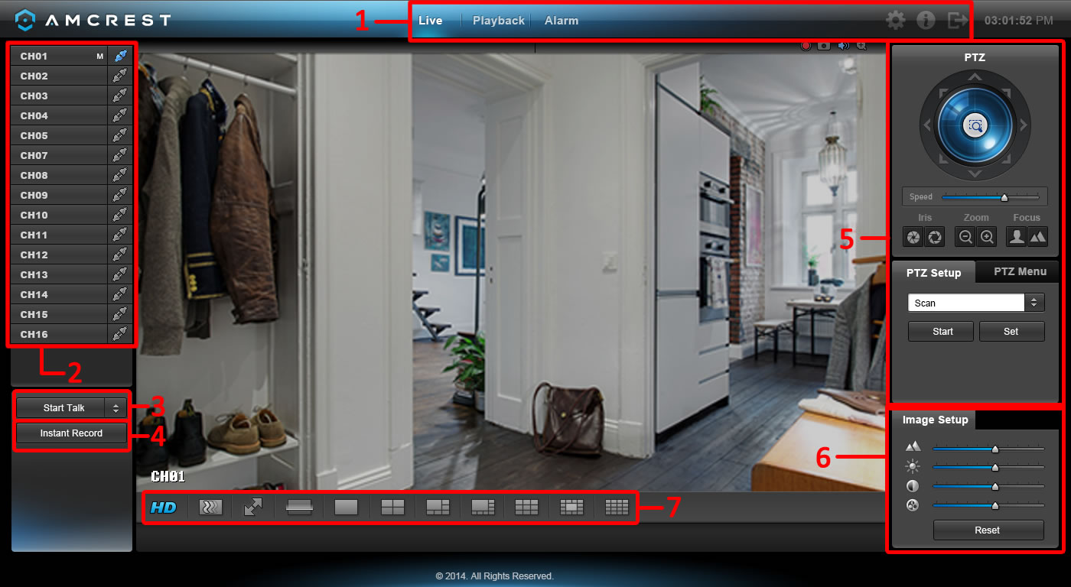

There are minor differences between the LAN and WAN Live View Interfaces.
The interface on the WAN Live View consists of 7 major sections:
- Menu Bar: There are 6 menu items on the menu bar.
  - Live: This button takes the user to the Live View interface (pictured above)
  - Playback: This button takes the user to the Playback interface. See section 5.3.3.
  - Alarm: This button takes the user to the Alarm interface. See section 5.3.4.
  - Settings: This button takes the user to the Settings interface. See section 5.4.
  - Info: This button takes the user to the Information interface. See section 5.5.
  - Logout: This button logs the user out of the system. See section 5.6.
- Channel List: On this side bar, there is a list of all the channels available, as well as an Open All button. The Open All button enables/disables real-time channel monitoring for all of the channels.
  - To switch between the main stream and the sub stream, click the channel name and select which stream to use. For more information on main stream vs sub stream, see section 4.10.5.3.
- Start Talk Button: This button allows the user to broadcast audio via their audio-enabled camera or audio output device. Note: If the audio input port from the device to the client-end is using the first channel audio input port, during the bidirectional talk process, the system will not encode the audio data from the 1-channel. There are 4 bidirectional talk protocols available in the system:
  - Default
  - G711a
  - G711u
  - PCM
- Instant Record Button: This button allows the user to begin manual recording. Click the button again to restore the system to the previous recording mode.
- PTZ Operation Panel: This set of controls allows the user to remotely control PTZ enabled cameras. Please refer to section 4.4.2 for more information on how to use the PTZ controls.
- Image Setup: These controls allow the user to modify the live-feed image settings.
- Live Feed View Settings: This set of controls allows the user to change their view in the live view screen. From left to right, the buttons do the following: Set video quality, set video fluency, enter full screen mode, scan, enter 1-window mode, enter 4-window mode, enter 6-window mode, enter 8-window mode, enter 9-window mode, enter 13-window mode, and enter 16-window mode.

5.3.3 Playback Interface
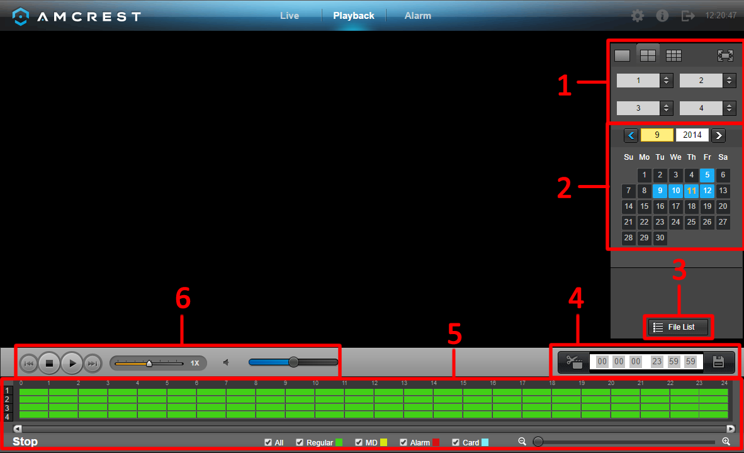

This is the interface for the DVR web access playback menu. There are 6 main sections:
- View Selection: This panel allows the user to view the different channel layouts.
- Calendar: This panel allows the user to pick a date that they would like to playback video from.
- File List: This button opens a file list of all recorded video for a specific date range. From here, the user can download these videos to their PC.
- Trim Panel: This panel allows the user to trim playback video for download. By specifying time stamps, the user can trim down.
- Recorded Video Panel: This panel allows the user to specify what type of video they would like to playback and it also allows the user to select where to start playback from.
- Playback Bar: This panel allows the user to control playback. It also allows the user to control playback speed, and playback volume.

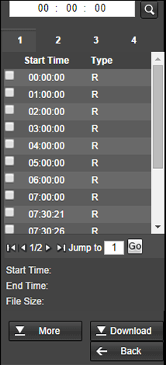
Clicking the File List opens the following screen on the sidebar:

This allows the user to select files for download. Select the files by clicking the checkbox next to each file, and then click download to download the files to the PC. Clicking more, opens the advanced download screen where the user can download individual files, download by time frame, or add a watermark to a video. Below are screenshots of the advanced download screen:

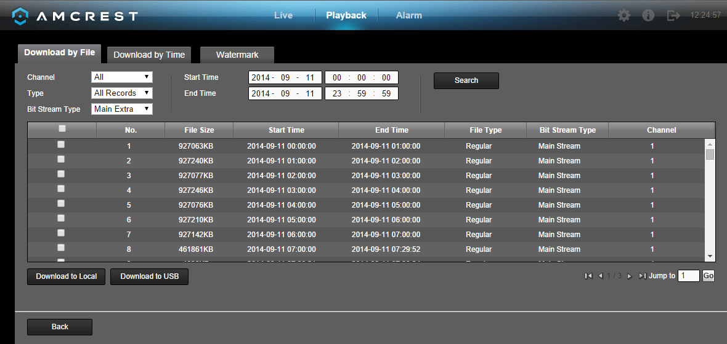
This is the Download by File screen. The top part of the screen allows the user to search through the files. The buttons on the bottom allow the user to download files to the PC or download to USB.

This is the Download by Time screen. The top part of the screen allows the user to select a channel and a time frame from which to download any recorded video. The Download to Local button opens a dialog box asks the user to where to save the downloaded file.
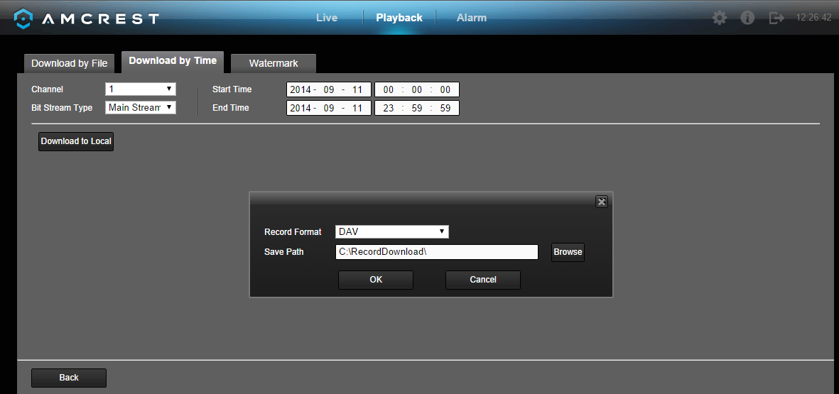

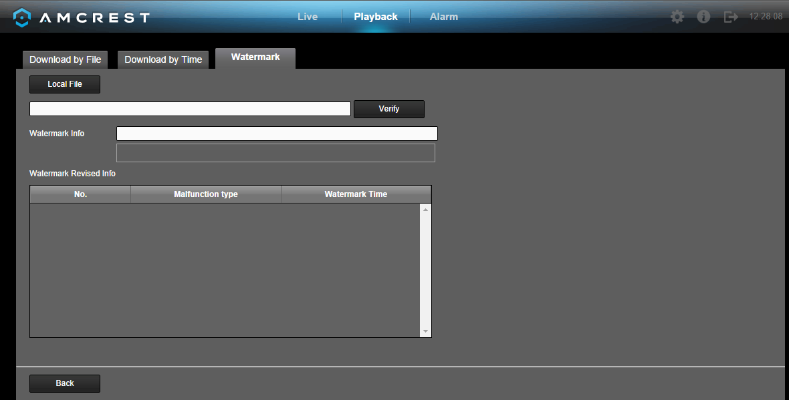
This is the Watermark screen. This screen allows users to add a watermark to downloaded video, and to verify watermarked videos.

5.3.4 Alarm Interface
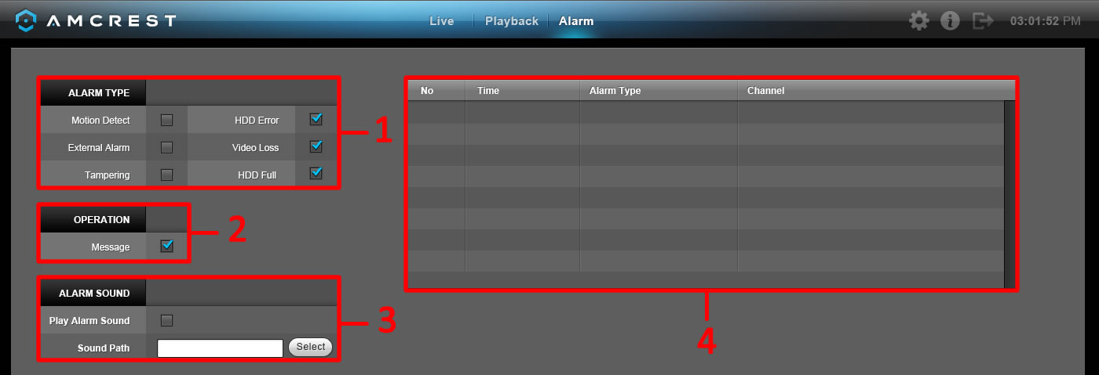

This is the interface for the DVR's Alarm management menu. There are 4 main sections. See the table below for more information:

Number | Section | Parameter | Function
1 | Alarm Type | Video loss | The system triggers the alarm when video loss occurs.
1 | Alarm Type | Motion detection | The system triggers the alarm when motion detection occurs.
1 | Alarm Type | Tampering | The system triggers the alarm when camera is maliciously masked.
1 | Alarm Type | Disk full | The system triggers the alarm when the disk is full.
1 | Alarm Type | Disk error | The system triggers the alarm when a disk error occurs.
1 | Alarm Type | External alarm | An alarm input device triggers the alarm.
2 | Operation | Prompt | The system automatically pops up an alarm icon on the Alarm button in the main interface when there is an alarm.
3 | Alarm Sound | Play alarm sound | The system sends out an alarm sound when an alarm occurs. A custom sound can be used.
3 | Alarm Sound | Sound path | Here you can specify the alarm sound file.
4 | Alarm Indicator | All | All triggered alarms are displayed here.

5.4 Web Access Settings Menu

The web access settings menu has slight differences with the DVR's menu. In this section, the web access settings menu will be explained in depth just like the DVR settings menu had been explained in the sections above. For more information about the DVR's Settings Menu, see section 4.10.

To access the web access settings menu, click the gear icon near the top right hand corner of the web access interface.

5.4.1 Camera Settings

5.4.1.1 Image Settings

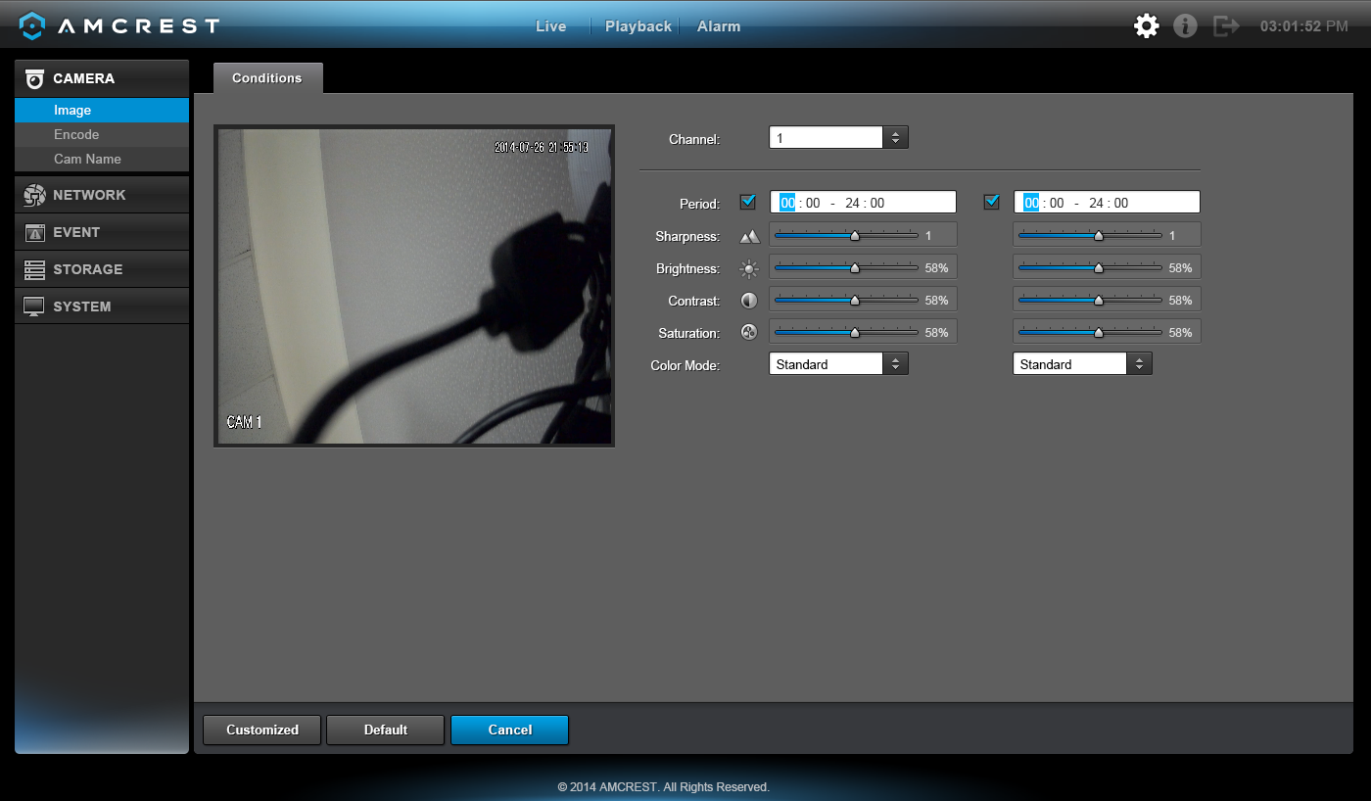
This screen is allows the user to adjust the image settings for each channel. See below for a screenshot of the image settings screen:

Below is an explanation for each of the fields on the Image Settings screen:
- Channel: This dropdown box allows the user to select a channel from the dropdown list to modify.
- Period: This dropdown box allows the user to select a period of time for which to modify the image settings. The user can configure up to 2 periods to encompass the entire 24 hours in the day. Click the checkbox to enable the period image settings changes.
- Saturation: This slider is used to adjust monitor window saturation. The value ranges from 0 to 100. The default value is 50. The larger the number, the strong the color is. This value has no effect on the general brightness of the whole video. The video color may become too strong if the value is too high. For the grey part of the video, the distortion may occur if the white balance is not accurate. Please note the video may not be clear if the value is too low. The recommended value ranges from 40 to 60.
- Brightness: This slider is used to adjust monitor window brightness. The value ranges from 0 to 100. The default value is 50. The larger the number, the brighter the video is. When you input the value here, the bright section and the dark section of the video will be adjusted accordingly. You can use this function when the whole video is too dark or too bright. Please note the video may become hazy if the value is too high. The recommended value ranges from 40 to 60.
- Contrast: This slider is used to adjust monitor window contrast. The value ranges from 0 to 100. The default value is 50. The larger the number is, the higher the contrast is. You can use this function when the whole video brightness is OK but the contrast is not correct. Please note the video may become hazy if the value is too low. If this value is too high, the dark section may lack brightness while the bright section may over expose. The recommended value ranges from 40 to 60.
- Sharpness: This slider is used to adjust the sharpness of the video. The value ranges from 0 to 100. The larger the value is, the clearer the edges are and vice versa. Note: The higher the value, the higher likelihood of picture noise occurring. The default value is 50 and the recommended value ranges from 40 to 60.

To customize the picture, click Customize near the bottom left hand corner. To revert to default settings, click the Default button near the bottom left hand corner. To cancel any modifications, click the Cancel button near the bottom right hand corner.

5.4.1.2 Encode Settings

5.4.1.2.1 Encode

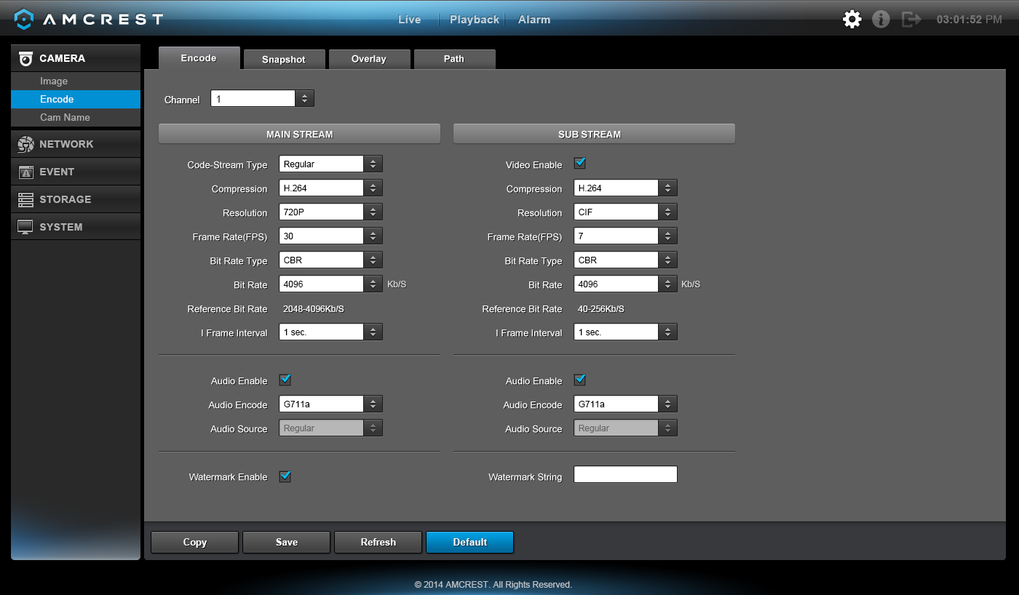
This tab is used to set the video encoding settings for each channel. See below for a screenshot of the tab:

Below is an explanation of the fields on the Encode settings screen:

Parameter | Function
Channel | This dropdown box allows the user to select a channel from the dropdown list to modify.
Video Enable | This checkbox allows the user to enable the extra video stream. This is checked by default for the main stream.
Code Stream Type | This dropdown box allows the user to select different encode frame rates for different recorded events.  This includes the main stream, motion stream, and alarm stream.  The system supports active control frame function (ACF). It allows the user to record in different frame rates.  For example, a high frame rate can be used to record important events, and a low frame rate can be used to record scheduled events. The DVR also allows for the option to set different frame rates for motion detection recordings and alarm recordings.
Compression | This dropdown box allows the user to select a compression protocol. The system supports H.264 and MJPEG video compression protocols.
Resolution | This dropdown box allows the user to set the resolution. The system supports various resolutions and they can be selected from this dropdown list.
Frame Rate | This dropdown box allows the user to select a frame rate. Frame rate settings range from 1f/s to 25f/s in NTSC mode and 1f/s to 30f/s in PAL mode.
Bit Rate | This dropdown box allows the user to select a bit rate type. The system supports two bit rate types: CBR and VBR. In VBR mode, video quality can be set.
Reference Bit Rate | This is the recommended bit rate value according to the resolution and frame rate selected.
I Frame | This field allows the user to set the P frame amount between two I frames. The value ranges from 1 to 150 seconds. Default value is 50. Recommended value is frame rate *2.
Audio Source | This dropdown box allows the user to select an audio source. The system supports two audio sources: Normal or HDCVI. In normal mode, the audio signal comes from the audio input. In HDCVI mode, the audio signal comes from the camera coaxial cable.
Watermark Enable | This function allows the user to verify if the video has been tampered with.  Watermark bit stream, watermark mode, and a watermark string can be selected. The default string is DigitalCCTV. The maximum length is 85 characters. This string can only include numbers, characters, and underscores.

To copy settings to another channel, click the Copy button. To confirm settings, click the Save button. To refresh the page, click the Refresh button. To revert to default settings, click the Default button.

5.4.1.2.2 Snapshot

This tab allows for the selection of snapshot settings. See below for a screenshot of the Snapshot tab:
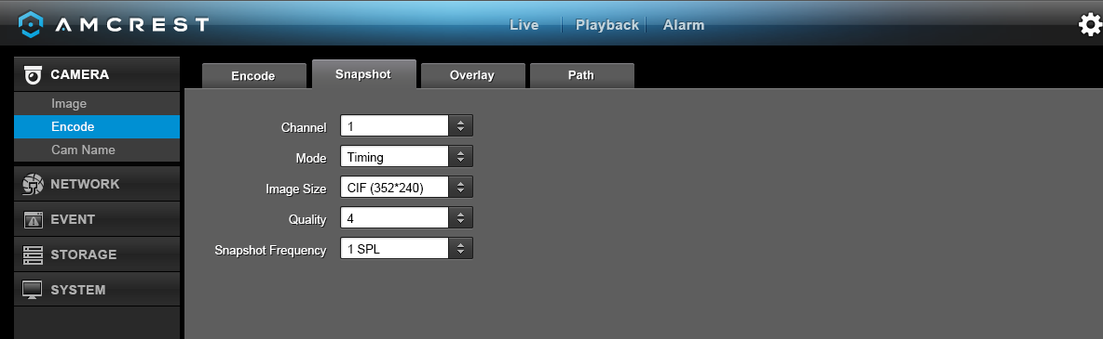

Below is a list of snapshot settings that can be modified on this screen:

Parameter | Function
Snapshot Mode | This dropdown box allows the user to select a snapshot mode. There are two snapshot modes: regular and trigger.  - Regular snapshots are taken as scheduled.  - Trigger snapshots occur when a motion detection alarm, a tampering alarm, or a local activation alarm is triggered.
Image Size | This dropdown box allows the user to select an image size. There are 4 settings: D1, HD1, 2CIF, and CIF.
Image Quality | This dropdown box allows the user to select image quality. Quality is adjusted on a scale of 1-10.
Snapshot Frequency | This is to set snapshot frequency. The value ranges from 1 to 7 seconds.  The maximum setting for a customized interval is 3600s/picture.

To copy settings to another channel, click the Copy button. To confirm settings, click the Save button. To refresh the page, click the Refresh button. To revert to default settings, click the Default button.

5.4.1.2.3 Overlay

The overlay tab allows the user to change overlay settings for each channel. Below is a screenshot of the overlay tab:
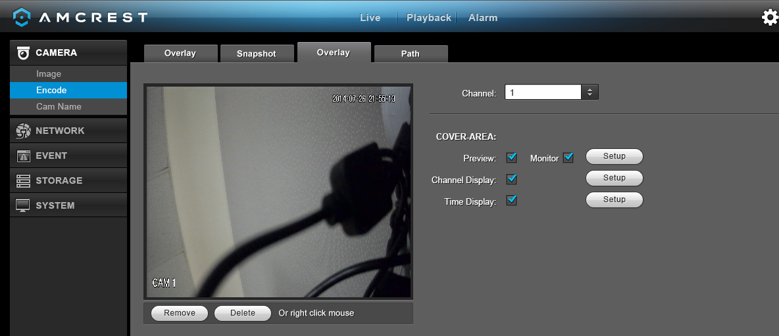
Below is an explanation of fields that can be modified on the overlay settings screen:

Parameter | Function
Channel | This dropdown box allows the user to select a channel from the dropdown list to modify.
Cover-Area | This button allows the user to set the cover area. Drag the mouse to set the proper section size. The system supports a maximum of 4 zones in one channel.
Preview/Monitor | There are two types of cover areas  - Preview means the privacy mask zone cannot be viewed by user when system is in preview status.  - Monitor means the privacy mask zone cannot be viewed by the user when system is in monitor status.
Time Display | This button allows the user to select whether or not the system displays time on playback video. Clicking the set button and allows the user to drag the timestamp to the desired position on the screen.
Channel Title | This button allows the user to select whether or not the system displays channel number on playback video. Clicking the set button allows the user to drag the title to the corresponding position on the screen.

To copy settings to another channel, click the Copy button. To confirm settings, click the Save button. To refresh the page, click the Refresh button. To revert to default settings, click the Default button.

5.4.1.2.4 Path

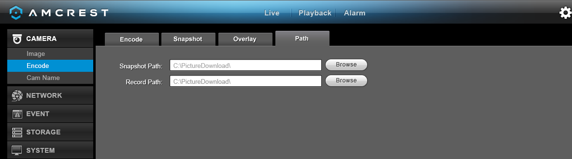
The path tab allows the user to specify a path to record snapshots and manual recordings to on the PC. Below is a screenshot of the path tab:

To confirm settings, click the Save button. To revert to default settings, click the Default button.

5.4.1.3 Channel Name
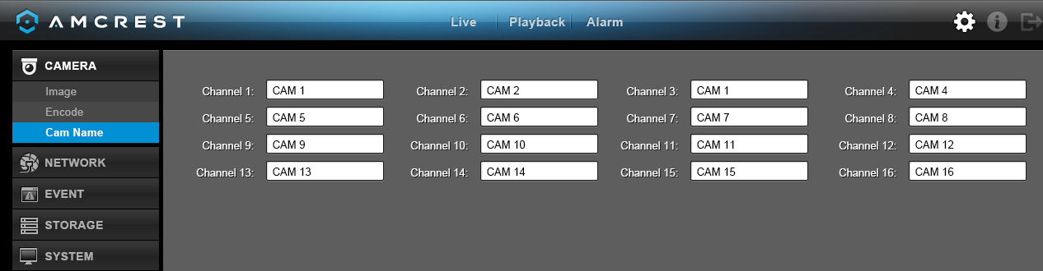
Here you can set channel name. Below is a screenshot of the channel name settings screen:

To confirm settings, click the Save button. To refresh the page, click the Refresh button. To revert to default settings, click the Default button. To confirm settings, click the Save button.

5.4.2 Network

5.4.2.1 TCP/IP

5.4.2.1.1 TCP/IP

TCP/IP stands for Transmission Control Protocol/Internet Protocol and it is the language/protocol that allows communication between internet connected devices, whether on a local network, or a on the Internet at large. This screen allows for TCP/IP settings to be modified in order for the DVR to establish connection to the network. Below is a screenshot of the TCP/IP settings screen:
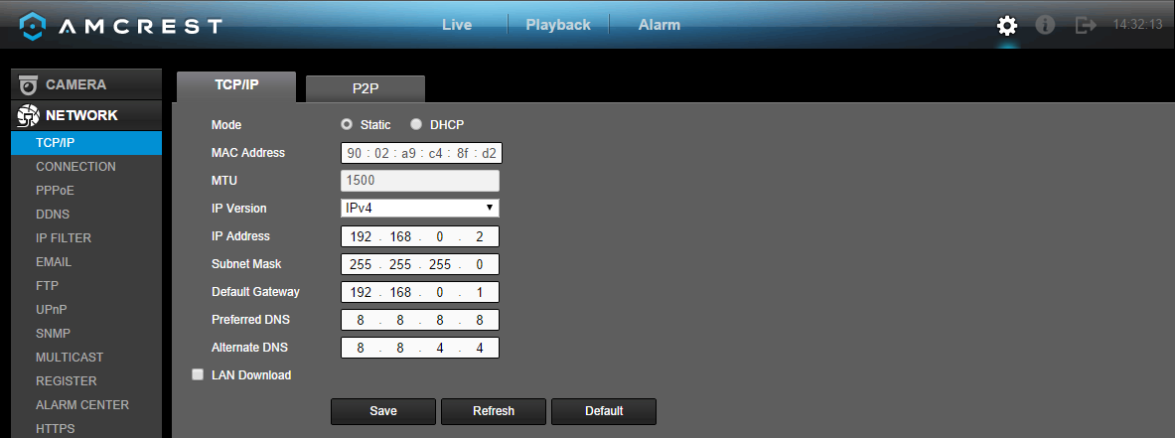
Below is an explanation of the fields on the TCP/IP settings screen:

Parameter | Function
Mode | Static vs DHCP: This check box allows the user to choose between a static IP address, and a dynamic IP address. DHCP stands for Dynamic Host Configuration Protocol, and this enables the DVR to automatically obtain an IP address from another network device such as a server or more commonly, a router. When the DHCP function is enabled, the user cannot modify the IP address, Subnet Mask, or Gateway, as these values are obtained from the DHCP function. To view the current IP address, DHCP needs to be disabled. Note: When PPPoE is enabled, modification of IP Address, Subnet Mask, and Gateway becomes prohibited.
MAC Address | This field shows the DVR’s MAC address, which is unique to this device. This number is read-only and is used to access a local area network (LAN).
IP Version | This dropdown allows the user to select the IP version. The two options are IPV4 and IPV6.
IP Address | This field allows the user to enter a custom IP address.
Preferred DNS | This field allows the user to enter the DNS server IP address.
Alternate DNS | This field allows the user to enter the Alternate DNS server IP address.
For the IP address of IPv6 version, default gateway, preferred DNS, and alternate DNS, the input value should be 128-digits. It should not be left blank.
LAN Download | This checkbox allows the user to enable the user to process the downloaded data first. The download speed is 1.5X or 2.0X compared to the normal streaming speed.

To confirm settings, click the Save button. To refresh the page, click the Refresh button. To revert to default settings, click the Default button. To confirm settings, click the Save button.

5.4.2.1.2 P2P

The P2P settings screen is where users can use a QR code to connect their smartphone or tablet to the DVR. The HDCVI uses an app called Amcrest View, and it is available on both iOS and Android. Below is a screenshot of the P2P settings screen:
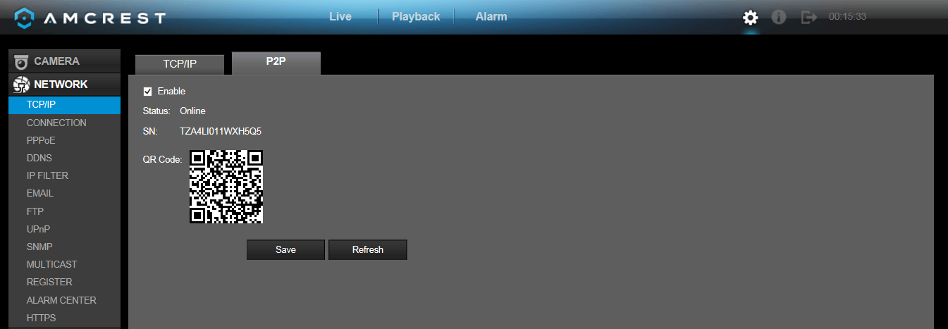

Below is an explanation of the fields on the P2P settings screen:
- Enable: This checkbox allows the user to enable the P2P feature for the DVR.
- Connect Status: This field shows the status of the P2P connection. Once connected using the app, this field should display the word Online
- SN: This is an alternate string of characters used to denote the QR code in case the QR code scanner isn't working.
- QR Code: This is the unique QR code used to help the app user connect to the DVR.
  - Note: The physical design of the QR code may change based on the network settings used. All QR code connections should be made with the image that displays on this screen, and not through any static saved images.
- To confirm settings, click the Save button. To refresh the page, click the Refresh button. To revert to default settings, click the Default button. To confirm settings, click the Save button.

To confirm settings, click the Save button. To refresh the page, click the Refresh button.

5.4.2.2 Connection

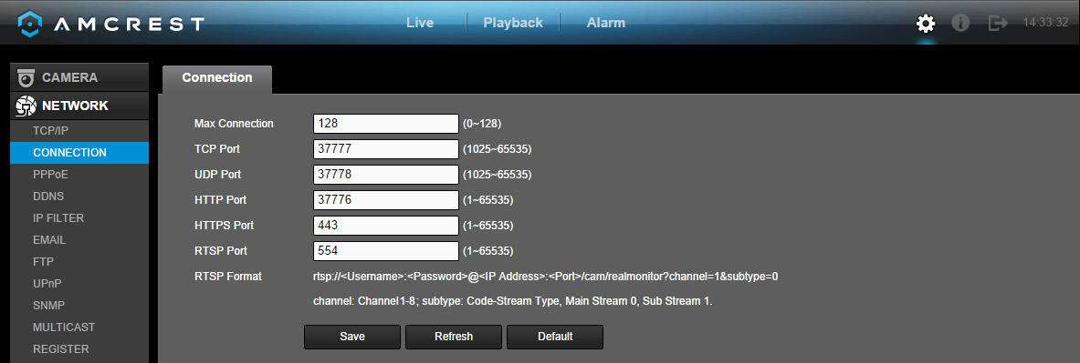
This screen allows users to configure port connections. It is important that the system is rebooted if any changes are made to the settings on this screen. Also, ensure that port values do not conflict.
Below is a screenshot of the connection screen:

Below is an explanation of the fields on the Connection settings screen:

Parameter | Function
Maximum Connection | This field represents the maximum amount of users that can be connected to the DVR at the same time. The maximum number of users the DVR can support at one time is 128.
TCP Port | This field designates the Transmission Control Protocol (TCP) port number. The default value is 37777.
UDP Port | This field designates the User Datagram Protocol (UDP) port number. The default value is 37778.
HTTP Port | This field designates the Hypertext Transfer Protocol (HTTP) port number. The default value is 80.
HTTPS | This field designates the Hypertext Transfer Protocol Secure (HTTPS) port number. The default value is 443.
RTSP Port | This field designates the Real Time Streaming Protocol (RTSP) port number. The default value is 554.

To confirm settings, click the Save button. To refresh the page, click the Refresh button. To revert to default settings, click the Default button.

5.4.2.3 PPPoE

PPPoE stands for Point-to-Point Protocol over Ethernet. This screen allows users to configure PPPoE connections.

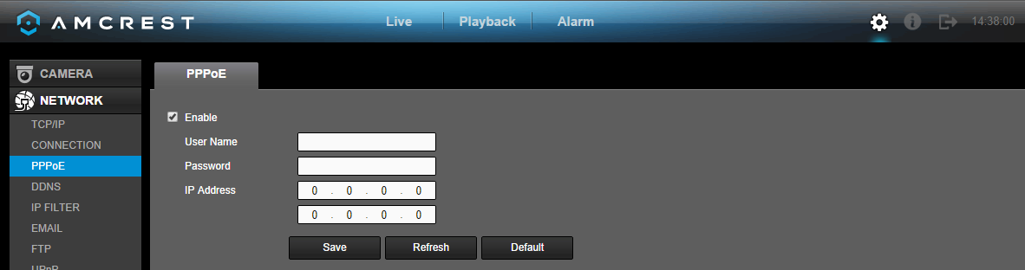
Below is a screenshot of the PPPoE screen:

To confirm settings, click the Save button. To refresh the page, click the Refresh button. To revert to default settings, click the Default button.

5.4.2.4 DDNS

DDNS stands for Dynamic Domain Name Server. This technology is used to automatically update name servers in real time in order to help the DVR maintain a persistent address despite changes in location or configuration. What this means is that even when the DVR is restarted, moved, or reconfigured, it can keep the same IP address, thus allowing remote users uninterrupted access to the DVR, rather than having to request a new IP address to use for remote access anytime a change is made.

To use this feature, users will need to setup an account with a DDNS service. The DVR supports a variety of DDNS services such as Quick DDNS, NO-IP DDNS, CN99 DDNS, Dyndns DDNS, and private DDNS services. Based on which service is selected, different options may show on this screen. For purposes of this guide, QuickDDNS will be used.
To use Quick DDNS, go to http://www.quickddns.com and register for an account. If the account is inactive for a year, Quick DDNS may take back the domain name, but an email will be sent beforehand as a warning.
Below is a screenshot of the DDNS settings screen, configured to QuickDDNS:
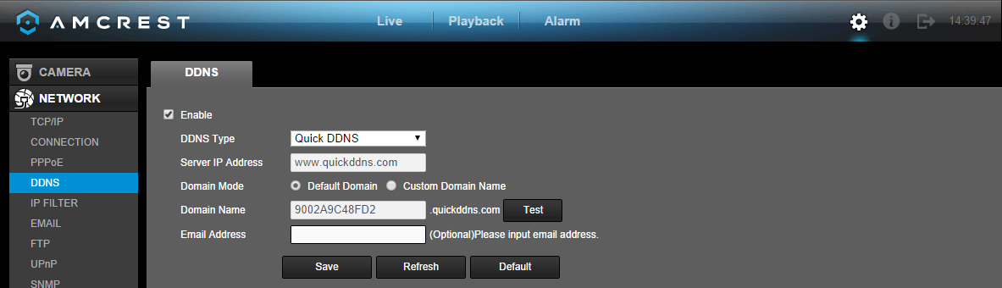

Below is an explanation of the fields that can be configured on DDNS settings screen when set to Quick DDNS type:

Parameter | Function
DDNS Type | This dropdown box is used to select which DDNS service is being used on the DVR.
Server IP Address | This field allows the user to enter the IP address for the server used by the specific DDNS service.
Domain Name | This field is where the domain name from the Quick DDNS service is entered.

To confirm settings, click the Save button. To refresh the page, click the Refresh button. To revert to default settings, click the Default button.

5.4.2.5 IP Filter

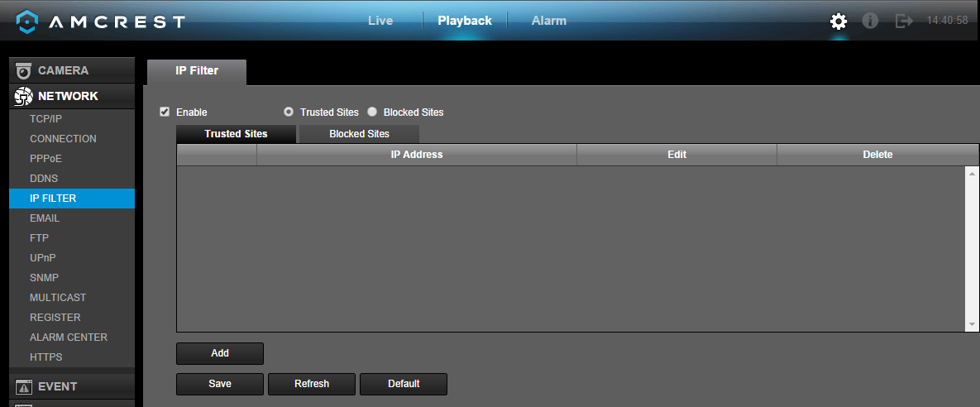
This screen allows for the filtering of IP addresses, either blocking them, or granting them access to the DVR. This feature helps make the DVR more secure by limiting remote access only to approved users. Below is a screenshot of the IP Filter screen:

Below is an explanation of fields on the IP Filter settings screen:
- Enable: This checkbox allows the user to enable the IP Filter feature. Many of the other fields below cannot be edited if this checkbox is not checked.
- Type: This radio button allows the user to select an IP address type. There are two types of IP addresses that can be used by this feature. Only one of them can be activated at a time.
  - Trusted Sites: This setting allows the user to enter trusted IP addresses. All other addresses will be blocked.
  - Blocked Sites: This setting allows all IP addresses, but blocks the ones that are specified.
- Delete: This button allows a user to remove a specific IP address from the IP Filter list.
- Edit: This button allows a user to edit start or end addresses.

To add another line item, click the Add button. To confirm settings, click the Save button. To refresh the page, click the Refresh button. To revert to default settings, click the Default button.

5.4.2.6 Email

This screen allows for the configuring of email settings in order to permit the DVR to send emails when the connected cameras or alarms are triggered. Below is a screenshot of the email settings screen:
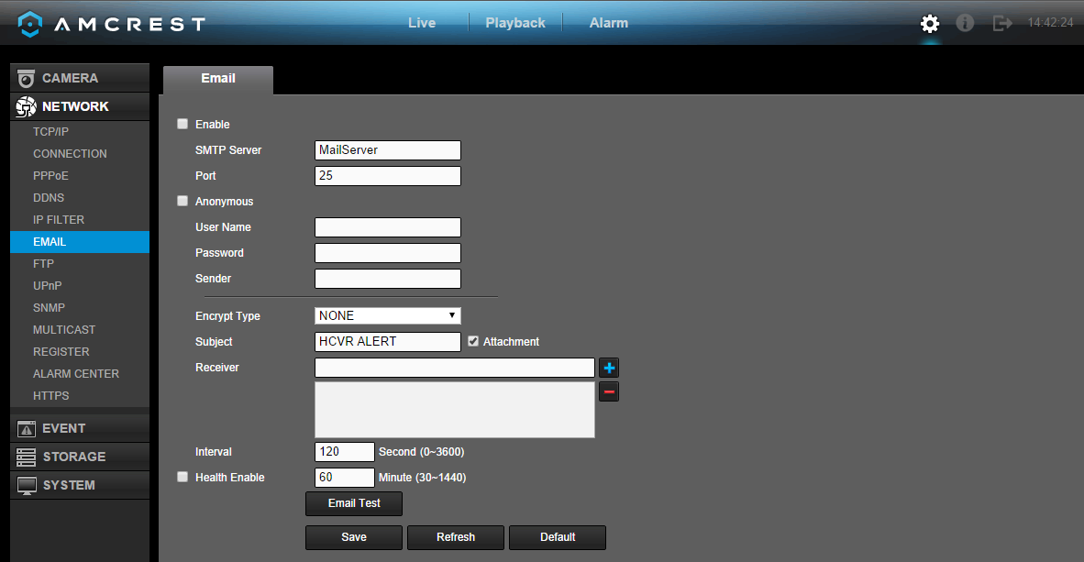
Below is an explanation of the fields on the Email settings screen:

Parameter | Function
Enable | This checkbox allows the user to enable the email feature.
SMTP Server | SMTP stands for Simple Mail Transfer Protocol. This field allows the user to enter the SMTP server used by the email service.
Port | This field allows the user to enter the port that corresponds to the selected SMTP server.
Anonymity | This checkbox allows the user to anonymously login to the server.
User Name | This field allows the user to enter the username used to login to the selected SMTP server.
Password | This field allows the user to enter the password associated with the SMTP username.
Sender | This field allows the user to enter the sender email address. This email address will be the one that sends out all emails pertaining to the alerts and alarm emails sent by the DVR.
Encryption Type | This dropdown box allows the user to select an encryption type. There are two types of email encryption that are available.  - SSL: Secure Socket Layer  - TLS: Transport Layer Security
Subject | This field allows the user to define the subject line of the email that is sent to the receivers.
Attachment | This checkbox allows the user to enable the attachment of screenshots with emails.
Receiver | This field allows the user to enter the receiver email address. These email addresses are the ones that will receive any emails pertaining to alert and alarm emails sent by the DVR. Up to 3 email addresses can be entered in this field.
Interval | This field allows the user to define, in seconds, how many events can be triggered concurrently.
Health Enable | This checkbox allows the user to enable the function that causes the system to send out a test email to ensure if the connection is OK or not.
Email Test | This button causes the system to automatically send out an email once to test the connection is OK or not. Prior to the email test, please save the email setup information.

To email a test email, click the Test Email button. To confirm settings, click the Save button. To refresh the page, click the Refresh button. To revert to default settings, click the Default button.

5.4.2.7 FTP

FTP stands for File Transfer Protocol. This protocol allows for remote uploading of files to a server. This feature requires the use of a FTP tool on a computer in order to enable the use of FTP features on the DVR.

Once an FTP tool has been acquired, installed, and configured to allow read, write, append, and delete access, then the DVR can be configured to use FTP. Below is a screenshot of the FTP menu screen:

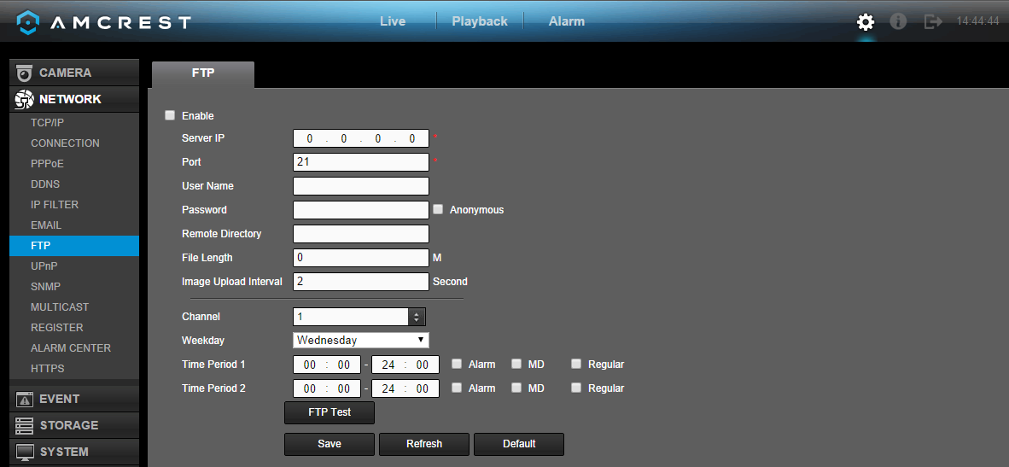
Below is an explanation of the fields on the FTP settings screen:
- Enable: This checkbox allows the user to enable the FTP feature for the DVR.
- Server IP: This field allows the user to enter the FTP server IP address and port.
- User Name: This field allows the user to enter the FTP username.
- Password: This field allows the user to enter the FTP server password. The checkbox next to this field enables anonymous access to the FTP.
- Remote Directory: This field allows the user to designate which folder the DVR will upload files to.
- File Length: This field allows the user to dictate how large upload files can be.
- Image Upload Interval: This field allows the user to define, in seconds, how often images can be uploaded to the FTP server.
- Channel: This field allows the user to pick a channel to set FTP settings for.
- Weekday: This field allows the user to pick a day of the week to set FTP settings for.
- Time Period 1: This field allows the user to specify a time period and what types of files to upload (Alarm, Motion, and Regular).
- Time Period 2: This field allows the user to specify a time period and what types of files to upload (Alarm, Motion, and Regular).

To test the FTP, click the Test FTP button. To confirm settings, click the Save button. To refresh the page, click the Refresh button. To revert to default settings, click the Default button.

5.4.2.8 UPnP

UPnP stands for Universal Plug and Play, and it is a protocol used to easily connect devices to the internet. In the case of this DVR, it allows the DVR to connect to the router in an easy manner to quickly allow for remote connection. Below is a screenshot of the UPnP settings screen:
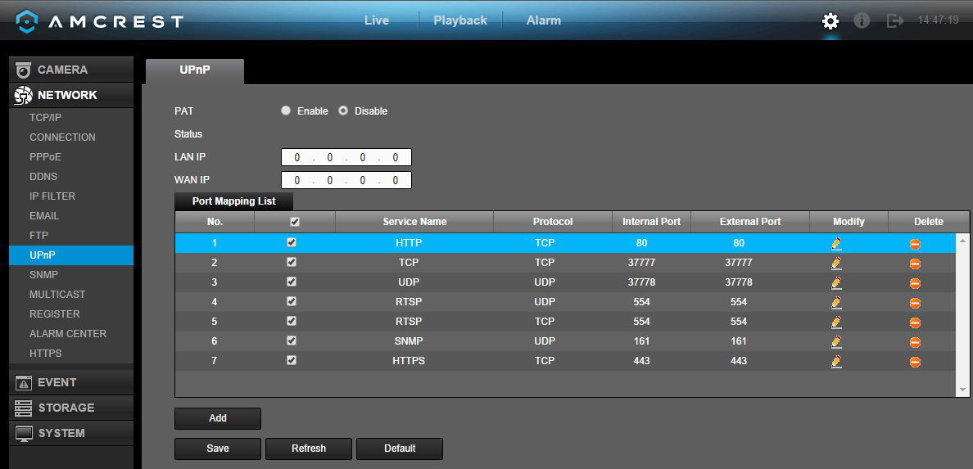

Below is an explanation of the fields in the UPnP settings screen:
- PAT: PAT stands for Port Address Translation, and it is something that the UPnP protocol handles. This checkbox allows the user to enable UPnP on the device.
- UPnP Status: This field shows the UPnP status and has two options:
  - Unknown: This means that UPnP is offline.
  - Successful: This means that UPnP is working.
- Router LAN IP: This field allows the user to enter the IP address of the router that the DVR is trying to connect to.
- WAN IP: This field is where the DVR Wide Area Network (WAN) IP is populated. This IP address is what is used to remotely access the DVR through web access.
- PAT Table: This table is used to show how the ports for each protocol listed below have been remapped by the UPnP protocol.
  - The first column shows the order of the services.
  - The second column shows the name of the services. To edit this, double click on the service line item.
  - The third column shows the name of the protocol used by that service. To edit this, double click on the service line item.
  - The fourth column shows the Internal Port used by that service. To edit this, double click on the service line item.
  - The fifth column shows the External Port used by that service. To edit this, double click on the service line item.

To view a video on how to remotely access your DVR using UPnP, go to http://amcrest.com/videos and view the video titled “How to Gain Remote Access to Your HDCVI DVR with Universal Plug and Play”.

To view more information on how to set up the HDCVI DVR for remote access using UPnP, see section 5.2.1.

To add another line item, click the Add button. To confirm settings, click the Save button. To refresh the page, click the Refresh button. To revert to default settings, click the Default button.

5.4.2.9 SNMP

SNMP stands for Simple Network Management Protocol. This protocol is used to provide a basic framework in order to allow connection between various network devices. Below is a screenshot of the SNMP settings screen:
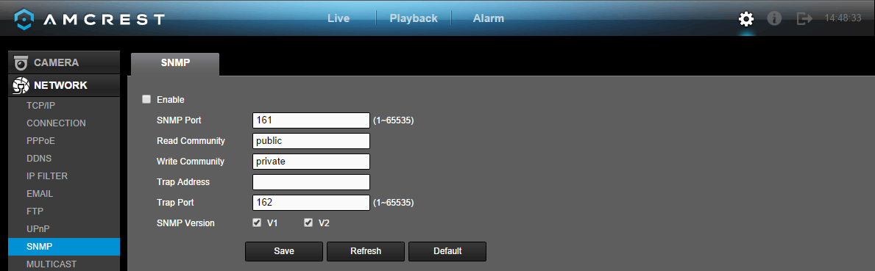

Use of SNMP required additional software to create a Management Information Base (MIB) database. A popular set of tools for this purpose are MIB Builder and MG-SOFT MIB Browser. Using these tools, two MIB files need to be created: BASE-SNMP-MIB and DVR-SNMP-MIB. To configure SNMP, follow the steps below:
- On the SNMP screen, check the text box to enable the SNMP function. Input the IP address of the PC that is running the MIB software in the Trap address. Default values may be used for the rest of the fields.
- Compile the above mentioned two MIB files via the software MIB Builder.
- Run the MG-SOFT MIB Browser to load the file from the previous step into the software.
- Input the device IP you want to manage in the MG-SOFT MIB Browser. Please set the corresponding version for your future reference.
- Open the tree list on the MG-SOFT MIB Browser. This software shows device configuration. Using this software, the user can see how many video channels and audio channels the device has, as well as view other information about the DVR.

Note: SNMP port number and Trap number should not be the same, as it will cause a port conflict and neither will work.
Below is an explanation about the different fields in the SNMP settings screen:
- Enable: This checkbox allows the user to enable the SNMP feature for the DVR.
- SNMP Port: This field allows the user to specify which port is used for SNMP.
- Read-Community: This field allows the user to specify which user community has read access.
- Write-Community: This field allows the user to specify which user community has write access.
- Trap Address: This field allows the user to enter the IP address of the PC running the MIB software.
- Trap Port: This field allows the user to enter the port number of the PC running MIB software.
- SNMP Version: These checkboxes allow the user to select which versions of SNMP are used.

To revert to default settings, click the Default button near the bottom left hand corner. To confirm settings, click the Save button near the bottom right hand corner. To cancel any modifications, click the Cancel button near the bottom right hand corner. To apply the settings, click the Apply button near the bottom right hand corner.

5.4.2.10 Multicast

Multicast is a feature that enables the DVR to broadcast it’s live view to multiple computers on the same network.
Below is a screenshot of the multicast screen:

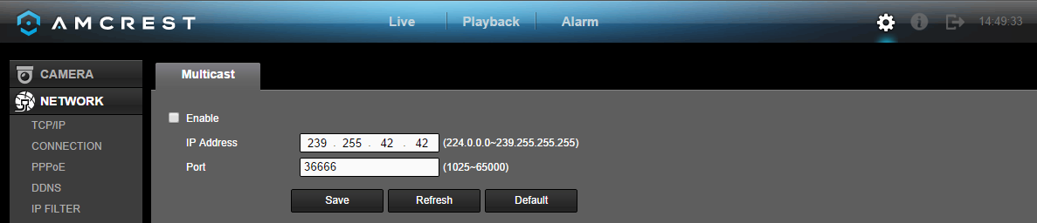

Below is an explanation of the fields in the Multicast settings screen:
- Enable: This checkbox allows the user to enable the Multicast feature for the DVR.
- IP Address: This field allows the user to enter the multicast IP address.
- Port: This field allows the user to enter the port number for the multicast IP address.

For more information on how to configure multicast, see the information below.

Multicast IP Address Range (IPV4): 224.0.0.0 through 239.255.255.255

Well-known IPv6 multicast addresses
Address | Description
ff02::1 | All nodes on the local network segment
ff02::2 | All routers on the local network segment
ff02::5 | OSPFv3 All SPF routers
ff02::6 | OSPFv3 All DR routers
ff02::8 | IS-IS for IPv6 routers
ff02::9 | RIP routers
ff02::a | EIGRP routers
ff02::d | PIM routers
ff02::16 | MLDv2 reports (defined in RFC 3810)
ff02::1:2 | All DHCP servers and relay agents on the local network segment (defined in RFC 3315)
ff02::1:3 | All LLMNR hosts on the local network segment (defined in RFC 4795)
ff05::1:3 | All DHCP servers on the local network site (defined in RFC 3315)
ff0x::c | Simple Service Discovery Protocol
ff0x::fb | Multicast DNS
ff0x::101 | Network Time Protocol
ff0x::108 | Network Information Service
ff0x::181 | Precision Time Protocol (PTP) version 2 messages (Sync, Announce, etc.) except peer delay measurement
ff02::6b | Precision Time Protocol (PTP) version 2 peer delay measurement messages
ff0x::114 | Used for experiments

To revert to default settings, click the Default button near the bottom left hand corner. To confirm settings, click the OK button near the bottom right hand corner. To cancel any modifications, click the Cancel button near the bottom right hand corner. To apply the settings, click the Apply button near the bottom right hand corner.

5.4.2.11 Register

The register feature allows the DVR to register itself with a specified proxy, so that the DVR can be remotely accessed via a proxy. A proxy is a computer server that acts as an intermediary between client computers that are seeking resources from a server. Below is a screenshot of the Register settings screen:

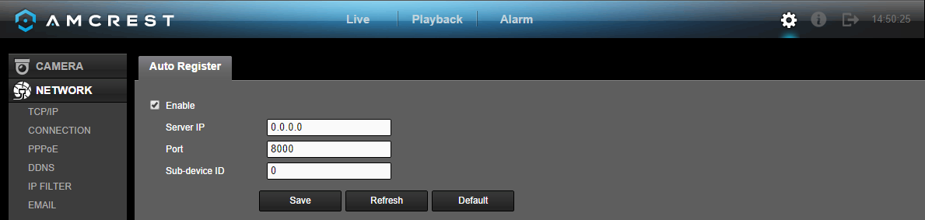
Below is an explanation of the fields on the Register settings screen:
- Enable: This checkbox allows the user to enable the Register feature for the DVR.
- No: This dropdown box allows the user to select the proxy number. Currently the DVR can only configure one proxy.
- Server IP Address: This field allows the user to enter the proxy server IP address.
- Port: This field allows the user to enter the proxy port number.
  - Note: Do not enter a network default port for this port number. It may result in a port conflict.
- ID: This field allows the user to enter the proxy ID number.

To confirm settings, click the Save button near the bottom right hand corner. To refresh the page, click the Refresh button. To revert to default settings, click the Default button near the bottom left hand corner.

5.4.2.12 Alarm Center

The alarm center feature is used to allow users to connect the DVR to their alarm server, so the server can receive a notice when certain events happen. One common use for the alarm center is to send daily reports on the status of the DVR’s connection to the network.
Below is a screenshot of the Alarm Center settings screen:
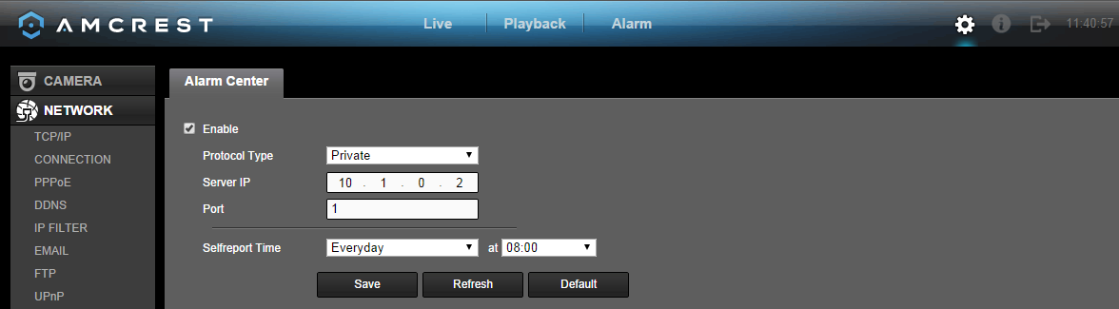

Below is an explanation of the fields on the Alarm Center settings screen:
- Enable: This checkbox allows the user to enable the Alarm Center feature for the DVR.
- Protocol Type: This field allows the user to select which protocol type they want to use for the alarm. Currently, only the private protocol type is available.
- Server IP: This field allows the user to enter the IP address of the alarm server.
- Port: This field allows the user to enter the port number of the alarm server.
- Self-Report Time: This field allows the user to enter a time of the day when they want to receive a report about the DVR’s connection to the network each day.

To confirm settings, click the Save button near the bottom right hand corner. To refresh the page, click the Refresh button. To revert to default settings, click the Default button near the bottom left hand corner.

5.4.2.13 HTTPS

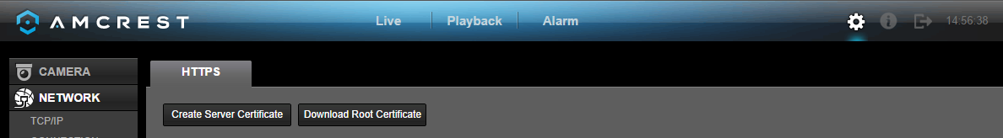
The HTTPS screen is used to allow users to create a server certificate. Below is a screenshot of the HTTPS settings screen:

Click the Create Server Certificate button to create a server certificate. The create server certificate screen looks like the screenshot below:
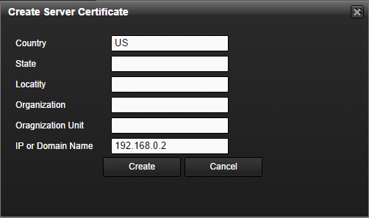

Click the Download Root Certificate to download a root certificate. The system will allow the user to download the root certificate to any folder on their PC.

5.4.3 Event

5.4.3.1 Detect

Main Menu -> Settings -> Event -> Detect opens up the Detection interface. Here there are 3 options, each representing a detection type: Motion Detection, Video Loss, and Tampering.

Tips:
- The video loss and tampering screens have no detection regions or sensitivity setup.
- The motion detection icon will be present if the motion detection alarm has been triggered on the current channel.
- To set the motion detection region, click and drag the mouse over the region desired. Once the region has been set, click the OK button to save the current region setup, and right click on the mouse to exit the motion detection interface.

5.4.3.1.1 Motion Detect

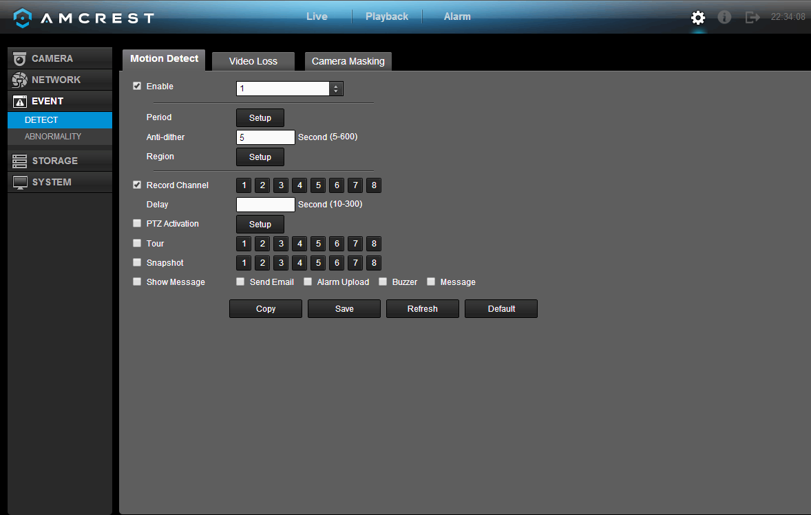
The motion detection settings screen is where motion detection can be setup for each individual channel. Based on the active motion detection region, the DVR can generate a motion detection alarm when a moving signal is detected in a specified area. Below is a screenshot of the motion detection settings screen:
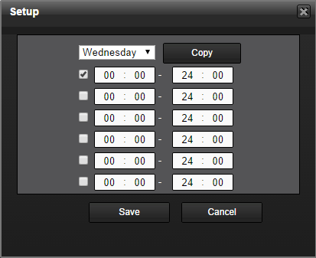
Below is a screenshot of the period setup screen:
Below is a screenshot of the region setup screen:
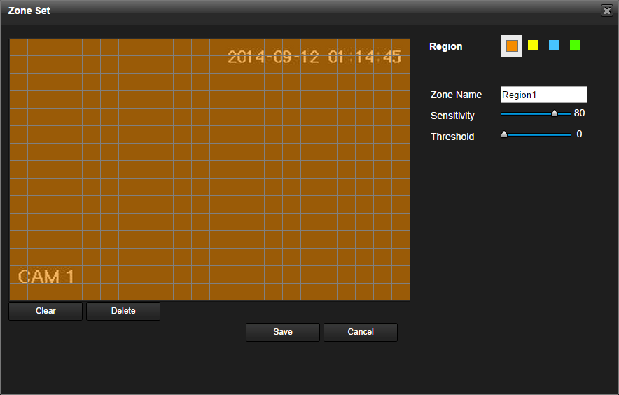

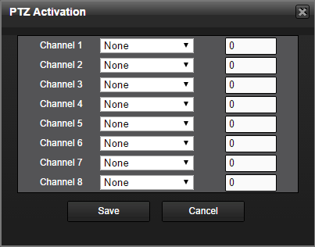
Below is a screenshot of the PTZ Activation screen:

Below is a description of the fields on the Motion Detection settings page:

Parameter | Function
Enable | This checkbox allows the user to enable the motion detection function for a specific channel.
Period | This setup button takes the user to the motion detection period settings screen.
Anti-dither | This field allows the user to set the anti-dither time. The values in this field can range from 5 to 600 seconds. This time value controls how long the alarm signal lasts. Based on motion detection, a buzzer can go off, a tour can begin, PTZ can be activated, a snapshot can be taken, or a channel can begin recording.  - For example, if the anti-dither time is set to 10 seconds, each alarm may last 10 seconds if the local alarm is activated. During the process, if the system detects another local alarm signal at the fifth second, the buzzer, tour, PTZ activation, snapshot, record channel functions will begin another 10 seconds while the screen prompt, alarm upload, email will not be activated again. After 10 seconds, if system detects another alarm signal, it can generate a new alarm since the anti-dither time has expired.
Region | The setup button takes the user to the motion detection region setup screen for that specific channel.  - When the setup button is clicked, the current channel’s interface comes into a full screen view. The user can then set up to 4 regions, each with their own region name, sensitivity (1-100), and threshold (1-100). Each region has a specific color, and the region selector tool is displayed when the mouse is moved to the top of the screen.  - Sensitivity is the amount of change required to increase the motion detected by a percentage. The lower the sensitivity, the more movement is required to trigger an alarm.  - Threshold is the level that the motion detection needs to reach in order to trigger an alarm. The lower the threshold, the more likely that motion will trigger an alarm.  - To designate a zone, click and drag the mouse over the area desired. When a colored box is displayed over the live feed, that area is now enabled for motion detection. Clicking the FN button will switch the mode between armed and disarmed, so that clicking and dragging the mouse can either designate a motion detection zone, or remove any motion detection zone markers.  - After the motion detection zone is set, click the enter button to exit the motion detection screen. Remember to click the save button on the motion detection settings screen, otherwise the motion detection zones will not go into effect. Clicking the escape button to leave the motion detection zone and will not save the zone setup.
Record Channel | This checkbox allows the user to enable the system to record video for that channel when a motion detection alarm is triggered.
Record Delay | This field specifies in seconds how long the delay between alarm activation and PTZ activation should be.
PTZ Activation | This checkbox allows the user to enable the system to activate PTZ movement when a motion detection alarm is triggered. To setup the PTZ activation settings, click the setup button next to PTZ activation.  - On the PTZ Activation screen, each camera can be setup to perform a preset PTZ action based upon motion detection.
Tour | This checkbox allows the user to enable the system to cause a PTZ tour to occur when a motion detection alarm is triggered. Multiple cameras can be specified to perform a tour.
Snapshot | This checkbox allows the user to enable the system to take a snapshot when a motion detection alarm is triggered. Multiple cameras can be specified to perform a tour.
Alarm out | This checkbox allows the user to enable the system to upload alarm information when a motion detection alarm is triggered.
Buzzer | This checkbox allows the user to enable the system to activate a buzzer when a motion detection alarm is triggered.
Show message | This checkbox allows the user to enable the system to show an on-screen message when a motion detection alarm is triggered.

To copy settings to another channel, click the Copy button. To confirm settings, click the Save button. To refresh the page, click the Refresh button. To revert to default settings, click the Default button.

5.4.3.1.2 Video Loss

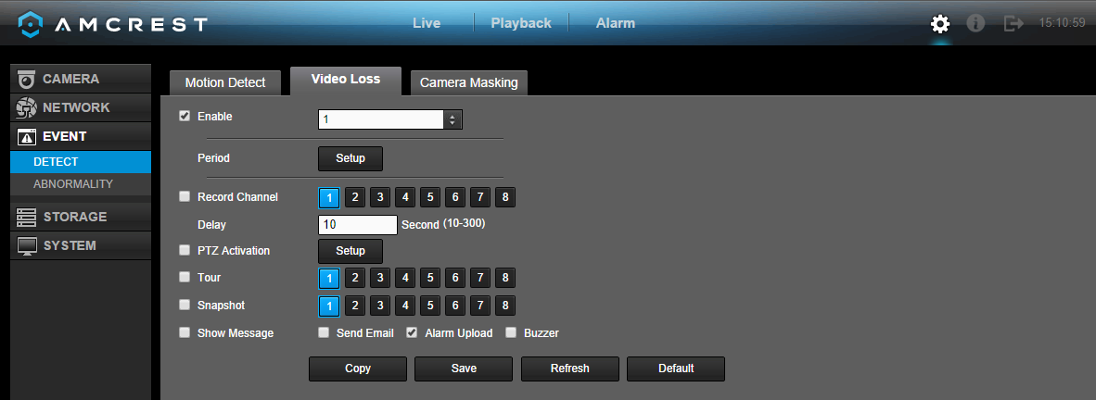
The video loss settings screen is where the DVR can be setup to notify the user any time there is video loss on any of the channels. Below is a screenshot of the video loss settings screen:
Below is a screenshot of the period setup screen:

Below is a screenshot of the PTZ Activation screen:

Below is a description of the fields on the Video Loss settings page:

Parameter | Function
Enable | This checkbox allows the user to enable the video loss function for a specific channel.
Period | This setup button takes the user to the video loss period settings screen.
Record Channel | This checkbox allows the user to enable the system to record video for that channel when a video loss alarm is triggered.
Record Delay | This field specifies in seconds how long the delay between alarm activation and PTZ activation should be.
PTZ Activation | This checkbox allows the user to enable the system to activate PTZ movement when a video loss alarm is triggered. To setup the PTZ activation settings, click the setup button next to PTZ activation.  - On the PTZ Activation screen, each camera can be setup to perform a preset PTZ action based upon video loss.
Tour | This checkbox allows the user to enable the system to cause a PTZ tour to occur when a video loss alarm is triggered. Multiple cameras can be specified to perform a tour.
Snapshot | This checkbox allows the user to enable the system to take a snapshot when a video loss alarm is triggered. Multiple cameras can be specified to perform a tour.
Alarm out | This checkbox allows the user to enable the system to upload alarm information when a video loss alarm is triggered.
Buzzer | This checkbox allows the user to enable the system to activate a buzzer when a video loss alarm is triggered.
Show message | This checkbox allows the user to enable the system to show an on-screen message when a video loss alarm is triggered.

To copy settings to another channel, click the Copy button. To confirm settings, click the Save button. To refresh the page, click the Refresh button. To revert to default settings, click the Default button.

5.4.3.1.3 Camera Masking

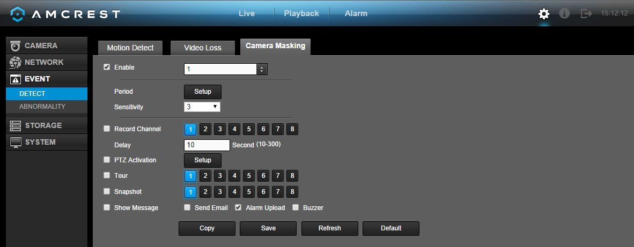
The camera masking settings screen is where the DVR can be setup to notify the user any time there is camera masking on any of the channels. Below is a screenshot of the camera masking settings screen:

Below is a screenshot of the period setup screen:

Below is a screenshot of the PTZ Activation screen:

Below is a description of the fields on the Video Loss settings page:

Parameter | Function
Enable | This checkbox allows the user to enable the camera masking function for a specific channel.
Period | This setup button takes the user to the camera masking period settings screen.
Record Channel | This checkbox allows the user to enable the system to record video for that channel when a camera masking alarm is triggered.
Record Delay | This field specifies in seconds how long the delay between alarm activation and PTZ activation should be.
PTZ Activation | This checkbox allows the user to enable the system to activate PTZ movement when a camera masking alarm is triggered. To setup the PTZ activation settings, click the setup button next to PTZ activation.  - On the PTZ Activation screen, each camera can be setup to perform a preset PTZ action based upon camera masking.
Tour | This checkbox allows the user to enable the system to cause a PTZ tour to occur when a camera masking alarm is triggered. Multiple cameras can be specified to perform a tour.
Snapshot | This checkbox allows the user to enable the system to take a snapshot when a camera masking alarm is triggered. Multiple cameras can be specified to perform a tour.
Alarm out | This checkbox allows the user to enable the system to upload alarm information when a camera masking alarm is triggered.
Buzzer | This checkbox allows the user to enable the system to activate a buzzer when a camera masking alarm is triggered.
Show message | This checkbox allows the user to enable the system to show an on-screen message when a camera masking alarm is triggered.

To copy settings to another channel, click the Copy button. To confirm settings, click the Save button. To refresh the page, click the Refresh button. To revert to default settings, click the Default button.

5.4.3.2 Abnormality

This screen is used to specify system action in the case of either hard drive abnormality, or network abnormality.

5.4.3.2.1 HDD Error

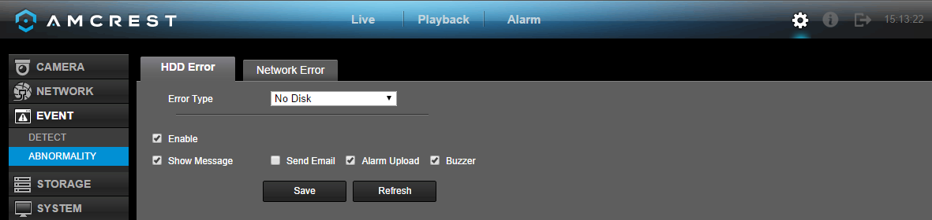
This screen allows the user to specify actions that occur when there is an abnormality with the DVR’s hard disk drive (HDD). Below is a screenshot of the HDD Error settings screen:

Parameter | Function
Error Type | Error Type: This field allows the user to specify which HDD abnormality event type they would like to configure settings for.  - No Disk: No hard drive is detected.  - Disk Error: The hard drive has an error.  - Disk No Space: The hard drive is about to, or has run out of space.  - Less Than: This field allows the user to specify at what percentage of free disk space this condition should be triggered.
Enable | This checkbox allows the user to enable the features below for the specified event type.
Show message | This checkbox allows the user to enable the system to show an on-screen message when an HDD error occurs.
Send Email | This checkbox allows the user to enable the system to send an email when an HDD error occurs.
Buzzer | This checkbox allows the user to enable the system to activate a buzzer when an HDD error occurs.

To confirm settings, click the Save button. To refresh the page, click the Refresh button.

5.4.3.2.2 Network Error

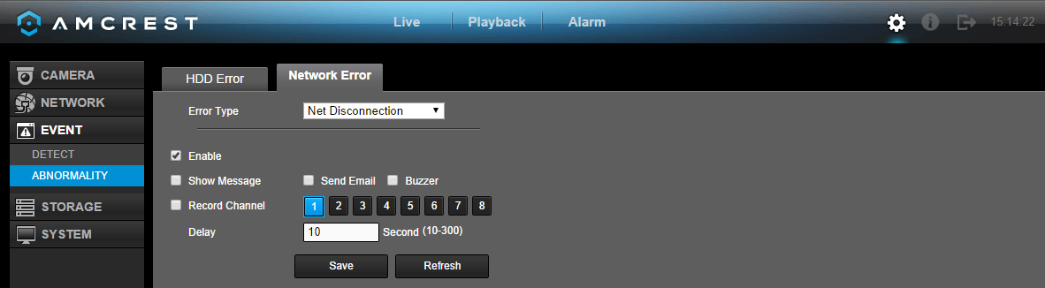
This screen allows the user to specify actions that occur when there is an abnormality with the DVR’s hard disk drive (HDD). Below is a screenshot of the HDD Abnormality settings screen:

Below is an explanation of the fields on the Network Abnormality settings screen:
Parameter | Function
Error Type | Event Type: This field allows the user to specify which Network abnormality event type they would like to configure settings for.  - Net Disconnected: The network connection has been disconnected.  - IP Conflict: There is a device on the network with the same IP address.  - MAC Conflict: There is a device on the network with the same MAC address.
Enable | This checkbox allows the user to enable the features below for the specified event type.
Show message | This checkbox allows the user to enable the system to show an on-screen message when a network error occurs.
Send Email | This checkbox allows the user to enable the system to send an email when a network error occurs.
Buzzer | This checkbox allows the user to enable the system to activate a buzzer when a network error occurs.
Delay | This field specifies in seconds how long the delay between alarm activation and buzzer activation should be.

To confirm settings, click the Save button. To refresh the page, click the Refresh button.

5.4.4 Storage

This set of menu items deal with storage of data on the DVR.

5.4.4.1 Schedule

This screen is used to specify the recording schedule for both recorded video and snapshots.

5.4.4.1.1 Schedule

This tab is where video recording settings are configured. Below is a screenshot of the Schedule settings screen:

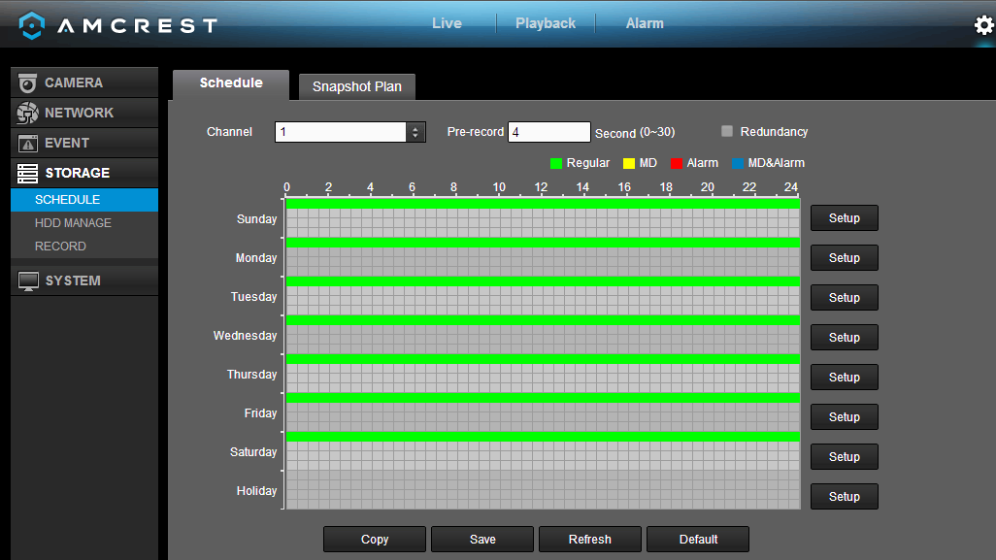

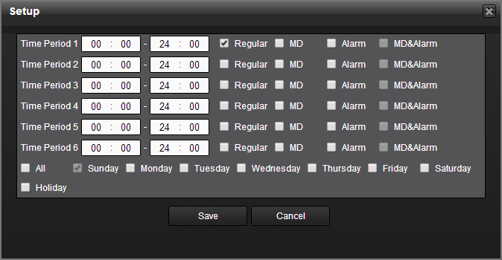
Below is a screenshot of the time period setup screen:

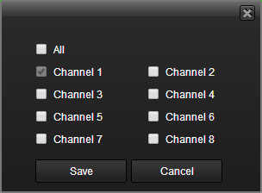
Below is a screenshot of the copy screen:

Below is an explanation of the fields on the Schedule settings screen:

Parameter | Function
Channel | This dropdown box allows the user to pick which channel they would like to change video recording settings for.
Pre-record | This field allows the user to capture extra video that occurs before an event. Up to 30 seconds of video prior to a recording event can be captured in order to provide context to a recording.
Redundancy | This checkbox allows the user to enable the redundancy backup feature. This feature allows the DVR to record video to two hard drives concurrently in order to ensure that in the case of a hard drive failure, the recorded data may be backed up to another hard drive.  - Note: This function only works if the HDD has two hard drives installed.  - Note: One hard drive has to be designated as redundant from the HDD Manager menu. See section 4.10.5.2 for more details.
Holiday | This dropdown box allows the user to enable the holiday function. Holiday settings are configured in the System settings section. See section 4.10.4.1.3 for more information on holiday settings.
Setup | In order to specify time zones in greater detail for each day, click the setup button to the left of the time bar, and the Time Period setup screen will appear. The system allows for the configuration of up to 6 different time periods. Click the checkbox to the left of the time period to enable that time period. Click the text next to each period to edit the time period. To copy time periods, click the checkboxes next to the days of the week that you’d like to copy the settings to. Once finished on this screen, click Save to return to the time period settings screen.

To copy settings to another channel, click the Copy button. To confirm settings, click the Save button. To refresh the page, click the Refresh button. To revert to default settings, click the Default button.

5.4.4.1.2 Snapshot Plan

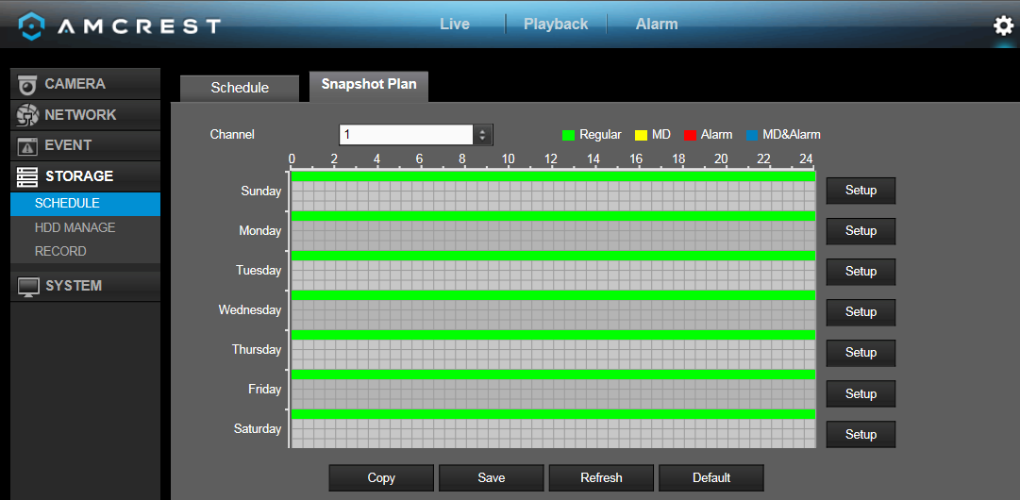
This tab is where snapshot recording settings are configured. Below is a screenshot of the Snapshot settings screen:

Below is a screenshot of the time period setup screen:

Below is a screenshot of the copy screen:

Below is an explanation of the fields on the Snapshot settings screen:

Parameter | Function
Channel | This dropdown box allows the user to pick which channel they would like to change snapshot recording settings for.
Holiday | This dropdown box allows the user to enable the holiday function. Holiday settings are configured in the System settings section. See section 4.10.4.1.3 for more information on holiday settings.
Setup | In order to specify time zones in greater detail for each day, click the setup button to the left of the time bar, and the Time Period setup screen will appear. The system allows for the configuration of up to 6 different time periods. Click the checkbox to the left of the time period to enable that time period. Click the text next to each period to edit the time period. To copy time periods, click the checkboxes next to the days of the week that you’d like to copy the settings to. Once finished on this screen, click Save to return to the time period settings screen.

To copy settings to another channel, click the Copy button. To confirm settings, click the Save button. To refresh the page, click the Refresh button. To revert to default settings, click the Default button.

5.4.4.2 HDD Manage/Local Storage

This screen is meant to help the user monitor the DVR’s hard drives. Using this screen, the user can see the current HDD type, status, and capacity. The user can also use this screen to format hard drives and change hard drive properties. Below is a screenshot of the HDD Manage settings screen:

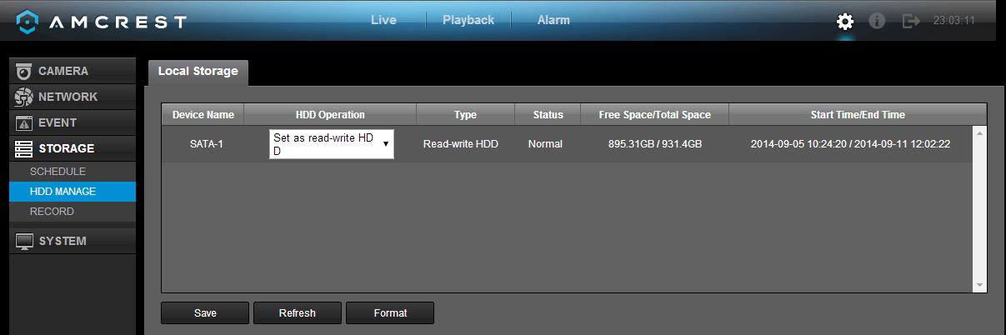
Below is an explanation of the fields on the HDD Manage settings screen:
- SATA:
  - This shows how many hard drives the system can support.
  - 1 here means the system supports a maximum of 1 HDD.
  - The symbol on the next row shows the status of the connected hard drive.
    - 0 means that the current HDD is functioning normally.
    - X means there is an error with the hard drive connection, or that there is no connected hard drive.
    - ? means that the hard drive is damaged and should be replaced.
- Hard Drive List:
  - This shows what hard drives are currently connected to the DVR, and displays information about them.
  - Device Name: This column shows the names of the connected hard disk drives (HDD).
  - Type: This column shows the type of access the DVR has to the hard drive. To change a hard drive’s type, click the downward arrow next to the HDD’s type and select the desired type. There are 3 possible settings:
    - Read-Only: This allows the DVR to read the data, but not modify it in anyway.
    - Write-Only: This allows the DVR to write data to the HDD, but not read any data from it.
    - Read/Write: This allows the DVR to both read and write data on the HDD.
  - Status: This column shows the status of the connected hard drive. There are 3 statuses:
    - Normal: This means the hard drive is operating normally.
    - Error: This means the DVR is experiencing an error when attempting to access the hard drive.
    - Disconnected: This means that the HDD has disconnected from the DVR.
  - Free Space/Total Space: This field shows the free space on the hard drive compared to its total capacity.

To confirm settings, click the Save button. To refresh the page, click the Refresh button. To format a hard drive, click the Format button.

5.4.4.3 Record

This screen allows the user to specify which channels are able to record and take snapshots. The settings on this screen supersede all others when it comes to allowing channels the ability to record information. Below is a screenshot of the Record screen:

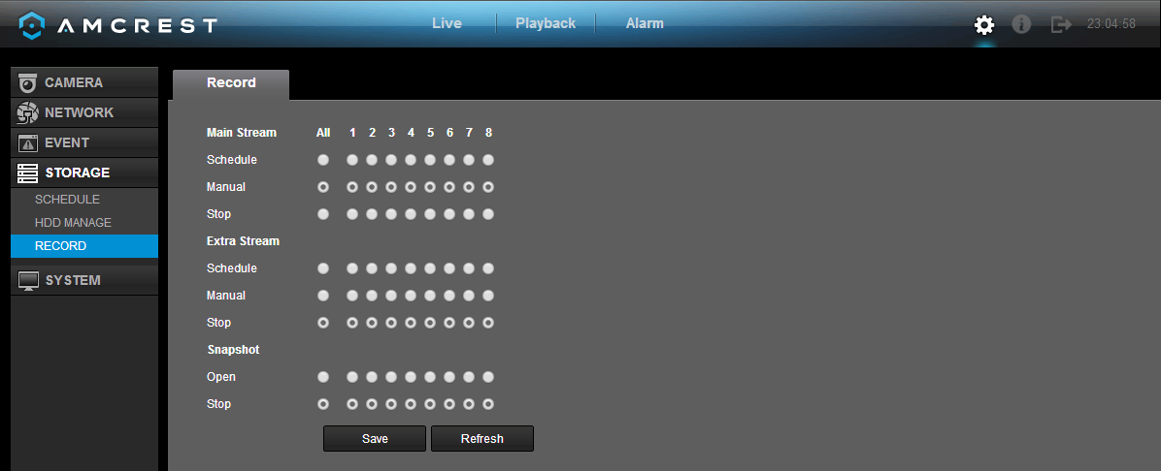

Below is an explanation of all of the fields on the Record settings page:
- Main Stream: The main stream is the stream through which the channels transmit data by default. There are 3 settings that can be used for the main stream.
  - Schedule: Channels will record as they have been scheduled, and not in any other capacity.
  - Manual: Channels will support all recording type. This includes scheduled recording.
  - Stop: Channels will not record in any capacity. This includes scheduled and manual recording.
- Extra Stream: Otherwise known as the sub stream, this stream allows for additional data to be transmitted. There are 3 settings that can be used for the main stream.
  - Schedule: Channels will record as they have been scheduled, and not in any other capacity.
  - Manual: Channels will support all recording type. This includes scheduled recording.
  - Stop: Channels will not record in any capacity. This includes scheduled and manual recording.
- Snapshot: This set of options can either enable or disable the snapshot functionality for specific channels.

To confirm settings, click the Save button. To refresh the page, click the Refresh button.

5.4.5 System

5.4.5.1 General

The general settings interface includes general, date/time, and holiday settings.

5.4.5.1.1 General

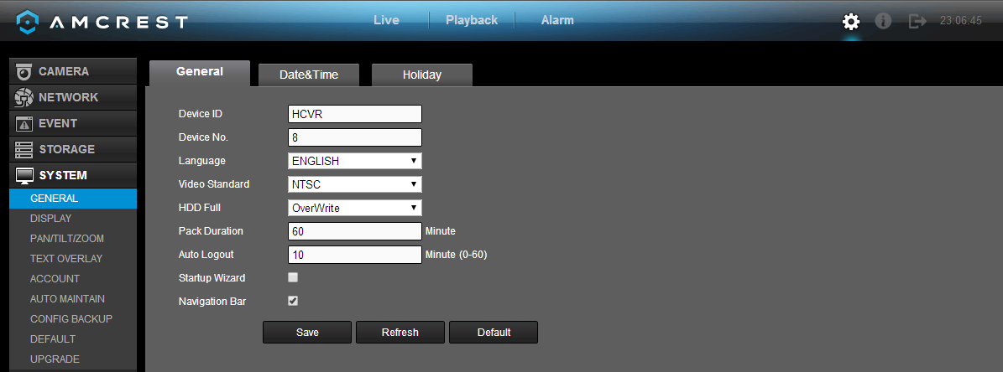
This screen displays general settings for the DVR. Below is a screenshot of the general settings screen:

Parameter | Function
Device ID | This field allows the user to customize the name of the HDCVI.
Device No. | This field allows the user to customize the device’s number.
Language | This dropdown box allows the user to select a language for the DVR. Options include English, Simplified Chinese, Traditional Chinese, Italian, Japanese, French, and Spanish.  Please note the device needs to reboot to activate the modification.
Video Standard | This dropdown box allows the user to select a video standard. The options are between PAL and NTSC.
HDD Full | This dropdown box allows the user to specify what to do when the HDD is full. There are two options:  - Overwrite: This option lets the DVR overwrite the oldest recorded video on the DVR.  - Stop Record: This option causes the DVR to stop recording once the HDD is full.
Pack Duration | This field allows the user to define the recording duration. The default value is 60 minutes
Auto Logout | This field allows the user to define in minutes how long the system can stay idle before a user is logged out. The value can range from 0 to 60 minutes.
Startup Wizard | This checkbox allows the user to enable the startup wizard the next time the system is restarted.
Navigation Bar | This checkbox allows the user to enable the navigation bar that shows on the main screen.

To confirm settings, click the Save button. To refresh the page, click the Refresh button. To revert to default settings, click the Default button.

5.4.5.1.2 Date & Time

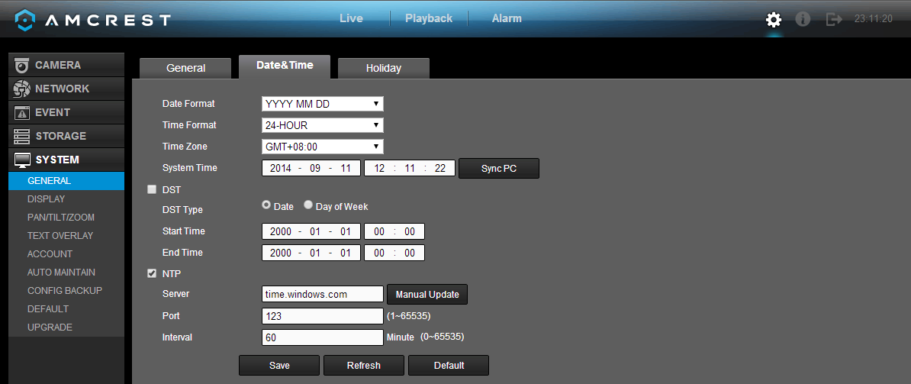
This screen displays date and time settings for the DVR. Below is a screenshot of the Date & Time settings screen:

Below is an explanation of the fields on the Date & Time settings screen:

Parameter | Function
Date Format | This dropdown box allows the user to specify a date and time format for the DVR to use. There are 3 options.  - YYYY MM DD: Year, Month, Day.  - MM DD YYYY: Month, Day, Year.  - DD MM YYYY: Day, Month, Year.
Time Format | Time Format: This dropdown box allows the user to specify a time format for the DVR to use. There are two options.  - 24 Hour  - 12 Hour
Time Zone | This dropdown box allows the user to specify a time zone for the DVR to use.
System Time | This field allows the user to set the system time and time zone. Click Save to save the system time as it is shown in the display.
Sync PC | Click this button to save the DVR system time as your PC’s current time.
DST | This checkbox allows the user to enable DST on the DVR. This fields below it allow the user to set DST settings such as DST type, start time, and end time.
NTP | NTP stands for Network Time Protocol. This checkbox allows the user to enable the use of an NST server to synchronize the date and time settings on the DVR.
NTP Server IP | This field allows the user to set the NTP server IP address. Clicking the Manual Update button pulls a time update from the server.
NTP Port Number | This field allows the user to set the NTP server port number.
Interval | This field allows the user to set the NTP synchronization interval. This number determines how often the DVR queries the NTP server to get accurate date and time information. This value can be between 0 and 60 minutes.

To confirm settings, click the Save button. To refresh the page, click the Refresh button. To revert to default settings, click the Default button.

5.4.5.1.3 Holiday

This screen displays the holiday settings for the DVR. Below is a screenshot of the Holiday settings screen:

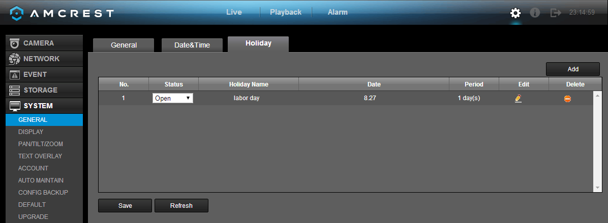

Below is an explanation of the fields on the Holiday settings screen:
- 1: This number indicates how many holidays are in the system. Each line item has a number to signify its place in the list.
- Status: This dropdown box indicates the status of the holiday. There are two options:
  - Open: The holiday is active, and the DVR will stop recording for that holiday period.
  - Stop: The holiday is inactive, and the DVR will continue normal operation for that holiday period.
- Name: This column is where the name of the holiday is displayed.
- Date: This column shows the date that the holiday occurs on.
- Period: This column shows the range in which the holiday occurs.
- Edit: This column has a button that allows for the editing of the holiday.
- Delete: This column has a button that allows for the deletion of the holiday.
- Add New Holidays: This button allows the user to add a holiday.

Note:
- Holidays take precedence over the scheduled setup.
- Holidays do not roll over based on their inherent date. Meaning, if a holiday is set for October 30th, then the system will treat every October 30th as a holiday.

To confirm settings, click the Save button. To refresh the page, click the Refresh button.

5.4.5.2 Display

5.4.5.2.1 Display

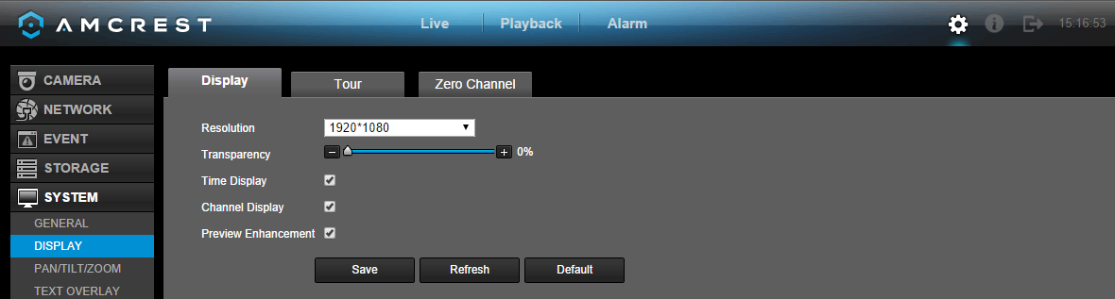
This screen allows the user to adjust display settings, tour settings, and zero-channel encoding settings for the DVR.

Below is an explanation of the fields on the Display settings screen:

Parameter | Function
Resolution | This dropdown box allows the user to change the resolution of the DVR. There are 4 options:  - 1920×1080  - 1280×1024 (default)  - 1280×720  - 1024×768
Transparency | This slider allows the user to change the transparency of the menu screens on the DVR. The range goes from 0% to 100%.
Time Display/  Channel Display | These checkboxes allows the user to choose whether or not the time stamp and channel number are shown in the playback video.
Preview Enhancement | This checkbox allows the user to optimize the margin of the playback video.

To confirm settings, click the Save button. To refresh the page, click the Refresh button. To revert to default settings, click the Default button.

5.4.5.2.2 Tour

This screen is used to activate tour functionality for the live preview. Below is a screenshot of the Tour Setup screen:

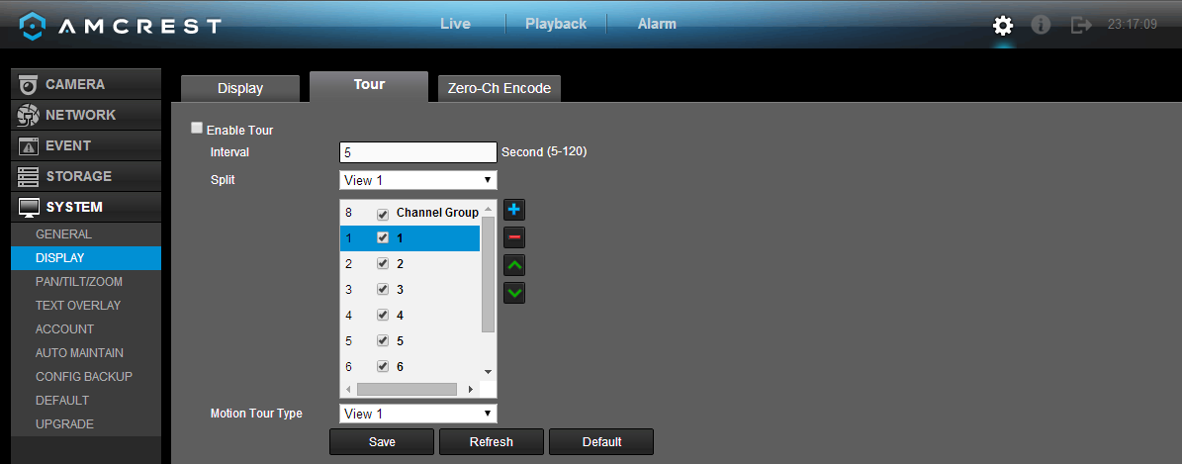

Below is an explanation of the fields on the Tour Setup settings screen:

Parameter | Function
Enable Tour | This checkbox allows the user to enable the tour functionality.
Interval | This field allows the user to set an interval in seconds for how quickly the tour cycles through channels. This value ranges from 5 to 120 seconds.
Split | This list allows the users to select channels add as a part of the tour. The number in the corner indicates how many channels are available.  - Add: This button allows the user to add a channel to the tour.  - Delete: This button allows the user to remove a channel from the tour.  - Move Up: This button allows the user to move a camera up in the tour queue.  - Move Down: This button allows the user to move a camera down in the tour queue.
Motion Tour Type | This dropdown box allows the user to select whether they want to see 1 or 4 cameras at a time in the tour.

To confirm settings, click the Save button. To refresh the page, click the Refresh button. To revert to default settings, click the Default button.

5.4.5.2.3 Zero-Channel Encoding

This screen is used to configure zero channel encoding functionality. This feature allows for the preview of several channels in one channel’s window. Note: This feature only works on the Web Access view. Below is a screenshot of the Zero-Channel Encoding settings screen:

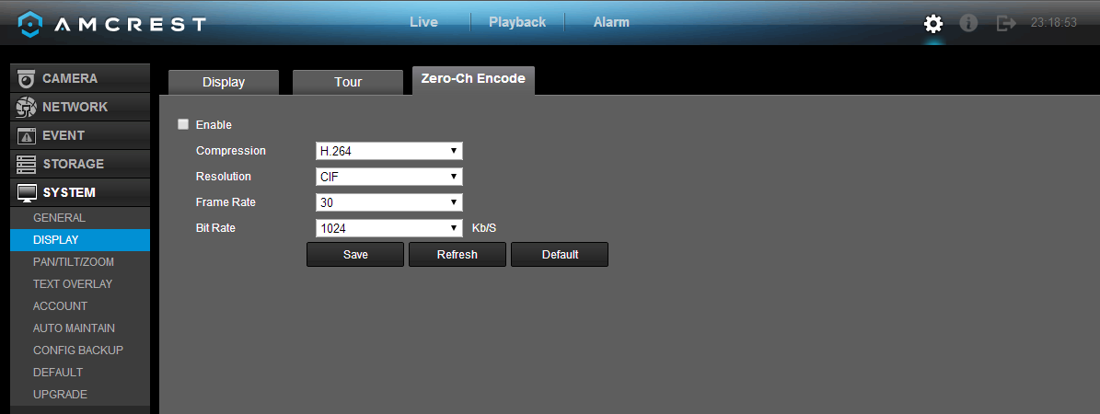

Below is an explanation of the fields on the Zero-Channel Encoding settings screen:

Parameter | Function
Enable | This checkbox allows the user to enable the zero-channel encoding functionality.
Compression | This dropdown box allows the user to select the compression settings used by the system for zero-channel encoding. The default is H.264.
Resolution | This dropdown box allows the user to select the resolution used by the system for zero-channel encoding. There are 2 options for resolution (in pixels):  - CIF: 352 x 240  - D1 720 x 480
Frame Rate | This dropdown box allows the user to select the frame rate used by the system for zero-channel encoding. The range is between 1 and 30 frames per second.
Bit Rate | This dropdown box allows the user to select the bit rate used by the system for zero-channel encoding. There are 7 options and all are measures in kilobytes per second (Kb/S): 896, 1024, 1280, 1536, 1792, 2048, 4016

To confirm settings, click the Save button. To refresh the page, click the Refresh button. To revert to default settings, click the Default button.

5.4.5.3 Pan/Tilt/Zoom

This screen is used to configure Pan/Tilt/Zoom (PTZ) functionality. Below is a screenshot of the PTZ settings screen:

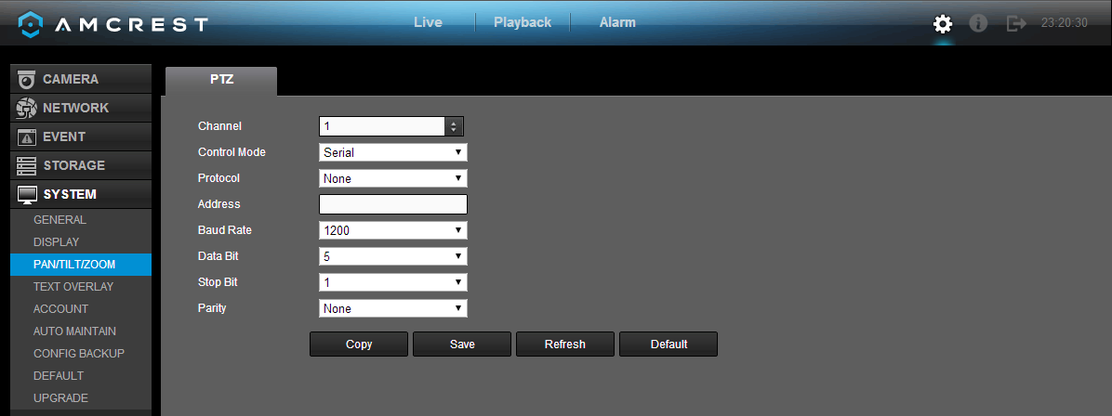

Below is an explanation of the fields on the PTZ settings screen:

Parameter | Function
Channel | This dropdown box allows the user to pick which channel they would like to change PTZ settings for.
Control Mode | This dropdown box allows the user to pick which control move they would like to use for the specified channel. The two options are Serial and HDCVI.
Protocol | This dropdown box allows the user to pick a protocol for the specified channel. Default is HDCVI.
Address | This dropdown box allows the user to pick the corresponding PTZ address for the channel.
Baud Rate | This dropdown box allows the user to pick a baud rate for the PTZ channel. The options are 1200, 2400, 4800, 9600, 19200, 38400, 57600, or 115200.
Data Bit | This dropdown box allows the user to pick the amount of data bits for the PTZ transmission. The options are 5, 6, 7, or 8.
Stop bit | This dropdown box allows the user to pick the amount of stop bits for the PTZ transmission. The options are 1, 1.5, or 2.
Parity | This dropdown box allows the user to pick the parity for the PTZ transmission. The options are none, odd or even.

To copy settings to another channel, click the Copy button. To confirm settings, click the Save button. To refresh the page, click the Refresh button. To revert to default settings, click the Default button.

5.4.5.4 Text Overlay

This screen is used to configure Text Overlay settings. This allows the DVR to record data brought in from Automated Teller Machines (ATMs) or Point of Sales (POS) systems and overlay the text onto the recorded video. Below are screenshots of the Text Overlay settings screen:
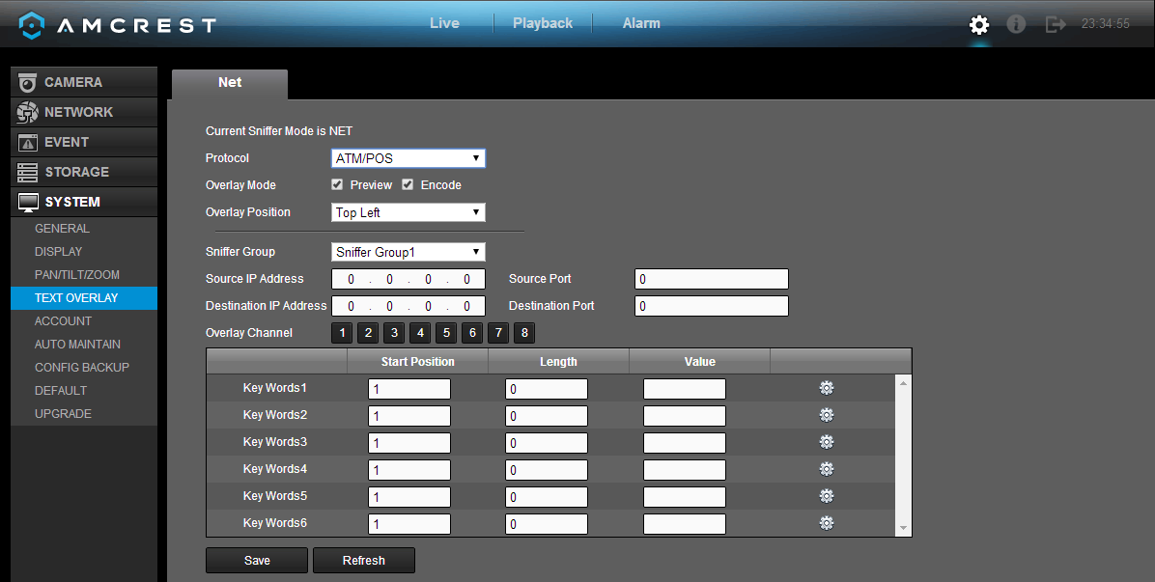
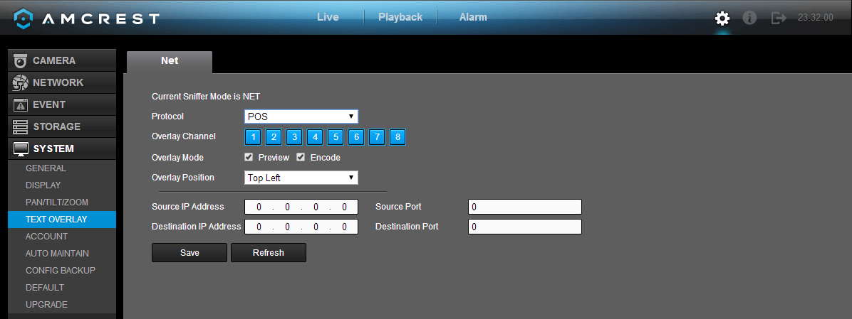
Below is an explanation of the fields on the Text Overlay settings screen:
- Protocol: This dropdown box allows the user to pick a protocol for text overlay. The options are ATM/POS and POS. Default is POS.
- Overlay Channel: This field allows the user to pick which overlay channels should be used with the video.
- Overlay Mode: These checkboxes allow the user to preview and enable the text overlay feature.
- Overlay Position: This dropdown box allows the user to pick which position for the overlaid text appears.
- Source IP: This field allows the user to enter the ATM or POS IP address and port number from which the text overlay data is gathered.
- Destination IP: This field allows the user to enter the ATM or POS IP address and port number to which the text overlay data is sent.

To confirm settings, click the Save button. To refresh the page, click the Refresh button.

5.4.5.5 Account

This menu is used to manage user accounts, user account passwords, and user groups. Below are a few considerations to keep in mind when editing this information:

- The DVR comes with 2 usernames by default:
  - Username: admin Password: admin
  - Username: default Password: default
- It is highly recommended to change the passwords for the admin and default accounts.
- Each user name and user group name can only contain letters, numbers, underline marks, dashes, or dots. No empty spaces are allowed.
- The maximum number of users is 64, and the maximum number of users that can be in one group is 20.
- There are two levels for user management: administrator and user. Administrator has more rights than a normal user and can modify key DVR settings.
- Each user can belong to only one group, and user rights cannot exceed group rights.

5.4.5.5.1 User

This screen is used to configure User Account settings. Below is a screenshot of the User Account settings screen:

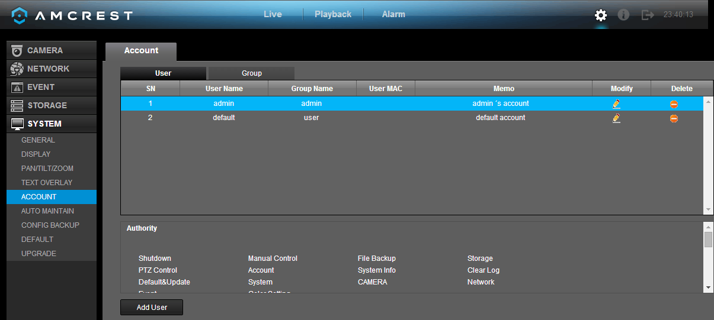

Below is an explanation of the fields on the User Account settings screen:
- Number: This number indicates how many users are in the system. Each line item has a number to signify its place in the list.
- User Name: This column indicates an account's username.
- Group Name: This column shows which group the username belongs to.
- Modify: This column has a button that allows for the account's properties to be edited.
- Delete: This column has a button that allows for the account's properties to be deleted.
- Status: This column shows what the status of a certain account is.
- MAC Address: This column shows the account's MAC address.
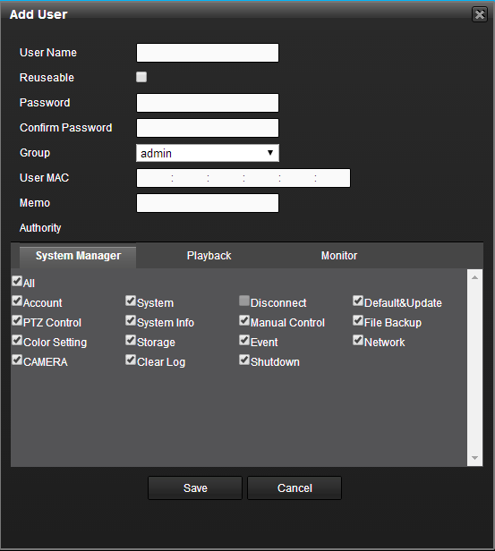
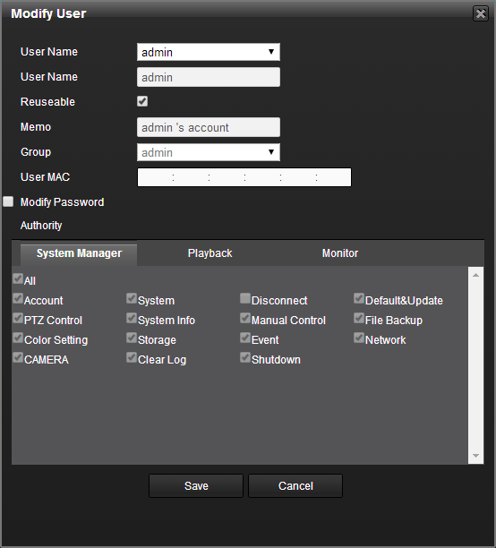
- Add User: This button allows the user to add another user account. Below is a screenshot of the Add User screen.

Note:
- It is recommended to give the general user fewer rights than an administrative one.
- When a new user is created, a MAC address can be entered for the user. This can limit the user's ability to logon from another device. If left blank, the user can logon from any MAC address.
- There are a total of 98 rights that can be assigned to a user.

5.4.5.5.2 Group
This screen is used to configure Group Account settings. Below is a screenshot of the Group Account settings screen:

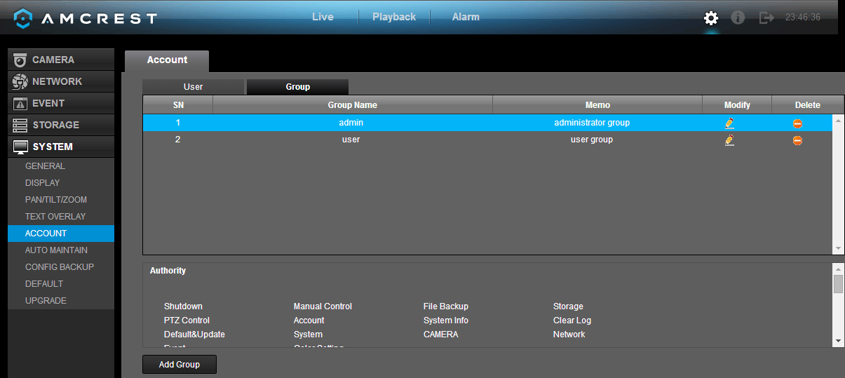

Below is an explanation of the fields on the User Group settings screen:
- Number: This number indicates how many groups are in the system. Each line item has a number to signify its place in the list.
- Group Name: This column indicates an account's username.
- Modify: This column has a button that allows for the account's properties to be edited.
- Delete: This column has a button that allows for the account's properties to be deleted.
- Memo: This column indicates any notes about the user group.
- Add Group: This button allows the user to add another user group. On the next page is a screenshot of the Add Group screen.
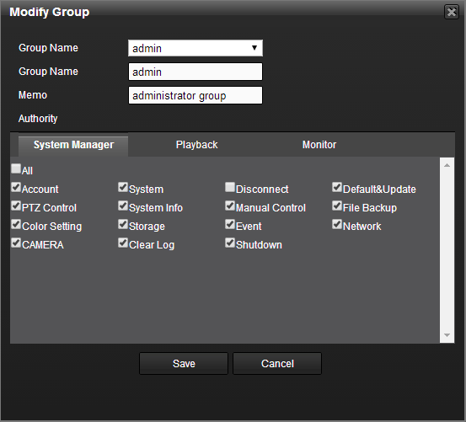
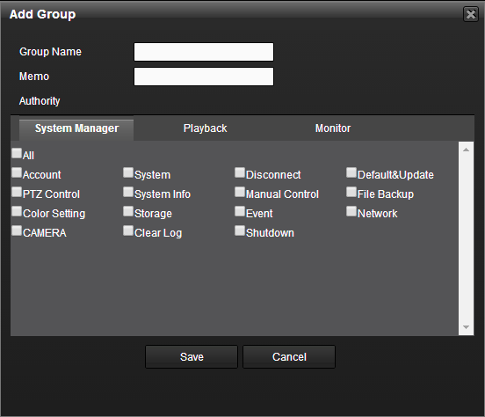

Note:
- It is recommended to give the general user fewer rights than an administrative one.
- There are a total of 98 rights that can be assigned to a user.

5.4.5.6 Auto Maintain

This screen is used to configure Auto Maintenance settings for the DVR. Below is a screenshot of the Auto Maintain settings screen:
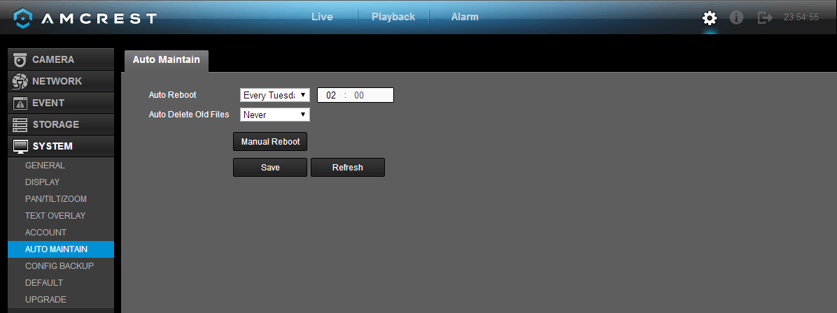

Below is an explanation of the fields on the Auto Maintain settings screen:
- Auto Reboot System: This dropdown field allows the user to set a day of the week and time to automatically reboot the system in order to keep the system healthy.
- Auto Delete Old Files: This dropdown field allows the user to delete old files. The two settings are Never and Customized. When customized is selected, a number of days can be specified. Any files that exist past that many days in the past are deleted to create space on the DVR's hard drive.

To confirm settings, click the Save button. To refresh the page, click the Refresh button.

5.4.5.7 Config Backup

This screen is used to manage importing and exporting of system configurations. This feature can be used to clone the settings from one DVR to another. Below is a screenshot of the Config Backup settings screen:

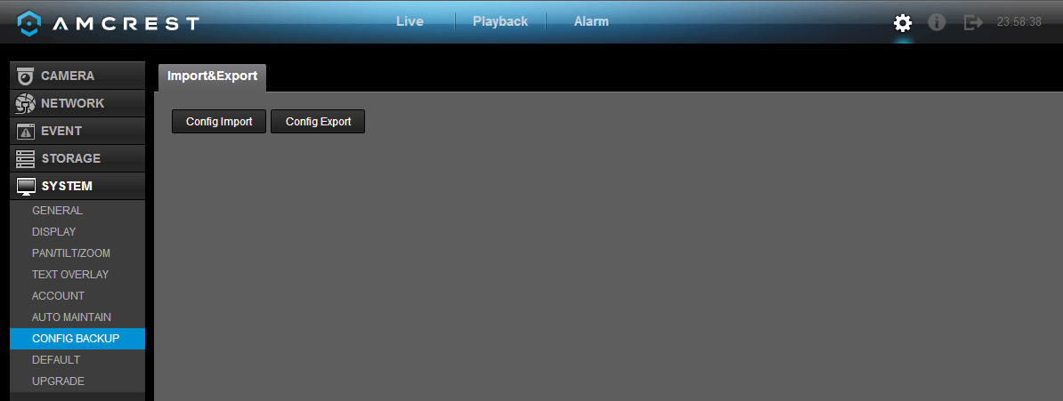

Below is an explanation of the fields on the Config Backup settings screen:

Parameter | Function
Import | This button allows the user to import configuration data to the DVR.
Export | This button allows the user to export current configuration data to another device.

5.4.5.8 Default

This screen is used to revert the DVR back to its default settings. This feature can be used to restore the DVR to its factory setup conditions. Below is a screenshot of the Default settings screen:

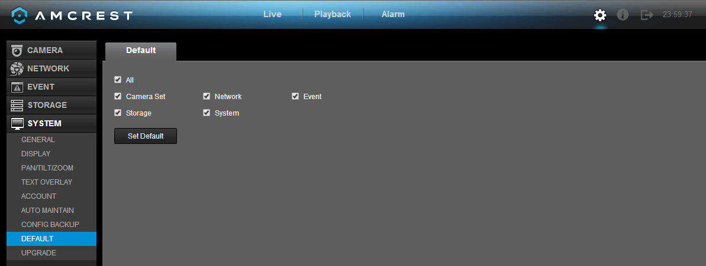
There are 5 different settings areas that can be reset to default settings: Camera settings, Event settings, Network settings, System settings, and Storage settings. All of these settings can be reset by the use of the All checkbox.
The following settings are also reset with a factory reset:

- System Menu Color
- Language
- Time Display Mode
- Video Format
- IP Address
- User Accounts

Click the Set Default button to restore the DVR to default settings for the categories selected.\

5.4.5.9 Upgrade

This screen is used to update the DVR's firmware to the latest version. To conduct a system update, it is required to put an update file onto a USB storage device and plug it into the DVR. Ensure the update file is named update.bin. Below is a screenshot of the Upgrade screen:
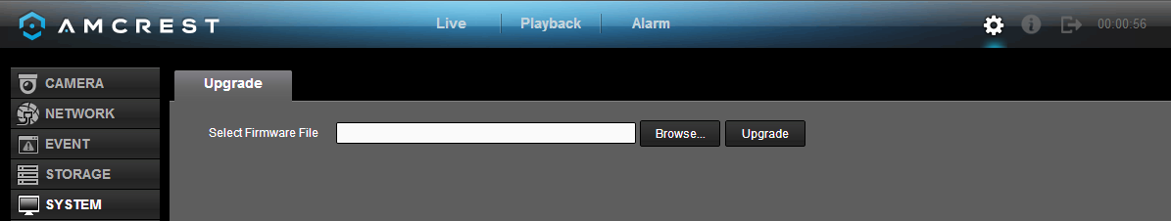
Click the Browse button to find the upgrade file, and click upgrade to start the upgrade process.

5.5 Web Access Information Menu

This menu can be accessed by clicking the 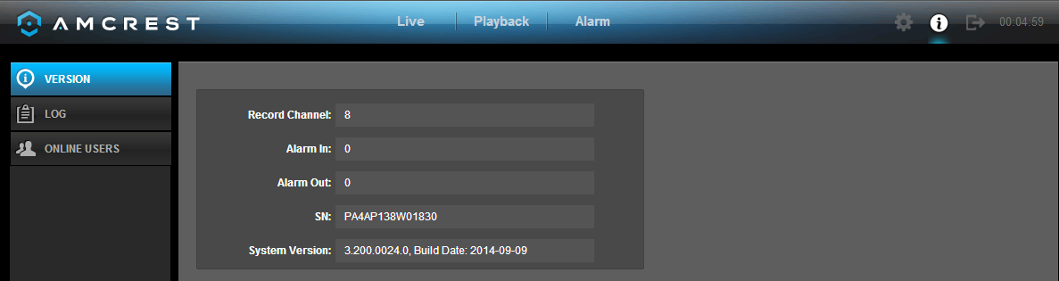 button near the top right corner of the web access interface.

5.5.1 Version

This screen is used to display record channel information, alarm input information, alarm output information, system serial number, and system version. Below is a screenshot of the version screen:

5.5.2 Log

This screen is used to keep a log of all activity on the DVR. Below is a screenshot of the Log screen:

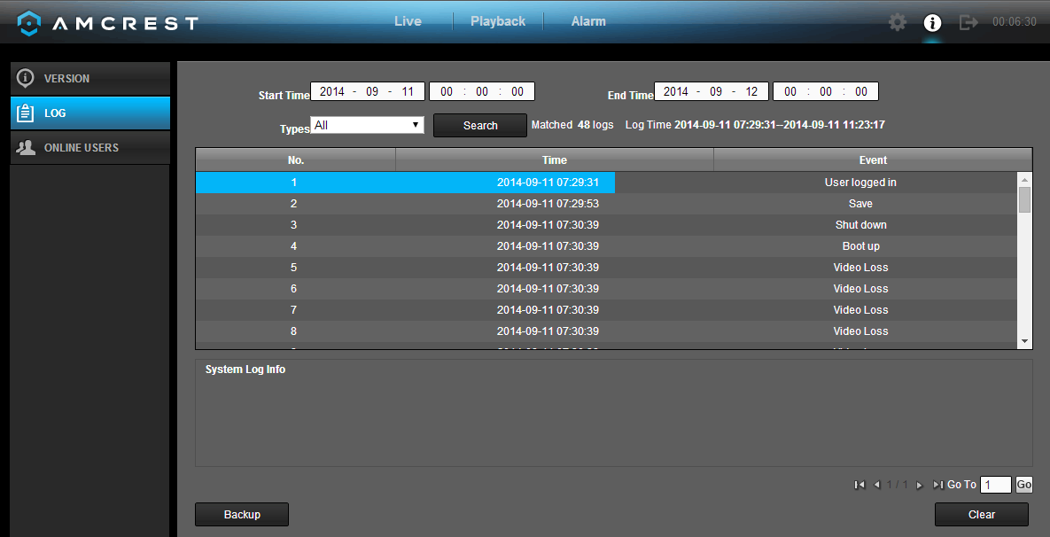

The system lists the following information:

- System Operation
- Configuration Operation
- Data Management
- Alarm Events
- Record Operation
- Account Manager
- Log Clear
- File Operation
- Reboot Type

Below is an explanation of the fields on the log screen:

Parameter | Function
Type | This dropdown box allows the user to select which type of log they want to view. Log types include: system operation, configuration operation, data operation, event operation, record operation, user management, and log clear.
Start time | This field allows the user to set the start time of the requested log.
End time | This field allows the user to set the end time of the requested log.
Search | You can select the log type from the drop down list and then click search button to view the list.  You can click the stop button to terminate the current search operation.
Detailed Information | Double click a line item to open a more detailed view of that log item.
Clear | This button deletes all log files that are currently displayed.
Backup | Click this button to backup log files to the PC.

5.5.3 Online Users

This screen shows a list of all the users that are currently online and accessing the DVR, either through the DVR itself, through local access, or through remote access. Below is a screenshot of the Online Users screen:

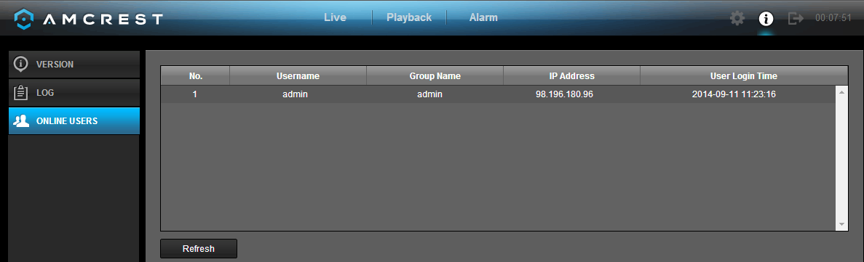

5.6 Log Out

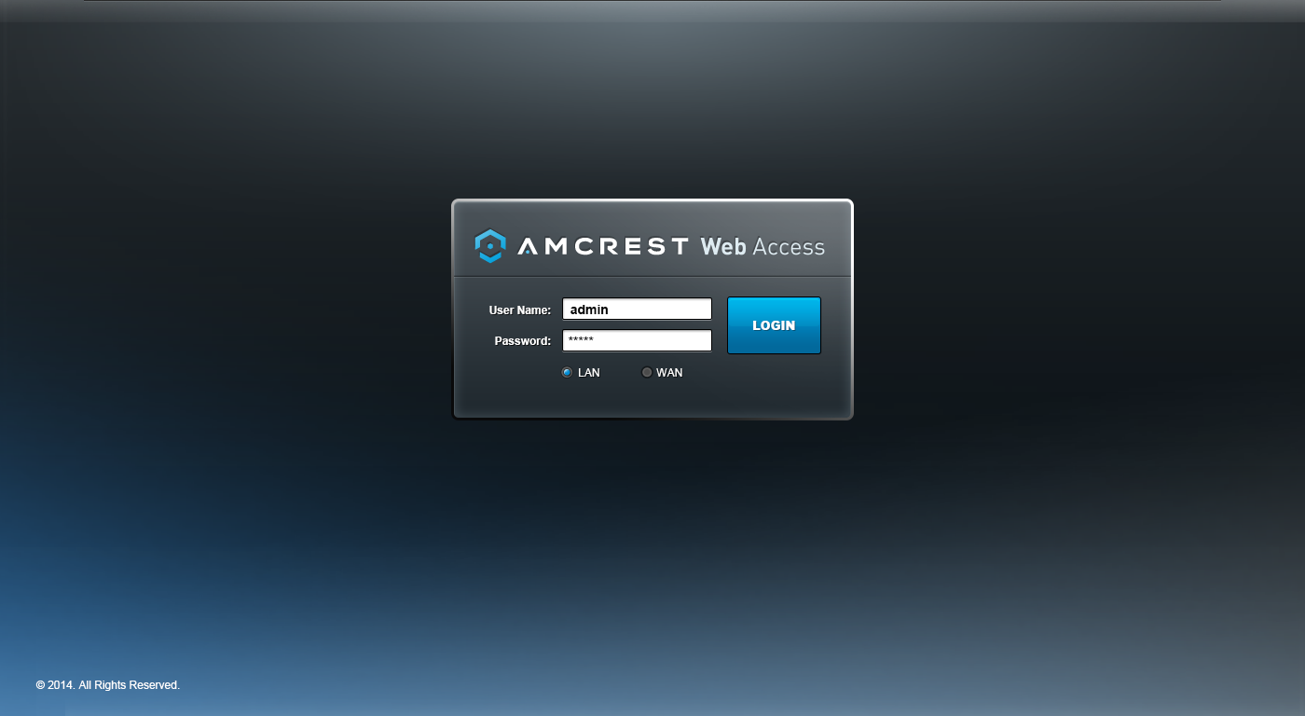
The logged in user can logout by using the 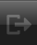 button near the top right hand corner of the screen. Once logged out, the DVR Web Access will return to the login screen, where another user may login. Below is a screenshot of the login screen:

6. FAQs/Troubleshooting

- The DVR does not boot up properly.
Below are a few possible reasons why this may be occurring:
- The power input is not correct voltage.
- The power cable connection is not secured correctly.
- The power button is damaged or malfunctioning.
- The firmware was upgraded incorrectly.
- There is an HDD malfunction or something is wrong with the HDD cable.
- There is damage to the DVR's main motherboard.

- DVR often automatically shuts down or stops running.
Below are a few possible reasons why this may be occurring:
- The input voltage is too low or is not stable.
- There is an HDD malfunction or something is wrong with the HDD cable.
- The power button is damaged or malfunctioning.
- Video output signal is not stable.
- The insides of the DVR have accumulated too much dust.
- The temperature is either too hot or too cold.
- The hardware is malfunctioning.

- The system does not detect a hard drive.
Below are a few possible reasons why this may be occurring:
- The hard drive is broken.
- The hard drive cable is damaged.
- The hard drive cable connection is loose.
- The DVR's main motherboard SATA port is broken.

4. There is no video output on any of the channels.
Below are a few possible reasons why this may be occurring:
- The DVR firmware is incompatible with the attached cameras. Upgrade to the latest firmware.
- The image brightness is set to 0. Change the brightness using the image settings or restore the DVR to factory default settings.
- There is no video input signal or the signal is too weak.
- A privacy mask or screensaver may be enabled.
- There might be a malfunction with the DVR hardware.

5. Real-time video color is distorted.
Below are a few possible reasons why this may be occurring:
- When using a BNC output, NTSC and PAL may be setup incorrectly. The real-time video may become black and white.
- The DVR is not compatible with the monitor.
- The video transmission cable is too long or signal degradation is too great.
- The DVR's color or brightness settings are not correctly configured.

6. Local Recordings are not searchable.
Below are a few possible reasons why this may be occurring:
- The hard drive cable is damaged.
- The hard drive is broken.
- The DVR's firmware is incompatible with the recorded video.
- The recorded files have been overwritten.
- The recording function has been disabled.

7. Local playback video is distorted.
Below are a few possible reasons why this may be occurring:
- The video quality setting is too low.
- The DVR software has a read error. Restart the DVR to solve this problem.
- The hard drive cable is damaged.
- The hard drive is malfunctioning.
- The DVR's hardware is malfunctioning.

8. There is no audio during real-time monitoring.
Below are a few possible reasons why this may be occurring:
- The microphone being used is not sufficiently powered.
- The speakers being used are not sufficiently powered.
- The audio cable is damaged.
- The DVR hardware is malfunctioning.

9. There is no audio during recorded video playback.
Below are a few possible reasons why this may be occurring:
- Audio may not be enabled for that channel.
- The corresponding channel may not have any audio input.

10. The timestamp is not displaying the correct time.
Below are a few possible reasons why this may be occurring:
- The time and date settings may not be configured correctly.
- The battery inside the DVR may be loose, or the battery is running low.

11. PTZ control is not working.
Below are a few possible reasons why this may be occurring:
- There may be an error with the PTZ front panel buttons.
- The PTZ decoding settings aren't configured correctly.
- The PTZ connection may be loose, or may not be installed correctly.
- An incorrect cable may be used to connect the PTZ enabled device to the DVR.
- The PTZ decoder and the DVR protocol are not compatible.
- The PTZ decoder and DVR address are not compatible.
- Multiple PTZ decoders are causing reverberation or impedance matching, causing PTZ signal interference. Use a 120 Ohm resister between the PTZ cables to reduce interference.
- The PTZ cable is too long or signal degradation is too great.

12. Motion detection does not work.
Below are a few possible reasons why this may be occurring:
- The motion detection time period may be incorrectly configured.
- Motion detection zone setup is not correctly configured.
- Motion detection sensitivity is too low.

13. Web Access isn't working.
Below are a few possible reasons why this may be occurring:
- Windows version is pre -Windows 2000 service pack 4. Use a more recent version of Windows.
- ActiveX controls have been disabled.
- The PC is not using DirectX 8.1 or higher. Upgrade to a more recent version of DirectX.
- The DVR is having network connection errors.
- Web access may be setup incorrectly.
- The username or password may be incorrect.
- The client end computer is not compatible with the DVR's firmware.

14. Web Access live view is only displaying a static picture. Both live playback and recorded playback aren't working.
Below are a few possible reasons why this may be occurring:
- The network speed is not sufficient to transfer video data via web access.
- The client PC may have limited resources.
- Multicast mode may be causing this issue.
- A privacy mask or screensaver may be enabled.
- The logged in user may not have sufficient rights to monitor real-time playback.
- The DVR's local video output quality is not sufficient.

15. Network connection is not stable.
Below are a few possible reasons why this may be occurring:
- The network is not stable.
- There may be an IP address conflict.
- There may be a MAC address conflict.
- The PC or DVR network card may be defective.

16. CD backup is not working/USB backup is not working.
Below are a few possible reasons why this may be occurring:
- The CD burner and the DVR are using the same data cable.
- The system is using too many CPU resources. Stop recording first and then begin the backup process.
- The data being backed up exceeds the backup device's capacity.
- The backup device is not compatible.
- The backup device is damaged.

17. Keyboard is not working with the DVR.
Below are a few possible reasons why this may be occurring:
- The DVR serial port is not setup correctly.
- The keyboard may be drawing too much power.
- The keyboard cable too long.
- The keyboard is not compatible with the DVR's firmware.

18. The alarm signal cannot been disarmed.
Below are a few possible reasons why this may be occurring:
- An alarm may be setup incorrectly.
- An alarm output may have been manually opened.
- The DVR may have an input device error or the connection is not correctly configured.
- There may be an error in the DVR's firmware.

19. Alarms are not working.
Below are a few possible reasons why this may be occurring:
- The alarm is not setup correctly.
- The alarm cable is not connected correctly.
- The alarm input signal is not correctly configured.
- There are two loops connected to one alarm device.

21. The camera is not recording enough video.
Below are a few possible reasons why this may be occurring:
- The hard drive's capacity is not enough.
- The hard drive is damaged.

22. Downloaded files cannot be played back.
Below are a few possible reasons why this may be occurring:
- The media player software on the PC may not be able to read the file format.
- The PC may not have DirectX 8.1 or higher.
- The PC may not have Windows XP or higher.

23. Forgot local menu operation password or network password
Please contact Amcrest support to reset the DVR's password.

To contact Amcrest support, please do one of the following:
- Visit http://amcrest.com/contacts and use the email form
- Call Amcrest Support using one of the following numbers
Toll Free: (888) 212-7538
International Callers (Outside of US): +1-713-893-8956
USA: 713-893-8956
Canada: 437-888-0177
UK: 203-769-2757
- Email Amcrest Customer Support support@amcrest.com

24. When I login via HTTPS, a dialogue says the certificate for this website is for another address.
Please refer to section 5.4.2.13 for directions on how to create a server certificate.

25. When I login via HTTPS, a dialogue says the certificate is not trusted.
Please refer to section 5.4.2.13 for directions on how to download a root certificate.

26. When I login via HTTPS, a dialogue says the certificate has expired or is not valid yet.
Ensure the PC has the same time as the DVR's system time.

Maintenance Tips:
- Please use a brush to clean the motherboard, socket connectors, and the DVR chassis and keep it free of dust.
- The device should be soundly grounded in case there is an audio/video disturbance. Keep the device away from static electricity or induced electricity.
- Please unplug the power cable before you remove audio/video signal cables, RS232 cables, or RS485 cables.
- Always shut down the device properly. Please use the shutdown function in the menu or can press the power button on the front panel for at least three seconds to shut down the DVR. Incorrect shutdown may result in a hard drive malfunction.
- Keep the device is away from direct sunlight or other heat sources, and keep the DVR well ventilated.

Appendix A: Hard Disk Drive (HDD) Capacity Calculation

To calculate the total capacity needed by each DVR according to video recording settings (video recording type and video file storage time).
Step 1: According to Formula (1) to calculate storage capacity that is the capacity of each channel needed for each hour, unit Mbyte.
(1)
In the formula: means the bit rate, unit Kbit/s
Step 2: After video time requirement is confirmed, according to Formula (2) to calculate the storage capacity, which is storage of each channel needed unit Mbyte.
(2) = ××
In the formula:
means the recording time for each day (hour)
means number of days for which the video shall be kept
Step 3: According to Formula (3) to calculate total capacity (accumulation) that is needed for all channels in the DVR during scheduled video recording.

(3)
In the formula: means total number of channels in one DVR

Step 4: According to Formula (4) to calculate total capacity (accumulation) that is needed for all channels in DVR during alarm video recording (including motion detection).

(4) ×a%

In the formula：a% means alarm occurrence rate

Appendix B: Compatible Backup Device List

Compatible USB drive list:
NOTE: Please upgrade the DVR firmware to latest version to ensure the accuracy of the table below. If you use a USB drive, please confirm it is formatted to FAT or FAT32.

Manufacturer | Model | Capacity
Sandisk | Cruzer Micro | 512M
Sandisk | Cruzer Micro | 1G
Sandisk | Cruzer Micro | 2G
Sandisk | Cruzer Freedom | 256M
Sandisk | Cruzer Freedom | 512M
Sandisk | Cruzer Freedom | 1G
Sandisk | Cruzer Freedom | 2G
Kingston | DataTraveler Ⅱ | 1G
Kingston | DataTraveler Ⅱ | 2G
Kingston | DataTraveler | 1G
Kingston | DataTraveler | 2G
Maxell | USB Flash Stick | 128M
Maxell | USB Flash Stick | 256M
Maxell | USB Flash Stick | 512M
Maxell | USB Flash Stick | 1G
Maxell | USB Flash Stick | 2G
Kingax | Super Stick | 128M
Kingax | Super Stick | 256M
Kingax | Super Stick | 512M
Kingax | Super Stick | 1G
Kingax | Super Stick | 2G
Netac | U210 | 128M
Netac | U210 | 256M
Netac | U210 | 512M
Netac | U210 | 1G
Netac | U210 | 2G
Netac | U208 | 4G
Teclast | Ti Cool | 128M
Teclast | Ti Cool | 256M
Teclast | Ti Cool | 512M
Teclast | Ti Cool | 1G
SanDisk | cruzer mirco | 2G
SanDisk | cruzer mirco | 8G
SanDisk | Ti Cool | 2G
SanDisk | Hongjiao | 4G
Lexar | Lexar | 256MB
Kingston | Data Traveler | 1G
Kingston | Data Traveler | 16GB
Kingston | Data Traveler | 32GB
Aigo | L8315 | 16GB
Sandisk | 250 | 16GB
Kingston | Data Traveler Locker+ | 32GB
Netac | U228 | 8GB

Compatible SD Card List
Please refer to the following sheet for compatible SD card brands.

Brand | Standard | Capacity | Card type
Transcend | SDHC6 | 16GB | SD
Kingston | SDHC4 | 4GB | SD
Kingston | SD | 2GB | SD
Kingston | SD | 1GB | SD
Sandisk | SDHC2 | 8GB | Micro-SD
Sandisk | SD | 1GB | Micro-SD

Compatible Portable HDD List
Please refer to the following sheet for compatible portable HDD brands.

Brand | Model | Capacity
YDStar | YDstar HDD box | 40G
Netac | Netac | 80G
Iomega | Iomega RPHD-CG" RNAJ50U287 | 250GB
WD Elements | WCAVY1205901 | 1.5TB
Newsmy | Liangjian | 320GB
WD Elements | WDBAAR5000ABK-00 | 500GB
WD Elements | WDBAAU0015HBK-00 | 1.5TB
Seagate | FreeAgent Go(ST905003F) | 500GB
Aigo | H8169 | 500GB

Compatible USB DVD Burner List
NOTE: Please upgrade the DVR firmware to latest version to ensure the accuracy of the table below.

Manufacturer | Model
Sony | DRX-S70U
Benq | TW200D

Compatible SATA DVD Burner List
NOTE: Please upgrade the DVR firmware to latest version to ensure the accuracy of the table below.

Manufacturer | Model
Pioneer | DVR-215CHG
Panasonic | SW-9588-C
Samsung | TS-H653
Sony | DRU-V200S
Sony | DRU-845S
Samsung | TS-H653
Pioneer | DVR-217CHG
LG | GH22NS30

Compatible SATA HDD List
NOTE: Please upgrade the DVR firmware to latest version to ensure the accuracy of the table below. SATA hard drives should be connected to the DVR's SATA port. It is recommended to use a hard drive with a capacity between 500 gigabytes and 4 terabytes.

Manufacturer | Series | Model | Capacity | Port Mode
Seagate | Seagate SV35.1 | ST3250824SV | 250G | SATA
Seagate | Seagate SV35.1 | ST3500641SV | 500G | SATA
Seagate | Seagate SV35.2 | ST3250820SV | 250G | SATA
Seagate | Seagate SV35.2 | ST3320620SV | 320G | SATA
Seagate | Seagate SV35.2 | ST3500630SV | 500G | SATA
Seagate | Seagate SV35.2 | ST3750640SV | 750G | SATA
Seagate | Seagate SV35.3 | ST3250310SV | 250G | SATA
Seagate | Seagate SV35.3 | ST3500320SV | 500G | SATA
Seagate | Seagate SV35.3 | ST3750330SV | 750G | SATA
Seagate | Seagate SV35.3 | ST31000340SV | 1T | SATA
Seagate | Seagate SV35.4 | ST3320410SV | 320G | SATA
Seagate | Seagate SV35.4 | ST3250311SV | 250G | SATA
Seagate | Seagate SV35.5 | ST3500410SV | 500G | SATA
Seagate | Seagate SV35.5 | ST3500411SV | 500G | SATA
Seagate | Seagate SV35.5 | ST31000525SV | 1T | SATA
Seagate | Seagate SV35.5 | ST31000526SV | 1T | SATA
Seagate | Seagate SV35.5 | ST1000VX000 | 1T | SATA
Seagate | Seagate SV35.5 | ST2000VX003 | 2T | SATA
Seagate | Seagate SV35.5 | ST2000VX002 | 2T | SATA
Seagate | Seagate SV35.5 | ST2000VX000 | 2T | SATA
Seagate | Seagate SV35.5 | ST3000VX000 | 3T | SATA
Seagate | Seagate Pipeline HD | ST3320410CS | 320G | SATA
Seagate | Seagate Pipeline HD | ST3320310CS | 320G | SATA
Seagate | Seagate Pipeline HD | ST3500422CS | 500G | SATA
Seagate | Seagate Pipeline HD | ST3500321CS | 500G | SATA
Seagate | Seagate Pipeline HD2 | ST3250412CS | 250G | SATA
Seagate | Seagate Pipeline HD2 | ST3320311CS | 250G | SATA
Seagate | Seagate Pipeline HD2 | ST3500414CS | 500G | SATA
Seagate | Seagate Pipeline HD2 | ST3500312CS | 500G | SATA
Seagate | Seagate Pipeline HD2 | ST31000424CS | 1T | SATA
Seagate | Seagate Pipeline HD2 | ST31000322CS | 1T | SATA
Seagate | Seagate Pipeline HD2 | ST1000VM002 | 1T | SATA
Seagate | Seagate Pipeline HD2 | ST1500VM002 | 1T | SATA
Seagate | Seagate Pipeline HD2 | ST2000VM002 | 2T | SATA
Seagate | Seagate Pipeline HD2 | ST2000VM003 | 2T | SATA
Seagate | Seagate Constellation ES | ST3500514NS | 500G | SATA
Seagate | Seagate Constellation ES | ST31000524NS | 1T | SATA
Seagate | Seagate Constellation ES | ST32000644NS | 2T | SATA
Seagate | Seagate Constellation ES | ST2000NM0011 | 2T | SATA
Seagate | Seagate Constellation ES | ST1000NM0011 | 1T | SATA
Seagate | Seagate Constellation ES | ST500NM0011 | 500G | SATA
Seagate | Seagate Constellation ES | ST2000NM0031 | 2T | SATA
Seagate | Seagate Constellation ES | ST1000NM0031 | 1T | SATA
Seagate | Seagate Constellation ES | ST500NM0031 | 500G | SATA
Seagate | Seagate Constellation ES | ST2000NM0051 | 2T | SATA
Seagate | Seagate Constellation ES | ST1000NM0051 | 1T | SATA
Seagate | Seagate Constellation ES | ST500NM0051 | 500G | SATA
Seagate | Seagate Constellation ES.2 | ST33000650NS | 3T | SATA
Seagate | Seagate Constellation ES.2 | ST32000645NS | 2T | SATA
Seagate | Seagate Constellation ES.2 | ST33000651NS | 3T | SATA
Seagate | Seagate Constellation ES.2 | ST32000646NS | 2T | SATA
Seagate | Seagate Constellation ES.2 | ST33000652NS | 3T | SATA
Seagate | Seagate Constellation ES.2 | ST32000647NS | 2T | SATA
Westem Digital | Cariar SE | WD3200JD | 320G | SATA
Westem Digital | Cariar SE | WD3000JD | 300G | SATA
Westem Digital | Cariar SE | WD2500JS | 250G | SATA
Westem Digital | Cariar SE16 | WD7500KS | 750G | SATA
Westem Digital | Cariar SE16 | WD5000KS | 500G | SATA
Westem Digital | Cariar SE16 | WD4000KD | 400G | SATA
Westem Digital | Cariar SE16 | WD3200KS | 320G | SATA
Westem Digital | Cariar SE16 | WD2500KS | 250G | SATA
Westem Digital | WD Caviar SE16 | WD2500YS-01SHB0 | 250G | SATA
Westem Digital | WD Caviar RE16 | WD3200YS-01PGB0 | 320G | SATA
Westem Digital | WD Caviar RE2 | WD5000YS-01MPB0 | 500G | SATA
Westem Digital | WD AV—AVJS | WD2500AVJS-63WDA0 | 500G | SATA
Westem Digital | WD AV—AVJS | WD3200AVJS-63WDA0 | 320G | SATA
Westem Digital | WD AV—AVJS | WD5000AVJS-63YJA0 | 500G | SATA
Westem Digital | WDAV-GP—AVCS | WD5000AVCS-63H1B1 | 500G | SATA
Westem Digital | WDAV-GP—AVCS | WD7500AVCS-63ZLB0 | 750G | SATA
Westem Digital | WDAV-GP—AVCS | WD3200AVCS | 320G | SATA
Westem Digital | WDAV-GP—AVCS | WD2500AVCS | 250G | SATA
Westem Digital | WDAV-GP—EVCS | WD10EVCS-63ZLB0 | 1T | SATA
Westem Digital | WDAV-GP—EVCS | WD20EVCS-63ZLB0 | 2T | SATA
Westem Digital | WDAV-GP—AVVS | WD3200AVVS-63L2B0 | 320G | SATA
Westem Digital | WDAV-GP—AVVS | WD5000AVVS-63ZWB0 | 500G | SATA
Westem Digital | WDAV-GP—AVVS | WD7500AVVS-63E1B1 | 750G | SATA
Westem Digital | WDAV-GP—AVVS | WD7500AVVS-63E1B1 | 750G | SATA
Westem Digital | WDAV-GP—EVVS | WD10EVVS-63E1B1 | 1T | SATA
Westem Digital | WDAV-GP—EVDS | WD10EVDS-63N5B1 | 1T | SATA
Westem Digital | WDAV-GP—EVDS | WD15EVDS-63V9B0 | 1.5T | SATA
Westem Digital | WDAV-GP—EVDS | WD20EVDS-63T3B0 | 2T | SATA
Westem Digital | WDAV-GP—AVDS | WD5000AVDS-63U7B0 | 500G | SATA
Westem Digital | WD AV-GP | WD30EURS | 3T | SATA
Westem Digital | WD AV-GP | WD25EURS | 2.5T | SATA
Westem Digital | WD AV-GP | WD20EURS | 2T | SATA
Westem Digital | WD AV-GP | WD15EURS | 1.5T | SATA
Westem Digital | WD AV-GP | WD10EURS | 1T | SATA
Westem Digital | WD AV-GP | WD10EURX | 1T | SATA
Westem Digital | WD AV-GP | WD7500AURS | 750G | SATA
Westem Digital | WD AV-GP | WD7500AVDS | 500G | SATA
Westem Digital | WD AV-GP | WD500AVDS | 500G | SATA
Westem Digital | WD AV-GP | WD10EUCX | 1T | SATA
Samsung | Samsung—HA | HA500LJ/CE | 500G | SATA
Samsung | Samsung—HA | HA751LJ | 750G | SATA
Samsung | Samsung—HA | HA101UJ/CE | 1T | SATA
Samsung | Samsung—HD | HD502HI/CEC | 500G | SATA
Samsung | Samsung—HD | HD103SI/CEC | 1T | SATA
Samsung | Samsung—HD | HD154UI/CE | 1.5T | SATA
Hitachi | HitachiCinemaStar™ 5K500 | HCP725050GLA380 | 500G | SATA
Hitachi | HitachiCinemaStar™ 7K1000.B | HCT721050SLA360 | 500G | SATA
Hitachi | HitachiCinemaStar™ 7K1000.B | HCT721075SLA360 | 750G | SATA
Hitachi | HitachiCinemaStar™ 7K1000.B | HCT721010SLA360 | 1T | SATA
Maxtor | DiamondMax 20 | STM3320820AS | 320G | SATA
Maxtor | DiamondMax 20 | STM3250820AS | 250G | SATA

Appendix C: Compatible CD/DVD Device List

NOTE: Please upgrade the DVR firmware to latest version to ensure the accuracy of the table below.

Manufacturer | Model | Port Type | Type
Sony | DRX-S50U | USB | DVD-RW
Sony | DRX-S70U | USB | DVD-RW
Sony | AW-G170S | SATA | DVD-RW
Samsung | TS-H653A | SATA | DVD-RW
Panasonic | SW-9588-C | SATA | DVD-RW
Sony | DRX-S50U | USB | DVD-RW
BenQ | 5232WI | USB | DVD-RW

Appendix D: Compatible Display List

Please refer to the following sheet for the compatible device brands.

Brand | Model | Dimension (Unit: inch)
BENQ（LCD） | ET-0007-TA | 19-inch (wide screen)
DELL（LCD） | E178FPc | 17-inch
BENQ（LCD） | Q7T4 | 17-inch
BENQ（LCD） | Q7T3 | 17-inch
LENOVO（LCD） | LXB-L17C | 17-inch
SANGSUNG（LCD） | 225BW | 22-inch (wide screen)
HFNOVO (CRT) | LXB-FD17069HB | 17-inch
HFNOVO (CRT) | LXB-HF769A | 17-inch
HFNOVO (CRT) | LX-GJ556D | 17-inch
Samsung（LCD） | 2494HS | 24-inch
Samsung（LCD） | P2350 | 23-inch
Samsung（LCD） | P2250 | 22-inch
Samsung（LCD） | P2370G | 23-inch
Samsung（LCD） | 2043 | 20-inch
Samsung（LCD） | 2243EW | 22-inch
Samsung（LCD） | SMT-1922P | 19-inch
Samsung（LCD） | T190 | 19-inch
Samsung（LCD） | T240 | 24-inch
LG（LCD） | W1942SP | 19-inch
LG（LCD） | W2243S | 22-inch
LG（LCD） | W2343T | 23-inch
BENQ（LCD） | G900HD | 18.5-inch
BENQ（LCD） | G2220HD | 22-inch
PHILIPS（LCD） | 230E | 23-inch
PHILIPS（LCD） | 220CW9 | 23-inch
PHILIPS（LCD） | 220BW9 | 24-inch
PHILIPS（LCD） | 220EW9 | 25-inch

Appendix E: Compatible Switch List

Please refer to the following sheet for a list of compatible switches.

Brand | Model | Network Working Mode
D-LinK | DES-1016D | 10/100M self-adaptive
D-LinK | DES-1008D | 10/100M self-adaptive
Ruijie | RG-S1926S | There are five network modes：  1、AUTO  2、HALF-10M  3、FULL-10M  4、HALF-100M  5、FULL-100M
H3C | H3C-S1024 | 10/100M self-adaptive
TP-LINK | TL-SF1016 | 10/100M self-adaptive
TP-LINK | TL-SF1008+ | 10/100M self-adaptive

Appendix F: Compatible Wireless Mouse List

Please refer to the following sheet for compatible wireless mouse brands.

Brand | Model
 | V80
Rapoo | 3500
Logitech | M215
Shuangfeiyan | Tianyao G7-630

Appendix H: Toxic or Hazardous Materials or Elements

Component Name | Toxic or Hazardous Materials or Elements
Component Name | Pb | Hg | Cd | Cr VI | PBB | PBDE
Sheet Metal(Case) | ○ | ○ | ○ | ○ | ○ | ○
Plastic Parts（Panel） | ○ | ○ | ○ | ○ | ○ | ○
Circuit Board | ○ | ○ | ○ | ○ | ○ | ○
Fastener | ○ | ○ | ○ | ○ | ○ | ○
Wire and Cable/Ac Adapter | ○ | ○ | ○ | ○ | ○ | ○
Packing Material | ○ | ○ | ○ | ○ | ○ | ○
Accessories | ○ | ○ | ○ | ○ | ○ | ○

Note
O: Indicates that the concentration of the hazardous substance in all homogeneous materials in the parts is below the relevant threshold of the SJ/T11363-2006 standard.

X: Indicates that the concentration of the hazardous substance of at least one of all homogeneous materials in the parts is above the relevant threshold of the SJ/T11363-2006 standard. During the environmental-friendly use period (EFUP) period, the toxic or hazardous substance or elements contained in products will not leak or mutate so that the use of these (substances or elements) will not result in any severe environmental pollution, any bodily injury or damage to any assets. The consumer is not authorized to process such kind of substances or elements, please return to the corresponding local authorities to process according to your local government statutes.

Note:
- For a detailed operational introduction, please refer to our CD included in your package for the electronic version of the User Manual.
- To view setup videos for many of the steps outlined in this guide, go tohttp://amcrest.com/videos
- This quick start guide is for reference only. Slight differences may be found in the user interface.
- All the designs and software here are subject to change without prior written notice.
- All trademarks and registered trademarks mentioned are the properties of their respective owners.
- If you have any questions or concerns, please contact us at support@amcrest.com, or call us at 888-212-7538.

